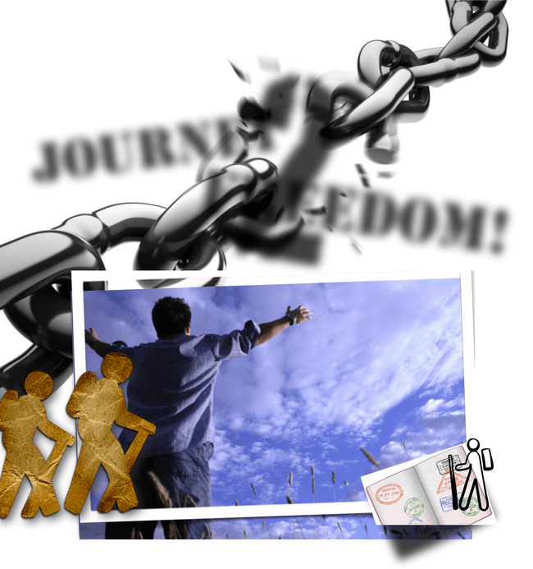
JOURNEY 2
FREEDOM!

Man’s PURPOSE and

the GIFTS of the Spirit

J2F Book 1


There is no copyright on this material. However, no part may be reproduced and/or presented for personal gain. All rights to this material are reserved to further the Kingdom of our Lord Jesus Christ ONLY.

For further information or to place an order, please contact us at:

Tel: +27 (0) 60 825 5780 (as from 1 March 2018)

Fax: 086 681 9458
E-mail: kanaan@iafrica.com
Website: www.kanaanministries.org

Office hours:

Monday to Friday, 9 AM to 2 PM

Kanaan International Website

Website: www.eu.kanaanministries.org

Overview of the Journey

- J2F1 “Man’s Purpose And The Gifts Of The Spirit”

We discover that each and everyone of us have been created by GOD the Father with a UNIQUE purpose and destiny. In fulfilling this purpose, GOD
has placed within each of us a special combination of gifts. When we discover our gifts, and develop them, we are able to walk in GOD’s Destiny for us … as well as being able to bless and help others. We also learn how to protect our gifts from attack.

- j2f2 “Generational Blessings”

Each and every one of us have been given a piece of land, a garden. This land represents ourselves, as well as our family. We study the important and vital role of the father — how it is his job to keep, protect, and nurture the garden of our family.

As priest of the home, a father has a mandate to bless his children. This blessing is not simply speaking words of encouragement — but role-modelling, training, and teaching our children to walk in GOD’s Ways and SH’MA His Voice in LOVING obedience. It is a father that establishes our identity and gives us significance … and it is a father’s purpose to bring up his children in the LORD, leaving behind a generational legacy of righteousness.

- J2F3 “Blessings And Curses Over Motherhood”

Just as important is the role of the father, so is the role of the mother to nurture and bond with her children. It is from our mothers that we learn to develop and interact in relationships … we learn to either LOVE or FEAR, depending on our mother’s nurturing.

- j2f4 “Understanding water baptism (MIKVAH) and the baptism of the Holy Spirit”

In order to possess and enter our land, we must be empowered and equipped! Both the water baptism [mikvah] and baptism in the Holy Spirit set us apart as unto the LORD, and empower us to walk this journey with

success.

The baptism in water (mikvah) of repentance is our declaration of following Messiah Y’shua¹ (Jesus) as King and LORD … it is our “change of status”

from slavery and bondage to NEW life in Messiah. Baptism in the Holy Spirit is our receiving our own special prayer language — we now speak GOD’s Language! The Holy Spirit is also our Perfect Counsellor, directing and guiding our steps on this journey. He guides us into all Truth, strengthens us, and brings us refreshing.
- J2F Books 5 - 6


Like Israel in the Book of Deuteronomy, we are stand at the border, looking into the land. We have come out of Egypt, been through the Red Sea (mikvah), received the Covenant at Mount Sinai, and learnt the lessons of the wilderness. We are ready to enter and POSSESS the land. We have

seen the g ia nts and places of strongholds — and yet we know we have the VICTORY in Messiah! He will lead us into battle, and grant us the victory. Are you ready for the battle?

In this manual, we explain the warfare … just who/what the enemy is, how he and his kingdom operate, and the weapons we have in Messiah to fight. GOD has given us the land — His Fullness, Wholeness, and FREEDOM in Messiah — but we must possess it, we must fight. Are you prepared to take action? The WILL to possess the land is going to be one of the most important factors in gaining the VICTORY. The rest is just basic, straight-forward, battle tactics and warfare strategy. The motto? Know your enemy … and be on the offensive.

*"Y’shua"(Hebrew)"is"Jesus’"real"name,"which"means"“Salva9on”."We"have"no" problem"with"the"name"“Jesus”"—"it"is"merely"the"Greek"translitera9on"of" “Y’shua”."Jesus"is"the"name"most"of"us"grew"up"with."Remember"though," Y’shua"was"a"Jew,"of"the"Tribe"of"Judah,"not"a"Greek."It’s"sort"of"like"this"…" when"you"come"to"know"someone’s"real"name,"you"want"to"use"it,"hence"the" use"of"Y’shua"instead"of"Jesus."Another"powerful"reason"to"use"Y’shua"is"that" every"9me"you"say"His"Name,"you"are"proclaiming"“Salva9on”."You"will"also" note"in"some"places,"we"have"used"the"real"Name"of"the"FATHER,"YHVH."The" Name"is"made"up"of"the"Hebrew"leQers,"YodRHeyRVavRHey,"and"is" most"commonly"pronounced"“Yahweh”"or"“Jehovah”."Again,"we"have"chosen" to"use"this,"as"YHVH"is"the"FATHER’s"Name.


Deuteronomy* 1:21 !“21! ! Behold,!the!LORD!your!GOD!has! set!the! land!before!you;! go!up!and! possess! it,! as! the! LORD,! the! GOD! of! your! fathers,! has! said! to! you.! Fear! not,! neither! be! dismayed.”

- J2F Books 7-9

We end the J2F series by looking at “the other side of the coin” — dealing with EMOTIONAL roots and pain. Satan does not only put us in bondage … but he also bruises us. These bruises grow roots, which we will need to face and root out of our lives. In J2F7, we look at the roots of bitterness, rejection, rebellion, and pride.

We work through forgiveness and learn to let go of the past so that we can embrace our PURPOSE and destiny in Messiah Y’shua (Jesus)! In the last two books (Book 8 and Book 9) of J2F, we continue to look at understanding emotional pain/wounds, and how to walk the journey of healing/restoration ...
- J2F Book 8 and 9

As Kanaan Ministries continues to learn MORE, we again and again realize the IMPORTANCE of bonding and building JOY-capacity in childhood, and just how ESSENTIAL it is to address childhood pain on the journey to freedom and RESTORATION ... when we are emotionally bruised and hurt in childhood, and these wounds are NOT dealt with ... we will be ARRESTED in our development, unable to MATURE as GOD designed ... to love and grow within family and community.


%'$!( "

W H Y ? ! W e w e r e c r e a t e d f o r RELATIONSHIP and FELLOWSHIP, right from the Beginning, when GOD walked with Adam in the Garden, in the cool of the day ... within each and everyone of us is the DESIRE and NEED for family, fellowship, and COMMUNITY ...

&#)"

When I’m hurt in childhood — either through rejection, abuse (sexual,

emotional, physical), and/or trauma — I loose trust and become a SURVIVOR ...

“I can’t trust ANYONE!”

“If I don’t look out for MYSELF, who else will?!”

“I’m not going to let ANYONE hurt me like that again!”

And so we waver between desperately wanting LOVE and fellowship (co-dependency), and putting up walls around us (isolation). NOT healing the wounds of childhood perpetuates the destructive family CYCLES of brokenness and hurt, from generation to generation ...

Unable to cope with life, Experiences, People, and “escape” from the pain ...

we turn to B.E.E.P.S. — Behaviors, Events, Substances — anything that brings comfort or

In J2F8, we learn the development stages of childhood, and how our brains are literally wired through BONDING ... this is so important for PARENTS! We also learn about the lies/pain of childhood, and how we carry this BAGGAGE into adulthood, which keeps us in ARRESTED development ...

J2F9 is the follow-on from J2F8, and discusses more specifically MOTHER-bonds, and how, if our mother-bonds were weak or unhealthy/un-Godly, we will be open to abuse and DECEPTION, particularly in the FALSE prophetic ...


As with the entire J2F series, J2F8 and J2F9 deal with addressing the ROOT issues ... this is the only way for true/ complete RESTORATION!

Y’shua (Jesus) said He came to put an AXE to the ROOT — if you only look at dealing with the FRUIT (drugs, depression, eating disorders, anger, and so forth) and not the roots that PRODUCE the fruit,

you will not walk in lasting victory and wholeness ...

)"$"$"# #!#

In J2F8 and J2F9 we learn to address the ROOTS of pain, hurt, and lies in our childhood — and what the building blocks are to grow to MATURITY — and the steps in the HEALING journey ...

Armed with these TOOLS, you can start to pray that these missing building blocks (of Godly bonding, building joy-capacity, family/community, and mentorship) be put back into place, that you can walk in greater intimacy with GOD the Father, and others! That you can MATURE and walk in WHOLENESS!

A word on the prayers of renunciation ...

Our books of prayers of renunciations work IN-CONJUNCTION with the J2F series (as you work through the materials) — they are not designed to be used on their own ...


And we want to EMPHASIZE the importance of working through the entire J2F series, in order to get the full understanding/ teaching/background of dealing with generational curses and deliverance, how the spiritual realm works, and inner healing

- that you can pray so much more EFFECTIVELY!

PLEASE NOTE! In our years of experience/ministry, we have
found that deliverance and inner healing are NOT just a prayer — we are VERY complicated beings, and there are so many areas one has to explore, to find the roots of so many issues we battle with.

This is why we ask people to work through the entire J2F series — this enables the person to understand what went wrong, to recognize and identify the roots/issue they need to deal with ... and how they are able to receive healing, and keep their deliverance ...

We also strongly encourage those who can, to get the J2F DVD’s. The manuals are really just the framework for the series, where the DVD’s are the real “meat” with Amanda teaching/expounding the material, using real-life examples, as well as slides and diagrams -- we especially encourage everyone to get the J2F6 DVD’s, for more detailed explanation in dealing with and breaking generational curses.

CONTENTS: UPDATED & REVISED Feb ‘09

INTRODUCTION: THE CREATION STORY | 5
PART 1: HEBRAIC UNDERSTANDING TO MAN’S PURPOSE
AND THE GIFTS OF THE HOLY SPIRIT | 6
PART 2: THE BORN-AGAIN EXPERIENCE - OUR IDENTITY
IS IN CHRIST! | 19
PART 3: I HAVE BEEN GIVEN ALL I NEED FOR LIFE
AND GODLINESS | 34
PART 4: GOD’S PURPOSE FOR MAN | 45
PART 5: MAN REBELS AND STRAYS OFF COURSE | 71
PART 6: GOD’S PLAN OF REDEMPTION / RESTORATION | 85
PART 7: HOW DO WE DIFFERENTIATE BETWEEN THE GIFTS OF THE
FATHER, GIFTS OF YESHUA (FIVE-FOLD MINISTRY) AND
GIFTS OF THE HOLY SPIRIT? | 100
PART 8: THE PATH TO A PURPOSE-FILLED LIFE | 103
PART 9: MAKE USE OF THE FOLLOWING REDEMPTIVE GIFTS
QUESTIONNAIRE TO HELP YOU IDENTIFY YOUR CALLING | 111
PART 10: STUDY THE FOLLOWING ANALYSIS OF EACH GIFT.
FOCUS ON YOUR OWN TWO / THREE TOP GIFTS TO BETTER
UNDERSTAND HOW YOU HAVE BEEN MADE | 115
PART 11: OBTAIN GOD AND YOUR FATHER’S BLESSING TO FLOW
IN YOUR ANOINTING AND CALLING | 193
PART 12: OUR PURPOSE / GIFTS CAN BE CURSED | 196
PART 13: PRAYERS OF RENUNCIATIONS | 216
PART 14: WALK IN DOMINION – BY REVEALING YOUR CALLING
IN GRACE TO THE BODY OF MESSIAH | 232
PART 15: IMPROPER FATHERING WOUNDS THE SPIRIT AND
THEREFORE BLOCKS THE GIFTS OF THE SPIRIT FROM BEING
ABLE TO OPERATE | 255
PART 16: GOD IS ALREADY BUSY RE-PARENTING US | 259
RESOURCES | 266
 | 3

FOREWORD

This book sets out one of the most important foundational principles that a believer must discover in their journey to healing which includes healing of their emotions from hurts and wounds.

The understanding of the Gifts of God, the revelation knowledge on how these can impact your own life as well as minister to others and the wisdom to apply these at the right place (space) and time, will be a huge step in your healing.

Our focus with this book is to utilize these principles from a Hebraic mindset, namely to empower the believer to come to a full understanding of:

- Their role as “son of God”

- Their calling to transform from the image of the man of dust to a Heavenly Man

- Their purpose to use these gifts to “love your neighbor as you love yourself”

- Their Father’s blessing to impact eternity.

The Body of Messiah has been blessed since the early 1990’s with literature covering this aspect by Don and Kate Fortune: “Discover your God-given Gifts”.

This couple has also written a practical help to empower parents to identify their children’s gifts so that parents can fulfill their God-given calling to set the child out on the correct path towards their destiny.

Other resources which we can recommend to an earnest Torah student who wants to further their study in this regard are:

- Spiritual Gifts Descriptions www.churchgrowth.org/giftslist.php

- “Knowing Me Knowing God” by Malcolm Goldsmith

- Arthur Burk Website: http://www.plumblineministries.com/south_africa1

We trust that you will be blessed as you work through this manual!

4

INTRODUCTION: THE CREATION STORY

When God created the world and all we see around us, He spoke all things into being.

He very carefully and lovingly prepared this world and all that is in it like parents would prepare a nursery for the new born baby.

He did it all for man to enjoy all his days upon the earth. God spoke to the earth and the trees and all vegetation came into being. If you take a tree out of the soil – its source – it dies. God did the same with the fish in the sea – He spoke to the waters and created all the sea / water creatures and plants. Again, if you take the fish out of its source, it dies.

When God made man, He spoke to Himself: “Let Us make man in Our Image.” He took out of Himself LIFE which belongs to Him only, and placed it into man. Man was created from God – God is man’s Source. If man walks away from God, He is cut off from his Source and will die!

The purpose of this book is to help man find his way back to God and to be restored to his Source. May God give us His grace as we journey back into His Presence through the Door, Yeshua, and by His Blood alone, this has been made possible!!

HALLELUJAH!!
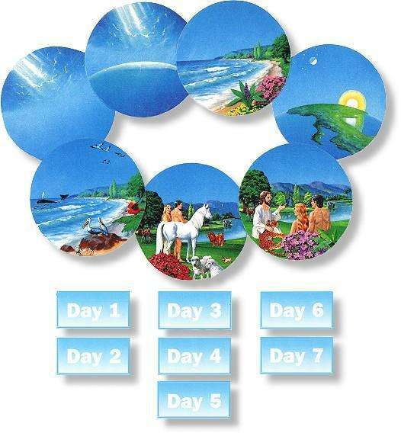

5

PART 1: A HEBRAIC UNDERSTANDING TO MAN’S PURPOSE AND THE GIFTS OF THE HOLY SPIRIT

We have been studying the Hebraic roots of our faith to fully understand God’s purpose for our lives, i.e. how do we walk in obedience to His Will.

One of these aspects evolved in our study of the feast of Yom Kippur and the Book of Jonah. It was here that we came to understand that a believer can miss out / walk away from his purpose / calling.

This choice exercised by every individual could by due to:

- our own failure to know what our gift / purpose is.
- my choice to be disobedient.
- my capitulation / defeat after the attacks from the kingdom of darkness.

We have extended this study (using the principle taught by Arthur Burk) to now include a practical understanding of the type of gifts, the reasons why I would choose to be disobedient to my calling and the curses / attacks which could cause me to loose heart.
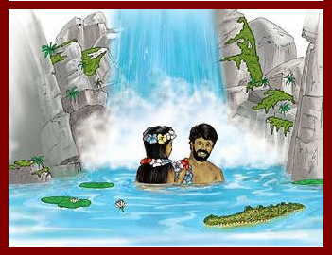

God creates Man:

Man is uniquely made by God. Science has proved that every person is exclusively different in:

- our finger prints
- our DNA samples
and yet we are all created in God’s Image:

Gen. 1:26a “26 God said, Let Us [Father, Son, and Holy Spirit] make mankind in Our image, after Our likeness...”

6


WHO AM I?

I am a SPIRIT,

Who has a SOUL,
That lives in a BODY!

1 Thessalonians 5:23 “23 And may the

God of peace Himself sanctify you
through and through [separate you from
profane things, make you pure and
wholly consecrated to God]; and may
your spirit and soul and body be
preserved sound and complete [and

found] blameless at the coming of our Lord Jesus Christ (the Messiah).”

God’s order, according to this scripture, is first the SPIRIT, then the SOUL and then the BODY.

GOD CONSCIOUSNESS:

The part of my being that has awareness to God and the spiritual realm.

SELF CONSCIOUSNESS:

This is the part of us that is made up of mind, will and emotions.

WORLD CONSCIOUSNESS:

The part of my being that understands the world or environment around me through my senses.

When Adam and Eve sinned, their spirits died.

Genesis 2:17 “In the day you eat of it you shall surely die.”

The answer to that problem: You must be born again!

John 3:3 “3 Jesus answered him, I assure you, most solemnly I tell you, that unless a person is born again (anew, from above), he cannot ever see (know, be acquainted with, and experience) the kingdom of God.”


Ephesians 2:1 “1 AND YOU He made alive, when you were dead (slain) by [your] trespasses and sins”

Ezekiel 36:26-27 “26 A new heart will I give you and a new spirit will I put within you, and I will take away the stony heart out of your flesh and give you a heart of flesh.”

7

THE BODY
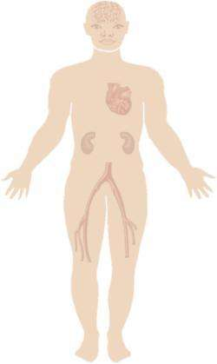

Romans 7:22-23


“For I endorse and delight in the Law of God in my inmost self [with my new nature].

But I discern in my bodily members [in the sensitive appetites and wills of the flesh] a different law (rule of action) at war against the law of my mind (my reason) and making me a prisoner to the law of sin that dwells in my bodily organs [in the sensitive appetites and wills of the flesh].”

Romans 8:13


“For if you live according to [the dictates of] the flesh, you will surely die. But if through the power of the [Holy] Spirit you are [habitually] putting to death the [evil] deeds prompted by the body, you shall live forever.”

Ephesians 2:4-6


“But God—so rich is He in His mercy! Because of …the great and wonderful and intense love with which He loved us, even when we were dead by [our own] shortcomings and trespasses, He made us alive together in

fellowship and in union with Christ; it is by grace that you are saved and He raised us up together with Him and made us sit down together in the heavenly sphere [by virtue of our being] in Christ Jesus…”


The body is guided by the 5 senses.

The power of sin offers temptation through the senses of the body.

- Touch

- Taste

- See

- Hear

- Smell

Romans 7:23

“But I discern in my bodily members [in the sensitive appetites and wills of the flesh] a different law (rule of action) at war against the law of my mind (my reason) and making me a prisoner to the law of sin that dwells in my bodily organs [in the sensitive appetites and wills of the flesh].”

Romans 12:1


“1 I APPEAL to you therefore, brethren, and beg of you in view of [all] the mercies of God, to make a decisive dedication of your bodies [presenting all your members and faculties] as a living sacrifice, holy (devoted, consecrated) and well pleasing to God , which is your reasonable (rational, intelligent) service and spiritual worship.”

8

THE SOUL

The soul is made up of three components, and together these reflect your personality and character, as it has been formed since child birth.

Wrong role-model examples, wounding by others which has not been dealt with in a Godly manner, etc will all form your soul. In fact the Hebrew word for the verb to “do” is “asah” and has the connotation of a ball of wet clay on the potter’s wheel. Kind, gentle loving pressure
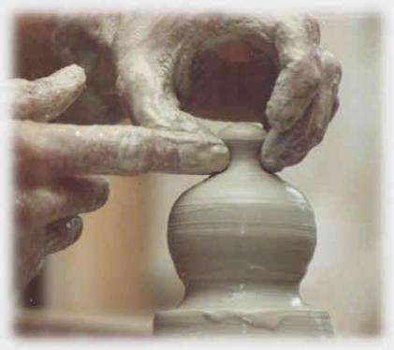
make a beautiful ornament but hardness of touch will cause the “pot” to be scarred for life.

Our own minds cause us to look at life and try to make the best out of every situation. How often have we heard stories from an older generation?

History records that it was tough – but mostly the stories are about some event that they

chose to remember – more often than not, they will recall the good “old” times. They remember what you could buy for a “tiekie” (a very small money value) but forget to say how hard it was to earn one.

THE MIND

One’s personality includes:


- Intelligence

- Intuition

- Reason

- Logic


Rom. 12:2 ““And do not be conformed to this world, but be transformed by the renewing of your mind¹, that you may prove what is that good and acceptable and perfect will of God.”

This aspect of one’s personality is not about a reflection of how high your IQ is. Rather it’s a reflection of how you have been taught to see life.

From a Greco-Roman mindset you think:

- that performance

- individualization

- material possession is a measure of success.

- A more detailed study on how to renew the mind is available from Kanaan Ministries.

9

From a Hebraic mindset one would expect the above to follow as evidence of a blessing. However the focus of the mind will be on:

- relationships

- covenant

- Community.

The value system – how our minds order things in priority, then causes us to focus on will determine the journey that we walk.

The platform from which the mind views life’s opportunities and challenges will determine which commandments, precepts, and values we choose to use in order to build the strongholds of our mind.
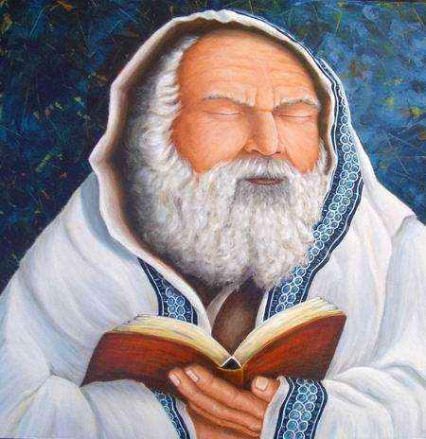

A Godly basis or foundation to our mind is the implanting of the Word of God which says:

“Hear of Israel – the Lord your God is one.”

This declaration of a “single” God on one hand, and the fact that everyone is created equal on the other, is one of the basic steps to keep to renewing your mind.

The Word gives us an early warning system – it tells us what to look out for in our minds.

Our minds can be:

- Chasing after earthly things – i.e. focusing on the material rewards, the commendation of man, recognition and fame

Philippians 3:19 “19 They are doomed and their fate is eternal misery (perdition); their god is their stomach (their appetites, their sensuality) and they glory in their shame, siding with earthly things and being of their party.

Romans 8:5 “5 For those who are according to the flesh and are controlled by its unholy desires set their minds on and pursue those things which gratify the flesh, but those who are according to the Spirit and are controlled by the desires of the Spirit set their minds on and seek those things which gratify the [Holy] Spirit.


10


Colossians 2:18 “18 Let no one defraud you by acting as an umpire and declaring you unworthy and disqualifying you for the
prize, insisting on self -abasement and worship of angels, taking his stand on visions [he claims] he has seen, vainly puffed up by his sensuous notions and inflated by his

unspiritual thoughts and fleshly conceit,

Ephesians 4:17 “17 So this I say and solemnly testify in [the name of] the Lord [as in His presence], that you must no longer live as the heathen (the Gentiles) do in their

perverseness [in the folly, vanity, and emptiness of their souls and the futility] of their minds.

- Blinded to the reality of God’s purpose and calling.


We can be walking through life without really knowing what we should be doing. Moreover we could be swayed by the opinion of man.

2 Corinthians 3:14 “14 In fact, their minds were grown hard and calloused [they had become dull and had lost the power of understanding]; for until this present day, when the Old

Testament (the old covenant) is being read, that same veil still lies [on their hearts], not being lifted [to reveal] that in Christ it is made void and done away.

James 1:8 “8 [For being as he is] a man of two minds (hesitating, dubious, irresolute), [he is] unstable and unreliable and uncertain about everything [he thinks, feels, decides].

James 4:8 “8 Come close to God and He will come close to you. [Recognize that you are] sinners, get your soiled hands clean; [realize that you have been disloyal] wavering individuals with divided interests, and purify your hearts [of your spiritual adultery].

11


- Defiled.

When we hear this word, we normally react to think only of impurity, lustful, immoral acts / thoughts. In reality our minds are defiled if we can see when someone is wronged and yet we choose to close our eyes to the injustice.

Any thought or action which is one degree away from that which is righteous, good, honest and pure is a defiled action.

Titus 1:15 “15 To the pure [in heart and conscience] all things are pure, but to the defiled and corrupt and unbelieving nothing is pure; their very minds and
consciences are defiled and polluted.

2 Corinthians 11:3 “3 But [now] I am fearful, lest that even as the serpent beguiled Eve by his cunning, so your minds may be corrupted and seduced from wholehearted and sincere and pure devotion to Christ.

- At war with God.

We can choose to declare that we are the enemy of God. This can take the form of acts of rebellion or it can go further where we cause harm to the Body of Messiah.

Note – this harm does not only include physical harm but also that caused by slander, gossip and any act to enslave someone else.

Romans 1:28 “28 And so, since they did not see fit to acknowledge God or approve of Him or consider Him worth the knowing,

God gave them over to a base and condemned mind to do things not proper or decent but loathsome, Romans 8:7 “7 [That is] because the mind of

the flesh [with its carnal thoughts and purposes] is hostile to God, for it does not submit itself to God’s Law;; indeed it cannot.

Fortunately, the Torah also gives us an indication of where God’s Benchmark can be found.

Amos speaks of a plumb -line; this form of measurement helps us to determine how far we are from God’s Standard.

12

A mind after God’s Heart will be:


- Focused on God’s calling and direction, will be at a state of readiness to move at the call of the Holy Spirit, will be willing to lay-down our own agenda, hopes and plans.

Acts 17:11 “11 Now these [Jews] were better disposed and more noble than those in Thessalonica, for they were entirely ready and accepted and welcomed the message

[concerning the attainment through Christ of eternal salvation in the kingdom of God] with inclination of mind and eagerness, searching and examining the Scriptures daily to see if these things were so.

2 Corinthians 8:12 “12 For if the [eager] readiness to give is there, then it is acceptable and welcomed in proportion to what a person has, not according to what he does not have.

Isaiah 26:3 “3 You will guard him and keep him in perfect and constant peace whose mind [both its inclination and its character] is stayed on You, because he commits himself to You, leans on You, and hopes confidently in You.


- Pure and humble – the mind focused on God’s

Will have laid down the plans and ambitions of man.

Therefore our acts will be a reflection of the soundness / purity of our understanding of God’s principle.

Acts 20:19 “19 Serving the Lord with all humility in tears and in the midst of adversity (affliction and trials) which befell me, due to the plots of the Jews [against me];

2 Timothy 1:7 “7 For God did not give us a spirit of timidity (of cowardice, of craven and cringing and fawning fear), but [He has given us a spirit] of power and of love and of calm and well-balanced mind and discipline and self-control.

2 Peter 3:1 “1 BELOVED, I am now writing you this second letter. In [both of] them I have stirred up your unsullied (sincere) mind by way of remembrance,

13

THE WILL

The will is formed largely by our reaction to an authority figure in your childhood. As adults choose to treat a child, so will his will be impacted. Our will is either formed in a Godly way or is misshapen. A will which does not walk in humility or in true submission, needs to be transformed.

We can see that a will can be formed into anything from a tyrant to a slave. The true alignment for our will is to be a son of God. It is therefore critical in this process of transforming my will to a place of Sonship i.e. total submission to the Father, that I must break down the stronghold of oppression, fear, and uncertainty, and build a new foundation of truth.

Mankind somehow has an in-build ability to hide and or ignore the wrong or bad attributes and to believe that we have an open mind and a free will which will mostly choose that which is the right thing to do.


It is therefore necessary to stand before the Mirror of God’s Word so that we can see what constitutes the Will of God.

The more clearly we define this Standard, the closer to

God’s Standard we can move:

(a) God asks us to present our bodies as a Living Sacrifice.

What does this mean? It means that our physical bodies should be maintained in a healthy manner.

My will is tested:

- with what I choose to eat, drink etc,

- by the level of exercise that I do,

- by my attitude towards a healthier place / environment in which I stay.


Today we live in a world of speed, performance and stress.

It is therefore also pertinent that we look at:

- how much we sleep,

- How much we rest.

14

Our sacrifice is to a level of submission to moderation.

Romans 12:1 “1 I APPEAL to you therefore, brethren, and beg of you in view of [all] the mercies of God, to make a decisive dedication of your bodies [presenting all your members and faculties] as a living sacrifice, holy (devoted, consecrated) and well pleasing to God, which is your reasonable (rational, intelligent) service and spiritual worship.

1 Corinthians 3:16-17 “16 Do you not discern and understand that you [the whole church at Corinth] are God’s temple (His sanctuary), and that God’s

Spirit has His permanent dwelling in you [to be at home in you, collectively as a church and also individually]?
17 If anyone does hurt to God’s temple or corrupts it [with false doctrines] or destroys it, God will do hurt to him and bring him to the corruption of death and destroy him. For the temple of God is holy (sacred to Him) and that [temple] you [the believing church and its individual believers] are.


(b) God asks us to render reasonable services.

Much of the charismatic teachings today revolve around the concept of grace. At the same time they scoff at any form of obedience to God’s Commandments and precepts.

God has placed us here to make an impact on our

community. Importantly God tells us that we must do these things.

Matthew 12:33 “33 Either make the tree sound (healthy and good), and its fruit sound (healthy and good), or make the tree rotten (diseased and bad), and its fruit rotten (diseased and bad); for the tree is known and recognized and judged by its fruit.

35 The good man from his inner good treasure flings forth good things, and the evil man out of his inner evil storehouse flings forth evil things.

Romans 12:1 “1 I APPEAL to you therefore, brethren, and beg of you in view of [all] the mercies of God, to make a decisive dedication of your bodies [presenting all your members and faculties] as a living sacrifice, holy (devoted, consecrated) and well pleasing to God, which is your reasonable (rational, intelligent) service and spiritual worship.

- The fact that we are called to service / to acts of obedience is nowhere more clearly stated than in the Beatitudes where we are called to work in God’s Kingdom.

Matthew 5:3-12 “3 Blessed (happy, to be envied, and spiritually prosperous— with life-joy and satisfaction in God’s favor and salvation, regardless of their
outward conditions) are the poor in spirit (the humble, who rate themselves insignificant), for theirs is the kingdom of heaven!

15

4 Blessed and enviably happy [with a happiness produced by the experience of God’s favor and especially conditioned by the revelation of His matchless

grace] are those who mourn, for they shall be comforted!

- Blessed (happy, blithesome, joyous, spiritually prosperous—with life-joy and satisfaction in God’s favor and salvation, regardless of their outward conditions) are the meek (the mild, patient, long-suffering), for they shall inherit the earth!

- Blessed and fortunate and happy and spiritually prosperous (in that state in which the born-again child of God enjoys His favor and salvation) are those who hunger and thirst for righteousness (uprightness and right standing with God), for they shall be completely satisfied!
- Blessed (happy, to be envied, and spiritually prosperous—with life-joy and satisfaction in God’s favor and salvation, regardless of their outward conditions) are the merciful, for they shall obtain mercy!
- Blessed (happy, enviably fortunate, and spiritually prosperous—possessing the happiness produced by the experience of God’s favor and especially conditioned by the revelation of His grace, regardless of their outward conditions) are the pure in heart, for they shall see God!
- Blessed (enjoying enviable happiness, spiritually prosperous—with life-joy and satisfaction in God’s favor and salvation, regardless of their outward conditions) are the makers and maintainers of peace, for they shall be called the sons of God!
- Blessed and happy and enviably fortunate and spiritually prosperous (in the state in which the born-again child of God enjoys and finds satisfaction in
God’s favor and salvation, regardless of his outward conditions) are those who are persecuted for righteousness’ sake (for being and doing right), for theirs is the kingdom of heaven!
- Blessed (happy, to be envied, and spiritually prosperous—with life-joy and satisfaction in God’s favor and salvation, regardless of your outward conditions) are you when people revile you and persecute you and say all kinds of evil things against you falsely on My account.
- Be glad and supremely joyful, for your reward in heaven is great (strong and intense), for in this same way people persecuted the prophets who were before you.
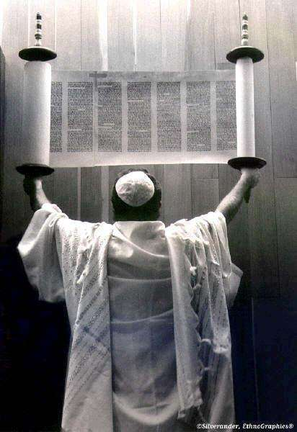

We must not be conformed to this world but transformed away from it. We are told to carefully study what the present world sees as a standard of performance, lifestyle value.

We are then told to study the Torah to find God’s Benchmark.

Any standard which does not measure up to God’s Standard must then be clearly identified and we must make an action plan to move in exactly the opposite direction.

16

Romans 12:2 “2 Do not be conformed to this world (this age), [fashioned after and adapted to its external, superficial customs], but be transformed (changed) by the [entire] renewal of your mind [by its new ideals and its new attitude], so that you may prove [for yourselves] what is the good and acceptable and perfect will of God, even the thing which is good and acceptable and perfect [in His sight for you].


- We must come to the full knowledge of the truth. This is not only a matter of studying

God’s Word, but applying this in our day to day walk.

The reality is that the Truth of God’s

Word must be evidenced by deeds.

Hebrews 4:12 12 For the Word that God speaks is alive and full of power [making it active, operative, energizing, and effective]; it is sharper than any two-edged sword, penetrating to the dividing line of the breath of life (soul) and [the immortal] spirit, and of joints and marrow [of the deepest parts of our nature], exposing and sifting and analyzing and judging the very thoughts and purposes of the heart.

2 Timothy 3:16 “16 Every Scripture is God-breathed (given by His inspiration) and profitable for instruction, for reproof and conviction of sin, for correction of error and discipline in obedience, [and] for training in righteousness (in holy living, in conformity to God’s will in thought, purpose, and action),

James 1:19 19 Understand [this], my beloved brethren. Let every man be quick to hear [a ready listener], slow to speak, slow to take offense and to get angry.

James 1:27 “27 External religious worship [religion as it is expressed in outward acts] that is pure and unblemished in the sight of God the Father is this: to visit and help and care for the orphans and widows in their affliction and need, and to keep oneself unspotted and uncontaminated from the world.

Romans 8:12 “12 So then, brethren, we are debtors, but not to the flesh [we are not obligated to our carnal nature], to

live [a life ruled by the standards set up by the dictates] of the flesh.

13 For if you live according to [the dictates of] the flesh, you will surely die. But if through the power of the [Holy] Spirit you are [habitually] putting to death (making extinct, deadening) the [evil] deeds prompted by the body, you shall [really and genuinely] live forever.

17

THE EMOTIONS
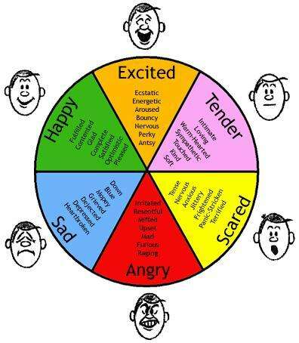

- Sadness

- Anger

- Love

- Joy

What the mind thinks…the individual will feel!

- Anger

- Anxiety or Depression

- Pressure

- Greed

Emotions reveal the heart…however emotions do not reveal a person’s identity!

The pattern of thinking that rules

my mind, whether positive or negative, the degree to which I have a will focused on self or focused on Godly principles, will determine my feelings / emotions.

Emotions are the dashboard of the heart – they reveal the state of mind of the individual and as such are an amazing tool as a barometer of an individual’s health.


18

PART 2: THE BORN-AGAIN EXPERIENCE - OUR IDENTITY IS IN CHRIST!

2 Cor. 5:17 “Therefore, if anyone is in Christ, he is a new creation; old things have passed away; behold, all things have become new.

What has become new?


It is only the spirit that has become new because it has now reconnected again with our Creator.

- We have been translated out of the kingdom of death into the Kingdom of Life in Christ Jesus.

- We are under new “Management” and under a new Law of Life.
- Now we have the power and

authority to deal with the bondages and hurts in our lives.

John 17:15-17

15 I do not ask that You will take them out of the world, but that You will keep and protect them from the evil one.
16 They are not of the world (worldly, belonging to the world), [just] as I am not of the world.
17 Sanctify them [purify, consecrate, separate them for Yourself, make them holy] by the Truth; Your Word is Truth.

Emotions cannot give us directions or answer why we feel a certain way.

The Word of God is the only path to ALL TRUTH…not our emotions.

THE DIFFERENCE BETWEEN THE SPIRIT AND THE SOUL

SPIRIT: Has mind, will and emotions

SOUL: Has mind, will and emotions.
BODY: Has brain that must grow for soul to express itself.


Spirit: | Soul: | Body:
Spirit: | Soul: | Brain
Mind, Will & | Mind, Will & | Brain
Emotions | Emotions

19

The Myelination of the nerve sheets in the brain:

Myelination of the nerve sheets is like putting insulation around each nerve sheet so that information can be stored and retrieved – pathways in the brain need to be formed. Until that takes place, the information is randomly sparking from one nerve sheet to the other.
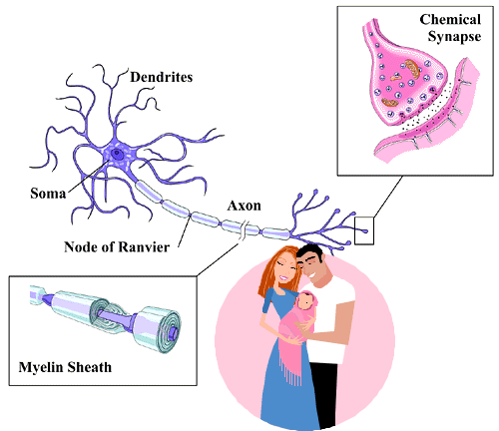

This takes place after you are born, approximately 4 - 6 weeks to 24 months, and until this process takes place, your brain cannot think.

This process enables the messages:

- to run,
- to be stored and
- to be exchanged
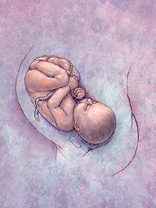
That is why learning is such a slow process – the brain is being connected during this time.

Yet, as prayer ministers we know that the infant can remember things that happened to it in the womb and birth trauma.

The doctors are right - the brain cannot think - the soul cannot remember because the brain is not working.

BUT

The spirit is not dependent on the brain - the spirit is fully functional even though the soul is going to take 18 months before it can learn to say: "NO!"

20

That is the difference between the soul and the spirit!
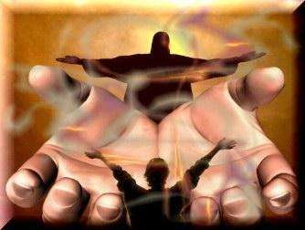

God gave your spirit a 10 month head-start on the soul INTENTIONALLY.

God took out the competition between the spirit and the soul.

God made the brain unable to think for the first 10 months.
Your spirit would have an advantage over the soul so that we can
walk in the spirit and not in the soul!!
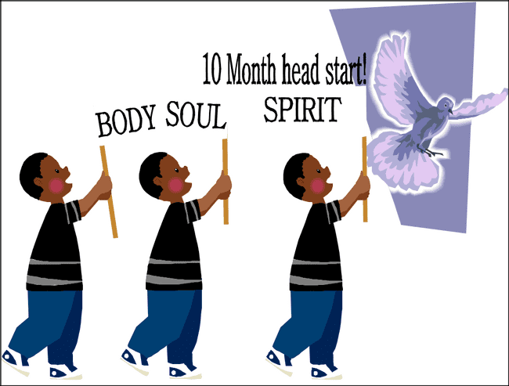

God has intended for us to know the difference between four voices:

- God's Voice.

- The devil's voice.
- The voice of your spirit.
- The voice of your soul.

God intends you to separate out the voices of soul and spirit so you can know who is speaking.

21

WE NEED TO DISCERN BETWEEN THE SPIRIT AND SOUL

We have all read and understood that God’s Breath is equivalent to His Creative power. Just as He spoke to
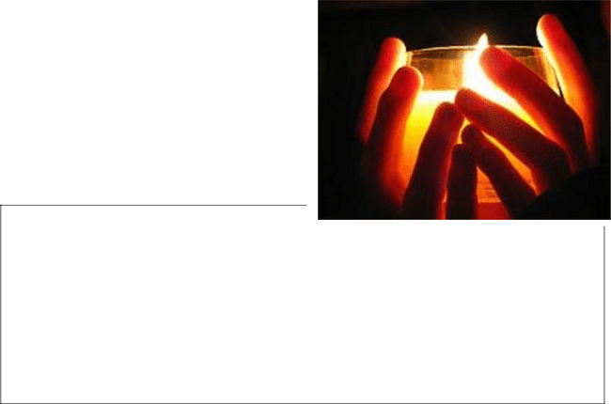
things (by breathing out His air), so too, this becomes the flow of life into man.

We are created in His Image. That Image does not mean that we follow a predetermined pattern in life but that we all have a purpose or reason to exist.

Psalm 16:7-11 “7 I will bless the Lord,

Who has given me counsel; yes, my heart instructs me in the night seasons. 8 I have set the Lord continually before me; because He is at my right hand, I shall not be moved.
9 Therefore my heart is glad and my glory [my inner self] rejoices; my body too shall rest and confidently dwell in safety,
10 For You will not abandon me to Sheol (the place of the dead), neither will You suffer Your holy one [Holy One] to see corruption.
11 You will show me the path of life; in Your presence is fullness of joy, at Your right hand there are pleasures forevermore.

We have also come to realize that my spirit-man is the template (pattern) for my soul-man. The Word highlights very clearly for us that the spirit of man operates on all three levels (mind, will, emotions); the same is also found in the soul.

The Word reveals that the spirit-man experiences every sense / feeling / emotion that can be found in the soul man.

Let’s go through a number of verses to illustrate the interrelatedness of the spirit-man and the soul-man.
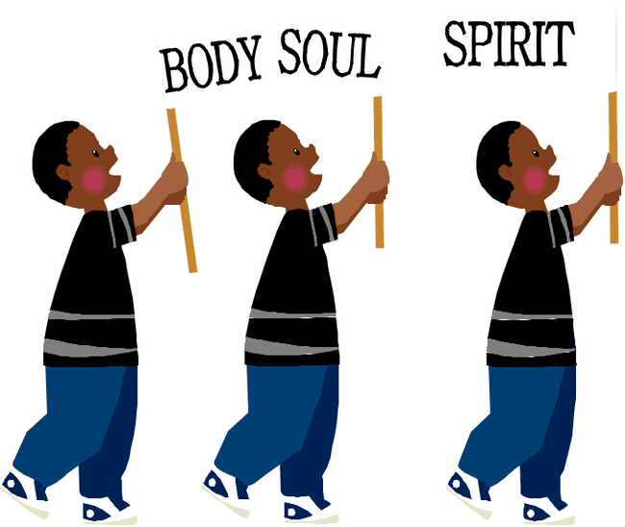

22

THE SPIRIT-MAN’S MIND


Any believer who searches his heart with integrity and honesty will come to know the Mind and Will of God.

Romans 8:27 “27 And He Who searches the hearts of men knows what is in the mind of the [Holy] Spirit [what His intent is], because

the Spirit intercedes and pleads [before God] in behalf of the saints according to and in harmony with God’s will.

God tells us that the Deliverer (Yeshua) comes out of Zion and that those who accept Him are the “beloved” of God.

For those who fall into this category, we are promised that we should see the effect / result of our gifts and calling which are irrevocable.

When we exercise / use these gifts we have access to the depths of the Knowledge and Wisdom of God; but no matter what we do, we will never be able to know the extent of the “Mind of God” – my spirit mind’s-connectedness with God depends on my degree of searching for God’s Mind.

Romans 11:33 “33 Oh, the depth of the riches and wisdom and knowledge of God! How unfathomable (inscrutable, unsearchable) are His judgments (His decisions)! And how untraceable (mysterious, undiscoverable) are His ways (His methods, His paths)
34 For who has known the mind of the Lord and who has understood His thoughts, or who has [ever] been His counselor?

We often face trials and tribulations because of our own wilful wrong choices in life. But it is also true that God places us in places of stress so that we can learn to discern and understand His Mindset.

So how are we put in “custody” to be shown the “Mind” of God?

Leviticus 24:10-12 “10 Now the son of an Israelite woman, whose father was an Egyptian, went out among the Israelites, and he and a man of Israel quarreled and strove together in the camp.

- The Israelite woman’s son blasphemed the Name [of the Lord] and cursed. They brought him to Moses—his mother was Shelomith, the daughter of Dibri, of the tribe of Dan.

- And they put him in custody until the Mind of the Lord might be declared to them.

  - The Hebrew word for “custody” used here is “mishmâr” Strongs 4929 and means:

- to guard a man at a prison

- a deposit

23

x an example

- The Hebrew word for “Mind” used here is “peh” - Strongs 6310 and means:
x mouth, literally as in blowing specifically in speech

  - two-edged word

- The Hebrew word for “declared” used here is “pârash” - Strongs 6567 and means:
  - to separate by wounding

  - to declare

  - sting

We are created with a one-on-one relationship between my spirit-man and my soul-man. This allows us to understand how we can reach into the depths of God’s Wisdom so that our walk on earth will be easier.

- I must reach into the spirit of my understanding - I am made to learn from God.

We are often faced with attacks from other people, from believers and pagans. When rebuke or reproach is made, I hear the words of accusation and if I rely on my soul-man, I will probably react with fear, anger and words of defiance.

Or alternatively, I can rely on my spirit-man to connect with God’s Spirit which will help me to have a God-given response.

Job 20:3 “3 I have heard the reproof which puts me to shame, but out of my understanding my spirit answers me.

Job 32:8 “8 But there is [a vital force] a spirit [of intelligence] in man, and the breath of the Almighty gives men understanding.

Our reliance on our spirit-man to sense and see God’s understanding of a situation is critical. We do not want to inherit the heritage of a wicked man.

We therefore pray that the heart be quietened so that we will react with God’s attributes and therefore save (protect) the things that we desire and restore that for which we have laboured.

- My spirit-man’s words of love, life and hope can cause the mind of someone else’s spirit to be revived.
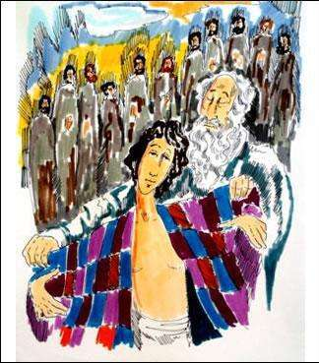

Example of Jacob and Joseph

Many years earlier, the brothers of Joseph had sold him off into slavery. They had come with lies, false images and deceit to bring Jacob the news that his son was dead.

24

They dishonoured their father over many years, as they watched his pain and grief, and yet did nothing to alleviate the pain for their father.

Once a lie has been told and the consequences have been set in motion, it is not easy to reverse this curse.

And yet we read of a day where the words from the long lost son and his gifts revived the spirit of Jacob.

Genesis 45:27 “27 But when they told him all the words of Joseph which he had said to them, and when he saw the wagons which Joseph had sent to
carry him, the spirit of Jacob their father revived [and warmth and life returned].


We have to take care that our words, especially when we speak of others, must carry the gift of revival in them.

My words should have the power to revive someone else whose heart has been broken. Only God’s Spirit-Mind’s words will have this effect.

- My spirit-man’s strength of character will allow me to keep a secret.

Who has a faithful spirit – someone whose mind is focused on the Spirit of God?

Only those who truly understand, experience, and feel God’s goodness in all circumstances, will be able to have the capacity to also have a faithful spirit. A man who understands how God thinks and sees each one of His created human beings will realize that God’s grace is continuously being poured out over mankind.

As we realize this, and our own shortcomings in life we can:

- love our neighbour no matter what happens,

- keep our mouth shut to conceal a matter.

Proverbs 11:12 “12 He who belittles and despises his neighbor lacks sense, but a man of understanding keeps silent.
“13 He who goes about as a talebearer reveals secrets, but he who is trustworthy and faithful in spirit keeps the matter hidden.


(Note: this is not a declaration to keep silence about sin and wrongdoing but a commitment not to gossip / slander / bring others into disrepute.)

25

- My spirit-man’s mind can be heavy / troubled.

From time to time circumstances in this world become a burden which is almost too difficult to carry. We have often spoken about the straw which breaks the camel’s back.

We have a great capacity to carry burdens, injustices etc.
The Torah describes this feeling of overload as heaviness.

Strongs 3544 – “kehah” which means:

- feeble

- obscure

- a somewhat dark, smoky heaven.

The modern world describes much of this feeling with the terminology – “stress”.

When our spirit man’s mind reaches up to God and into His ways of thinking and doing, i.e. when we see how Yeshua reacted to all circumstances and we make this our lifestyle, then we come to the understanding that God’s plan is one of exchange:

- beauty for ashes

- comfort for mourning

- Garments of praise for the heaviness.

Isaiah 61:3 “3 To grant [consolation and joy] to those who mourn in Zion—to give them an ornament (a garland or diadem) of beauty instead of ashes, the oil of joy instead of mourning, the garment [expressive] of praise instead of a heavy, burdened, and failing spirit—that they may be called oaks of righteousness [lofty, strong, and magnificent, distinguished for uprightness, justice, and right standing with God], the planting of the Lord, that He may be glorified.

Genesis 41:8 “8 So when morning came his spirit was troubled, and he sent and called for all the magicians and all the wise men of Egypt. And Pharaoh told them his dreams, but not one could interpret them to [him].

My spirit-man’s mind must be renewed to have an expectancy of God’s “exchange” so that I will Glorify Him.


26

I can Choose to, in my Spirit-man’s “Mind” to Work in the Opposite Spirit – i.e. in one form of rebellion or other.

- My spirit-man mind can be hardened so that my heart becomes obstinate
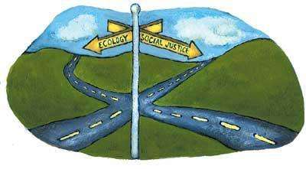

Our journey along life’s path is littered with crossroads, places where we are supposed to stop, seek God’s Will and make an informed choice before we proceed.

Every man, who exercises his freedom of choice to move in the opposite direction to the guidance of the Holy

Spirit, often does so in a way which progressively leads further and further away from God.

This path may take the form of

- legalism - a form of religion without life or;

- lawlessness - a form of religion without obedience.

Either way, we become conditioned to our way of thinking.


The Torah describes this as “hardened” and tells us that God’s Spirit brings this state of affairs to a head.

Strongs 7285 – “qashah” and means:

- a property that is dense

- hard

- stiff-necked.

Deuteronomy 2:30 “30 But Sihon king of Heshbon would not let us pass by him; for the Lord your God hardened his spirit and made his heart obstinate, that He might give him into your hand, as at this day.


People whose minds have not been renewed and which have been hardened, over time become obstinate.

Strongs 553 – “amats” and means:

- to be alert

- steadfast

- making strong in their attempts to defy God

27

Believers who follow this path, of failing to search for God’s plan will find that He chooses to use a process of trials and tribulations in order that we come to a realization that we need to change.

The sad part is that unless we repent it can mean that we drop into the depths of bondage / slavery.

- We can become ill when we react in anger against the spirit-man’s mind

We have been empowered to live a life of victory. This implies that my physical body and soul are in right standing to my spirit-man. When my spirit is attuned to God’s Ways, Will, and Wisdom I will react to circumstances
in the way that He wants me too.

The life-story of Moses explains something of this to us. We know that it is recorded that Moses was a friend of God.

We see many instances where he waits on God, goes before God on behalf of the Israelites.
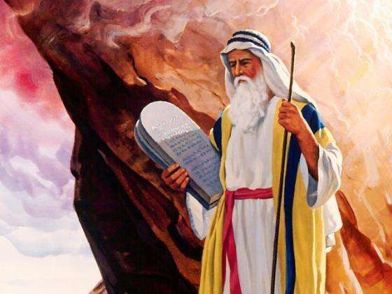

We can safely say that the spirit-man’s mind of Moses was closely tuned into God’s Spirit.

We see however that when the Israelites rebel against God’s Spirit inside of Moses that Moses is unable to restrain himself.

He becomes angry at them and

consequently, because of his reaction to their rebellion, he becomes ill.

Psalm 106:32 “32 They angered the Lord also at the waters of Meribah, so that it went ill with Moses for their sakes;
33 For they provoked [Moses’] spirit, so that he spoke unadvisedly with his lips.

Our reactions, when we are provoked, especially when we walk close to God, will result in pain and suffering.

28

- We can lose direction in life and follow false teaching / movement when our spirit is proud / haughty


A humble spirit will always seek righteousness and will also see the future as an opportunity.

Those who are proud / haughty believe in their own self effort.

They are comfortable with the knowledge that they have the talent / gift to “walk alone”.

All too often our gifts are inadequate, our physical strength

melts with sickness and old age, and circumstances outside of our control impact us negatively.

Because the proud / haughtily look to their own strength they will react:

- with anger

- with words to negate what others have done in the present.

Ecclesiastes 7:8 -10 “8 Better is the end of a thing than the beginning of it, and the patient in spirit is better than the proud in spirit.
9 Do not be quick in spirit to be angry or vexed, for anger and vexation lodge in the bosom of fools.
10 Do not say, Why were the old days better than these? For it is not wise or because of wisdom that you ask this.

God’s Spirit, connected to our spirit will cause our minds to be rejuvenated, renewed. We see that God’s Wisdom, when translated into tangible action on earth by an obedient son of God will be:

- a good inheritance

- profitable

- a defence for money

- Life to those that have it.


Exodus 7:11-14 “11 Then Pharaoh called for the wise men [skilled in magic and divination] and the sorcerers (wizards and jugglers). And they also, these magicians of Egypt, did similar things with their enchantments and secret arts.

12 For they cast down every man his rod and they became serpents; but Aaron’s rod
swallowed up their rods.

13 But Pharaoh’s heart was hardened and stubborn and he would not listen to
them, just as the Lord had said.

14 Then the Lord said to Moses, Pharaoh’s heart is hard and stubborn;; he

refuses to let the people go.

29

THE SPIRIT-MAN’S EMOTIONS

Emotions are seen to be a human thing – often seen as the irresponsible, illogical part of man.

The Torah describes how the Spirit of God experiences various emotions. The emotions which are clearly are felt and remembered are those associated with hurt and pain.


(a) My spirit can be in anguish.

Exodus 6:9 “9 Moses told this to the Israelites, but they refused to listen to Moses because of their impatience and anguish of spirit and because of their cruel bondage.


- My spirit can be jealous

.
Numbers 5:14 “14 And if the spirit of jealousy comes upon him and he is jealous and suspicious of his wife who has defiled herself—or if the spirit of jealousy comes upon him and he is jealous and suspicious of his wife though she has not defiled herself—

(c) My spirit can be sorrowful.


1 Samuel 1:15 “15 But Hannah answered, No, my lord, I am a woman of a sorrowful spirit. I have drunk neither wine nor strong drink, but I was pouring out my soul before the Lord.


(d) My spirit can be wounded.

Psalm 18:4 “4 The cords or bands of death surrounded me, and the streams of ungodliness and the torrents of ruin terrified me.

(e) My spirit can be vexed.

Ecclesiastes 1:14 “14 I have seen all the works that are done under the sun, and behold, all is vanity, a striving after the wind and a feeding on wind.

30

THE SPIRIT-MAN’S WILL

A man’s will can be free to make the right choice to serve God. Only a will which has been connected to God’s Will will be able to reveal the strength of character that God desires for man.


The Torah clearly defines how man’s will must reflect the spirit-man’s Will of God.

- If my Spirit-man’s Will is connected to God’s Spirit, I will be stirred up and willing to bring

- service

- offering

Exodus 35:21 “21 And they came, each one whose heart stirred him up and whose spirit made him willing, and brought the Lord’s offe ring to be used for the [new] Tent of Meeting, for all its service, and the holy garments.

- My Spirit-man’s Will will contain no deceit

Man uses his free will to come in repentance before God. The choice to recognise that actions, words and even omissions have caused harm to others needs to have a resolute will which stands to acknowledge all wrongs.

In addition we must be resolute in facing the consequences of our deeds or lack of them and must take course to make restitution.

Only those whose hearts are pure in this regard can say that because God has forgiven, there is no deceit in our minds.
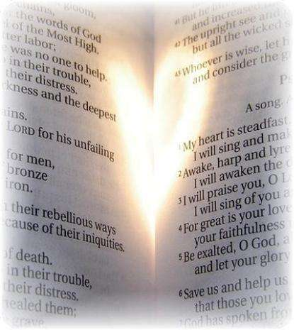

One needs to actively search out your heart regularly to make sure that this line between you and God remains open.

The most difficult of all wrongs to recognize are those times when we simply failed to step up to help / stand in the gap for another.

Nobody, other than you and God, knows what you were gifted and tasked to do.

Psalm 32:1 “1 BLESSED (HAPPY, fortunate, to be envied) is he who has forgiveness of his transgression continually exercised upon him, whose sin is covered.
“2 Blessed (happy, fortunate, to be envied) is the man to whom the Lord imputes no iniquity and in whose spirit there is no deceit.

31

- My Spirit-man’s Will will be steadfast.

How can we climb every mountain of opposition, accusation, trial and tribulations?

We do this when our will has come to the knowledge and understanding that God’s Will always responds as He has described Himself.

Once our will has received the revelation of this wisdom we become resolute in our walk of obedience. We no longer are distracted by the “noise” of man and the winds of change of this fickle world.

Psalm 34:18 “18 The Lord is close to those who are of a broken heart and saves such as are crushed with sorrow for sin and are humbly and thoroughly penitent.

Psalm 51:17 “17 My sacrifice [the sacrifice acceptable] to God is a broken spirit; a broken and a contrite heart [broken down with sorrow for sin and humbly and thoroughly penitent], such, O God, You will not despise.

Psalm 78:7 “7 That they might set their hope in God and not forget the works of God, but might keep His commandments
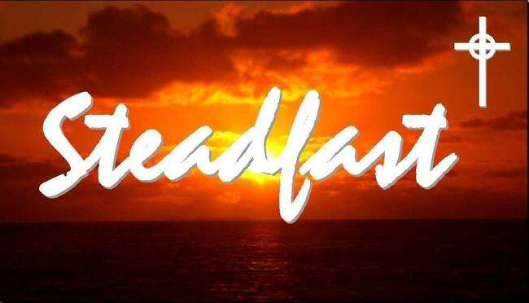

32

PAIN IS FOUND IN THE SPIRIT, SOUL AND BODY.

Pain in the body is easy to discern and we have amazing medical technology available to minister healing to the physical body.

It is very important to discern between pain in the spirit and pain in the soul because the ministry of healing will be different to each area.

Jesus knew that Judas would betray Him. He washed the feet of the disciples, sat down and spoke a few profound things.

After He had spoken these things, “He was troubled in His Spirit.”

John 13:21 “After Jesus had said these things, He was troubled (disturbed, agitated) in spirit and said, I assure you, most solemnly I tell you, one of you will deliver Me up [one of you will be false to Me and betray Me]!

This shows us that “betrayal” is a wound in the human spirit.

Another example:

Job 7:11 “11 Therefore I will not restrain my mouth;; I will speak in the anguish of my spirit, I will complain in the bitterness of my soul [O Lord]!”

Here we see that anguish is a wound in the spirit and bitterness is a wound in the soul.

So begin to read the scriptures with a keen focus on emotions and wounds and take note of exactly where the wounding takes place – be it in the spirit or soul - so that we can be more effective in co-partnering with the Holy Spirit to be able to minister to the wounded.

33

PART 3: I HAVE BEEN GIVEN ALL I NEED FOR LIFE AND GODLINESS.

2 Pet 1:3-4 “3 For His divine power has bestowed upon us all things

that [are requisite and suited] to life and godliness,

through the [full, personal] knowledge of Him Who called us by and to His own glory and excellence (virtue).
4 By means of these He has bestowed on us

His precious and exceedingly great promises, so that through them you may

escape [by flight] from the moral decay (rottenness and corruption) that is in the world because of covetousness (lust and greed), and become sharers

(partakers) of the divine nature.”

We are still in a mess because we have been looking outside instead of inside for the resources that we need to life.

In addition to that light of our spirit, we have the amazing concept of DATA.

We take data and convert it to light – we run it along fiber-optics – bring it out the other end and convert it back to data.
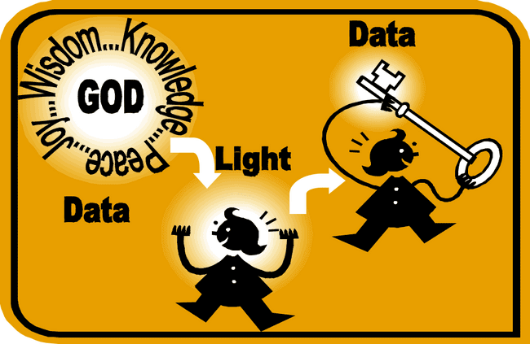

God does it so much better then our science does. Your light is not just light but it is data-rich light.

So your spirit is carrying a massive amount of truth that needs to be unpacked.

34

So if you are broken, then the key to resolving your brokenness is found in the data that is already embedded in your light.


Applying the scripture that I have been given ALL things pertaining to Life and Godliness

Example:

You are born with a genetic ability to be an extraordinary violinist:

- You can not buy the genes

- there is no genetic transplant
- there was no brain surgery
- it did not come through the laying on of hands, etc.

- It was there from conception.


HOWEVER:

You still have to spend thousands of:

- hours practicing,

- Rands/Dollars/Euro in music lessons

to develop the resource that is within you.

In our spiritual walk we have been given everything we need for life and Godliness within our:

- spiritual genes

- chromosomes
- our DNA.

BUT: for many years we have been looking for it outside:


• We need a blessing
• We need a prophetic word
• We need an impartation
• We need a laying on of hands
- Someone else has whatever I need for me to be
able to go forward

• Until that someone gives me the missing piece to my life, I can't progress.

We run from seminar to seminar, conference to conference, looking for the one who will bring something

from OUTSIDE that will make us complete so that we can possess our birthright!!

35

There is room for impartation from outside, but God said that you have been given everything you need for life and Godliness!


In your spirit, together with the Holy Spirit, you can unpack the resources that you need for victory to get past that glass ceiling that you are up against in your walk with God.

The key is: YOU HAVE IT!! You will have to practice to develop it!!

What is the Essence of my being?

It is the liberty of knowing:


x That I am not a victim!

- That I am not helpless

- That I am not necessarily dependant on somebody to impart something to me
- That in me already is that thing I am already looking for

If the Holy Spirit will shine His Light on your light in the right place you would see that.

Num. 6:24-26 “The Lord bless you and watch, guard, and keep you; 25 The Lord make His face to shine upon and enlighten you and be gracious (kind, merciful, and giving favor) to you;

26 The Lord lift up His [approving] countenance upon you and give you peace (tranquility of heart and life continually).”

What does it mean for you to turn your face to the Father and allow His Light to shine on your spirit?


You have the right to look into the Face of God – and when you look into His Face, His Light shines on your spirit – it will enlarge the light of your spirit – it will increase the intensity.

God has designed our spirit to shine forth to other people’s spirits – especially our children’s spirit.

36

A STATEMENT OF LIBERTY


Rom. 8:16 “The Spirit Himself [thus] testifies together

with our own spirit, [assuring us] that we are children of God.”

Liberty is rooted in our SPIRIT, not in our soul.

SCRIPTURES TO PROVE THAT OUR SPIRIT IS LIGHT

Ps. 36:9 “ For with You is the fountain of life; in Your light do we see light.”

Ps. 44:3 “ For they got not the land [of Canaan] in possession by their own sword, neither did their own arm save them; but Your right hand and Your arm and the light of Your countenance [did it], because You were favorable toward and did delight in them.”


Ps. 89:15 “Blessed (happy, fortunate, to be envied) are the people who know the joyful sound [who understand and appreciate the spiritual blessings symbolized by the feasts]; they walk, O Lord, in the light and favor of Your countenance!”

Matt. 5:16 “Let your light so shine before men that they may see your moral excellence and your praiseworthy, noble, and good deeds and recognize
and honor and praise and glorify your Father Who is in heaven.”

Isaiah 58:8 “Then shall your light break forth like the morning, and your healing (your restoration and the power of a new life) shall spring forth speedily;
your righteousness (your rightness, your justice, and your right relationship with God) shall go before you [conducting you to peace and prosperity], and the glory of the Lord shall be your rear guard.”

Isaiah 58:10 “And if you pour out that with which you sustain your own life for the hungry and satisfy the need of the afflicted, then shall your light rise in darkness, and your obscurity and gloom become like the noonday.”


37


Is. 60:1-3 “ARISE [from the depression and prostration in which circumstances have kept you—rise to a new life]!

Shine (be radiant with the glory of the Lord), for

your light has come,
and the glory of the Lord has risen upon you!

2 For behold, darkness shall cover the earth, and dense darkness [all] peoples, but the Lord shall arise upon you [O Jerusalem], and His glory shall be seen on you.
3 And nations shall come to your light, and kings to the brightness of your rising.”

It does not say that the nations will come to God’s glory but that nations will come to your light and kings to the brightness of your dawn!!
God wants your spirit to be so intense, so bright, so alive, that who have turned their back on God will be intrigued by the light of your spirit.

The New Jerusalem

Rev 21:24-26 “The nations shall walk by its light and the rulers and leaders of the earth shall bring into it their glory.
25 And its gates shall never be closed by day, and there shall be no night there. [Isa. 60:11.]
26 They shall bring the glory (the splendor and majesty) and the honor of the nations into it.

God is the Light that will fill the City and Jesus is the Lamp so the Light of God shines through Jesus Christ.

Then God will bring into the New Jerusalem the glory of the nations! God is going to show-case the glory of human-beings!


38

HOW I REVEAL GOD’S LIGHT TO THIS WORLD

Rom. 12:6-8 “Having gifts (faculties, talents, qualities) that differ according to the grace given us, let us use them: [He whose gift is] prophecy (PROPHET), [let him prophesy] according to the proportion of his faith;

7 [He whose gift is] practical service (SERVANT), let him give himself to serving; he who teaches (TEACHER), to his teaching;
8 He who exhorts (encourages) (EXHORTER), to his exhortation; he who contributes (GIVER), let him do it in simplicity and liberality; he who gives aid and superintends (RULER) (to be in charge of something), with zeal and singleness of mind; he who does acts of mercy (MERCY), with genuine cheerfulness and joyful eagerness.”

THE SPIRIT IS LIGHT, LIGHT DIVIDES INTO 7 WHEN IT SHINES THROUGH A PRISM:


Each gift is planted in your DNA at conception and needs to be “grown” by your loved ones.

Only when others see the Fruit of the Holy Spirit revealed in your deeds / attitudes will they be able to “taste” of your gift and be nourished.

Galatians 5:23 “23 Gentleness (meekness, humility), self -control (self-restraint, continence). Against such things there is no law [that can bring a charge].

24 And those who belong to Christ Jesus (the Messiah) have crucified the flesh (the godless human nature) with its passions and appetites and desires.

39

GOD CREATES EVERY PERSON UNIQUELY

God expressly pre-determines these individual characteristics:

Ps. 139:13-17 “13 For You did form my inward parts; You did knit me together in my mother’s womb.

14 I will confess and praise You for You are fearful and wonderful and for the awful wonder of my birth! Wonderful are Your works, and that my inner self knows right well.
15 My frame was not hidden from You when I was being formed in secret [and] intricately and curiously wrought [as if embroidered with various colors] in the depths of the earth [a region of darkness and mystery].
16 Your eyes saw my unformed substance , and in Your book all the days [of my life] were written before ever they took shape, when as yet there was none of them.

17 How precious and weighty also are Your thoughts to me, O God! How vast is the sum of them!”

Jer. 1:5 “5 Before I formed you in the womb I knew [and] approved of you [as My chosen instrument], and before you were born I separated and set you apart, consecrating you;; [and] I appointed you as a prophet to the nations.”

GOD HAS DESIGNED YOUR SPIRIT TO WALK IN DOMINION


Generally our spirit has not walked in dominion.

God’s design is that Spirit-man will always take the lead

You have to wait until it is God’s time and God’s way. God has to grow the spirit to an appropriate level and then God will direct your spirit as to when it is time to assume the seat of dominion.

INSTRUCTING / DIRECTING THE HUMAN SPIRIT

The human spirit was designed by God to be actively involved in everyday living.


It is very easy to fall into witchcraft when you are directing somebody else’s spirit. Witchcraft is when you are controlling somebody else.

You have to build a relationship with somebody’s spirit, and when they really start to trust you, then you can engage with their spirit,.

If you start being directive, you can easily step into the place of God and commit the terrible sin of witchcraft in somebody else’s life.

40

There are limited situations where it is appropriate to be directive to the spirit. If the person you are working with knows what you are going to do, they give you the permission to speak directly to your spirit – they are fully aware and fully willing then it is appropriate.

Handicapped children have limited comprehension and will in their soul; this gives their parents the right to speak to the child and to direct his spirit to deal with the issue at hand.

Aside from those issues where there is agreement on healing, or when you are dealing with somebody whose soul-communication is impaired, you must walk very, very gently in being directive.

There is one area of direction where you can always feel comfortable with:


That is, to tell somebody’s spirit – even if you know nothing about their spirit – you don’t know their background, you don’t know where they are in their Christian walk etc, – you can be perfectly comfortable to tell their spirit to turn their face toward God and get their instruction from God.

As prayer minister, you can legitimize / liberate the spirit by saying:


“You have been number 2 for forty years but that is irrelevant. You were

designed by God to be number 1. You have within you everything you need to lead and some day God will very clearly, very precisely, very efficiently move you into a place of leadership over the soul.”

Spirit, it doesn’t matter that the soul does not agree with or approve of that. In God’s time you the spirit will grow to the level that you are capable to do what you were designed to do, and that is to lead the soul.”
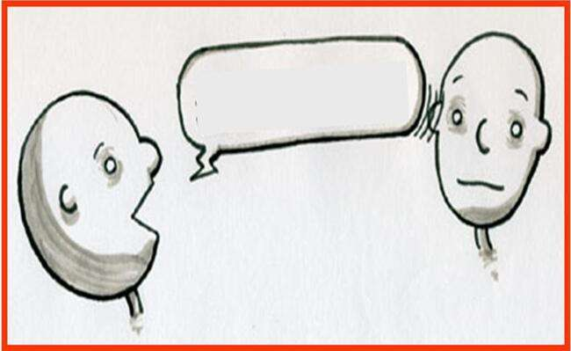

SPIRIT-MAN, I

BLESS YOU…

41

THE DIFFERENCE IN COMMUNICATION BETWEEN SPIRIT AND SOUL

In our culture we give high marks to any one who is eloquent. The individual who can rapidly understand the ideas in a meeting and come to a conclusion, gets the prize in our community.

When our spirit is not as eloquent as our soul, it feels inadequate and lacks the liberty to be itself.

It feels stupid and ridiculous.


Your soul was never made to adequately express the brilliance of what your spirit encounters.

Your soul sits in judgment on the spirit.

The soul says: “If you can’t explain it so I can understand it, it must not matter.”

Your soul is dead wrong!!

1 Cor 14:15 “Then what am I to do? I will pray with my spirit [by the ^{i}Holy Spirit that is within me], but I will also pray [intelligently] with my mind and understanding;

I will sing with my spirit [by the Holy Spirit that is within me], but I will sing [intelligently] with my mind and understanding also.

Please note Paul did not say he prays IN the spirit – he prays WITH his spirit but also with his mind. He is not praying in tongues!

There is room for your soul to be involved in your spiritual exercises.

But there are things that your spirit can understand that your soul never will.

Paul went to Heaven and when he came back he said it was impossible to try and imagine what it is like.

1 Cor 2:9 “But, on the contrary, as the Scripture says, What eye has not seen and ear has not heard and has not entered into the heart of man, [all that] God has prepared (made and keeps ready) for those who love Him [^{f}who hold Him in affectionate reverence, promptly obeying Him and gratefully recognizing the benefits He has bestowed].

Something profound happens when your spirit is set free because your soul is used to sitting in judgment.


Your soul weighs everything around you:

- Is it safe to sit next to you?

- Should I sit in the front row?

- Is the room too cold or too hot?

- Do I like your outfit or not?

42

My spirit cannot communicate certain things to my soul and it is not because my spirit is incompetent. It is because my soul does not have the soft ware to run the language of the spirit.

Timing is very important when calling the spirit forward to take the lead.

Do not allow your soul to second-guess the things that your soul can not explain. Your soul is magnificent! Your soul understands this arena. Your soul has an incredible grasp around the world!

“So wait, spirit! - Because in God’s perfect timing, you will fit into the larger world around you.


You will not have to make a place for yourself spirit – God will make a place.

You will not have to change the culture so that there is an open door for you – you will not have to kick down a door – God will deal with the culture.

God will create just the right scene in the play for your entrance to be absolutely spectacular at the right time!

So for now spirit, turn your face to the Father and ask Him

what needs to be impacted – who am I? – What portion of my spirit needs to be brought to reality – what truth have You placed in me that it is now the time for me to understand today?

Your spirit must grow to be bigger than your soul! Do not let your soul sit in judgment on the process that God is choosing to unpack the treasures in your spirit.”

LESSONS FROM A TREE

Ps 1:3 “And he shall be like a tree firmly planted [and tended] by the streams of water, ready to bring forth its fruit in its season; its leaf also shall not fade or wither; and everything he does shall prosper [and come to maturity].


What is the fruit-bearing season of a tree?

x A Papaya Tree bears fruit in about eight months in a good climate.

x An orange tree bears fruit in about three years.

- A Brazil nut tree starts bearing fruit in 75 years!

There are different time-lines for trees. Many of us move way ahead of God’s timing several times in our lives. Many times we get frustrated for the lack of movement.

43

We get prophetic dreams, visions, words, etc. You believe in them and you stand on them and you are trying to move towards them.
You must remember: In the fullness of time you will be released!!
God will place you at the right place in the right time! You must trust Him!

TAKE THE FREEDOM TO WALK ACCORDING TO THE TIME-LINE OF GOD’S SPIRIT AND NOT THE EXPECTATION OF ANY CULTURAL SYSTEM AROUND YOU!!

- Moses began bearing fruit when he was 80 years old.

- Samuel began bearing fruit when he was 4 years old.

- Some people bear fruit all their life like Samuel.

- Esther bore fruit for about a 2 year period.

Everybody’s fruit-bearing season is unique.

Be released to bear fruit in God’s season and not according to your culture’s expectations, in Yeshua’s Name!!
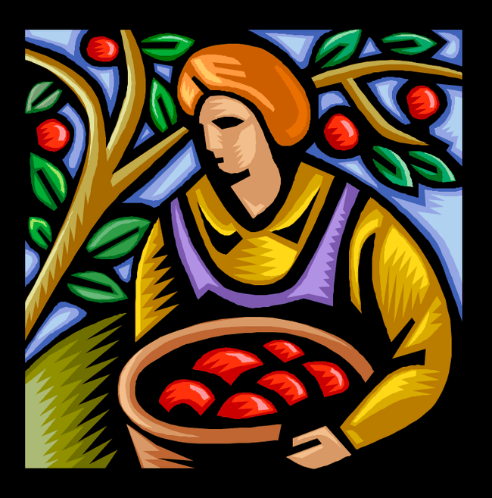

44

PART 4: GOD’S PURPOSE FOR MAN

God did not place us on earth only to be in right standing with Him, but there is so much more. Clearly we were consecrated to prepare a place of intimacy so that God can be revealed to the nations.


This irrevocable calling was given by God to Adam and Eve.

Romans 11:29 “29 For God’s gifts and His call are

irrevocable. [He never withdraws them when once they are given, and He does not change His mind about those to whom He gives His grace or to whom He sends His call.]

Ephesians 1:18 “18 By having the eyes of your heart

flooded with light, so that you can know and understand the hope to which He has called you, and how rich is His glorious inheritance in the saints (His set-apart ones),

Rom. 12:6-8 “Having gifts (faculties, talents, qualities) that differ according to the grace given us, let us use them: [He whose gift is] prophecy (PROPHET), [let him prophesy] according to the proportion of his faith;
7 [He whose gift is] practical service (SERVANT), let him give himself to serving; he who teaches (TEACHER), to his teaching;
8 He who exhorts (encourages) (EXHORTER), to his exhortation; he who contributes (GIVER), let him do it in simplicity and liberality; he who gives aid and superintends (RULER) (to be in charge of something), with zeal and singleness of mind; he who does acts of mercy (MERCY), with genuine cheerfulness and joyful eagerness.”

God gave man a gift of purpose (prophet, servant, teacher, exhorter,  ruler, mercy), which we need to “enlarge” to its fullest potential so that I can operate under the Holy Spirit to use this gift to impact the world, restoring my place of dominion so that God’s intimacy can be re-established. 


Our gifts (Redemptive purpose) and our understanding , developing and operating in them will define the extent that we fulfil our calling. “Gifts / Purpose” and “calling” are directly linked.

45

THE FIVE STAGES OF A PURPOSEFUL LIFE

We are no longer living in the Old Testament time. Although the Torah is still the roadmap for our purpose we move to the New

Testament to put context to our purpose.

Purpose can only be within the boundary of God’s Covenant. Yeshua gives us the boundary to our purpose.

Matthew 22:37-40 “37 And He replied to him, You shall love the Lord your God with all your heart and with all your soul and with all your mind (intellect).

38 This is the great (most important, principal) and first commandment.
39 And a second is like it: You shall love your neighbor as [you do]

yourself.
40 These two commandments sum up and upon them depend all the Law and the Prophets.

Any goal or purpose which therefore falls outside of this boundary is not from God but is a creation of self.

FIRST STAGE - YOU MUST BE BLESSED BY A FATHER
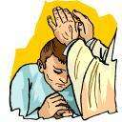

God is the Ultimate Father – in fact He goes on to say – do not let any man call himself father.

We need to clarify something: any person can join together with a woman and make a baby – this physical act makes us a biological father.

However the title “father” that we are alluding to is someone who exhibits / lives the attributes of God whose blessings are not focused on well-being, wealth etc. but on the desire to see a son walk through life without restrictions or limitations.
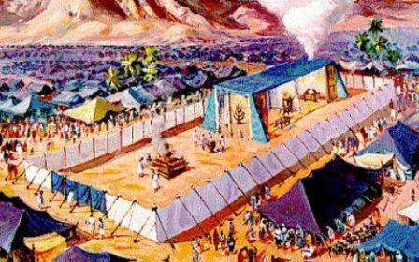

We start this process of blessing by following God’s pattern.

God lays out patterns for us to follow. Paul tells us that the earthly tabernacle is a pattern of the “real” Tabernacle in the Heaven.

If we can’t follow these earthly patterns and instructions how are we going to be able to worship and

praise God when we are with Him in Heaven?

46

So too, man’s purpose is laid out in a definite pattern / protocol. If we do not get the order right – we will not get the result that was planned.

- Immediately after man becomes a living creature (when God’s Breath entered his being), God blesses – i.e. God connected man’s spirit (as baby) to His spirit.


Genesis 1:27 “27 So God created man in His own image, in the image and likeness of God He created

him; male and female He created them.

Genesis 1:28 “28 And God blessed them and said to them, Be fruitful, multiply, and fill the earth, and subdue it [using all its vast resources in the service of God and man]; and have dominion over the fish of the sea, the birds of the air, and over every living creature that moves upon the earth.


Then God says: “Go forth, fill the earth and subdue it.

Genesis 9:1 “1 AND GOD pronounced a blessing upon Noah and his sons and said to them, Be fruitful and multiply and fill the earth.

PLEASE NOTE: blessing comes before multiplication.

We need to understand that this concept of “multiply” applies to:

- physical children

- material wealth

- spiritual growth.

The concept of blessing is not a once-off event at conception but a lifelong process by a father, which is why we are commanded to declare God’s Words over all mankind.

A father therefore connects his baby’s spirit to God’s Spirit by prayer and words of affirmation and welcome.


Numbers 6:24-27 “24 The Lord bless you and watch, guard, and keep you;

25 The Lord make His face to shine upon and enlighten you and be gracious (kind, merciful, and giving favor) to you;

26 The Lord lift up His [approving] countenance upon you and give you peace (tranquility of heart and life continually).
27 And they shall put My name upon the Israelites, and I will bless them.

47

SECOND STAGE - ACCEPT THE FULLNESS OF GOD’S LIBERTY FOR YOU

Before we go much further it is good to set out a definition of what the word liberty means.

The Cambridge Online Dictionary says:

Liberty means:

- to be allowed to do something,

- to do something that will have an effect on someone else without asking their opinion
- the freedom to live as you wish or to go where you want – e.g. religious, political freedom,
- to have confidence that no laws can be enforced which restrict our ancient rights.


God gave us total liberty to choose eternal life. By the keeping of one Commandment we (Adam and Eve):

- could live forever,

- Could have complete dominion over all of creation.

Genesis 2:16 “16 And the Lord God commanded the man, saying, You may freely eat of every tree of the garden;
17 But of the tree of the knowledge of good and evil and blessing and calamity you shall not eat, for in the day that you eat of it you shall surely die.

Adam accepted the liberty to name all the animals. Interestingly, Noah is told to build an ark to hold all the animals so that Noah’s domain on the earth can continue.

Adam and Eve reject their liberty and allowed Satan to have legal right over their lives.
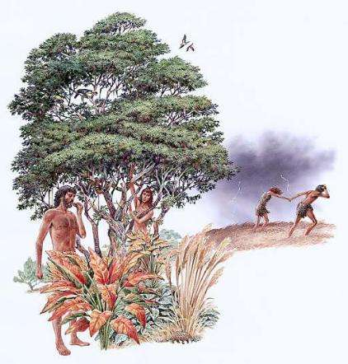

Genesis 3:1-3 “1 NOW THE serpent was more subtle and crafty than any living creature of the field which the Lord God had made. And he [Satan] said to the woman, Can it really be that God has said, You shall not eat from every tree of the garden?

2 And the woman said to the serpent, We may eat the fruit from the trees of the garden,

3 Except the fruit from the tree which is in the middle of the garden. God has said, You shall not eat of it, neither shall you touch it, lest you die.

48

Adam’s side was pierced to give birth to Eve – a symbol of the Bride.

Yeshua chose to do something for each one of us – something that would restore our relationship with God – His side was pierced without asking our opinion – He did it for the love of the Father.
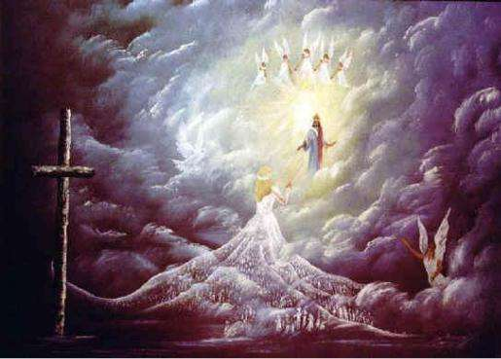

As a result we have become the Bride of Messiah.

Isaiah 53:4 “4 Surely He has borne our griefs (sicknesses, weaknesses, and distresses) and carried our sorrows and

pains [of punishment], yet we [ignorantly] considered Him stricken, smitten, and afflicted by God [as if with leprosy].

Isaiah 53:10 “10 Yet it was the will of the Lord to bruise Him; He has put Him to grief and made Him sick. When You and He make His life an offering for sin
[and He has risen from the dead, in time to come], He shall see His [spiritual] offspring, He shall prolong His days, and the will and pleasure of the Lord shall prosper in His hand.

John 20:27 “27 Then He said to Thomas, Reach out your finger here, and see My hands; and put out your hand and place [it] in My side. Do not be faithless and incredulous, but [stop your unbelief and] believe!
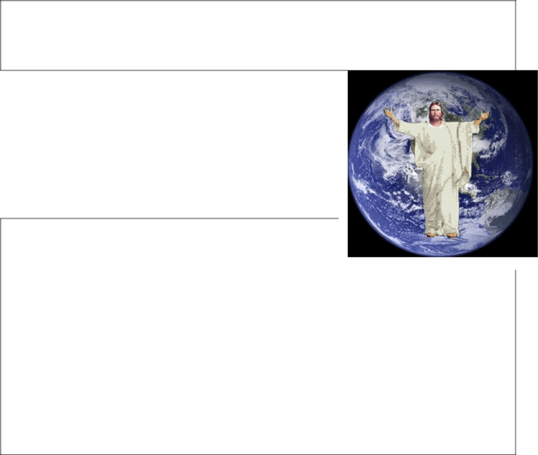
28 Thomas answered Him, My Lord and my God!

We were born to experience and to live in absolute and true Liberty – the choice to willingly be obedient to the Father.

I therefore stand to attention and accept my responsibility / assignment to be a helper in God’s Administration of this world / universe.

1 Corinthians 15:24-28 “24 After that comes the end (the completion), when He delivers over the kingdom to God the Father after rendering

inoperative and abolishing every [other] rule and every authority and power. 25 For [Christ] must be King and reign until He has put all [His] enemies under His feet.
26 The last enemy to be subdued and abolished is death.
27 For He [the Father] has put all things in subjection under His [Christ’s] feet. But when it says, All things are put in subjection [under Him], it is evident that He [Himself] is excepted Who does the subjecting of all things to Him.
28 However, when everything is subjected to Him, then the Son Himself will also subject Himself to [the Father] Who put all things under Him, so that God may be all in all [be everything to everyone, supreme, the indwelling and controlling factor of life].

49

THIRD STAGE - TAKE UP YOUR MANDATE TO HAVE DOMINION

Let’s clarify the meaning of the word “dominion” from the Cambridge Online Dictionary.


- control over a country of people

(God has dominion over all of His Creation)

The word “dominion or control” has taken on much of a negative context due to the abuse over people / earth, etc, by man.

Consequently we have to establish what God means with this vital aspect of our purpose in this life.

- The first use of the word “dominion” is found in:

Genesis 1:26 “26 God said, Let Us [Father, Son, and Holy Spirit] make mankind in Our image, after Our likeness, and let them have complete authority over the fish of the sea, the birds of the air, the [tame] beasts, and over all of the earth, and over everything that creeps upon the earth.


The context or area of domain is described very carefully. We have dominion over:


- fish of sea

- bird of the air

- Every living creature on earth.

We do not have dominion over:

- people

Strongs: “dominion” – 7287 – “radah” and means:

- tread down

- subjucate

- to prevail against

- to have domain

And comes from the root word – 7985 – “sholtan” and means

- to have mastery

- to have power

- to be a ruler

50

- God has everlasting dominion over the earth. We should be willing to praise and worship Him at all time, recognising that He is the Creator of all things.

Daniel 4:34 “34 And at the end of the days [seven years], I, Nebuchadnezzar, lifted up my eyes to heaven, and my understanding and the right use of my mind returned to me; and I blessed the Most High [God] and I praised and honored and glorified Him Who lives forever, Whose dominion is an everlasting dominion; and His kingdom endures from generation to generation.


Daniel 7:13 “13 I saw in the night visions, and behold, on the clouds of the heavens came One like a Son of man, and He came to the Ancient of Days and was presented before Him.

14 And there was given Him [the Messiah] dominion and glory and kingdom, that all peoples, nations, and languages should serve Him. His dominion is an everlasting dominion
which shall not pass away, and His kingdom is one which shall not be destroyed.

1 Peter 4:11 “11 Whoever speaks, [let him do it as one who utters] oracles of God; whoever renders service, [let him do it] as with the strength which God furnishes abundantly, so that in all things God may be glorified through Jesus Christ (the Messiah). To Him be the glory and dominion forever and ever (through endless ages). Amen (so be it).

Revelation 1:6 “6 And formed us into a kingdom (a royal race), priests to His God and Father—to Him be the glory and the power and the majesty and the dominion throughout the ages and forever and ever. Amen (so be it).


- Man has been given the responsibility to take dominion over vast areas of land.

The manner in which he exercises his “ambassadorial” role will determine whether he retains this right.

Daniel 4:22 “22 It is you, O king, who have grown

and become strong; your greatness has increased and it reaches to the heavens, and your dominion to the ends of the earth.

Daniel 11:4 “4 And as soon as he has fully arisen, his [Alexander the Great’s] kingdom shall be broken [by his death] and divided toward the four winds [the east, west, north, and south] of the heavens, but not to his posterity, nor according to the [Grecian] dominion which he ruled, for his kingdom shall be torn out and uprooted and go to others [to his four generals] to the exclusion of these.

51

- We, the believers in Messiah, should be using the right to bring glory and honour to God.

Jude 2:5 “1 May mercy, [soul] peace, and love be multiplied to You.

Revelation 1:6 “6 And formed us into a kingdom (a royal race), priests to His God and Father—to Him be the glory and the power and the majesty and the dominion throughout the ages and forever and ever. Amen (so be it).

We have dominion, i.e. we can rule over the works of our own hands.

Psalm 8:6 “6 You made him to have dominion over the works of Your hands;

You have put all things under his feet:

Psalm 49:14 “14 Like sheep they are appointed for Sheol (the place of the dead); death shall be their shepherd. And the upright shall have dominion over them in the morning; and their form and beauty shall be consumed, for Sheol shall be their dwelling.

Psalm 103:22 “22 Bless the Lord, all His works in all places of His dominion; bless (affectionately, gratefully praise) the Lord, O my soul!


52

FOURTH STAGE - WE MUST FULFIL OUR CALLING TO BE A SERVANT TO THE BODY OF MESSIAH AND TO BUILD A HEDGE OF PROTECTION AROUND IT.

This stage speaks to our interaction with the Body of Messiah. The “garden” is a place of intimacy with God here on earth; our interface with the Body of Messiah creates a Garden of Eden on earth.

There are two critical verses that we have to study as a foundation to our understanding of our purpose at this stage of God’s pattern.

Genesis 2:8 “8 And the Lord God planted a garden toward the east, in Eden [delight]; and there He put the man whom He had formed (framed, constituted).


The first word to be studied in “plant” –

Strongs 5193 – “na’ta” and means to:

- strike in

- specifically plant

So we can see that the place where we have been put into has been specifically / emphatically determined.

The Garden of Eden and the Body of Messiah are reflections of two sides of the same coin. We have been specifically planted into the Body of Messiah.

Genesis 2:15 “15 And the Lord God took the man and put him in the Garden of Eden to tend and guard and keep it.

We are going to study the meaning of a few of the critical words in this verse.

- “Put” – Strongs 5117 – “nûach” which means
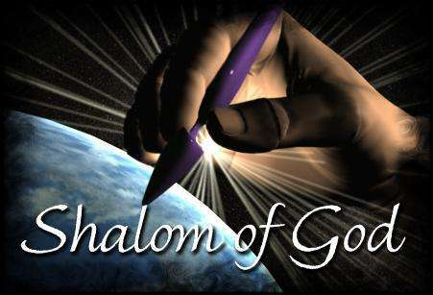

- to rest

- to settle down

This word literally, figuratively and causatively means to be left alone / to have comfort, to be at rest. This brings a whole new dimension as to the “value” that Adam and Eve experienced whilst in the Garden of Eden.

No matter what circumstances arose, their place of intimacy with God made them so secure that they always experienced the fullness of Shalom.

53

- “to dress” – Strongs 5647 – “a’bad” and means:

- to work / till / husband-man

- to be a worshipper

- to become a servant / to cause to serve.

In Gen 1:28 we read that we are mandated to “subdue” the earth.

Genesis 1:28 “28 And God blessed them and said to them, Be fruitful, multiply, and fill the earth, and subdue it [using all its vast resources in the service of God and man]; and have dominion over the fish of the sea, the birds of the air, and over every living creature that moves upon the earth.

The understanding that these two concepts bring is that we are called to use the vast resources that God has provided in service to God the Creator and to our fellow man.
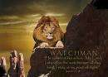

- “to keep it” – Strongs 8104 – “shâmar” which means

- to build a hedge about as with thorns

- to guard / protect

- to look narrowly / be circumspect / to be watchful
- to watch for that which lies in wait.

Clearly we see a second and equally critical role – that of the watchman on the wall, this is not a passive role but an active job of building a hedge.

The last two concepts to dress / servant and to keep / watch therefore go together. As we step into this stage of our purpose we need to be aware that both roles are vital and equally important to our well-being.

It is therefore clear that my calling has a two-fold aspect

x | one as servant | Son of God
x | one as watchman | Son of God


I would have thought that we would find very clear distinctions between these two roles – in fact, that is what the church has taught for many years – namely: some are called as shepherds while others are called to intercession and spiritual warfare. It now seems patently clear that this is not true.

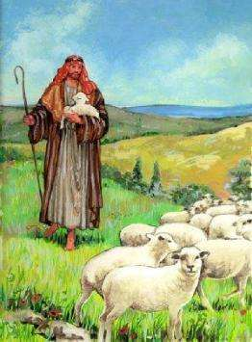

+

54

Who are called?

It is clear that we are all called with the same purpose / goal in mind.

1 Corinthians 7:7 “7 I wish that all men were like I myself am [in this matter of self-control]. But each has his own special gift from God, one of this kind and one of another.

EVIDENCE THAT YOU ARE A SON OF GOD SHOULD BE SEEN IN THE BLESSING ON YOUR TALENTS AND OCCUPATION
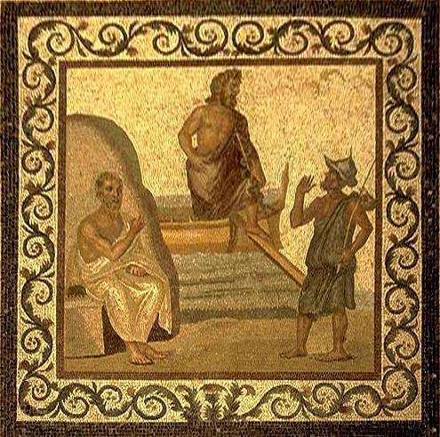

Our vocation / job is merely the place / forum where we live to role-model God’s Image to others and therefore none of these “jobs” is of greater value before God or not.

The Greco-Roman mindset of performance orientation causes man to focus on these occupations as the GOAL of life.

GRECO-ROMAN MINDSET


SHORT TERM

GOAL

To be known as:

sportsman

pastor
businessman
teacher

farmer

55

HEBRAIC MINDSET: |  |  |  | The Hebraic Mindset uses long
 |  |  |  | term goals to determine / filter out
 |  |  |  | the short term goals
 |  |  |  | LONG TERM | SHORT TERM
 |  |  |  | GOAL | GOAL
 |  |  |  | To be known as: | To be known as:
 |  |  |  | Son of God / Man | sportsman
 |  |  |  | of God | pastor
 |  |  |  |  | businessman
 |  |  |  |  | teacher
 |  |  |  |  | farmer



The Hebraic understanding causes us to focus on the end-time goal of eternity namely, on being A SON OF GOD. The blessings which are evident and should be seen in our talents and occupation will reflect our journey of obedience to God’s purposes.

1 John 3:1 “1 SEE WHAT [an incredible] quality of love the Father has given (shown, bestowed on) us, that we should [be permitted to] be named and called and counted the children of God! And so we are! The reason that the world does not know (recognize, acknowledge) us is that it does not know (recognize, acknowledge) Him.

Romans 8:23 “23 And not only the creation, but we ourselves too, who have and enjoy the firstfruits of the [Holy] Spirit [a foretaste of the blissful things to come] groan inwardly as we wait for the redemption of our bodies [from sensuality and the grave, which will reveal] our adoption (our manifestation as God’s sons).

2 Tim 1:9 “9 [For it is He] Who delivered and saved us and called us with a calling in itself holy and leading to holiness [to a life of consecration, a vocation of holiness]; [He did it] not because of anything of merit that we have done, but because of and to further His own purpose and grace (unmerited favor) which was given us in Christ Jesus before the world began [eternal ages ago].

56

An example from Nehemia

The Torah example which comes to mind is that of the building of the walls of Jerusalem in the time Nehemiah. We read of the time when each family built their own section of the wall while at the same time keeping guard with the sword.
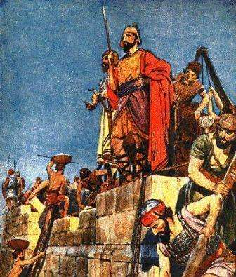

Nehemiah 4:13 “13 So I set [armed men] behind the wall in places where it was least protected; I even thus used the people as families with their swords, spears, and bows.


Nehemiah 4:16 “16 And from that time forth, half of my servants worked at the task, and the other half held the spears, shields, bows, and coats of mail; and the leaders stood behind all the house of Judah.


Nehemiah 4:18 “18 And every builder had his sword girded by his side, and so worked. And he who sounded the trumpet was at my side.


It seems that this is really the picture of a son of God that is busy “subduing” the earth.
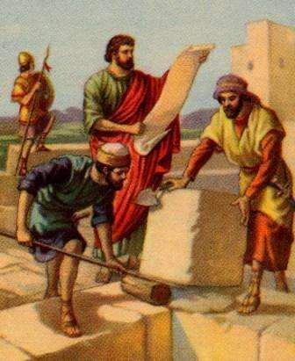

57

WHAT IS OUR “CALLING”?

It is at this stage that we need to establish what our “calling” is.

The Cambridge Online Dictionary defines “calling” as “the strong desire to do the job, one which is socially

valuable.”

The Strongs definition for “calling” is:

Strongs 7121 “qura”

- to encounter

- to call out

- to proclaim / publish

Strongs 2142 “zahar”

- to mark so as to be recognised

- to put to remembrance

This definition for “calling” (The Greek word means “invitation”) is however not accepted by all.

Those who are wise in the flesh, noble, and mighty in their own strength, will struggle to accept this invitation as they will all too often rely on their own
strength.

1 Corinthians 1:26 “26 For [simply] consider your own call, brethren; not many [of you were considered to be] wise according to human estimates and standards, not many influential and powerful, not many of high and noble birth.

2 Timothy 1:9 “9 [For it is He] Who delivered and saved us and called us with a calling in itself holy and leading to holiness [to a life of

consecration, a vocation of holiness]; [He did it] not because of anything of merit that we have done, but because of and to further His own purpose and grace (unmerited favor) which was given us in Christ Jesus before the world began [eternal ages ago].

Therefore I need a plumb-line or a benchmark against which I can measure myself to see if I have zoomed in / focused on my calling.

Benchmarks of someone who is following their calling:

- We have been called to liberty

  - We are called to love our neighbour to the fullest extent that God would. We are to act in all circumstances with the heart / mind of God.

58

Galatians 5:13 “13 For you, brethren, were [indeed] called to freedom; only [do not let your] freedom be an incentive to your flesh and an opportunity or excuse [for selfishness], but through love you should serve one another.


Acts 2:21 “21 And it shall be that whoever shall call upon the Name of the Lord [invoking, adoring, and worshiping the Lord—Christ] shall be saved.


Romans 10:13 “13 For everyone who calls upon the Name of the Lord [invoking Him as Lord] will be saved.

This role model of God’s attributes must be such that others will be confronted with the choice to call on God.
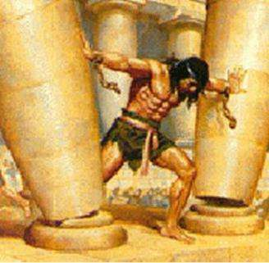

- We are given the liberty to act in God’s stead.

Samson’s mother has a visitation from a “man of God” who tells her what her son’s role and calling is to be.

Not all of us have the calling to act as a warrior against

the physical enemy but we certainly have the liberty to be warrior in the spiritual domain.

- We are given the liberty of restoring God’s Kingdom.

We are to possess this earth in a manner that would please the King of kings.

Daniel 7:18 “18 But the saints of the Most High [God] shall receive the kingdom and possess the kingdom forever, even forever and ever. Revelation 5:10 “10 And You have made them a kingdom (royal race) and priests to our God, and they shall reign [as kings] over the earth!


We are given the liberty to be trusted with authority on earth to administer the affairs of God.

Romans 8:14-18 “14 For all who are led by the Spirit of God are sons of God.

15 For [the Spirit which] you have now received [is] not a spirit of slavery to put you once more in bondage to fear, but
you have received the Spirit of adoption [the Spirit producing sonship] in [the bliss of] which we cry, Abba (Father)! Father!
16 The Spirit Himself [thus] testifies together with our own spirit, [assuring us] that we are children of God.17 And if we are [His] children, then we are [His] heirs also: heirs of God and fellow heirs with Christ [sharing His inheritance with Him]; only we must share His suffering if we are to share His glory.

59

Luke 10:19 “19 Behold! I have given you authority and power to trample upon serpents and scorpions, and [physical and mental

strength and ability] over all the power that the enemy [possesses]; and nothing shall in any way harm you.

Revelation 22:4 “4 They shall see His face, and His Name shall be on their foreheads.

5 And there shall be no more night; they have no need for lamplight or sunlight, for the Lord God will illuminate them and be their light, and they shall reign [as kings] forever and ever (through the eternities of the eternities)

- We have been given the liberty to know God – to have God reveal
Himself to us.


Numbers 12:6 “6 And He said, Hear now My words: If there is a prophet among you, I the Lord make Myself known to him in a vision and speak to him in a dream.

Ezekiel 3:17 “17 Son of man, I have made you a

watchman to the house of Israel; therefore hear the word at My mouth and give them warning from Me.

Jeremiah 15:19 “19 Therefore thus says the Lord [to Jeremiah]: If you return [and give up this mistaken tone of distrust and despair], then I will give you again a settled place of quiet and safety, and you will be My minister; and if you separate the precious from the vile [cleansing your own heart from unworthy and unwarranted suspicions concerning God’s faithfulness], you shall be My mouthpiece. [But do not yield to them.] Let them return to you— not you to [the people].

2. We are called to the Marriage of the Lamb
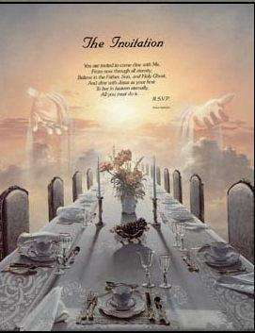

The Apostle John is banished to the island of Patmos. Here he sees a vision of the end times.

Part of this vision is the understanding that there will be a Marriage Ceremony where the Bride of Messiah and Yeshua are united.

Revelation 19:9 “9 Then [the angel] said to me, Write this down: Blessed (happy, to be envied) are those who are summoned (invited, called) to the marriage supper of the Lamb. And he said to me [further], These are the true words (the genuine and exact declarations) of God.


60

Marriage on Earth - First the Natural

Ephesians 5:22-25 “22 Wives, be subject (be submissive and adapt yourselves) to your own husbands as [a service] to the Lord.

23 For the husband is head of the wife as Christ is the Head of the church, Himself the Savior of [His] body. 24 As the church is subject to Christ, so let wives also be subject in everything to their husbands.
25 Husbands, love your wives, as Christ loved the church and gave Himself up for her,

Then the Spiritual

Hebrews 3:1 “1 SO THEN, brethren, consecrated and set apart for God, who share in the heavenly calling, [thoughtfully and attentively] consider Jesus, the Apostle and High Priest Whom we confessed [as ours when we embraced the Christian faith].

Isaiah 41:4 “4 Who has prepared and done this, calling forth and guiding the destinies of the generations [of the nations] from the beginning? I, the Lord—the first [existing before history began] and with the last [an ever-present, unchanging God]—I am He.

We have to realize that there are many people who form the Body of Messiah

– everyone who believe / accepts Yeshua as Messiah.

However, only those who pursue their calling to the very end will be the Bride of Messiah.

3. We have a calling to role-model the Word of God in our daily lives.


Paul speaks and prays that we will all receive the Spirit of Wisdom and Revelation of Him. As we immerse ourselves in this revelation we will be able to reach for the Glory of our inheritance.

God’s calling on us is to be able to reveal this revelation knowledge in a dynamic lifestyle to our fellow-man.

Ephesians 1:17 “17 [For I always pray to] the God of our Lord Jesus Christ, the

Father of glory, that He may grant you a spirit of wisdom and revelation [of
insight into mysteries and secrets] in the [deep and intimate] knowledge of Him,

61

18 By having the eyes of your heart flooded with light, so that you can know and understand the hope to which He

has called you, and how rich is His glorious inheritance in the saints (His set-apart ones),

19 And [so that you can know and understand] what is the immeasurable and unlimited and surpassing greatness of His power in and for us who believe, as demonstrated in the working of His mighty strength,

We must be diligent to make this calling sure so that we do not fall. If we diligently study, pray, and communicate with God, we will have our spirits opened to a richness / abundance of Truth and Life-giving Principle that we can apply on earth “as it is in Heaven ” to ensure that we build an everlasting Kingdom.

2 Peter 1:10-12 “10 Because of this, brethren, be all the more solicitous and eager to make sure (to ratify, to strengthen, to make steadfast) your calling and election; for if you do this, you will never stumble or fall.

11 Thus there will be richly and abundantly provided for you entry into the eternal kingdom of our Lord and Savior Jesus Christ.
12 So I intend always to remind you about these things, although indeed you know them and are firm in the truth that [you] now [hold].

When we truly become Sons of God, we start to operate on earth as true representatives from above.


A man of God will know the scriptures, be inspired by the Holy Spirit, and will be committed to good works.

2 Timothy 3:15-17 “15 And how from your childhood you have had a knowledge of and been acquainted with the sacred Writings, which are able to instruct you and give you the understanding for salvation which comes through faith in Christ Jesus.
16 Every Scripture is God-breathed (given by His inspiration) and profitable for instruction, for reproof and conviction of sin, for correction of error and discipline in obedience, [and] for

training in righteousness (in holy living, in conformity to God’s will in thought, purpose, and action),

17 So that the man of God may be complete and proficient, well fitted and thoroughly equipped for every good work.

62

A man of God knows his worth

.

Psalm 8:3-8 “3 When I view and consider Your heavens, the work of Your fingers, the moon and the stars, which You have ordained and established,

4 What is man that You are mindful of him, and the son of [earthborn] man that You care for him?
5 Yet You have made him but a little lower than God [or heavenly beings], and You have crowned him with glory and honor.
6 You made him to have dominion over the works of Your hands; You have put all things under his feet:
7 All sheep and oxen, yes, and the beasts of the field,
8 The birds of the air, and the fish of the sea, and whatever passes along the paths of the seas.

4. We are called to live a life of remembrance.
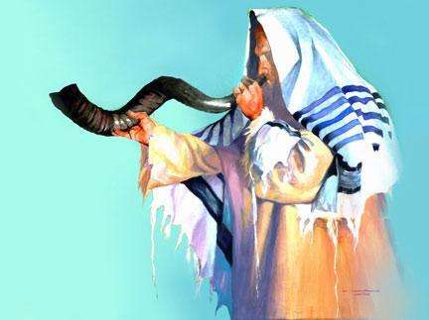

Throughout the Torah we are called to remember;

- that we have been delivered from Egypt,
- That we have been blessed.

This act of remembering is not an act of thinking back on what happened in some quiet corner.

Instead we are required to make festivals / proclamations to declare these facts into both the spiritual realm as well as the physical domain.

Jeremiah 33:3 “3 Call to Me and I will answer you and show you great and mighty things, fenced in and hidden, which you do not know (do not distinguish and recognize, have knowledge of and understand).

2 Peter 1:12-15 “12 So I intend always to remind you about these things, although indeed you know them and are firm in the truth that [you] now [hold]. 13 I think it right, as long as I am in this tabernacle

(tent, body), to stir you up by way of remembrance, 14 Since I know that the laying aside of this body of mine will come speedily, as our Lord Jesus Christ made clear to me.

15 Moreover, I will diligently endeavor [to see to it] that [even] after my departure (decease) you may be able at all times to call these things to mind.

63

Hebrews 10:32 “32 But be ever mindful of the days gone by in which, after you were first spiritually enlightened, you endured a great and painful struggle,
John 14:26 “26 But the Comforter (Counselor, Helper, Intercessor, Advocate, Strengthener, Standby), the Holy Spirit, Whom the Father will send in My name [in My place, to represent Me and act on My behalf], He will teach you all things. And He will cause you to recall (will remind you of, bring to your remembrance) everything I have told you.

5. We have been uniquely graced with gifts and a calling of God which is irrevocable.

Romans 11:29-31 “29 For God’s gifts and His call are irrevocable. [He never withdraws them when once they are given, and He does not change His mind about those to whom He gives His grace or to whom He sends His call.]

These gifts are set out for us as the means through which each one of us will impact the Body of Messiah and the non-believers so that God’s purposes will come to pass.

We individually subdue the kingdom of darkness and begin to rule and change our community when we release the power of our unique combination of gifts through our everyday living.


64

FIFTH STAGE - WE HAVE A BIRTHRIGHT – THE RIGHT TO ETERNAL LIFE WITH A GENERATIONAL BLOODLINE THAT REFLECTS GOD’S GLORY

The key verse is stated already in the Garden of Eden.

At the time before the fall, when Adam and Eve were in perfect harmony with God, a declaration of potential was made. Man would live forever. All they had to do was keep one Commandment.

Genesis 2:16 “16 And the Lord God commanded the man, saying, You may freely eat of every tree of the garden;

17 But of the tree of the knowledge of good and evil and blessing and calamity you shall not eat, for in the day that you eat of it you shall surely die.

We should take care never to despise our birthright as Esau did.
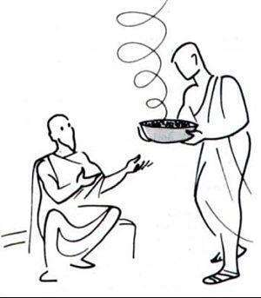

Genesis 25:34 “34 Then Jacob gave Esau bread and stew of lentils, and he ate and drank and rose up and went his way. Thus Esau scorned his birthright as beneath his notice.


Because we live in a material world with performance orientation as the main focus, i.e. the short-term gain, it is not always easy for one to sit back and contemplate a longer term – an eternal perspective.

Birthright is the right to succession. We want

to leave the next generation with a Godly bloodline, having seen a wonderful role-model of God’s Torah through the parents, and with the children empowered to move in their own God-given purpose.

Revelation 1:12-14 “12 Then I turned to see [whose was] the voice that was speaking to me, and on turning I saw seven golden lampstands,

13 And in the midst of the lampstands [One] like a Son of Man, clothed with a robe which reached to His feet and with a girdle of gold about His breast.

14 His head and His hair were white like white wool, [as white] as snow, and His eyes [flashed] like a flame of fire.

65

Sons of God are those who have lived a life of loving God and keeping His Commandments. Those who do so overcome this world.

Revelation 5:2-4 “2 And I saw a strong angel announcing in a loud voice, Who is worthy to open the scroll? And [who is entitled and deserves and is morally fit] to break its seals?
3 And no one in heaven or on earth or under the earth [in the realm of the dead, Hades] was able to open the scroll or to take a [single] look at its contents.
4 And I wept audibly and bitterly because no one was found fit to open the scroll or to inspect it.

The Difference between Destiny and Calling

We now need to define another word which is used very often when speaking especially to younger people – the word destiny.

For many believers the word “destiny” and “calling” are used interchangeably.


As defined by the Cambridge

Online Dictionary destiny is:

“The things that will happen in the future”

God shows us that we must take control and determine our own destiny. We can choose life or death, Heaven or hell.

A critical fact of this stage of our purpose is the understanding and

knowledge that we each chart our own destiny and only God really knows the intent of our hearts.

Luke 16:15 “15 But He said to them, You are the ones who declare

yourselves just and upright before men, but God knows your hearts. For what is exalted and highly thought of among men is detestable and abhorrent (an abomination) in the sight of God.
16 Until John came, there were the Law and the Prophets; since then the good news (the Gospel) of the kingdom of God is being preached, and

everyone strives violently to go in.

66

My unique path / journey to the fulfilment of my purpose is to come to the revelation that:


- I have a Father

- Who has a Mansion

- that has a room for me!!

John 14:1-3 “1 DO NOT let your hearts be troubled (distressed, agitated). You believe in and adhere to and trust in and rely on God; believe in and adhere to and trust in and rely also on Me.

2 In My Father’s house there are many dwelling places (homes). If it were not so, I

would have told you; for I am going away to prepare a place for you.

3 And when (if) I go and make ready a place for you, I will come back again and will take you to Myself, that where I am you may be also.

- Yeshua the Messiah has paved the way for Eternal Life through faith

1 Thessalonians 4:15-18 “15 For this we declare to you by the Lord’s [own] word, that we who are alive and remain until the coming of the Lord shall in no way precede [into His presence] or have any advantage at all over those who have previously fallen asleep [in Him in death].

16 For the Lord Himself will descend from heaven with a loud cry of summons, with the shout of an archangel, and with the blast of the trumpet of God. And those who have departed this life in Christ will rise first.
17 Then we, the living ones who remain [on the earth], shall simultaneously be caught up along with [the resurrected dead] in the clouds to meet the Lord in the air; and so always (through the eternity of the eternities) we shall be with the Lord!

18 Therefore comfort and encourage one another with these words.

- Yeshua’s Name will be ingrained on my forehead / on my DNA

Numbers 6:27 “27 And they shall put My name upon the Israelites, and I will bless them.


- I will see Him Face to face

Revelation 22:4-5 “4 They shall see His face, and His name shall be on their foreheads.

5 And there shall be no more night; they have no need for lamplight or sunlight, for the Lord God will illuminate them and be their light, and they shall reign [as kings] forever and ever (through the eternities of the eternities).

67

SEEKING MY END-TIME DESTINY

Once this level and dimension of God’s purposes have become a reality in my spirit and I have started to move to a place where I can reflect this in my life’s journey, I will start to seek my end-time destiny.

- I will search for and bring God’s

Glory


Romans 8:18 “18 [But what of that?] For I consider that the sufferings of this present time (this present life) are not worth being compared with the glory that is about to be revealed to us and in us and for us and conferred on us!


2 Peter 1:3 “3 For His divine power has bestowed upon us all things that [are requisite and suited] to life and godliness, through the [full, personal] knowledge of Him Who called us by and to His own glory and excellence (virtue).

2) I will bring honour to God

John 12:26 “26 If anyone serves Me, he must continue to follow Me [to cleave steadfastly to Me, conform wholly to My example in living and, if need be, in dying] and wherever I am, there will My servant be also. If anyone serves Me, the Father will honor him.


1 Thessalonians 4:4 “4 That each one of you should know how to possess (control, manage) his own body in consecration (purity, separated from things profane) and honor,

- I will strive for immortality / eternal life

1 Peter 3:4 “4 But let it be the inward

adorning and beauty of the hidden person of the heart, with the incorruptible and unfading charm of a gentle and peaceful spirit, which [is not anxious or wrought up, but] is very precious in the sight of God.

John 6:27 “27 Stop toiling and doing and producing for the food that perishes and decomposes [in the using], but strive and work and produce rather for the [lasting] food which endures [continually] unto life eternal; the Son of Man will give (furnish) you that, for God the Father has authorized and certified Him and put His seal of endorsement upon Him.

68

Seeking Blessings by Works?

Whilst each one of us follows this journey / walk of obedience, it could easily seem that we seek blessings because of what we do (works).


Obedience does not merit a blessing.

Blessings have already been given by grace (as evidenced in the Garden of Eden before Adam and Eve were given their mandate to take dominion).

Blessings demonstrate man’s acceptance of God’s gracious gifts and proof that God has kept His Word.

Philippians 1:2 “2 Grace (favor and blessing) to

you and [heart] peace from God our Father and the Lord Jesus Christ (the Messiah).

James 1:21-27 “21 So get rid of all uncleanness and the rampant outgrowth of wickedness, and in a humble (gentle, modest) spirit receive and welcome the Word which implanted and rooted [in your hearts] contains the power to save your souls.
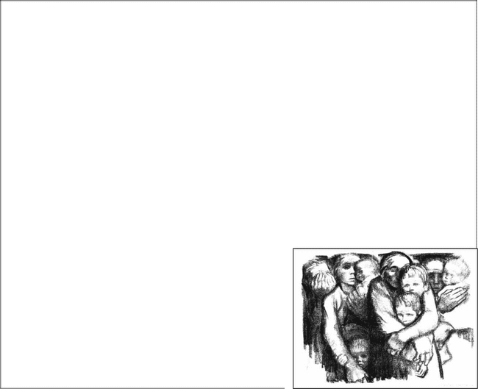
22 But be doers of the Word [obey the message], and not merely listeners
to it, betraying yourselves [into deception by reasoning contrary to the Truth]. 23 For if anyone only listens to the Word without obeying it and being a doer of it, he is like a man who looks carefully at his [own] natural face in a mirror; 24 For he thoughtfully observes himself, and then goes off and promptly forgets what he was like.

25 But he who looks carefully into the faultless law, the [law] of liberty, and is faithful to it and perseveres in looking into it, being not a heedless listener who forgets but an active doer [who obeys], he shall be blessed in his doing (his life of obedience.
26 If anyone thinks himself to be religious (piously observant of the external duties of his faith) and does not bridle his tongue but deludes his own heart, this person’s religious service is worthless

(futile, barren).

27 External religious worship [religion as it is expressed in outward acts] that is pure and unblemished in the sight of God the Father is this: to visit and help and care for the orphans and widows in their affliction and need, and to keep oneself unspotted and uncontaminated from the world.

69

PRAYER:


Father, we bring our lives before You and we ask for Your grace and mercy to be able to deal with the things in our lives that is not according to Your will and calling for us.

We choose to lay down all the unnecessary baggage and self efforts. We choose to come back to the original plan You had from the beginning of time – living a purposeful life and passing this truth on to the next generation.

Thank You, Father for Your power and strength to make all the changes necessary. We choose to live our lives so as to make a difference in this world for Your Name’s sake!

AMEN
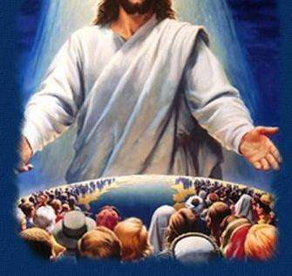

70

PART 5: MAN REBELS AND STRAYS OFF COURSE

In spite of everything God created, called and equipped us to be, man rebelled and strayed away from God.

His Word is a Love Letter calling us back to the original plan and purpose for man – i.e. walking everyday with God – knowing and enjoying Him and Him enjoying us!!


Throughout the generations, God calls and raises up leaders and prophets to speak His message of reconciliation to man.

In Deuteronomy we find Moses as a leader of the nation of Israel. His last words to the nation before he died were: “Choose life…”

Deut. 30:19 “19 I call heaven and earth to witness

this day against you that I have set before you life and death, the blessings
and the curses; therefore choose life, that you and your descendants may live.”

But we stray off course – and then God says: “Return to Me and I will return to you”:

Mal. 3:7 “7 Even from the days of your fathers you have turned aside from My ordinances and have not kept them.
Return to Me, and I will return to you, says the Lord of hosts. But you say, How shall we return?”

WHAT WAS THE EFFECT OF THE FALL? WHAT DID MAN LOSE?

We often look at the moment of sin in Adam and Eve’s life as the only reason for our predicament today. We fail to
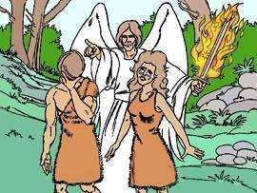
realize that every day we face the same choice, the same whisper of an alternate lifestyle and more often than not choose the same pattern that Adam did.

That moment in time when Adam and Eve chose to disobey God was a dividing line between Heaven / Garden of Eden and the world as we know it today where we are separated from God until we experience the love of Yeshua.

71

- We swopped Spiritual Eternal Life for a life separated from God.

Even though we accept Yeshua as Messiah our lives are still often not focused on the eternal.

Isaiah 59:2 “2 But your iniquities have made a separation between you and your God, and your sins have hidden His face from you, so that He will not hear.
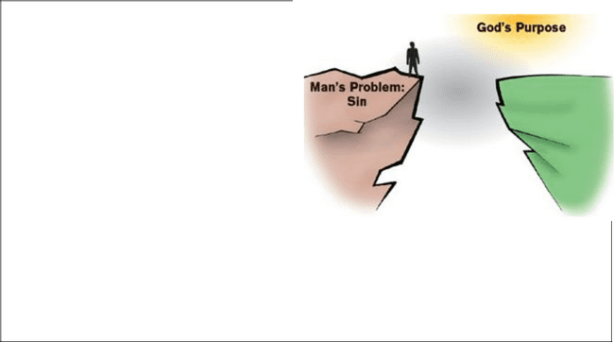
Romans 5:12^{i} “12 Therefore, as sin came into the world through one man, and death as the result of sin, so death spread to all men, [no one being able to stop it or to escape its power] because all men sinned.

13 [To be sure] sin was in the world before ever the Law was given, but sin is not charged to men’s account where there is no law [to transgress].

19 For just as by one man’s disobedience (failing to hear, heedlessness, and carelessness) the many were constituted sinners, so by one Man’s obedience the many will be constituted righteous (made acceptable to God, brought into right standing with Him)


This separation leads us down a path of depravity.

Ephesians 2:1-3 “1 AND YOU [He made alive], when you were dead (slain) by [your] trespasses and sins

2 In which at one time you walked [habitually]. You were following the course and fashion of this world [were under the sway of the tendency of this present age], following the prince of the power of the air. [You were

obedient to and under the control of] the [demon] spirit that still constantly works in the sons of disobedience [the careless, the rebellious, and the unbelieving, who go against the purposes of God].
3 Among these we as well as you once lived and conducted ourselves in the passions of our flesh [our behavior governed by our corrupt and sensual nature], obeying the impulses of the flesh and the thoughts of the mind [our cravings dictated by our senses and our dark imaginings]. We were then by nature children of [God’s] wrath and heirs of [His] indignation, like the rest of mankind.

Genesis 6:5 “5 The Lord saw that the wickedness of man was great in the earth, and that every imagination and intention of all human thinking was only evil continually.

- For a full explanation read Romans 5:12-21

72

- We swopped intimacy and communion with God for a place where we see God dimly, where the Voice of God is often confused with other voices.

Isaiah 69:2 “1 THE VISION [seen by spiritual perception] of Isaiah son of Amoz, which he saw concerning Judah [the kingdom] and Jerusalem [its capital] in the days of Uzziah, Jotham, Ahaz, and Hezekiah, kings of Judah. 2 Hear, O heavens, and give ear, O earth! For the Lord has spoken: I have nourished and brought up sons and have made them great and exalted, but they have rebelled against Me and broken away from Me.

1 Peter 2:24 “24 He personally bore our sins in His [own] body on the tree [as on an altar and offered Himself on it], that we might die (cease to exist) to sin and live to righteousness. By His wounds you have been healed.


We exchange trust and dependence on God for trust:

- in fellow man,

- in the power of my own flesh,

- in a heart which has departed from God and

Then find myself in a wilderness where I fail to see any good when it comes my way.

Jeremiah 17:5 “5 Thus says the Lord: Cursed [with great evil] is the strong man who trusts in and relies on frail man,

making weak [human] flesh his arm, and whose mind and heart turn aside from the Lord.
6 For he shall be like a shrub or a person naked and destitute in the desert; and he shall not see any good come, but shall dwell in the parched places in the wilderness, in an uninhabited salt land.

Not only do we fail to be able to hear God but we more often than not move to a place of total rebellion against God.

Isaiah 28:4 “4 And the fading flower of its glorious beauty, which is on the head of the rich valley, will be like the early fig before the fruit harvest, which, when anyone sees it, he snatches and eats it up greedily at once. [So in an amazingly short time will the Assyrians devour Samaria, Israel’s capital.]

Romans 8:7 “7 [That is] because the mind of the flesh [with its carnal thoughts and purposes] is hostile to God, for it does not submit itself to God’s Law;; indeed it cannot.

73

Psalm 39:4 “4 Lord, make me to know my end and [to appreciate] the measure of my days—what it is; let me know and realize how frail I am [how transient is my stay here].

“5 Behold, You have made my days as [short as] handbreadths, and my lifetime is as nothing in Your sight. Truly every man at his best is merely a breath! Selah [pause, and think calmly of that]!

THE EFFECT OF THE FALL ON SEXUAL INTIMACY AND THE SPIRITMAN:

The Garden of Eden….


The very first command God gave man was to have sex. It was placed in the context of being fruitful and to multiply – i.e. having sex!

Scripture is clear that Adam and Eve did not obey that command until after the fall. They did not “know” each other until after the fall.

God intended sexual intercourse to allow husband and wife to share their spirits in a life-giving way.


For example:

Many of us have ipods. We have to update our ipods regularly by plugging into our computers which we have loaded with new data. These two electronic devices synchronize with each other and share data until they both have all the data necessary.

God intended for the husband and wife to

grow during the day – they then “cross-pollinate” and share their spirits

at the moment of sexual climax.

Demonic Data Transfer

The emotional experience of a demon is imprinted onto the spirit of a person in such a way that it is indistinguishable from her own experiences.

The mechanism to transfer demonic data to a human being is by reaching climax during sexual intercourse. When a highly demonized individual is having intercourse with a human being they are capable at the moment of climax of imprinting something of themselves on that person’s spirit – our spirit is open and extraordinary vulnerable for input in that brief few seconds at the moment of sexual climax.

74

God created Adam and from Adam He created Eve – would they have been able to have resisted the temptation if they had been “whole”??

If they had “cross -pollinated” – had a data base transfer pre-fall – would that have made them wise enough / strong enough to be able to see through the demonic strategy and resist it??

The very first consequence of their sin was that they became alienated from their sexuality.

Before they sinned, they were naked and completely at peace with sexuality.

There was no shame about their nakedness and their sexuality.


The light of the glory of the Lord was shining out of them and they were clothed with

LIGHT!

When they sinned, the light went out – and so they defaulted to the fig leaves and consequently lost their liberty to be unashamed!

The first consequence of the fall is a sense of shame is attached to the body and to sexuality. Since then sex has been used for comfort, physically and emotionally, not for spiritual righteous things.

Yet, through all generations, sexuality has been used for unrighteous things. We read in the Old Testament, the Israelites were always brought into areas of sin by the pagan nations. Idolatry and adultery went together.

Worship and sex are profoundly connected in the occult realm. In the New Testament we have the Greco-Roman cultures had prostitution – worship and sex connected again.

In the Body of Christ we have down-played sex and have focused on the misuse of sex – the evil of sex and have

not taught on where does our sexuality, our human spirit and God all come together.

God intended there to be an incredible sense of worship in the consummation of your physical intimacy as your spirit and your spouse’s spirit and God’s Spirit are all magnificently united in a comfortable way!

We are not there yet as a people of God for TWO reasons:

- Lack of liberty / legitimacy.
- Lack of instruction.

75

Example:

If your spouse is not faithful in serving God and or there could have been unfaithfulness in the marriage, then the most profound time for restoration is during the act of sex.

Bless every part of your biology of being together – declaring all that God has made is GOOD!!

It is so important to bring your spirit-man to also take the lead in the sexual act.

Most of the time, because of the shame that is wrapped around sexuality, when we move towards the bedroom, our spirit shuts down, looks the other way, or runs away, because we have believed that this act is a biological and emotional experience – it is not a spiritual one.

Once the act is over, then you become “spiritual” again (or so you believe!) because we completely separated being spiritual from the act of sex.

It is time for us to take back what the devil has stolen from us!

There are levels of greatness that you can achieve with your spouse when sexuality and spirituality are one and the same.

If you continue to have sex as a physical, emotional encounter, you are never going to reach the heights of intimacy with your spouse or with God, or your effectiveness in life that you could, if we don’t redeem this!

PRACTICAL STEPS TO REDEEM YOUR SEXUALITY BACK TO GOD’S ORIGINAL PLAN


Where do we begin?

A third party that both the husband and wife trust, can speak to the couple and bring liberty to the spirit by explaining that it was a command by God that the marriage bed be holy and righteous.

Now you instruct the spirit directly:

“God designed you spirit-man to lead in this area.

God designed you to engage your spouse’s spirit as the physical moves to

climax and God gives you permission to exchange data, to share, to connect with God and with each other at the moment of climax.”

76

If you do not have a third party, each of you can do the above for the other. Speak to each other’s spirit explaining what you can be, this is what you should be, this is what you were made to be.


Spirit-man, this is a time for you to lead and not to retreat.

Wife, I call your spirit to fully engage with mine
and as you move into the climax, remember:
This is your moment! This is your time to
engage!
Go for it!!
Take us to a place where we have never been before!!

Actively engage your spirits together at the beginning, middle and the end so as to begin to move into a level of connectedness that you have never had before!

Your spirit knows that you were made for sexuality even though we have had centuries of repression and denial and all that goes with it.

What do we do when adultery and immorality has taken place in our marriage?

There are many of us that have been defiled by immorality in our own lives and in the lives of our forefathers.

You will need to deal with this iniquity as we have taught in our previous teachings on deliverance; breaking the soul ties, spirit ties, etc.

In addition to all of that, you can also do the following:


Go to the marriage supper of the Lamb in Revelations

Rev 19:7-8 “7 Let us rejoice and shout for joy [exulting and triumphant]! Let us celebrate and ascribe to Him glory and honor, for the marriage of the Lamb [at last] has come, and His bride has prepared herself.
8 She has been permitted to dress in
fine (radiant) linen, dazzling and white—for the fine linen is (signifies, represents) the righteousness (the upright, just, and godly living, deeds, and conduct, and right standing with God) of the saints (God’s holy people).”

In satan’s kingdom, there is absolutely nothing you can do to recover from a mistake. All you can do is lose. You can not regain after you have lost.

77

In God’s Kingdom, even if you are on the defence, you can win! You can redeem the previous battles when you were behind – we thrive on the come-backs!

Restoring Liberty

The Book of Revelation tell us that God is going to dress the Bride of Christ with white linen – even people who have been adulterous – this is a picture for God’s pattern for restoration.

So the righteous acts of the saints that will bring about that dressing in the white robes include the redemption of sexuality:

- We have all been terribly defiled,

- We have been adulterers,

- We have all been involved in very sinful acts

All of these sinful acts can be brought under the Blood of the Lamb.

God invites you now in the context of marriage to raise sexuality to a pure level – to redeem it through having it be a spirit-to-spirit encounter – not just a biological encounter.

To the degree that your spirit is engaging with the other person’s spirit, it will erase all of those tapes that have run from the immoral experiences that you wish never happened and you do not want those memories intruding when you are in bed with your husband/wife.

Present to the sinner that picture that they will be dressed in white robes at the Marriage Supper of the Lamb, and that it does represent the righteous acts of believers – now encourage them to redeem sexuality to the same extent that it was defiled – this is a significant tool to get people out of the past and into the present.
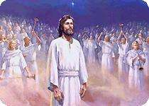

78

- We lose dominion over “things”

Psalm 8:6-8 “6 You made him to have dominion over the works of Your hands; You have put all things under his feet:
7 All sheep and oxen, yes, and the beasts of the field,
8 The birds of the air, and the fish of the sea, and whatever passes along the paths of the seas.

More clearly we now live in a place of restriction or limitation
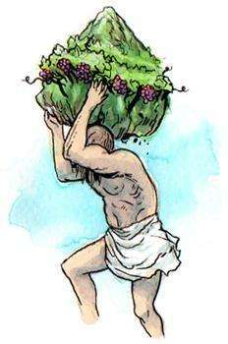

- Man is cursed to work hard, where the labour will break him down physically and cause his death over time.

Ecclesiastes 3:20 “20 All go to one place; all are of the dust, and all turn to dust again.


Ecclesiastes 2:18 “18 And I hated all my labor in which I had toiled under the sun, seeing that I must leave it to the man who will succeed me.


Ecclesiastes 4:8 “8 Here is one alone—no one with him; he neither has child nor brother. Yet there is no end to all his labor , neither is his eye satisfied with riches, neither does he ask, For whom do I labor and deprive myself of good? This is also vanity (emptiness, falsity, and futility); yes, it is a painful effort and an unhappy business.

Psalm 107:12 “12 Therefore He bowed down their hearts with hard labor; they stumbled and fell down, and there was none to help.


- The land is cursed with various limitation such as:

  - barrenness
  - weeds
  - germs

- The planets are out of alignment and

consequently impact on our lives e.g. weather conditions which are unpredictable.


Isaiah 30:26 “26 Moreover, the light of the moon will be like the light of the sun, and the light of the sun will be sevenfold, like the light of seven days [concentrated in one], in the day that the Lord binds up the hurt of His people, and heals their wound [inflicted by Him because of their sins].


79

Isaiah 35:1 -8 “1 THE WILDERNESS and the dry land shall be glad; the desert shall rejoice and blossom like the rose and the autumn crocus.

2 It shall blossom abundantly and rejoice even with joy and singing. The glory of Lebanon shall be given to it, the excellency of [Mount] Carmel and [the plain] of Sharon. They shall see the glory of the Lord, the majesty and splendor and excellency of our God.
For waters shall break forth in the wilderness and streams in the desert.
7 And the burning sand and the mirage shall become a pool, and the thirsty ground springs of water; in the haunt of
jackals, where they lay resting, shall be grass with reeds and rushes.
8 And a highway shall be there, and a way; and it shall be called the Holy Way. The unclean shall not pass over it, but it shall be for the redeemed; the wayfaring men, yes, the simple ones and fools, shall not err in it and lose their way.

Revelation 7:16 “16 They shall hunger no more, neither thirst any more; neither shall the sun smite them, nor any scorching heat.

4) We lose perfect God-consciousness.


Genesis 2:25 “25 And the man and his wife were both naked and were not embarrassed or ashamed in each other’s presence.


Genesis 3:7 “7 Then the eyes of them both were opened, and they knew that they were naked; and they sewed fig leaves together and made themselves apronlike girdles.

We now start to focus on self – the world changes from what can I do for God to what can God do for me.

5) We lose perfect self-control

From a place where Adam and Eve and all the animals lived in harmony, we change to a world where “values” have little value.

Galatians 6:5-7 “5 For every person will have to bear (be equal to understanding and calmly receive) his own [little] load [of oppressive faults]. 6 Let him who receives instruction in the Word [of God] share all good things with his teacher [contributing to his support].

7 Do not be deceived and deluded and misled; God will not allow Himself to be sneered at (scorned, disdained, or mocked by mere pretensions or professions, or by His precepts being set aside.) [He inevitably deludes himself who attempts to delude God.] For whatever a man sows, that and that only is what he will reap.

80

Man moves from considering others to lusting after that which would satisfy his appetites.
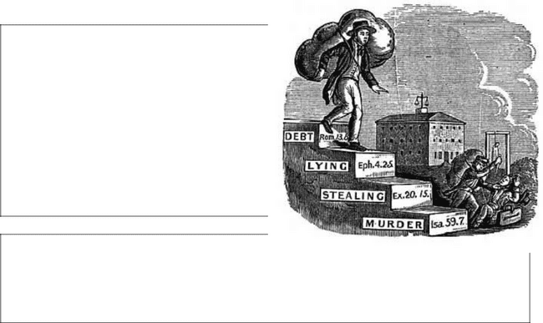

John 8:44 “44 You are of your father, the devil, and it is your will to practice the lusts and gratify the desires [which are characteristic] of your father. He was a murderer from the beginning and does not stand in the truth, because there is no truth in him. When he speaks a falsehood, he speaks what is natural to him, for he is a liar [himself] and the father of lies and of all that is false.

1 Corinthians 6:9 “9 Do you not know

that the unrighteous and the wrongdoers will not inherit or have any share in the kingdom of God? Do not be deceived (misled): neither the impure and immoral, nor idolaters, nor adulterers, nor those who participate in homosexuality,

- We lose God’s Glory

We move from a place of Gods Glory, found in the Garden of Eden, and again with the cloud and the fire in the wilderness, to a place where God’s Glory is something abnormal.
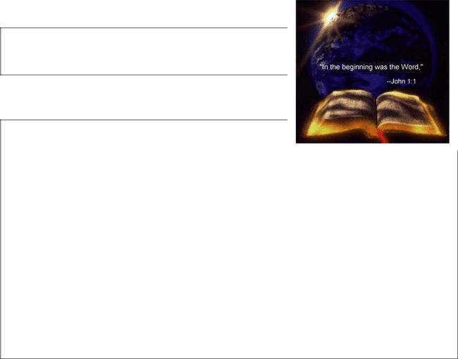

Romans 3:23 “23 Since all have sinned and are falling short of the honor and glory which God bestows and receives.

Promise of Restoration

Revelation 21:1-7 “1 THEN I saw a new sky (heaven) and a new earth, for the former sky

and the former earth had passed away (vanished), and there no longer existed any sea.
2 And I saw the holy city, the new Jerusalem, descending out of heaven from God, all arrayed like a bride beautified and adorned for her husband; 3 Then I heard a mighty voice from the throne and I perceived its distinct
words, saying, See! The abode of God is with men, and He will live (encamp, tent) among them; and they shall be His people, and God shall personally be with them and be their God.

4 God will wipe away every tear from their eyes; and death shall be no more, neither shall there be anguish (sorrow and mourning) nor grief nor pain any more, for the old conditions and the former order of things have passed away. 5 And He Who is seated on the throne said, See! I make all things new.

Also He said, Record this, for these sayings are faithful (accurate, incorruptible, and trustworthy) and true (genuine).

81

6 And He [further] said to me, It is done! I am the Alpha and the Omega, the Beginning and the End. To the thirsty I [Myself] will give water without price from the fountain (springs) of the water of Life.
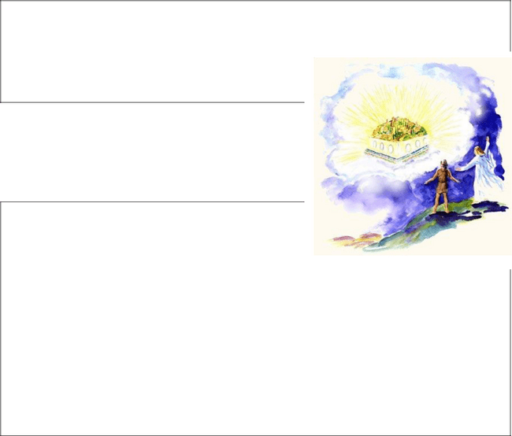
7 He who is victorious shall inherit all these things, and I will be God to him and he shall be My son.

7) We lose perfect health

We find our bodies subject to all kinds of illnesses, sicknesses and pain.

Genesis 3:16-19 “16 To the woman He said, I will greatly multiply your grief and your
suffering in pregnancy and the pangs of childbearing; with spasms of distress you

will bring forth children . Yet your desire and craving will be for your husband, and he will rule over you.
17 And to Adam He said, Because you have listened and given heed to the voice of your wife and have eaten of the tree of which I commanded you, saying, You shall not eat of it, the ground is under a curse because of you; in sorrow and toil shall you eat [of the fruits] of it all the days of your life.
18 Thorns also and thistles shall it bring forth for you, and you shall eat the plants of the field.
19 In the sweat of your face shall you eat bread until you return to the ground, for out of it you were taken; for dust you are and to dust you shall return.

Exodus 15:26 “26 Saying, If you will diligently hearken to the voice of the Lord your God and will do what is right in His sight, and will listen to and obey His commandments and keep all His statutes, I will put none of the diseases upon you which I brought upon the Egyptians, for I am the Lord Who heals you.

The Promise of Restoration

Matthew 8:17 “17 And thus He fulfilled what was spoken by the prophet Isaiah, He Himself took [in order to carry away] our weaknesses and infirmities and bore away our diseases.
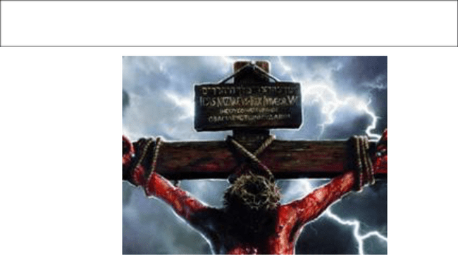

82

Revelation 22:1-3 “1 THEN HE showed me the river whose waters give life, sparkling like crystal, flowing out from the throne of God and of the Lamb
2 Through the middle of the broadway of the city; also, on either side of the river was the tree of life with its twelve varieties of fruit, yielding each month its fresh crop; and the leaves of the tree were for the healing and the restoration of the nations.
3 There shall no longer exist there anything that is accursed (detestable, foul, offensive, impure, hateful, or horrible). But the throne of God and of the Lamb shall be in it, and His servants shall worship Him [pay divine honors to Him and do Him holy service].

The Good News is: God is always looking out for His children who want to return.
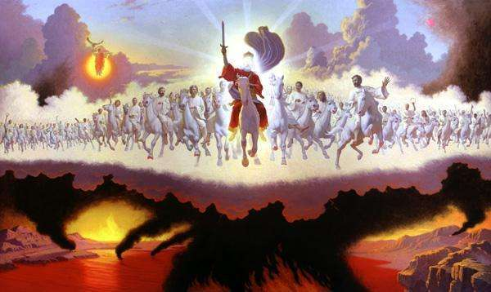

83

WHY DOES GOD RETURN TO US?

God knows the distress of my voice from “His” temple (i.e. from inside of my heart – my innermost sanctuary). He knows the most pre-mature calling of my heart.


Focus on: | Focus on:
Life – | World / Pagan on
Purpose – | Systems
Gifts | My ability
 | My talents
 | Management techniques
 | Competition

Most of us have been defined by a pagan / Greco-Roman mindset of “self”. This is almost the only role model that we ever see. Only by the deep study of the Torah / Word, will we understand God’s Purpose in terms of His standard.

84

PART 6: GOD’S PLAN OF REDEMPTION /

RESTORATION:

We see that Abraham and his descendants become known as “Hebrews” which means – “someone who has crossed over.”
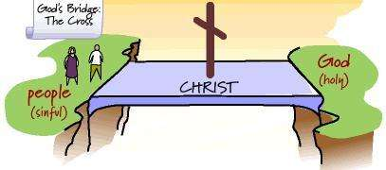

Those who have a revelation of God’s Purpose, i.e. to return / be born again and who makes the choice to walk and do what God asks of me, are those who have really “crossed over”.

“Crossed over” people are not perfect, but they have made a commitment to “return” to God and therefore they are quick to repent, to make restitution where we have caused harm, to restore relationships that we have broken.

Jonah is a member of the people called Hebrews but just as Abraham took action by faith to cross over into Canaan, so too Jonah took action to cross back into the land of a “lack of faith.”

 | Joppa
 |  | Ur
 | Jerusalem
Tarshish
Sea | Land / Place of | Desert
 | Covenant | Desert
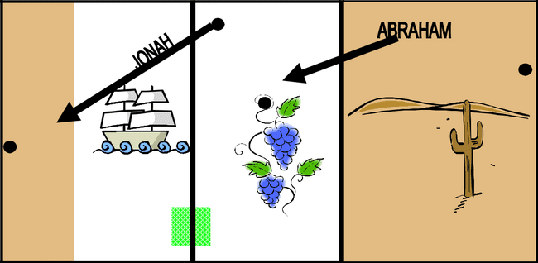

Jonah is still a Jew, so too I remain a believer, but I am living an unfulfilled life.

Note we are not talking about sin which has not been covered by repentance.

85

We are talking about someone who has rejected their God-given purpose. The greater the calling / purpose for your life, the greater will be the trial and tribulation for those who reject their purpose.

Jer. 7:23 “23 But this thing I did command them: Listen to and obey My voice, and I will be your God and you will be My people; and walk in the whole way that I command you, that it may be well with you.”


Transformation of the Sanctuary:

God had expelled man out of the first sanctuary.

God wants to dwell with His people.

Ex. 25:8 “8 Let them make Me a sanctuary, that I may dwell among them.”


The Priceless Gift of Atonement:


We know that God gave the Israelites a gift of atonement – this was the blood of an animal that took on the guilt of the individual.

When Yeshua dies at Golgotha, His Blood is not only the redemption from sin but an ongoing, permanent atonement or our frail humanity.
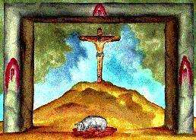

Contrary to much of modern day Church teaching that God’s GRACE is a New Testament revelation we see evidence of God’s GRACE in the Garden of Eden – the Garden of Delight.

Example 1: ADAM AND EVE
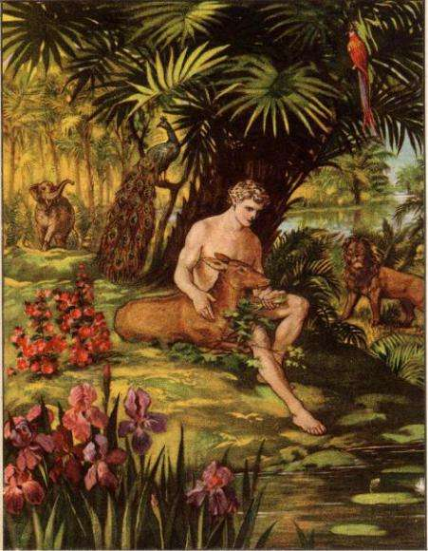

Man is placed in the Garden:

Gen 2:15 “15 And the Lord God took the man and put him in the Garden of Eden to tend and guard and keep it.”


The Commandment is given to Man

Gen 2:16-17 ”16 And the Lord God commanded the man, saying, You may freely eat of every tree of the garden;

17 But of the tree of the knowledge of good and evil and blessing and calamity you shall not eat, for in the day that you eat of it you shall surely die.”

86

Adam and Eve sin by disobeying God and listening and obeying the serpent.

We see three types of sin:

- Eve commits the sin of adding her own interpretation to God’s Word – the Rabbis say:

“You build a fence around the Torah/Word”.

We must always be careful how much weight we place on man’s interpretations as these can lead us astray.
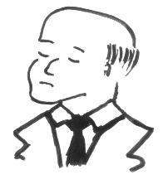

- Adam commits the sin of compromise, he choose not to take up his robe of “dominion” and authority over the Garden.

Adam and Eve are immediately aware of the breakdown in their level of intimacy with God.

3. Self-effort to make the matter right

Gen 3:7 “7 Then the eyes of them both were opened, and they knew that they were naked; and they sewed fig leaves together and made themselves apronlike girdles.”

I.e. Works of the flesh will always be of no value.

God however sees their effort of repentance and institutes the principle of Atonement by the blood of an innocent animal to clothe them with skin.

Gen 3:21 ”21 For Adam also and for his wife the Lord God made long coats (tunics) of skins and clothed them.”
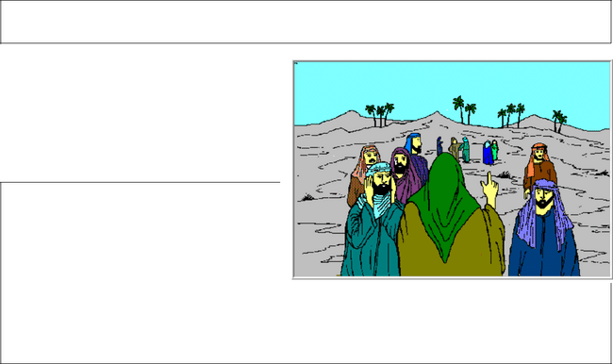

Example 2: NOAH

The Torah/Word tells us that the state of affairs in the world had become very bad.

Gen. 6:11 -12 “11 The earth was depraved and putrid in God’s sight, and the land was filled with violence (desecration, infringement, outrage, assault, and lust for power).

12 And God looked upon the world and saw how degenerate, debased, and vicious it was, for all humanity had corrupted their way upon the earth and lost their true direction.”

87

We find three descriptive phrases to describe what was happening:

- The world was “corrupt”:


“Corrupt” in Hebrew Strongs 7843 and means:

- sexual immorality

- idolatry

- The world was filled with “violence”:

“Violence” in Hebrew Strongs 2555 and means:
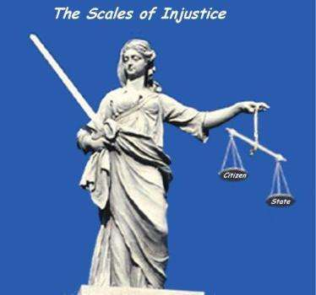

- cruelty

- oppression
- injustice
- Filled to the brim/maximum, it could not get any worse.

- The world was “perverted”:

“Perverted” in Hebrew Strongs 7843 and means:

- That it was so bad that it was about to be completely destroyed.

BUT


Noah is a “righteous” man

Gen 6:9 “9 This is the history of the generations of Noah. Noah was a just and righteous man, blameless in his [evil] generation; Noah walked [in habitual fellowship] with God.”


This does not mean that he was perfect and without sin.

It means that he was justified, he had repented of sin so that there was no blemish on him which had not been atoned for, forgiven, cleansed and washed away.

This righteousness was based on the fact that Noah passionately worshipped God.

Gen 6:9(b) “9 …blameless in his [evil] generation; Noah walked [in habitual fellowship] with God.”

88

God’s GRACE is poured out once again in the Old Testament. God decides to destroy the world BUT save the remnant – He tells Noah to build an ARK.

God tells Noah what to use to make the ARK, the ark was made of gofer wood and pitch:

The Hebrew word for “Gopher wood” is “atsei-gfer”.

The Hebrew word for “Pitch” is “kofer”.

What is amazing is the meaning of these root words.
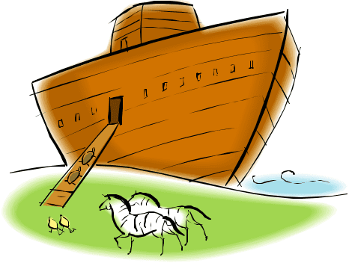

The root word for Gopher wood = g’far

The root word for Pitch = kafar

G’far means “to house”.

Kafar means “atonement – the covering of sins”.

The Ark was therefore:

“A Household of Atonement”.

God’s grace has no end – He finally sent the Lamb of God when Yeshua died on the Cross at Calvary.

††††††††††††††

At this stage of this study you must sit back, reflect on what you have read/heard and ask yourself where you are on God’s path of purpose,

calling and destiny.

The Torah/Bible tells us that God’s perspective of Noah was a man who listened and obeyed (Sh’ma”) God’s Words – he was righteous.

Gen 6:9 “9 This is the history of the generations of Noah. Noah was a just and righteous man, blameless in his [evil] generation; Noah walked [in habitual fellowship] with God.”

More importantly the Word describes Noah as “blameless”.

The common understanding today is someone who is sinless, without fault, perfect.

This is not the message of Noah.

The Hebrew word for blameless is “tamim” and comes from the root word “taman”.

89

This word has the meaning:

- Whole heartedly
- Totally utilized

God has placed you on earth at this time, gave you gifts to be revealed to the Body of Messiah as your “calling/destiny”.

In addition you have been blessed with “talents” to make your life’s journey with ease.

You may have experienced many times of difficulties, trials, tribulations, wounding, a lack of parental blessing, etc

BUT

You have to make the choice to choose life.


Deut. 30:19 “19 I call heaven and earth to witness this day against you that I have set before you life and death, the blessings and the curses; therefore choose life, that you and your descendants may live”

The question is if God were to stand before you today would He find you totally utilized?

Paul completed the race; his life was in totality complete:

2 Tim. 4:7 “I have fought the good (worthy, honorable, and noble) fight, I have finished the race, I have kept (firmly held) the faith.”

90

What does God want you to do?

Every time a day of celebration / feast appears on God’s calendar, God wants:
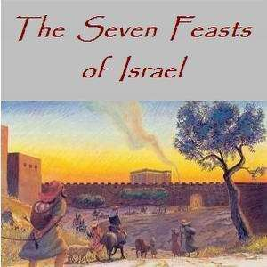

- His people to find Him again – to rediscover new Light of Revelation.

- His people to draw down on new spiritual resources that were not available the year before.

- God wants us to live each year / time as a unique gift with its own potential for destiny.

We have already seen that the main focus for me as individual is to reconcile and return to my original purpose – to take dominion – this implies that I do what God has set out for me to do².

I will have robbed the Body of Messiah:

- If I have never really discovered my purpose;

- If I have walked in my divine purpose but for some reason I have deviated from the course;

- If I have prevented others from living out their divine purpose;
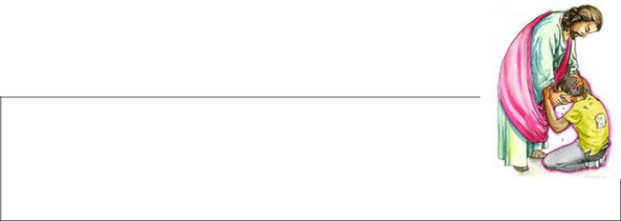

I therefore use this time of repentance and soul searching to move closer to God and by reaching up into God’s Kairos Time I am empowered to see what plans God has for me.

Prov.16:3, 9 “3 Roll your works upon the Lord [commit and

trust them wholly to Him; He will cause your thoughts to become agreeable to His will, and] so shall your plans be established and succeed.

9 A man’s mind plans his way, but the Lord directs his steps and makes them sure.”

Is. 25:1 “1 O LORD, You are my God;; I will exalt You, I will praise Your

name, for You have done wonderful things, even purposes planned of old [and fulfilled] in faithfulness and truth.”

- Note: We are speaking to people who have already chosen God as the only One and True God, i.e. those who are born-again and who regularly make sure that they have repented of sin.

91

God’s plans for you will reflect streams of water, oil and gold flowing from the source of life.


- Water: a reflection of how the Torah / Word of God should be manifested in my walk of obedience to God’s Commandments.

- Oil: a reflection of my obedience to the direction of the Holy Spirit.

- Gold: a reflection of the way in which I represent

God’s authority and glory here on earth.


ARE YOU:

- A pagan / unbeliever, someone outside of the terms of the covenant?

OR

- A believer that is in right standing with God but not living in obedience to your purpose / destiny in the Body of Messiah?

The Israelites had:
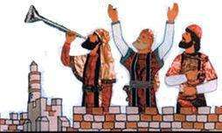

- accepted a Covenantal relationship with God at Mount Sinai

- Promised to carry God’s Image to the nations.

- Accepted God’s Word / Torah as the basis for their lifestyle, (i.e. their value system differentiated them from the world) so that they would be the Light of revelation that would draw men to God.

92

Jonah – The Man Who Deviated from His God-Given Purpose:


In this short analysis we focus only on men and women who have either never discovered their God-given purpose or have sometimes made a free-will choice to walk on a different path – one away from God’s purpose for them.

I am created for a purpose:

- My life and talents will be used in the service to the King, to make

this world a place where God’s Glory can return.


Evidence of this mandate from God is:

a) Man has the ability to create – every single seed that he sows into the soil will produce a harvest.

b) Man has the ability to differentiate – we can distinguish between:

- good and bad
- right and wrong

All the rest of God’s Creation can only produce after their own kind.

Not only am I created for a purpose BUT I am unique:

Nobody will have my purpose or the skills and talents to achieve what I am called for.

BUT:

- I will need to develop / draw this gift out

- I will need to cut through the deceit of my heart so that I will see myself as I am.

- I will need to accept that I will / must be different in order that other believers can be what they need to be.

Many believers, followers of the Messiah, live life with a great deal of frustration, anxiety and pain. They may even be quite “successful” in the day to day things of the world, but continue to search for some higher / hidden / unknown purpose.

93

This could arise from one of two reasons:

- I don’t know what God wants me to do.

OR

- I am running away from God’s Purpose for my life. Such was the case with Jonah.
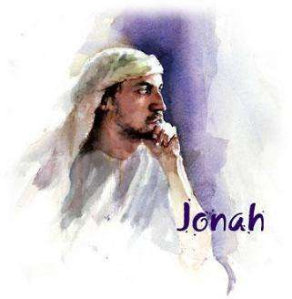
Who is Jonah³?

Jonah’s name is given as “Ben Amittai” which means “Son of Truth”.

Elijah and the Widow

The Bible tells us that Elijah goes to see / stay with a widow in Zarepath. The widow only had a small bit of flour and a bit of oil. Elijah asks her to allow him to eat first and promises that they will not go hungry.

The son of the widow becomes sick and dies. Elijah goes to pray, stretches himself over the child three times and brings him back to life.

The woman answers:

1 Kings 17:24 “…By this I know that you are a man of God and that the word of the Lord in your mouth is truth.”

- The sages believe that this young boy was Jonah, and that he lived and walked in Elijah’s prophetic school.

- History then takes us to the story of “one of the sons of the prophets” who gets given the job to anoint Jehu as King;

2 Kings 9:1, 3, 4, 6 “1 AND ELISHA the prophet called one of the sons of the prophets and said to him, Gird up your loins, take this flask of oil in your hand, and go to Ramoth-gilead.
2 Kings 9:3 “3 Then take the cruse of oil and pour it on his head and say, Thus says the Lord: I have anointed you king over Israel. Then open the door and flee; do not tarry.

4 So the young man, the young prophet, went to Ramoth-gilead.

- For a more in-depth study on the life of Jonah, see book Yom Kippur: Reflections on the Life of Jonah available from Kanaan Ministries.

94

2 Kings 9:6 “6 And Jehu arose, and they went into the house. And the prophet poured the oil on Jehu’s head and said to him, Thus says the Lord, the God of Israel: I have anointed you king over the people of the Lord, even over Israel.”

2 Kings 10:30 “30 And the Lord said to Jehu, Because you have executed well what is right in My eyes and have done to the house of Ahab as I willed, your sons to the fourth generation shall sit on Israel’s throne. [Fulfilled in II Kings 15:12.]”
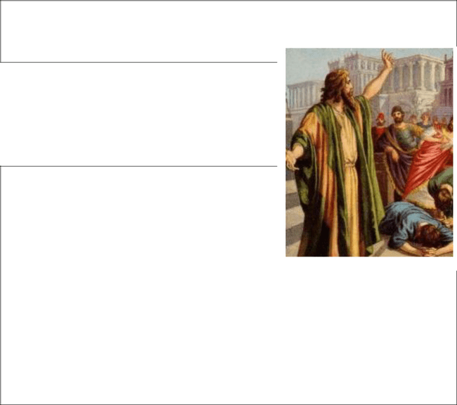

- We see further evidence of Jonah’s anointing as prophet. We find that he gives an “unrighteous king” a message from God. The King does what he is told and extends the borders of the land:

2 Kings 14:23-27 “23 In the fifteenth year of Amaziah son of Joash king of Judah Jeroboam
- son of Jehoash king of Israel began to reign in Samaria, and reigned forty-one years.
24 He did evil in the sight of the Lord; he did not depart from all the sins of Jeroboam [I] son of Nebat, with which he made Israel to sin.

25 Jeroboam restored Israel’s border from the entrance of Hamath to the [Dead] Sea of the Arabah, according to the word of the Lord, the God of Israel, which He spoke through His servant Jonah son of Amittai, the prophet from Gath-hepher.

26 For the Lord saw as very bitter the affliction of Israel; there was no one left, bond or free, nor any helper for Israel.
27 But the Lord had not said that He would blot out the name of Israel from under the heavens, so He saved them by the hand of Jeroboam [II] son of
Jehoash.”

95

LET’S SUMMARIZE WHAT WE HAVE UNTIL NOW:

We can say that Jonah was “reborn”, given a new / second chance at life; we can see that he has been blessed with talents and gifts, i.e. he operates as a prophet.
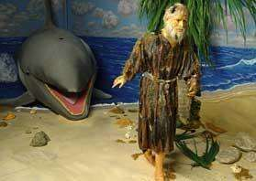

It is also clear that he has found his purpose / destiny in life.

He has given his life to serve the King of Kings.

Definition of Destiny:

We can say that destiny is the choice / option that we make to live our life focused on God’s needs.

The choice that we all make is this:

- Wide is the gate and wide the path to destruction;

OR
- Straight is the gate and narrow is the way to life;

Gal. 6:7-8 “7 Do not be deceived and deluded and misled; God will not allow Himself to be sneered at (scorned, disdained, or mocked by mere pretensions or professions, or by His precepts being set aside.) [He inevitably deludes himself who attempts to delude God.] For whatever a man sows, that and that only is what he will reap.
8 For he who sows to his own flesh (lower nature, sensuality) will from the flesh reap decay and ruin and destruction, but he who sows to the Spirit will from the Spirit reap eternal life.”

Deut. 30:15 “15 See, I have set before you this day life and good, and death and evil.”

Matt. 7:13-14 “13 Enter through the narrow gate; for wide is the gate and spacious and broad is the way that leads away to destruction, and many are those who are entering through it.
14 But the gate is narrow (contracted by pressure) and the way is straitened and compressed that leads away to life, and few are those who find it.”

We need to understand that the narrowness of the way is not a reflection of difficulty or problems but rather a reflection of our obedience or the lack thereof to the task at hand.

A lifestyle of repentance therefore keeps us on the narrow way.

96

Truth: the path to Salvation is narrow – there is only one:
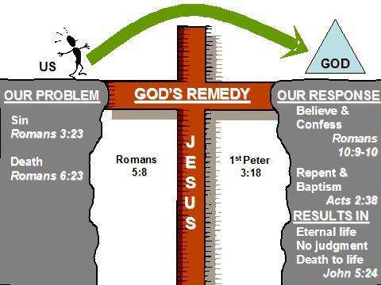

- accept Yeshua by faith

- And the keeping of a continual lifestyle of repentance.

What happens to Jonah?

We indicated earlier that the feasts

point to the future fulfilment of
God’s Plan on one hand while on
the other they give us a clear
message of what we are to do /
how we are to live in order to stay

on the narrow way to God’s pleasure.

Pentecost / Shavuot empowers us, by the implanted Torah / Word of God into our hearts, by the discernment in our spirit provided by the Holy Spirit, to live a life of obedience as a Priest and a Holy Nation.

As this priest – Jonah and I – move off towards our corporate purpose of being restored to our full potential so that we can rule

and reign with Yeshua, i.e. to take dominion.

What is your name? Do you know what you have been called to do?

What is the Truth that you must “light” to the world?

To fulfil my purpose and destiny, I need to identify my

gift, develop this gift to its fullest potential and use this gift to impact the Bride of Messiah.

2 Thess. 1:11-12 “11 With this in view we constantly pray for you, that our God may deem and count you worthy of [your] calling and [His] every gracious purpose of goodness, and with power may complete in [your] every particular work of faith (faith which is that leaning of the whole human personality on God in absolute trust and confidence in His power, wisdom, and goodness).
12 Thus may the name of our Lord Jesus Christ be glorified and become more glorious through and in you, and may you [also be glorified] in Him according to the grace (favor and blessing) of our God and the Lord Jesus Christ (the Messiah, the Anointed One).”

2 Tim. 1:8-9 “8 Do not blush or be ashamed then, to testify to and for our Lord, nor of me, a prisoner for His sake, but [with me] take your share of the suffering [to which the preaching] of the Gospel [may expose you, and do it] in the power of God.

97

9 [For it is He] Who delivered and saved us and called us with a calling in itself holy and leading to holiness [to a life of consecration, a vocation of holiness]; [He did it] not because of anything of merit that we have done, but because of and to further His own purpose and grace (unmerited favor) which was given us in Christ Jesus before the world began [eternal ages ago].”

2 Pet. 1:10 “10 Because of this, brethren, be all the more solicitous and eager to make sure (to ratify, to strengthen, to make steadfast) your calling and election; for if you do this, you will never stumble or fall.”

Can we better define the Word “Purpose”?


We know that we are created in God’s Image. We know that we have been given gifts.

We know that we have been given a “calling”.

Rom. 11:29 “29 For God’s gifts and His call are irrevocable. [He never withdraws them when once they are given, and He does not change His mind about those to whom He gives His grace or to whom He sends His call.]”

Calling – Greek Strongs 2821 κλη̂ σις klē sis:

has the meaning of:

- to be called forth

OR

- an invitation.

So what are we invited / called forth to be? Our Purpose!!


Purpose – Hebrew Strongs 2803 בשָׁחַ chashab:

Which means to:

-

-
-

weave;

plait / interpenetrate;

to fabricate.

Prov. 15:22 “22 Where there is no counsel, purposes are frustrated, but with many counselors they are accomplished.”

Prov. 20:18 “18 Purposes and plans are established by counsel;; and [only] with good advice make or carry on war.”

98


Nugget of Truth: We therefore have to take our Redemptive gift and weave / plait it into the Body of Messiah in such a way so as to ensure that the whole Body is strengthened / purified.


Eccl. 3:1, 17 “1 TO EVERYTHING there is a season, and a time for every matter or purpose under heaven:
17 I said in my heart, God will judge the righteous and the wicked, for there is a time [appointed] for every matter and purpose and for every work.”

Purpose: Hebrew Strongs 2656 ץֶפֵח chephets (343a); from 2654a; delight,

pleasure:— care(1), delight(8), delightful(2), delights(1), desirable things(1), desire(10), desired(2), event(1), good pleasure(3), matter(1), pleased(1), pleasure(3), precious(1), sight(1), undesirable*(2), what you desire(1).

Nugget of Truth: It tells us that we each have a specific unique time allocated to us to perform God’s Will on earth.

Rom. 8:28 “28 We are assured and know that [God being a partner in their labor] all things work together and are [fitting into a plan] for good to and for those who love God and are called according to [His] design and purpose.”

Rom. 9:11 “11 And the children were yet unborn and had so far done nothing either good or evil. Even so, in order further to carry out God’s purpose of selection (election, choice), which depends not on works or what men can do, but on Him Who calls [them],”

Purpose: Greek Strongs 4286 πρόθεσις prothesis:

which means to:

- set forth
- make a proposal.

Nugget of Truth: It tells us that we have a unique / specific purpose to reveal our redemptive gift in the same way that the “showbread in the temple is exposed to God”.


Let’s study the path to a purposeful life:

- Define the gifts and identify which gift you need to light to the world.

- Obtain God’s and your father’s blessing in life to flow in this anointing.

- Renew your inner-man to walk in dominion reflecting the fullness of your gifting.

99

PART 7: HOW DO WE DIFFERENTIATE BETWEEN THE GIFTS OF THE FATHER, GIFTS OF YESHUA (FIVE-FOLD MINISTRY) AND GIFTS OF THE HOLY SPIRIT?

We have already seen that God has created us for a purpose / destiny. He places inside us, at conception, at least two of the redemptive gifts which will be that aspect of the Bride of Messiah that you are called and anointed to manifest in reflecting God’s Love to your neighbour..

We need to clarify the various terminologies used:

- FIVE-FOLD MINISTRY (OFFICE) is about WALKING IN RULERSHIP.


Certain believers are called to walk in positions of governance.

Eph. 4:11-13 “11 And His gifts were [varied; He Himself appointed and gave men to us] some to be apostles (special messengers), some prophets

(inspired preachers and expounders), some evangelists (preachers of the Gospel, traveling missionaries), some pastors (shepherds of His flock) and teachers.
12 His intention was the perfecting and the full equipping of the saints
(His consecrated people), [that they should do] the work of ministering toward building up Christ’s body (the church),

13 [That it might develop] until we all attain oneness in the faith and in the comprehension of the [full and accurate] knowledge of the Son of God,

that [we might arrive] at really mature manhood (the completeness of personality which is nothing less than the standard height of Christ’s own

perfection), the measure of the stature of the fullness of the Christ and the completeness found in Him.”

This represents standing in a full time ministry, recognised by the outpouring of God’s gift to give direction to the Body of Messiah.

It is clear the person is the one “gifted” for the purpose of equipping the other saints.

- The Gifts of the Holy Spirit is the flow of the Holy Spirit’s leading which I allow to benefit mankind.

1 Cor. 12:4-12 “4 Now there are distinctive varieties and distributions of endowments (gifts, extraordinary powers distinguishing certain Christians, due to the power of divine grace operating in their souls by the Holy Spirit) and they vary, but the [Holy] Spirit remains the same.


100

5 And there are distinctive varieties of service and ministration, but it is the same Lord [Who is served].
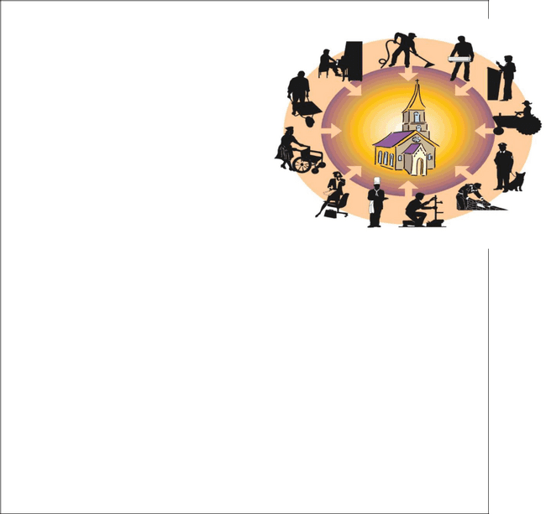
6 And there are distinctive varieties of operation [of working to accomplish things], but it is the same God Who inspires and energizes them all in all.

7 But to each one is given the manifestation of the [Holy] Spirit [the evidence, the spiritual illumination of the Spirit] for good and profit.

- 8 To one is given in and through the [Holy] Spirit [the power to speak] a

message of wisdom,
- and to another [the power to express] a word of knowledge and
understanding according to the same [Holy] Spirit;
- 9 To another [wonder-working] faith by the same [Holy] Spirit,
- to another the extraordinary powers of healing by the one Spirit;
- 10 To another the working of miracles,
- to another prophetic insight (the gift of interpreting the divine will and purpose);
- to another the ability to discern and distinguish between [the utterances of true] spirits [and false ones], to another various kinds of [unknown] tongues,
- to another the ability to interpret [such] tongues.
11 All these [gifts, achievements, abilities] are inspired and brought to pass by one and the same [Holy] Spirit, Who apportions to each person individually [exactly] as He chooses.
12 For just as the body is a unity and yet has many parts, and all the
parts, though many, form [only] one body, so it is with Christ (the Messiah, the Anointed One).”

(See also 1 Cor. 14)

This represents the supernatural interaction between:

- God and man,

- Man and the Body of Messiah
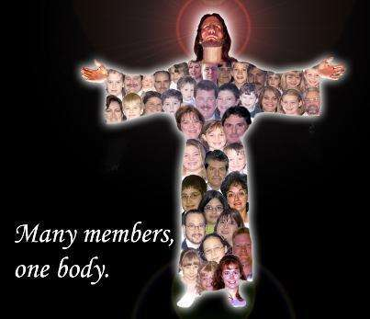

at a specific time and specific set of circumstances as the Holy Spirit works through a believer.

In many cases the manifestation of this gift will have a direct / beneficial outworking on the individual himself.

101

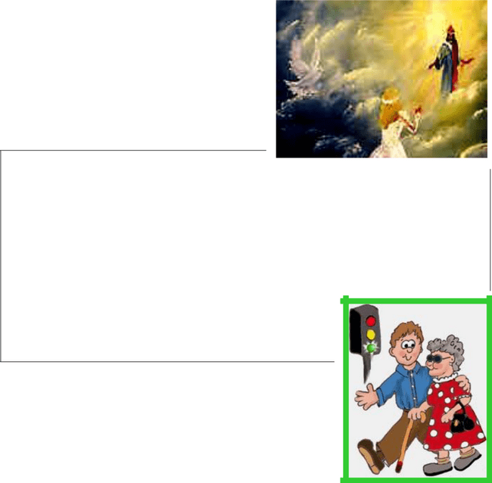
- The Gifts of the Father are given in order that I can go about fulfilling my purpose so that the Bride of Messiah is drawn closer in intimacy with God.

Rom. 12:6-8 “6 Having gifts (faculties,

talents, qualities) that differ according to the grace given us, let us use them: [He whose gift is] prophecy (PROPHET), [let him prophesy] according to the proportion of his faith;
7 [He whose gift is] practical service (SERVANT), let him give himself to serving; he who teaches (TEACHER), to his teaching;
8 He who exhorts (encourages) (EXHORTER), to his exhortation; he who contributes (GIVER), let him do it in simplicity and liberality; he who gives aid and superintends (RULER),

with zeal and singleness of mind; he who does acts of mercy (MERCY), with genuine cheerfulness and joyful eagerness.”

The gift / gifts that make up my DNA, define what God has destined me to be – that “part” reflection of God’s full Glory.

As each one of the gifts unite in the Body of Messiah, we cause the “Radiance” that will reflect the One True

God, i.e. each one specific gift or colour is needed to create the whole “rainbow”.

We have made a short summary of some of the attributes of each gift so that you can better identify who you are supposed to be.

102

PART 8: THE PATH TO A PURPOSE-FILLED LIFE

- OBTAIN AN UNDERSTANDING OF WHAT GOD’S REDEMPTIVE GIFTS

ARE AND WHICH AREA OF CALLING GOD HAS ELECTED FOR ME TO REVEAL TO THE BODY OF MESSIAH.

WHAT ARE THE MOTIVATIONAL / REDEMPTIVE GIFTS? HOW DO I IDENTIFY MY GIFT AND PLACE IN THE BODY OF MESSIAH?

Everyone has a redemptive gift (i.e. at least 2-3 gifts which will be your major “job” in life to use / to fit into and form the entire complete body of Messiah.

I have a Gift:

1 Pet. 4:10 “10 As each of you has received a gift (a particular spiritual talent, a gracious divine endowment), employ it for one another as [befits] good trustees of God’s many-sided grace [faithful stewards of the extremely diverse powers and gifts granted to Christians by unmerited favor].”

There are seven of these motivational / redemptive gifts. Which one is your special focus? What are you called to do as an area of ministry? Where do you fit into the Body of Messiah?

Rom. 12:4-8 “4 For as in one physical body we have many parts (organs, members) and all of these parts do not have the same function or use,

5 So we, numerous as we are, are one body in Christ (the Messiah) and individually we are parts one of another [mutually dependent on one another].
6 Having gifts (faculties, talents, qualities) that differ according to the grace given us, let us use them: [He whose gift is] prophecy (PROPHET), [let him prophesy] according to the proportion of his faith;
7 [He whose gift is] practical service (SERVANT), let him give himself to serving; he who teaches (TEACHER), to his teaching;
8 He who exhorts (encourages) (EXHORTER), to his exhortation; he who contributes (GIVER), let him do it in simplicity and liberality; he who gives aid and superintends (RULER), with zeal and singleness of mind; he who does acts of mercy (MERCY), with genuine cheerfulness and joyful eagerness.”

This gift was woven / built into you at the moment of creation in the womb – the gift is not by chance, but by specific proclamation of God.

103

Ps. 139:13-16 “13 For You did form my inward parts; You did knit me together in my mother’s womb.

14 I will confess and praise You for You are fearful and wonderful and for the awful wonder of my birth!

Wonderful are Your works, and that my inner self knows right well.
15 My frame was not hidden from You when I was being formed in secret [and] intricately and curiously wrought [as if embroidered with various colors] in the depths of the earth [a region of darkness and mystery]. 16 Your eyes saw my unformed substance, and in Your book all the days [of my life] were written before ever they took shape, when as yet there was none of them.”

The purpose of this Word study is to highlight that we have a unique purpose, that God ordained that fathers and mothers would identify this gift from an early age.

Prov. 22:6 “6 Train up a child in the way he should go [and in keeping with his individual gift or bent], and when he is old he will not depart from it.”

Parents who correctly recognize the unique set of gifts will go about the process of:


- Developing that attribute.

- Guarding against hurts which could wound the child.
- Dealing with generational issues that could restrain the child from the fullness of the victory.
- Encouraging the outflow of the gifts into the Body of Messiah.

Every individual is accountable for the gifts / talents that we have been given. We are warned not to neglect the gift:

1 Tim. 4:14 “14 Do not neglect the gift which is in you, [that special inward endowment] which was directly imparted to you [by the Holy Spirit] by prophetic utterance when the elders laid their hands upon you [at your ordination].”

Luke 12:48 “48 But he who did not know and did things worthy of a beating shall be beaten with few [lashes]. For everyone to whom much is given, of him shall much be required; and of him to whom men entrust much, they will require and demand all the more.”

104

God declares that we are all equal – we are one before Him – the only One God.

Deut. 6:4 “4 Hear, O Israel: the Lord our God is one Lord [the only Lord].”

Since we are all equal but have different gifts, we must recognize that every gift will have equal value in God’s eyes.

Paul clearly says that we are “parts” of One Body – that we are mutually dependant on each other.

Rom. 12:4-5 “4 For as in one physical body we have many parts (organs, members) and all of these parts do not have the same function or use,
5 So we, numerous as we are, are one body in Christ (the Messiah) and individually we are parts one of another [mutually dependent on one another].”

Ezekiel, the prophet describes how the Body of Messiah will be a restored united army.

Ezek. 37:5-14 “5 Thus says the Lord God to these bones: Behold, I will cause breath and spirit to enter you, and you shall live;

6 And I will lay sinews upon you and bring up flesh upon you and cover you with skin, and I will put breath and spirit in you, and you [dry bones] shall live; and you shall know, understand, and realize that I am the Lord [the Sovereign Ruler, Who calls forth loyalty and obedient service].
7 So I prophesied as I was commanded; and as I prophesied, there was a [thundering] noise and behold, a shaking and trembling and a rattling, and the bones came together, bone to its bone.
8 And I looked and behold, there were sinews upon [the bones] and flesh came upon them and skin covered them over, but there was no breath or spirit in them.
9 Then said He to me, Prophesy to the breath and spirit, son of man, and say to the breath and spirit, Thus says the Lord God: Come from the four winds, O breath and spirit, and breathe upon these slain that they may live. 10 So I prophesied as He commanded me, and the breath and spirit came into [the bones], and they lived and stood up upon their feet, an exceedingly great host.
11 Then He said to me, Son of man, these bones are the whole house of Israel. Behold, they say, Our bones are dried up and our hope is lost; we are completely cut off.
12 Therefore prophesy and say to them, Thus says the Lord God: Behold, I will open your graves and cause you to come up out of your graves, O My people; and I will bring you [back home] to the land of Israel.

13 And you shall know that I am the Lord [your Sovereign Ruler], when I have opened your graves and caused you to come up out of your graves, O My people.

105

14 And I shall put My Spirit in you and you shall live, and I shall place you in your own land. Then you shall know, understand, and realize that I the Lord have spoken it and performed it, says the Lord.”

So we now see that every single one of us have a unique gift and must fit into a Body of other Believers to be the Army of God.

Let us verify that each motivation / redemptive gift is connected to a part of the physical body.


- The prophet – is the one that must see the way in which God’s principles of design can be made operational, i.e. the prophet is the eye.

Matt. 6:22-23 “22 The eye is the lamp of the body. So if your eye is sound, your entire body will be full of light.

23 But if your eye is unsound, your whole body will be full of darkness. If then the very light in you [your conscience] is darkened, how dense is that darkness!”
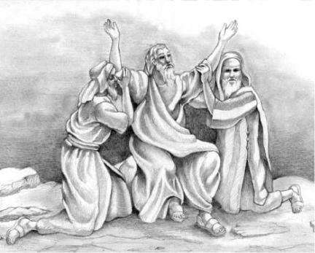

- The Servant – must reach out to others in need, must hold up the hands of those in leadership, i.e. the servant is the hands.

Prov. 31:20 “20 She opens her hand to the poor, yes, she reaches out her filled hands to the needy [whether in body, mind, or spirit].”



3. The Teacher – must have a mind to apply to study and collate the facts.

Acts 17:11 “11 Now these [Jews] were better disposed and more noble than those in Thessalonica, for they were entirely ready and accepted and welcomed the message [concerning

the attainment through Christ of eternal salvation in the kingdom of God] with inclination of mind and eagerness, searching and examining the Scriptures daily to see if these things were so.”

106

4. The Exhorter – has the power over suffering and therefore has the ability to speak into the lives of others – the mouth.


Acts 13:15 “15 After the reading of the Law and the Prophets, the leaders [of the worship] of the synagogue sent to them saying, Brethren, if you have any word of exhortation or consolation or encouragement for the people, say it.”


5. The Giver – has the ability to use his

strength / wisdom / initiative to build
generational wealth – the arms.

Luke 1:51 “51 He has shown strength and

made might with His arm; He has scattered the proud
and haughty in and by the imagination and purpose and designs of their hearts.”

Is. 51:9 “9 [Zion now cries to the Lord, the God of Israel] Awake, awake, put on strength and might, O arm of the Lord; awake, as in the ancient days, as in the generations of long ago. Was it not You Who cut Rahab [Egypt] in pieces, Who pierced the dragon [symbol of Egypt]?”

- The Ruler – has the gift to call people to a vision, to organize and manage a project to completion – the shoulders.
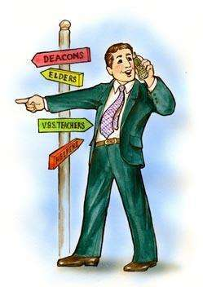

Is. 9:6 “6 For to us a Child is born, to us a Son is given; and the government shall be upon His shoulder, and His name shall be called Wonderful Counselor, Mighty God, Everlasting Father [of Eternity], Prince of Peace.”


- The Mercy – has a heart for the broken and the hurt.

Isaiah 61:1-3 “1 THE SPIRIT of the Lord God is upon me, because the Lord
has anointed and qualified me to preach the Gospel of good
tidings to the meek, the poor, and afflicted; He has sent me to
bind up and heal the brokenhearted, to proclaim liberty |  | to
the [physical and spiritual] captives and the opening of
the prison and of the eyes to those who are bound,


107

We are placed in One Body where God wants us to function:


Each gift correlates to one of the parts of the armour of God .

This reveals the area of warfare where we have given the greatest potential strengths to war on behalf of the Body of Messiah, but also the area where our individual weakness will also cause the most damage to the Body of Messiah.

Eph. 6:10-18: “10 In conclusion, be strong in the Lord [be empowered through your union with Him]; draw your strength from Him [that strength which His boundless might provides].

11 Put on God’s whole armor [the armor of a heavy -armed soldier which God supplies], that you may be able successfully to stand up against [all] the strategies and the deceits of the devil.
12 For we are not wrestling with flesh and blood [contending only with physical opponents], but against the despotisms, against the powers, against [the master spirits who are] the world rulers of this present darkness, against the spirit forces of wickedness in the heavenly (supernatural) sphere.

13 Therefore put on God’s complete armor, that you may be able to resist and stand your ground on the evil day [of danger], and, having done all [the crisis demands], to stand [firmly in your place].

14 Stand therefore [hold your ground],
- Prophet: having tightened the belt of truth around your loins
- Servant: and having put on the breastplate of integrity and of moral rectitude and right standing with God,
- Teacher: 15 And having shod your feet in preparation [to face the enemy with the firm-footed stability, the promptness, and the readiness produced by the good news] of the Gospel of peace.
- Exhorter: 16 Lift up over all the [covering] shield of saving faith, upon which you can quench all the flaming missiles of the wicked [one].
- Giver:17 And take the helmet of salvation
- Ruler: and the sword that the Spirit wields, which is the Word of God.
- Mercy: 18 Pray at all times (on every occasion, in every season) in the Spirit, with all [manner of] prayer and entreaty. To that end keep alert and watch with strong purpose and perseverance, interceding in behalf of all the saints (God’s consecrated people).”

108

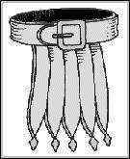
- Prophet: having tightened the belt of truth around your loins

The prophet speaks to declare the truth of God’s design and purposes into every situation as a benchmark for the believer to use as a point of reference in being restored.
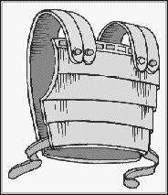

- Servant: and having put on the breastplate of integrity and of moral rectitude and right standing with God,

The Servant will use the authority to hold up and restore leadership to a place of right standing.

- Teacher: 15 And having shod your feet in preparation [to face the enemy with the firm-footed stability, the promptness, and the readiness produced by the good news] of the Gospel of peace.
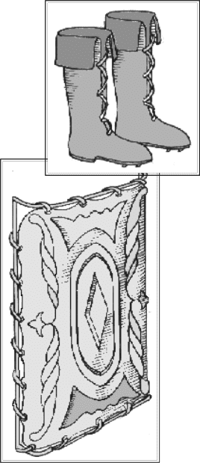

The Teacher will study, organize and present an ongoing revelation of the heart of God.

- Exhorter: 16 Lift up over all the [covering] shield of saving faith, upon which you can quench all the flaming missiles of the wicked [one].

The Exhorter will – after hearing from God – speak the word of direction and life into people’s situations and pain so that they can return to God.

- Giver:17 And take the helmet of salvation

The Giver will recognize and know that God is the Provider of all good things and will use his blessing to manifest God’s will to change the lives of others.
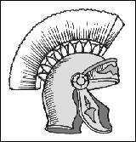

- Ruler: and the sword that the Spirit wields, which is the Word of God.
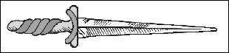

The Ruler will take the authority and courage to lead others on a path of empowerment and to a place of victory.
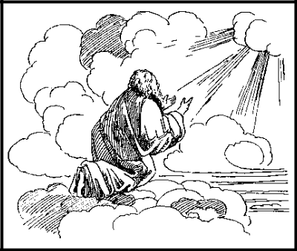

- Mercy: 18 Pray at all times (on every occasion, in every season) in the Spirit, with all [manner of] prayer and entreaty. To that end keep alert and watch with strong purpose and perseverance, interceding in behalf of all the saints (God’s consecrated people).

109

The Mercy will implement the Heart of God in acts of compassion to all hurt and wounded people, bringing an offer of worship.

Rom. 12:4-8 | Eph. 6:10-18
Prophet | Truth-girded belt
Servant | Breastplate of righteousness
Teacher | Shoes of peace
Exhorter | Shield of faith
Giver | Helmet of Salvation
Ruler | Sword of the Spirit
Mercy | Lance / Spear of Prayer

For illustrative purposes and with no hierarchical order we use the physical body as a means to make these concepts clearer.
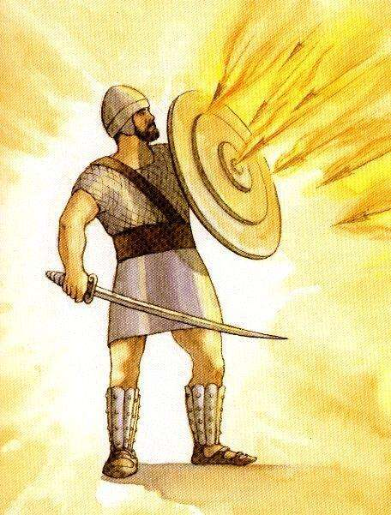

Helmet

Breast-plate

Belt

Shield

Sword

Shoes

An Example: The Exhorter who does not lift up those around them, or who causes / breaks up relationships due to their own hurts will individually, but also corporately, cause the Shield of Faith to fall to the ground – giving satan an opening to steal, kill and destroy.

110

PART 9: MAKE USE OF THE FOLLOWING REDEMPTIVE GIFTS QUESTIONNAIRE TO HELP YOU IDENTIFY YOUR CALLING:

Directions for completing the questionnaire:

For each of the statements, think about how you usually function in your organisation.

There may be times when you find it difficult to answer a particular question, but do the best that you can.
It might be useful for later discussion to note numbers of the questions that you find particularly difficult to answer.

Keep in mind that the accuracy of this survey depends on your openness and honesty in answering the questions.
This is not a test with right and wrong answers; rather, it is a tool for promoting thought and discussion.

Use the following scoring system:

If the statement is NEVER true for you, enter a 1

If the statement is SOMETIMES true for you, enter a 2
If the statement is MOSTLY true for you, enter a 4
If the statement is ALWAYS true for you, enter a 5

NEVER = 1, SOMETIMES=2, MOSTLY=4, ALWAYS=5

No. Question

- Present truth in a logical, systematic way

- Makes provision for future generations (e.g. children, grandchildren, etc.)

- Are highly motivated to organise and implement plans
- Capable of having significant disagreements without offence

- Have tremendous capacity to show love
- Quickly and accurately identifies right

- Recognise practical needs and is quick to meet them
- Validate truth by weighing it against the facts

- Are able to accommodate people with diverse viewpoints
- Prefer to be under authority in order to have authority

- Avoid being alone
- Sense the emotional atmosphere of a group/individual

- See everything as either black or white
- Enjoy showing hospitality

- Love to study and do research
- Like to keep all options open as long as possible

- Will endure criticism in order to accomplish the task


111


- Relate to people irrespective of culture, race, religion, background, etc.
- Avoid conflict and confrontation

- Easily perceive the character of individuals or groups
- Will stay with something until it is completed

- Emphasize facts and accuracy of words
- Handle every situation as a unique situation

- Are skilled at time management
- Love to encourage others to live victoriously

- Are attracted to people who are hurting or in distress
- Operate on principals

- Find it difficult to say "no" to requests for help
- Solve problems by starting with a theoretical foundation

- Tend to be more relative than absolute

- Easily facilitate resources and people to accomplish tasks or goals
- Want a visible response when teaching or speaking
- Easily detect insincerity or wrong motives

- Are eager to see own blind spots and help others to see theirs also
- Have a need to be appreciated

- Borrow things (e.g. books) without returning it promptly
- View family as important

- Prefer to move on to a new challenge once something is completed
- Greatly loved because of positive attitude

- Take care with words and actions to avoid hurting others
- Feel the need to verbalise or dramatise what you perceive

- Feel greatest joy in doing something that is helpful
- Have strong convictions and opinions based upon investigation of facts

- Are concerned about the greater community
- Thrive under stress/pressure

- View trials as opportunities to produce personal growth
- Are ruled by the heart rather than the head

- Have strong opinions and convictions
- Avoid leading others or projects

- Enjoy writing a lot
- See money as security

- Want to see things completed as quickly as possible
- Find it easy to communicate with others

- Sense things without being able to explain the "how"
- Are frank, outspoken and do not mince words

- Support those who are in leadership
- Tends to use biblical illustrations rather than life illustrations.

- Gives freely of possessions / time / love but want only the best.
- Enjoys long-term projects and does not like routine.

- Prefers to apply truth rather than research it.
- Rejoices when others are blessed, grieves if they are hurt.

- Believes that tribulation produces personal brokenness / humbleness.


112

- Is more interested in meeting the needs of others than own needs.
- Gets upset if scripture is used out of context.

- Gives without other knowing about it.
- Can easily delegate tasks and supervises to other.

- Wants to give people specific instructions on “how-to-do-it”.
- Does not like to be rushed.

- Believes that true repentance will be evidence by good fruit.
- Works on immediate goals rather than long-term goals.

- Is self-disciplined and self-controlled
- Has a strong belief in tithing / first-fruit offering.

- Is willing to let others get credit to get the job done.
- Loves to do personal counselling, but stops if no effort to change is seen.

- Typically avoids conflict / confrontations.

- Tends to only have one or two close friends and tends to be introspective.
- Shows love in deeds and actions more than words.
- Believes that truth has the power to change.

- Is not gullible / easily fooled.
- Is always writing notes to him- / herself.

- Expects a lot of others.
- Loves doing thoughtful things for others.

- Knows that he is called to be an intercessor.
- Tends to do the job rather than delegate.

- Has a select circle of friends based on common interest.
- Likes to see value for money.

- Know when to keep doing things in the old way and when to introduce new ideas.
- Needs to have someone as a “sounding board” to listen to idea / concepts.

- Is more concerned about mental / emotional stress than physical discomfort.
- Has a fervent desire to see God’s Plan manifest in all situations.

- Has a high energy level.


113

Redemptive Gifts Results Sheet:

Your highest score indicates your redemptive gift.

1 |  | 2 |  | 3 |  | 4 |  | 5 |  | 6 |  | 7
8 |  | 9 |  | 10 |  | 11 |  | 12 |  | 13 |  | 14
15 |  | 16 |  | 17 |  | 18 |  | 19 |  | 20 |  | 21
22 |  | 23 |  | 24 |  | 25 |  | 26 |  | 27 |  | 28
29 |  | 30 |  | 31 |  | 32 |  | 33 |  | 34 |  | 35
36 |  | 37 |  | 38 |  | 39 |  | 40 |  | 41 |  | 42
43 |  | 44 |  | 45 |  | 46 |  | 47 |  | 48 |  | 49
50 |  | 51 |  | 52 |  | 53 |  | 54 |  | 55 |  | 56
57 |  | 58 |  | 59 |  | 60 |  | 61 |  | 62 |  | 63
64 |  | 65 |  | 66 |  | 67 |  | 68 |  | 69 |  | 70
71 |  | 72 |  | 73 |  | 74 |  | 75 |  | 76 |  | 77
78 |  | 79 |  | 80 |  | 81 |  | 82 |  | 83 |  | 84
85 |  | 86 |  | 87 |  | 88 |  | 89 |  | 90 |  | 91
T |  | G |  | R |  | E |  | M |  | P |  | S

T

G

R

E

M

P

S

Score Gift


Teacher

Giver

Ruler

Exhorter

Mercy

Prophet

Servant

114

PART 10: STUDY THE FOLLOWING ANALYSIS OF EACH GIFT. FOCUS ON YOUR OWN TWO / THREE TOP GIFTS TO BETTER UNDERSTAND HOW YOU HAVE BEEN MADE

1. GIFT OF PROPHET

Much of the current teaching on prophet has been toward the “word” of God and more accurately reflects the manifestation of prophet. The gift of prophet is therefore not the prophet as we know it commonly today.

a) Yeshua acts as a Prophet:


1) He speaks only what the Father says:

John 12:49 “49 This is because I have never spoken on My own authority or of My own accord or as self-appointed, but the Father Who sent Me has Himself given Me orders [concerning] what to say and what to tell.”

2) He declares the Truth

John 14:6 “6 Jesus said to him, I am the Way

and the Truth and the Life; no one comes to the Father except by (through) Me.”

b) Joseph operating with the Gift of Prophet

We have been conditioned to see the prophetic as the utterance of a word of direction given without insight / prior knowledge of the opportunity or problem.
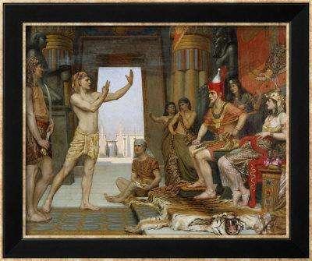

An interesting story which requires some further study is the interchange between Pharaoh and Joseph after he had the interpreted the dream.

We see that Joseph’s journey through life is not always easy. We find him for a part of his life in jail.

Even after he has helped one of his fellow inmates he still has to stay in captivity for two years longer.

115

We see clearly here that the reward or positive blessing from a good work does not always materialize very soon after the deed.

At some stage however, Joseph is set free in an instant. Joseph shares with

Pharaoh the insight and discernment of the dream at which stage we see:

- Joseph set free

- Joseph promoted to a high position

- Joseph being recognised by Pharaoh as having insight and wisdom.

Genesis 41:38-40 “38 And Pharaoh said to his servants, Can we find this man’s equal, a man in whom is the spirit of God?

39 And Pharaoh said to Joseph, Forasmuch as [your] God has shown you all this, there is nobody as intelligent and discreet and understanding and wise as you are.

40 You shall have charge over my house, and all my people shall be governed according to your word [with reverence, submission, and obedience]. Only in matters of the throne will I be greater than you are.

Of critical importance to understand his ability to discern and interpret the dream is not the marker of this blessing, but rather the fact that Joseph had been created and infused with this gift of the prophetic at conception.

We struggle to understand how the gift of prophecy can be used to take and implement God’s principles in a unique problem.

The life of Joseph shows us how he is appointed into a position of authority because he would use this gift wisely.
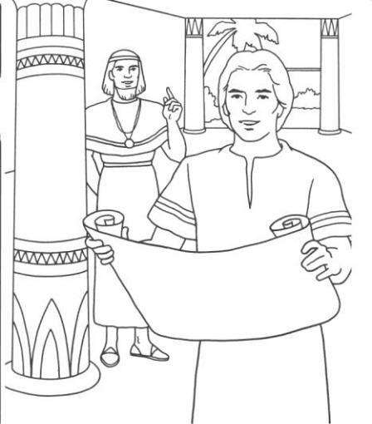

What do these attributes mean that Pharaoh describes in the above verses?

The word “insight” – Hebrew - “navon” -

Strongs 995 – “bijn” and means:

- Intuition

- Foresight

- Comprehension

- Discernment

This word therefore implies that we have the ability:

- to sort things into categories,

- to prioritize,

- to apply intellectual knowledge to a recognizable pattern of facts.

We can say that this comes from an application of hard work and study.

116

The word “wisdom” – Hebrew – Strongs - 2450 – “chacham” and means:

- Skilled

- Cunning / shrewd

- Learned

- Prudent

This word therefore implies the application of our creative ability to create a desired result. It is all about:

- practical /

- how to do it

- applied wisdom

that results in a goal being achieved. We can say that this comes from our exposure to life experiences.

Joseph had to spend his life in his father’s tents. He had been exposed to a study of the Torah principles and Word.
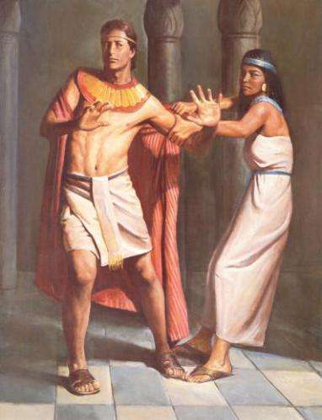

He has, through his experiences

- in the pit,

- in Potiphar’s house,

- in the jail,

learned how to react to the experiences of life.

He is able to take both of these gifts and use them to:

- Develop a plan

- Communicate the vision

- Sell the need

- Call others (not of his tribe) to work in alignment to the vision

So that his own family can be saved

THE PURPOSE OF A PROPHET:
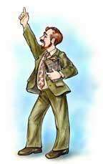

Background

The prophets were divine philosophers / teachers of the Hebraic principle of virtue / purity / integrity.

Prophets do not live in the public eye but largely keep to themselves unless they have a message / principle to proclaim in someone’s life:

117

They would be students of the:
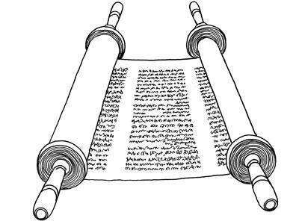
- Torah

- History of God’s people

- Legal system

Prophets would normally gather with the people at the time of:

- New moons

- Shabbat

as a time to instruct people in God’s Principles.

2 Kings 4:23 “23 And he said, Why go to him today? It is neither the New Moon nor the Sabbath. And she said, It will be all right.

In the story of the Shunammite woman who comes to Elisha on Mount Carmel we see that she understood that the prophet would know when and how to apply one of God’s Principles to solve her problem.

Note: She did not come for a prophetic word but for an application of God’s Principles.

2 Kings 4:22-37 “22 And she called to her husband and said, Send me one of the servants and one of the donkeys, that I may go quickly to the man of God and come back again.

23 And he said, Why go to him today? It is neither the New Moon nor the Sabbath. And she said, It will be all right.
24 Then she saddled the donkey and said to her servant, Ride fast; do not slacken your pace for me unless I tell you.
25 So she set out and came to the man of God at Mount Carmel. When the man of God saw her afar off, he said to Gehazi his servant, Behold, yonder is that Shunammite.
26 Run to meet her and say, Is it well with you? Well with your husband? Well with the child? And she answered, It is well.
27 When she came to the mountain to the man of God, she clung to his feet. Gehazi came to thrust her away, but the man of God said, Let her alone, for her soul is bitter and vexed within her, and the Lord has hid it from me and has not told me.
28 Then she said, Did I desire a son of my lord? Did I not say, Do not deceive me?
29 Then he said to Gehazi, Gird up your loins and take my staff in your hand and go lay my staff on the face of the child. If you meet any man, do not salute him. If he salutes you, do not answer him.

30 The mother of the child said, As the Lord lives and as my soul lives, I will not leave you. And he arose and followed her.

31 Gehazi passed on before them and laid the staff on the child’s face, but the boy neither spoke nor heard. So he went back to meet Elisha and said to him, The child has not awakened.
32 When Elisha arrived in the house, the child was dead and laid upon his bed.

118

33 So he went in, shut the door on the two of them, and prayed to the Lord.


34 He went up and lay on the child, put his mouth on his mouth, his eyes on his eyes, and his hands on his hands. And as he stretched himself on him and embraced him, the child’s flesh became warm.
35 Then he returned and walked in the house to and fro and went up again and stretched himself upon him. And the child sneezed seven times, and then opened his eyes.
36 Then [Elisha] called Gehazi and said, Call this Shunammite. So he called her. And when she came, he said, Take up your son.
37 She came and fell at his feet, bowing herself to the ground. Then she took up her son and went out.

The relevant Hebrew word for a prophet of this nature is “nabi” – an inspired man.

This prophet is a spokesman – someone who speaks for another. Abraham was a prophet after this gifting.

Genesis 20:7 “So now restore to the man his wife, for he is a prophet, and he will pray for you and you will live. But if you do not restore her [to him], know that you shall surely die, you and all who are yours.

He is given the gift of being able to identify new application for implementation of principles into the future.

He operates with the Principles of God’s design, to restore and release a person’s full birthright, gaining favour from the governmental / legal structures. He does not create; he re-applies the principles in a new / different context.

The restoration of God’s design comes about when the prophet:

- Accurately discerns between good and evil ( in this differentiation; the prophet will be black or white – there will be no areas for compromise)

Matt. 23:27 “27 Woe to you, scribes and Pharisees, pretenders (hypocrites)! For you are like tombs that have been whitewashed, which look beautiful on the outside but inside are full of dead men’s bones and everything impure.”


- Speaks out / becomes a leading figure in a “fight” for righteousness, justice or freedom.

- Identifies the bad fruit which come from the wrong / bad root system and defines the path to repentance.

119

- Embraces difficulties / trials / tribulations as a path to personal growth and humbleness.

- Visibly demonstrates his obedience to God’s Principles and

Commandments by a lifestyle of patterning Yeshua at all costs.

Jer. 1:5, 10 “5 Before I formed you in the womb I knew [and] approved of you [as My chosen instrument], and before you were born I separated and set you apart, consecrating you; [and] I appointed you as a prophet to the nations.
10 See, I have this day appointed you to the oversight of the nations and of
the kingdoms to root out and pull down, to destroy and to overthrow, to build and to plant.”

HOW DO WE IDENTIFY A PROPHET?

Someone who:

- takes initiative (does not like routine), i.e. needs new challenges.

Proverbs 29:18 “18 Where there is no vision [no redemptive revelation of God], the people perish; but he who keeps the law [of God, which includes that of man]—blessed (happy, fortunate, and enviable) is he.

- is verbally expressive / talks easily / is outspoken and does not mince words.
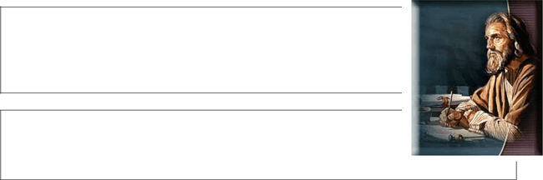

Proverbs 12:17 “17 He who breathes out truth shows forth righteousness (uprightness and right standing with God), but a false witness utters deceit.

18 There are those who speak rashly, like the piercing of a sword, but the tongue of the wise brings healing.

Proverbs 17:27 “27 He who has knowledge spares his words, and a man of understanding has a cool spirit.

28 Even a fool when he holds his peace is considered wise; when he closes his lips he is esteemed a man of understanding.

- has an inability to tolerate bondage / control.

- processes thoughts / concepts quickly, shift gears and therefore gets bored easily wherever repetition work is done.

- is fiercely competitive.

- judges himself harshly for every mistake that he makes.

- only has one or two real friends. They don’t easily compromise and therefore his friends are of similar “heart”. As they tend to be introspective, they are often happy to be alone but are not lonely.

120

THE SELF-IMAGE OF THE PROPHET:

The prophet’s God-given introspective nature, i.e. always considering and measuring themselves to what they perceive God’s Standard to be;; coupled with the God-given calling to define right and wrong, will give rise to negative feelings of self-worth which can even lead to depression.

The prophet’s emotions are intense – from an absolute high to the deepest dungeon. As a result, they will either speak incredible life / direction or unload every tactless, irresponsible thoughts which randomly just enter their heads.

CRITICAL SUCCESS FACTORS:


- He must bring a first-fruit offering of time, otherwise his time is devoured.

- He must become a strong intercessor to negate the inherent desire to be judgmental, to motivate others to pray, he must always pray before he speaks.

Proverbs 15:31-33 “31 The ear that listens to the reproof [that leads to or gives] life will remain among the wise.

32 He who refuses and ignores instruction and correction despises himself, but he who heeds reproof gets understanding.

33 The reverent and worshipful fear of the Lord brings instruction in Wisdom, and humility comes before honor.
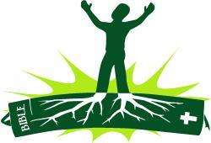

- He must have a strong root system of faith and an understanding of the Torah to stand against the words of opposition. Because his thought-process is quick, he will get opposition from those

who want to think / plan things carefully.

Many others will want to stay with the “tried and tested” and are often fearful of new untried concepts.

Proverbs 13:13 “13 Whoever despises the word and counsel [of God] brings destruction upon himself, but he who [reverently] fears and respects the commandment [of God] is rewarded.
14 The teaching of the wise is a fountain of life, that one may avoid the snares of death.

- He must make sure that relationships with people are retained and therefore must take time to restore friendships, especially when their friends have worked hard towards a common goal but have not received any recognition / blessing for the progress.

121

If the prophet fails in all / any of these critical success factors and instead starts to operate on his own interpretation of the gifts, he will cause some of the following impacts on the Body of Messiah:
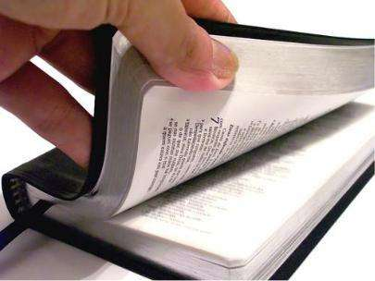

- He will steal God’s Truth from other believers. Each one of us has the God-given ability to study His Word, to pray and to worship. In time therefore it is likely that we will get the revelation / solution for our situation.

Where time / economic / relationship pressure are too heavy and we rely on a prophet’s direction we could be given false word.

- He can misuse the situation where he is aware of private, privileged information and raise his tongue in slander and gossip.

- He can make light of the circumstances, treating the situation as empty or light-hearted.

PRACTICAL APPLICATION:

The prophet has the gift to use the principle laid out in the Torah / Word in new applications. Every principle has what the

Rabbi’s call – a cause and effect relationship. From this we understand that every action by man can have:
- a negative or
- a positive effect.

In the case of a father – this will impact the next generation.

In the case of a believer – this will impact the cell / body of Messiah.

An elementary example is:

CAUSE | EFFECT
If we do not make people work for | They will become lazy, corrupt.
a reward, i.e. if they develop a
spirit of entitlement…
If we encourage a spirit of | We create a group of people with a
enterprise, diligence and | high moral fiber.
thankfulness…


122

A. The prophet’s tree of life has its roots in:


1) The talent that God has blessed him with.

2) The value system engraved by his parents.
3) The level / time spent in study of the Word.

B. The root system of the prophet support the trunk of the tree by the:

x direction given

x confidence instilled

x Level of empowerment through the nature / type of “blessing” pronounced regularly over the prophet’s life.

C. The truth produces branches of prophetic direction,

i.e. cause and effect relationship impact principles into every problem they are called to deal with.

Illustration:

A Principle set out in the Torah is:

- If you sow = you reap.

- If you sow wisely = you reap greater freedom.

- If you sow intensely = you reap bountifully.

We can see that the basic principle can have multiple levels of application; in addition the same principle can be used in all three levels of structure:

- Man / Matter: Physical seed = a harvest.

- Man / Spirit: Intensity of prayer = success in Spiritual warfare.

- Man / Man: Integrity of Role model = Generational blessing.
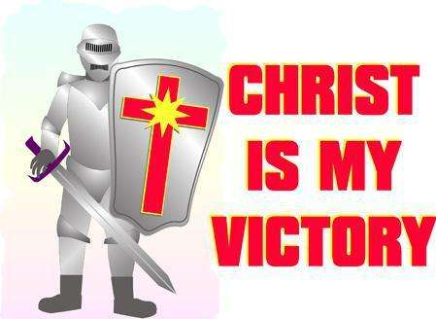

Domain of Personal Warfare:

The prophet’s nature is to cause hurt / wounds to relationships with his fellowman. This is however also his area of greatest blessing / authority.

The prophet must identify, speak out against, and root out all:

- Efforts of man to remain silent / tolerate acts of injustice against his fellow man.

- Acts of racism or sexism which go to separate man into groups resulting in inequality / inequity.
- Acts of physical / ritual abuse.

123

The prophet must proclaim / take a stand for:


- Reconciliation between people groups.
- Healing of the spiritually wounded.
- Liberty / equality of all before God.

Sign of the Holy Spirit:

The “Breath of God” would seem to best symbolize the gift of the prophet.

Gen. 2:7 “7 Then the Lord God formed man from the dust of the ground and breathed into his nostrils the breath or spirit of life, and man became a living
being.”

ATTACKS AGAINST THE GIFT OF PROPHET:

- Influence of Parenting:

x The father’s role is to bless the child into his purpose and to empower him through training / exposure to meet

challenges. If the father does not build this attribute, the prophet will be fearful and will want to run away from the unknown.


- The prophet who struggles with self-condemnation / rejection will focus on his own hurts and rob the Body of Messiah of God-given direction.

- The father must take steps to build the prophet’s self-image, by giving words of approval, by allowing him to express his feelings, by having him understand that mistakes are not the end of the world. If the father fails in this area the prophet will wrestle with bouts of anger over what he perceives as injustice.

- The father must channel the prophet’s thought pattern so that he will always be striving to test the answers / statements of others, so that he will know that it is good and acceptable to have a different opinion. If the father fails, the prophet could be argumentative and disrespectful of others even when their opinions are incorrect.

- The father must experiment with and encourage every area of creativity until he releases this aspect of

talents in the prophet. If he fails to do so the prophet’s ability to express himself is limited and will cause frustration and tension when it comes to adequately expressing God’s Word.


124

2) Influence of Woundedness:

Prophets by their nature and calling are compassionate people. Words which describe the calling are:

- sensitive,

- honest,
- loyal,
- Responsible.

They are deeply sensitive to hurts from rejection in the womb, as well as the emotional trauma that exists even after deliverance has taken place.

Because they are sensitive, any acts by a parent which reflects a lack of love (i.e. being ignored) will cause wounding.

It is estimated that 60-70% of all prophets are “wounded”.


The prophet should be bold, an initiator – not easily intimidated. However, if parents have raised you to be unwilling to risk, then you will operate under extreme stress especially if you are intolerant of the views of others, or push others to reach your own standard of maturity.

The prophet must guard against bitterness as this becomes the permanent battlefield of the prophet.

3) Generational / Spiritual force

We have chosen to proclaim the blessing in this paragraph. We have not gone into the details or described the negative consequences on the life of believers which is caused by the negative impact of
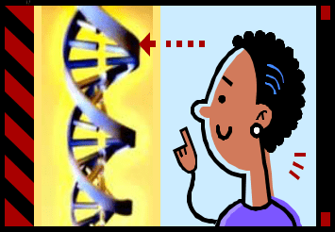
generational curses.

Please note that if this gift has been rejected / abused by the previous generations, then the gift will operate in the exact opposite way in which it should and the effect / impact thereof will be multiplied in the following generations (i.e. by my parents).

The prophet has the gift of being able to show people what their DNA is, to understand God’s call on their life and to show them the price they will have to pay to get there.

Root iniquity: This will come down to the abuse / misuse of the rights of the individuals or followers that have committed themselves to the leader.

125

2. GIFT OF SERVANT

(This is not the common description of someone who puts out the chairs and washes the cups every time.)
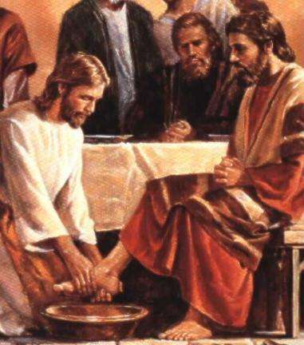

Yeshua as Servant:

1) Demonstrated service:

John 13:5 “5 Then He poured water into the washbasin and began to wash the disciples’ feet and to wipe them with the [servant’s] towel with which He was girded.”


Mark 10:43 “43 But this is not to be so among you; instead, whoever desires to be great among you must be your servant,”


Background

God knows that this world, with its focus on performance, materialism etc. needs to have an abundance of people who are blessed with the gift of servant.

What is astounding is the record of people who are called “servant” and yet

  - achieved great things,

  - always honoured their leaders.

- Deborah – Rebekah’s Nurse

Genesis 35:8 “8 But Deborah, Rebekah’s nurse, died and was buried below


Bethel under an oak; and the name of it was called Allon-bacuth [oak of weeping].

2) Joseph

Genesis 39:2-23 “2 But the Lord was with Joseph, and he [though a slave] was a successful and prosperous man; and he was in the house of his master the Egyptian.

3 And his master saw that the Lord was with him and that the Lord made all that he did to flourish and succeed in his hand.

4 So Joseph pleased [Potiphar] and found favor in his sight, and he served him. And [his master] made him supervisor over his house and he put all that he had in his charge.
5 From the time that he made him supervisor in his house and over all that he had, the Lord blessed the Egyptian’s

house for Joseph’s sake;; and the Lord’s blessing was on all that he had in the house and in the field.

126

21 But the Lord was with Joseph, and showed him mercy and loving-kindness and gave him favor in the sight of the warden of the prison
.22 And the warden of the prison committed to Joseph’s care all the prisoners who were in the prison; and whatsoever was done there, he was in charge of it.
23 The prison warden paid no attention to anything that was in [Joseph’s] charge, for the Lord was with him and made whatever he did to prosper.


3) Elisha

2 Kings 3:11 “11 But Jehoshaphat said, Is there no prophet of the Lord here by whom we may inquire of the Lord? One of the king of Israel’s servants answered, Elisha son of Shaphat, who served Elijah, is here.

4) The soldier of Cornelius

Acts 10:7 “7 When the angel who spoke to him had left, Cornelius called two of his servants and a God-fearing soldier from among his own personal attendants.

- The Centurion’s servant
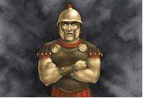

Luke 7:8 “8 For I also am a man [daily] subject to authority, with soldiers under me. And I say to one, Go, and he goes; and to another, Come, and he comes; and to my bond servant, Do this, and he does it.


The servant’s blessing.

Proverbs 27:7 “7 He who is satiated [with sensual pleasures] loathes and treads underfoot a honeycomb, but to the hungry soul every bitter thing is
sweet.
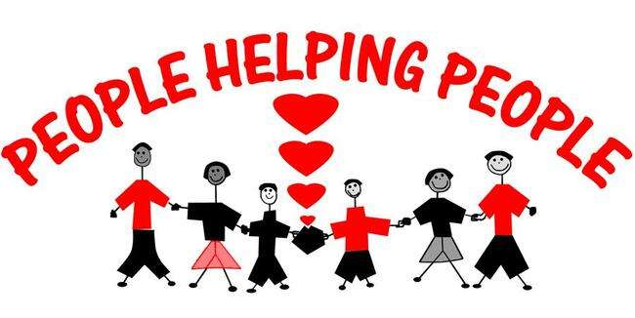

127

PURPOSE:


The servant has been given power over the principle of authority, because they do not want the spotlight, they don’t abuse it.

The restoration of the servant’s power over the principle of authority is manifested:

- in those acts of practical help that results in manual jobs being sorted out immediately.

- in acts of hospitality where friends and  newcomers are spoiled / treated with the utmost

care, but seldom is this care reflected in words of love.

- in the amount of effort / loyalty they will put into a project / ministry in order to ensure that it is successful. They sometimes need help to be more effective with their time.

Ex. 18:13-18 “13 Next day Moses sat to judge the people, and the people stood around Moses from morning till evening.

14 When Moses’ father-in -law saw all that he was doing for the people, he said, What is this that you do for the people? Why do you sit alone, and all the people stand around you from morning till evening?
15 Moses said to his father-in-law, Because the people come to me to inquire of God.
16 When they have a dispute they come to me, and I judge between a man and his neighbor, and I make them know the statutes of God and His laws.
17 Moses’ father-in-law said to him, The thing that you are doing is not good.

18 You will surely wear out both yourself and this people with you, for the thing is too heavy for you; you are not able to perform it all by yourself.”

- when the servant lets his heart follow God’s direction and God’s Timing to help lead others through the path of deliverance and restoration that is required – Moses (a servant) leads the people for forty years until “Egypt” was removed from their thinking.


The servant is the one that prays for leaders, protects leaders and can be the vehicle of counselling to cleanse leadership from impurities.

128

The servant has a heart for God’s Creation, man and ecology and actively seeks their restoration to their original purpose, i.e. to set proper boundaries.

HOW DO WE IDENTIFY THE SERVANT?


Someone:

- Who serves without guile – there are no false motives / no agendas.

Proverbs 11:27 “27 He who diligently seeks good seeks [God’s] favor, but he who searches

after evil, it shall come upon him.

Proverbs 14:35 “35 The king’s favor is toward a

wise and discreet servant, but his wrath is against him who does shamefully.

- Obeys the leader at all times

Ephesians 6:5 “5 Servants (slaves), be obedient to those who are your physical masters, having respect for them and eager concern to please them, in singleness of motive and with all your

heart, as [service] to Christ [Himself]—

1 Peter 2:18 “18 [You who are] household servants, be submissive to your masters with all [proper] respect, not only to those who are kind and considerate and reasonable, but also to those who are surly (overbearing, unjust, and crooked).

Titus 2:9 “9 [Tell] bond servants to be submissive to their masters , to be pleasing and give satisfaction in every way. [Warn them] not to talk back or contradict,

- Is conscientious – does things to the best of their ability

Titus 2:10 “10 Nor to steal by taking things of small value, but to prove themselves truly loyal and entirely reliable and faithful throughout, so that in everything they may be an ornament and do credit to the teaching [which is] from and about God our Savior.

129

- Who does not keep book – there are no I.O.U.’s;; he does not seek a reward.

Proverbs 13:7 “7 One man considers himself rich, yet has nothing [to keep permanently]; another man considers himself poor, yet has great [and indestructible] riches.


- Who collects “things” – they are hoarders.

- Who has integrity, simplicity and honour at all times.

Proverbs 12:9 “9 Better is he who is lightly esteemed but works for his own support than he who assumes honor for himself and lacks bread.

Proverbs 22:9 “9 He who has a bountiful eye shall be blessed, for he gives of his bread to the poor.

- Render services in a cheerful spirit.


1 Peter 2:19 “19 For one is regarded favorably (is approved, acceptable, and thankworthy) if, as in the sight of God, he endures the pain of unjust suffering. 20 [After all] what kind of glory [is there in it] if, when you do wrong and are punished for it, you take it patiently? But if you bear patiently with suffering [which results] when you do right and that is undeserved, it is acceptable and pleasing to God.


Colossians 3:23 “23 Whatever may be your task, work at it heartily (from the soul), as [something done] for the Lord and not for men,

Ephesians 6:7 “7 Rendering service readily with goodwill, as to the Lord and not to men,

- While not a strong scholar, walks in holiness. They will not always have a “Word” answer, but their hearts are tuned into God and therefore they reflect God’s Integrity.

Proverbs 18:24 “24 The man of many friends [a friend of all the world] will prove himself a bad friend, but there is a friend who sticks closer than a
brother.

130

- Render services by doing the will of God.

1 Peter 2:21 “21 For even to this were you called [it is inseparable from your vocation]. For Christ also suffered for you, leaving you [His personal] example, so that you should follow in His footsteps.

Ephesians 6:6 “6 Not in the way of eye-service [as if they were watching you] and only to please men, but as servants (slaves) of Christ, doing the will of God heartily and with your whole soul;

- Who has a high energy level.

1 Peter 4:11 “…whoever renders service, [let him do it] as with the strength which God furnishes abundantly, so that in all things God may be glorified through Jesus Christ (the Messiah). To Him be the glory and dominion forever and ever (through endless ages). Amen (so be it).”


- Who is happy to be a follower and not a leader.

Galatians 5:13 “13 For you, brethren, were [indeed] called to freedom; only [do not let your] freedom be an incentive to your flesh and an opportunity or excuse [for selfishness], but through love you should serve one another.

1 Thessalonians 1:9 “9 For they themselves volunteer testimony concerning us, telling what an entrance we had among you, and how you turned to God from [your] idols to serve a God Who is alive and true and genuine,


131

THE SELF-IMAGE OF THE SERVANT:

The servant tends to be a shy personality – something that is inherently part of their DNA. A shy person will “like” other people, but will only open up to them when a foundation of trust has been build up.

A servant is far more likely to “do something” for you as apposed to “say” something good to you.

If these actions are not seen, not recognized, if trust is broken by exposing him in front of others, he will have a low self-image.


CRITICAL SUCCESS FACTS:

- The servant must learn to say NO, not to agree to all demands placed on him. The nature of the servant wants to help, however he must hear

from God as to where he must be or else he takes on a workload which cannot be met. He then disappoints others and creates his own internal pressure.

- The servant must take care not to spoil their own children or to neglect their family while helping

others.

- The servant must ensure that he does not become overly competitive. While the servant does not want personal spotlight, they can become very competitive in respect of the ministries / people that they support and can lose perspective.


- The servant must take up his authority to war against the spirit of death.

- The servant must learn to accept that others can serve them – they must learn to receive with the same grace that they give.

- The servant must learn to put and keep their priorities in order: God, family, job, and ministry. He should learn not to neglect the first calling.

- The servant must make sure that he does not render a service with the wrong heart and only in a manner so as to make it appear as if he has kept his word.

Colossians 3:22 “22 Servants, obey in everything those who are your earthly masters, not only when their eyes are on you as pleasers of men, but in simplicity of purpose [with all your heart] because of your reverence for the Lord and as a sincere expression of your devotion to Him.

132

- The servant must make sure that they praise God at all times.


Revelation 19:5 “5 Then from the throne there came a voice, saying, Praise our God, all you servants of His , you who reverence Him, both small and great!

- The servant must recognise that man’s reward is not the goal – the real reward comes from God.

Galatians 6:7 “7 Do not be deceived and deluded and misled; God will not allow Himself to be

sneered at (scorned, disdained, or mocked by mere pretensions or professions, or by His precepts being set aside.) [He inevitably deludes himself who attempts to delude God.] For whatever a man sows, that and that only is what he will reap.

8 For he who sows to his own flesh (lower nature, sensuality) will from the flesh reap decay and ruin and destruction, but he who sows to the Spirit will

from the Spirit reap eternal life.

Colossians 3:24 “24 Knowing [with all certainty] that it is from the Lord [and not from men] that you will receive the inheritance which is your [real] reward. [The One Whom] you are actually serving [is] the Lord Christ (the Messiah).
25 For he who deals wrongfully will [reap the fruit of his folly and] be punished for his wrongdoing. And [with God] there is no partiality [no matter what a person’s position may be, whether he is the slave or the master].

Prov. 31:16 “16 She considers a [new] field before she buys or accepts it [expanding prudently and not courting neglect of her present duties by
assuming other duties]; with her savings [of time and strength] she plants fruitful vines in her vineyard. [S. of Sol. 8:12.]”

PRACTICAL APPLICATION:

The servant’s call to walk in authority implies that there is a real understanding of the call to be in submission to leadership while always ensuring that the authority does not move
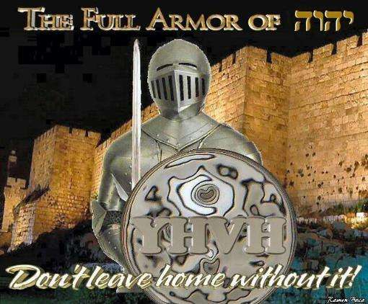
into the realm of domination.

Authority in line with God’s Principles implies that we:
- must subdue

  - nature, the land, o demons,

- BEFORE we can rule.

133

An illustration of subduing nature is when Yeshua “speaks” to the fish to find a coin for the taxman.
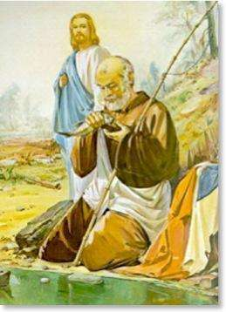

Matthew 17:24 “24 When they arrived in Capernaum, the collectors of the half shekel [the temple tax] went up to Peter and said, Does not your Teacher pay the half shekel?

26 And when Peter said, From other people not of their own family, Jesus said to him, Then the sons are exempt.
27 However, in order not to give offense and cause them to stumble [that is, to cause them to judge unfavorably and unjustly] go down to the sea and throw in a hook. Take the first fish that comes up, and when you open its mouth you will find there a shekel. Take it and give it to them to pay the temple tax for Me and for yourself.

The goal with authority is therefore to continually expand the area under the domain of Godly rulership. Yeshua illustrates this principle as follows:
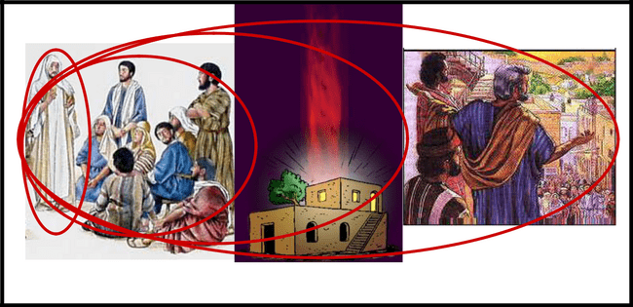

3000 disciples Acts

Yeshua 12 Disciples 120 in the upper room

In this way, Godly authority expands to transform the community.

The Path of Transformation:

- Recognize the potential in people / things.

- Apply God’s principles of cause and effect,

i.e. a piece of land if left alone will fill up with weeds.
A piece of land used productively will yield a harvest.

134

- Establish specific boundaries / structures to define the problem.

- Provide the necessary resources needed to implement the plan.

Domain of Personal Warfare:

The nature of the servant is to meet people’s needs instead of taking authority to empower change, i.e. the servant must set the example of meeting the needs of the Body of Messiah in such a way that others, who do not have this gift, will be set free to multiply in their gift.

The servant must speak out and take a stand against:


- Those who tolerate / accept their situation of bondage / abuse and stay in pain when they have the resources to move on to a place of victory in life.

- Those who need help due to their inability / passiveness to the extent that they represent an abused victim spirit unable to do anything on their own.

The servant must:

- Establish boundaries of acceptable behavior.

- Speak out against those who cause pain and abuse whether physical or verbal.

Sign of the Holy Spirit:
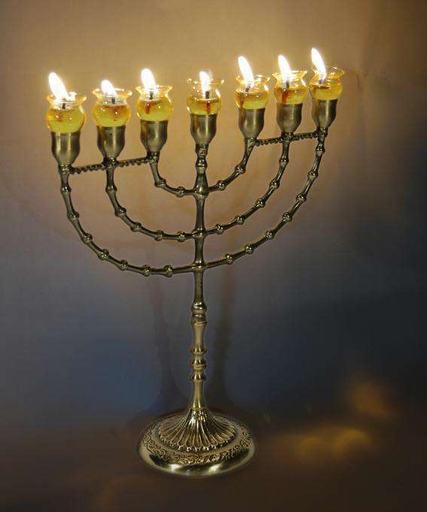

The “oil” of the Menorah would seem to best symbolize the Holy Spirit’s touch to the gift of servant.

Ex. 30:25 “25 And you shall make of these a holy anointing oil, a perfume compounded after the art of the perfumer; it shall be a sacred anointing oil.”


135

THE ATTACKS AGAINST THE GIFT OF SERVANT:

1. Influence of Parenting:

- A father must provide the layer of protection / security around a servant, encouraging him to step out into new situations without fear in order to overcome the sense of shyness and insecurity. If the father fails in this life task, the servant will live in fear of every unknown situation.

- A father must set a standard of praise and acknowledgment for every good work done – the praise must be in relation to the work done so that the servant learns the value of his actions. A father that fails in this area will leave his child overly dependant / craving for acknowledgement and could easily become a “people-pleaser”, or else highly critical of every effort made by others.

- A father must identify the creative gifting, i.e. where the servant will be useful in a practical sense with works of his hands, and expose the servant to training and experience in those fields. A father who fails will leave a frustrated, unsatisfied servant to wander on this earth.

- Parents who do not teach the children self-worth, confidence, courage will expose the servant to much pain when people are not fair and honourable towards them, i.e. they will often live under a victim mentality.


This can manifest itself in a number of ways:

- The servant’s need to be affirmed / recognized is so big that in almost every situation it becomes a disaster – “I am never appreciated!”

- The servant has a desperate need to succeed and

can become aggressive / pushy in trying to help others.

- The servant feels insecure and awkward when they are given something – they don’t know how to receive in grace.


136

2. Influence of Woundedness:

Servants are by nature helpful, reliable and sensitive people. Servants will be hurt when they do something for others that is not accepted

or acknowledged.

Negative treatment by parents can easily be seen when the child is embarrassed or forced to stand in front of the crowd to “sing or perform”.

This type of exposure causes a deep sense of insecurity, as a result 40-50% of servants experience wounding.

The servant will often be misused, abused and dishonoured. Someone who has been impacted with hurts to the extent that they have a “victim” mentality will be overpowered, manipulated and dominated.

The servant will often display the spirit of illegitimacy – of not feeling worthy.

3. Generational / Spiritual Force:

We have chosen to proclaim the blessing in this paragraph. We have not gone into the details or described the negative consequences on the life of believers which is caused by the negative impact of generational curses.


Please note that if this gift has been rejected / abused by the previous generations, then the gift will operate in the exact opposite way in which it should and the effect / impact thereof will be multiplied in the following generations (i.e. by my parents).

The servant has the integrity to be able to disclose satan’s lies and thereby bring cleansing and healing to God’s leadership and to release others in ministry.

Root iniquity: They desire to have peace with everybody at all costs.

137

PRAYER STRATEGY FOR THE SERVANT GIFT


Practical points on how to pray a hedge of protection as a prayer shield around our spiritual leaders.

Ephesians 6:10-18 “Finally, be strong in the Lord, and in the strength of His might. Put on the full armour of God, that you may be able to stand firm against the schemes of the devil. For our struggle is not against flesh and blood, but against the rulers, against the powers, against the world forces of this darkness, against the spiritual forces of wickedness in the heavenly places. Therefore, take up the full armour of God, that you may be able to resist in the evil day, and having done everything, to stand firm.

Stand firm therefore, having girded your loins with truth, and having put on the breastplate of righteousness, and having shod your feet with the preparation of the gospel of peace; in addition to all, taking up the shield of faith with which you will be able to extinguish all the flaming missiles of the evil one. And take the helmet of salvation, and the sword of the Spirit, which is the word of God. With all prayer and petition pray at all times in the Spirit, and with this in view, be on the alert, with all perseverance and petition for all the saints.”

I. PLACING A HEDGE AROUND YOUR PASTOR

Key Scripture – “Be strong in the Lord, and in the strength of His might.” (Eph. 6:10)

A. Meditate on the greatness of God on behalf of your pastor - Rom. 8:28, 31,37; 1 Pet. 3:12.

B. Expose the wiles of the devil - Eph. 6:11-12.

C. Claim scriptural promises for their overall protection - Is. 54:14-17; Ps.

34:7; Lk. 10:19; 2 Cor. 10:3-4.

D. Petition the Father to grant them a discerning spirit - 2 Cor. 11:14; 1Jn. 4:1.

II. THE PASTOR'S PRIVATE LIFE

Key Scripture – “Stand firm therefore ... girded ... with truth...” Eph. 6:14.

A. Request that their glory be solely in the cross - Gal. 6:14.

- Pray:

  - For their continued renewal - Is. 40:27-31.
  - For their holiness - 1 Pet. 1:16.

- Seek:

  - For them a clear vision of the merits of Christ - Phil. 3:7-10.
  - For godly contentment - 1 Tim. 6:6.

  - For the love of God to be shed abroad in their hearts - Rom. 5:5.

138

III. THE PASTOR'S PERSONAL LIFE

Key Scripture – “Stand firm therefore ... having put on the breastplate of righteousness.” (Eph. 6:14)

A. Intercede for their spouses, children and families - Ps. 91:9-12; Ps. 37:25.

B. Cancel in Jesus' name all assignments against them - Mt. 16:19.

C. Remove by faith all obstacles to their total health and prosperity - Mk. 11:23; Phil. 4:19.

V. THE PASTOR'S PRAISE LIFE

Key Scripture – “Stand firm therefore ... having shod your feet with the preparation of the gospel of peace.” (Eph. 6:15)

A. Ask the Father to give them a strong worship - Mt. 4:10.

- Bind:

  - The spirit of fear - Jn. 14:1.
  - The spirit of gloom - Is. 61:3.
  - The spirit of negativity - 2 Tim. 1:6-7.

- Listen for any other direction to pray - Eccles. 5:1-2.

V. THE PASTOR'S PRAYER LIFE

Key Scripture – “Stand firm therefore ... above all, taking the shield of faith with which you will be able to quench all the fiery darts of the wicked one.” (Eph. 6:16, NKJ)

A. Quench in the Holy Spirit, darts of doubt - Mk. 6:5-6.

B. Rebuke all distractions from their devotional time - Mk. 5:36.

C. Loosen the forces of heaven to aid in prayer:

- Mk. 1:35 (private prayer).
- Acts 1:14 (corporate prayer).

VI. THE PASTOR'S PROFESSIONAL LIFE

Key Scripture – “Stand firm therefore ... and take the helmet of salvation...” (Eph. 6:17a)

A. Shield them from the fear of men - Is. 11:1-3; Prov. 19:23.

B. Bestow on them:

139

  - Favour in the denomination - Prov. 18:16.

  - Support among their peers - Prov. 11:4. C. Entreat:
  - Jesus to give them an uncompromising truth - Prov. 4:20-27.
  - Wisdom in leadership - Jas. 1:5.

VII. THE PASTOR'S PREACHING LIFE

Key Scripture – “Stand firm therefore ... (with) the sword of the Spirit, which is the word of God.” (Eph. 6:17b)

A. Bless them with rich study time - Acts 6:4; 2 Tim. 2:15.

- Grant:

  - To them a bold proclamation of Jesus - Col. 1:28.
  - To them opportunities - Col. 4:3-4.

- Anoint them:

  - To preach and teach - Luk. 4:18; 1 Jn. 2:27.
  - For apostolic results - Acts 2:37.
  - For signs and wonders - Mk. 16:20.
  - To reveal truth - Mt. 16:17.

VIII. THE PASTOR'S PERSEVERING LIFE

Key Scripture – “Stand firm therefore ... praying always with all prayer and supplication in the Spirit, being watchful to this end with all perseverance...” (Eph. 6:18a, NKJ)

A. Honour them with lasting fruit - Mal. 3:11; Jn. 15:16.

B. Confess over them:

  - Steadfastness - 1 Cor. 15:58.
  - Bold vision - Is. 41:10.

  - Rest - Heb. 4; Mt. 11:28.

- Give thanks for their call and gifts - Col. 1:3-5.

- Secure them in courage - Josh. 1.

IX. CONCLUSION

Key Scripture – “Fight the good fight of faith...” (1 Tim. 6:12a)

A. Expect all that you have prayed.

B. Stand behind them girding them in prayer.

140

C. Yield to the Spirit for other areas of prayer and intercession.

D. Amen. Let it be so!

Remember, together, in Jesus, we make a Great Team!

Dr. James W. Goll

7 DAYS OF PRAYER FOR PASTORS, LEADERS, HUSBANDS, FATHERS, SONS

Be careful not to change from intersession into witchcraft prayer or meaningless prayer – we bring our ways to the table – our wounded ness Group prayer for pastors – can be dangerous – leave to intercessors – we have to pray God’s will – Use scriptures privately or corporately Intercession is praying God’s will into reality. Pro- active prayers bring the fullness of God to come to pass.

COL: 1: 9-11 “9: For this reason we have not ceased to pray and make

request known to you, asking that you be filled with the full knowledge of His Will .in all spiritual Wisdom [ in comprehensive insight into the ways and purposes of God] and in understanding and discernment of spiritual things
- That you may walk (live and conduct yourselves) in a manner worthy of the Lord, fully pleasing to Him and desiring to please Him in all things, bearing fruit in every good work and steadily growing and increasing in and by the knowledge of God [ with fuller, deeper and clearer insight, acquaintance, and recognition]
11. [We pray] that you may be invigorated and strengthened with all the power according to the Might of His Glory, [to exercise] every kind of endurance and patience (perseverance and Forbearance) with joy”

7 Days: Pastors, leaders, husbands, fathers, sons, bosses universally applicable:

Sometimes tension in church – intercessors hear in part before the right time to share, or before the pastors hear from God

Day 1:

Pray the knowledge of God’s will

Col.1:9: Pray the knowledge of God’s will through spiritual wisdom & understanding – every intercessor needs to pray God’s will – not just to have the knowledge; but to be filled with spiritual understanding & wisdom.

Generally pastors do not want to be taught by their sheep – sometimes tension in church – intercessors hear in part or long before the time is right to share – or before the pastor hears from God - pray that God will reveal His will to pastor through all spiritual wisdom & understanding (not through other leaders or democracy) – God will reveal His will to the pastor.

141

John 16: 13-14


“13. When He the Spirit of Truth comes, He will guide you into all truth. For

He will not speak His own message, but He will tell whatever He hears from the Father – declare things to come.

- He will honor and Glorify Me, because He will take off what is Mine and will reveal it to you.”

Fill – the pastor –sometimes we hear the Lord, get excited rush out –but we do not wait for details from the Holy Spirit

Monday 2nd day:

Walking worthy of his calling

You can know His will, but you need to live His will
We need to pray for internal transformation, that the pastor will walk worthy of his calling

Pastor to be lead by His spirit
Internally driven – not lead by social, cultural expectation – but by God’s Heavenly culture

Tuesday 3rd day:

Bearing fruit in every good work-

There is much teaching about faithfulness – but we need to be fruitful Hear the voice of God – sometimes we have to sow longer before we see results. When that happens do not become despondent.

John 15:16

“You have not chosen Me, but I have chosen you[ I have planted you], that

you might go and bear fruit and keep on bearing, and that your fruit may be lasting, so that whatever you ask the Father in My name, He may give it to you.”

Pray that the pastor be fruitful – if there’s a need for cleansing, chastening,

change methodology – let God determine that fruit in every good work
The trap of the enemy can be success – then we tend to camp out there- be
careful!! We need to push on! Cannot bear fruit one dimensionally – must be
in every area

Eph 2: 10

“We are uniquely designed for good works, which God prepares in advance for us” – one of a kind person-nobody like you.

Wednesday 4th day::
Growing in the knowledge of God
Huge difference between knowing the knowledge of God and growing in the knowledge of God - need to know Him!
Pray that pastor will have a profound encounter with God. – transformed – we are seeking the recognizing God in our midst.

142

Romans 12: 1,2


“Offer your bodies as living sacrifices and be transformed by the renewal of your mind, so that you may prove what is good and acceptable and perfect will of God.”

Healing our mind. Transform your mind to test and approve His perfect will. The more we know God (not about God) we will embrace His will – not drawing back – God will reveal Himself to us.

Ask God to reveal Himself to the pastor, father, leader, boss.

Pray it into reality, ask God to prepare man’s heart

What would Jesus do! – We often think in terms of right and wrong!! – It is more about the principle

As you know God, you will be able to make decisions.

Know God so well that you can say, this is what the father would do – even if the Holy Spirit is silent.

Thursday 5th day:

Strengthen in all power with His Glory & might

Eph 3: 10

“The manifold wisdom of God in all its variety and innumerable aspects be made known to the church”

Through problems –God has manifold wisdoms – variegated – different colors – many shades of God’s wisdom- should be made known to rulers.

God wants to manifest Himself – He wants to do it through the church. Humans are born with survival instinct - we have a natural desire not to get hurt – humanity – He called us to walk in the realm of the supernatural – when we are in a jam – mankind has no solution

Now God can run in a special way – 1st fruit of His manifestation.

People who flinch – don’t have staying power in the time of distress – Daniel – lion’s den – stench –excrement – lions all around him
Man has to run risk!.

God does not keep pain away from us – allowed it –

Strengthened with all power to God’s glorious Might –wants to position man into impossible situation

Always some new facet of God – so that God can reveal facets of His wisdom

143

Friday 6th day:


Great Endurance and patience

Endurance of preparation – lurch theology – seems we are in the same place for months or years – lurching forward –new level - we need to keep on walking across that plato
Facing the acute pressure of birthing a new work, and not to give up just before baby is born

Is 37:3

“3. Hezekiah said, this is a day of trouble and distress and disgrace;; for the children have come to birth, and there is no strength to bring them forth.”

No power to deliver the birth – Received vision – paid a price up to a certain point
Price became to high – birthing pains intense just before baby is born – backlash – push through – Pray that pastor will have all the endurance in fullness of time to be birthed

Ps 1:3

“He shall be like a tree firmly planted by the streams of water, ready to bring forth its fruit in its season.”

(What’s the tree?) Different people with different fruit bearing seasons.

It takes endurance that year after year without seeing the fruit – Bless the pastor, leader.

Saturday 7th day:

Great Joy

Joy must be natural fruit - pray as a blessing for our leaders – joy must fill his being
A grim bride is an insult to the Lord, there is a season for grimness – difficult times – not the norm – But when the new thing is birthed – we have to walk in joy!!

In His presence is the fullness of Joy – joy being the mark of our leaders – to share the inheritance Leadership is a lonely job. Radical holiness limits the number of people around you.
He would have others who would share with him – community of radical faith

Remember: You won’t see changes in a day.

Pray for 7 weeks, 49 days and you will see changes –on and on – quit complaining – focused united sustained prayer will change your leaders. Let us covenant together to pray powerful intercession for our leaders.

Amen!

144

3. GIFT OF TEACHER

Yeshua as Teacher:

1) He Always Taught the Truth:
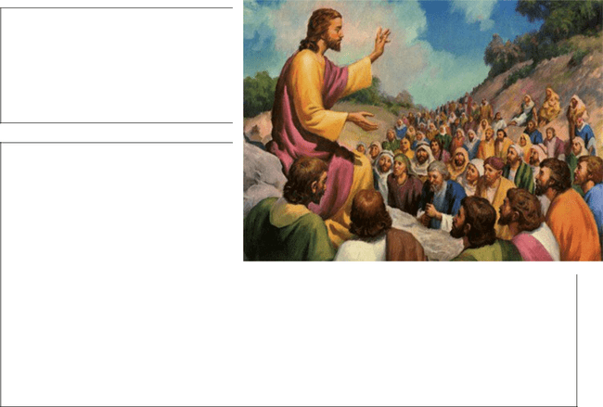

Matt. 4:4 “4 But He replied, It has been written, Man shall not live and be upheld and sustained by bread alone, but by every word that comes forth from the mouth of God.”

Matt. 5:21 -22 “21 You have heard that it was said to the men of old, You shall not kill, and whoever kills shall be liable to and unable to escape the punishment imposed by the court.

22 But I say to you that everyone who continues to be angry with his brother or harbors malice (enmity of heart) against him shall be liable to and unable to escape the punishment imposed by the court; and whoever speaks contemptuously and insultingly to his brother shall be liable to and unable to escape the punishment imposed by the Sanhedrin, and whoever says, You cursed fool! [You empty-headed idiot!] shall be liable to and unable to escape the hell (Gehenna) of fire.”


Luke 2:46 “46 After three days they found Him [came upon Him] in the [court of the] temple, sitting among the teachers, listening to them and asking them questions.”

Yeshua sets an example of how one should teach. The word comes from the

Greek word “didasko” (Strong’s G1321) and means:

  - to instruct,

  - to deliver a discourse,
  - To impart knowledge.

- They marvelled at what Yeshua said not what act / performance He gave.

- They received training in an informal way, more of a classroom situation where people can ask questions than a speech delivered to a room full of people.

Matthew 13:11 “11 And He replied to them, To you it has been given to know the secrets and mysteries of the kingdom of heaven, but to them it has not been given.

145

Luke 2:46 “46 After three days they found Him [came upon Him] in the [court of the] temple, sitting among the teachers, listening to them and asking them questions.

Matthew 8:10 “10 When Jesus heard him, He marveled and said to those who followed Him [who adhered steadfastly to Him, conforming to His example in living and, if need be, in dying also], I tell you truly, I have not found so much faith as this with anyone, even in Israel.

- The teacher usually sat down while teaching i.e. it’s not a case of someone standing high up on a platform.

Matthew 5:1 “1 SEEING THE crowds, He went up on the mountain; and when He was seated, His disciples came to Him.

Matthew 15:29 “29 And Jesus went on from there and passed along the shore of the Sea of Galilee. Then He went up into the hills and kept sitting
there.

Luke 4:20 “20 Then He rolled up the book and gave it back to the attendant and sat down; and the eyes of all in the synagogue were gazing [attentively] at Him.

While teaching is a gift:


- the way in which you teach, and

- what you should be teaching

is in fact a Commandment – there is a protocol to be followed. This is not a burden but in fact a template for you to use.

Exodus 18:20 “20 Teaching them the decrees and laws, showing them the way they must walk and the work they must do.

The word “teach” – Strongs 2094 – zâhar means

- to gleam

- to enlighten

- to admonish

The word “show them” – Strongs 3045 – yâda means

- to know by properly understanding what you see and making the decision to apply the principle.

146

The word “way” – Strongs 1870 – “derek” - means


- the road that must be trodden.

The word “teach” – Strongs 3925 – hâmad means:

- to goad (by implication push / shove / drag)

Deuteronomy 4:1 “1 NOW LISTEN and give heed, O Israel, to the statutes and ordinances which I teach you, and do them, that you may live and go in and possess the land which the Lord, the God of your fathers, gives you.

Deuteronomy 5:31 “31 But you [Moses], stand here by

Me, and I will tell you all the commandments and the statutes and the precepts which you shall teach them, that they may do them in the land which I give them to possess.

The word teach – Strongs - 3384 – “yârah” means

- to flow as water

- to lay or shoot an arrow

Deuteronomy 33:10 “10 [The priests] shall teach Jacob Your ordinances and Israel Your law. They shall put incense before You and whole burnt offerings upon Your altar.

Summary

The teacher

must
gleam, admonish, know, goad, shoot
the
understanding of the Commandments / statutes and judgement
into
the hearts and minds of others so that they
do
what they have learnt and walk on the road set out for them.

How will we see if this goal has been reached?

- The followers will observe the Commandments

Matthew 28:20 “20 Teaching them to observe everything that I have commanded you , and behold, I am with you all the days (perpetually, uniformly, and on every occasion), to the [very] close and consummation of the age. Amen (so let it be).

147

Acts 15:35 “35 But Paul and Barnabas remained in Antioch and with many others also continued teaching and proclaiming
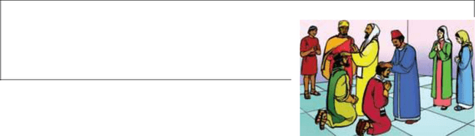
the good news, the Word of the Lord [concerning the attainment through Christ of eternal salvation in God’s kingdom].

- The followers will go to war for God’s cause

Jude 3:2 “1 Beloved, my whole concern was to write to you in regard to our common salvation. [But] I found it necessary and was impelled to write you and urgently appeal to and exhort [you] to contend for the faith which was once for all handed down to the saints [the faith which
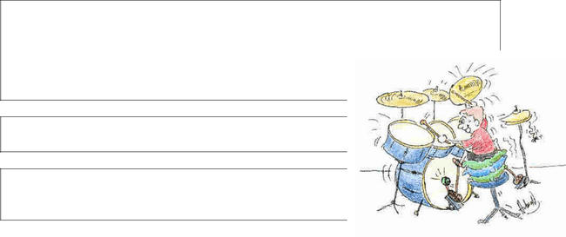
is that sum of Christian belief which was delivered verbally to the holy people of God].

Psalm 18:34 “34 He teaches my hands to war, so that my arms can bend a bow of bronze.

Psalm 144:1 “1 BLESSED BE the Lord, my Rock and my keen and firm Strength, Who teaches my hands to war and my fingers to fight—

- The followers will walk in Godly Wisdom

Job 32:7 “7 I said, Age should speak, and a multitude of years should teach wisdom [so let it be heard].

Psalm 34:11 “11 Come, you children, listen to me; I will teach you to revere and worshipfully fear the Lord.

- The followers will preach to the gentiles

1 Timothy 2:7 “7 And of this matter I was appointed a preacher and an apostle (special messenger)—I am speaking the truth in Christ, I do not falsify [when I say this]—a teacher of the Gentiles in [the realm of] faith and truth.

2 Timothy 1:11 “11 For [the proclaiming of] this [Gospel] I was appointed a herald (preacher) and an apostle (special messenger) and a

teacher of the Gentiles.

- The followers will possess their land

Exodus 18:20 “20 Teaching them the decrees and laws, showing them the way they must walk and the work they must do.

148

PURPOSE:

The teacher has been given the power over the principle of responsibility. This is an inner strength to search for the truth, but realizing it is a step-by-step growth process (God continually expands understanding / teaching.
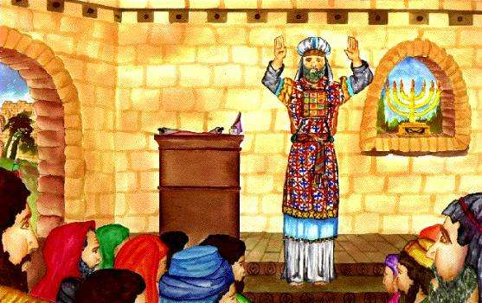

The teacher is likened to the Priests, those who stay in the tabernacle and provide spiritual nourishment to enthrone Yeshua.

The restoration of the principle of responsibility is manifested in the teacher:

- By the nature of the presentation, the richness of the detail and the organization of the facts.

- By the use of Biblical illustrations as a initial phase but also the use of practical or life-event illustrations so that the image is recorded clearly.

- By the emphasis on truth as the basis or foundation for all life choices.

Acts 18:26 “26 He began to speak freely (fearlessly and boldly) in the synagogue; but when Priscilla and Aquila heard him, they took him with them and expounded to him the way of God more definitely and accurately.”


- by the choice to disciple a group of people rather than take part in a mass evangelization project.

- by the presentation of God’s Word in such a way to say / imply that this

“truth” will have the power to change a person’s life, i.e. God’s Word and

practical application must challenge every believer to react.

Proverbs 2:1-8 “1 MY SON, if you will receive my words and treasure up my commandments within you,
2 Making your ear attentive to skillful and godly Wisdom and inclining and directing your heart and mind to understanding [applying all your powers to the quest for it];

3 Yes, if you cry out for insight and raise your voice for understanding,
4 If you seek [Wisdom] as for silver and search for skillful and godly Wisdom as for hidden treasures,
5 Then you will understand the reverent and worshipful fear of the Lord and find the knowledge of [our omniscient] God.

149

6 For the Lord gives skillful and godly Wisdom; from His mouth come knowledge and understanding.
7 He hides away sound and godly Wisdom and stores it for the righteous (those who are upright and in right standing with Him); He is a shield to those who walk uprightly and in integrity,
8 That He may guard the paths of justice; yes, He preserves the way of His saints.

Proverbs 4:1-5 “1 HEAR, MY sons, the instruction of a father, and pay attention in order to gain and to know intelligent discernment, comprehension, and interpretation [of spiritual matters].
2 For I give you good doctrine [what is to be received]; do not forsake my teaching.
3 When I [Solomon] was a son with my father [David], tender and the only son in the sight of my mother [Bathsheba],

4 He taught me and said to me, Let your heart hold fast my words; keep my commandments and live.
5 Get skillful and godly Wisdom, get understanding (discernment, comprehension, and interpretation); do not forget and do not turn back from the words of my mouth.

HOW DO WE IDENTIFY THE TEACHER?

Someone:

- who validates truth, making sure that the concept is sound.

Proverbs 17:3 “3 The refining pot is for silver and the furnace for gold, but the Lord tries the hearts.

Proverbs 17:8 “8 A bribe is like a bright, precious stone that dazzles the eyes and affects the mind of him who gives it; [as if by magic] he prospers, whichever way he turns.


- who is a safe person emotionally (does not reject people easily).

- with deep loyalty to others.

- who is likened to a tree, i.e. will stand through tough circumstances because they are self-controlled and self-disciplined and through it all, has the ability to anoint and reproduce others who reflect the “Light” of God.

Proverbs 18:4 “4 The words of a [discreet and wise] man’s mouth are like deep waters [plenteous and difficult to fathom], and the fountain of skillful and godly Wisdom is like a gushing stream [sparkling, fresh, pure, and life-giving].

150

Proverbs 18:15 “15 The mind of the prudent is ever getting knowledge, and the ear of the wise is ever seeking (inquiring for and craving) knowledge. Proverbs 24:3-6 “3 Through skillful and godly Wisdom is a house (a life, a home, a family) built, and by understanding it is established [on a sound and good foundation],

4 And by knowledge shall its chambers [of every area] be filled with all precious and pleasant riches.
5 A wise man is strong and is better than a strong man, and a man of knowledge increases and strengthens his power;
6 For by wise counsel you can wage your war, and in an abundance of counselors there is victory and safety.

- who has strong convictions based on their study and understanding of the “facts” of the Bible.

Proverbs 19:8 “8 He who gains Wisdom loves his own life; he who keeps understanding shall prosper and find good.

- who will seldom have superficial friendships,

they hate meaningless chit-chat and will be intense in their debate on the Word of God

THE SELF-IMAGE OF THE TEACHER:

Teachers tend to be very calm and collected in their thoughts as well as their emotional status, so much so, that in many ways they appear as if they are not able to express positive or negative emotions very easily.

Generally a teacher will have a good self-image. Because they are ruled by thoughts instead of emotions, they are able to deal with rejection and other negative events that occur.

The teacher is realistic about most things in life because he bases his opinion on facts – however he can become

dogmatic and will only change his mind based on a new set of “facts”.

The teacher will always ask “why?” and will often not participate in a process unless he has got the level of clarification that he requires.

151

CRITICAL SUCCESS FACTORS:


The teacher must have a strong prayer life, an intimacy with God in order to respond to the leading of the Spirit.

The teacher must guard against the potential problem that they fall into the trap of teaching facts and information, i.e. head knowledge without God’s Heart, they need to be able to reveal the practical application

of God’s Word in real life situations so that the Word is relevant.

The teacher who does not have intimacy with God is likened to a crippled priest, i.e. someone who can’t be a part of the tabernacle. The teacher who becomes legalistic / dogmatic robs the Body of Messiah of the intimacy of the Holy Spirit.

The teacher must be prepared to confront others in love who are not embracing the truth or are using scripture out of context.

However at the same time they must be prepared to be open-minded to study and accept other people’s viewpoints.


The teacher must learn to be disciplined with time, relationships and money, if they have the tendency to be undisciplined in these important aspects of a Godly lifestyle, they will not reflect God’s Love for others.

PRACTICAL APPLICATION:

The teacher has a responsibility to hear, study, interpret the Word of God by seeking His Face and His Revelation.
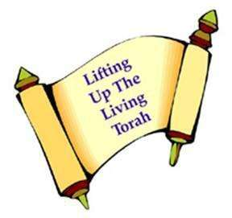

Proverbs 16:20 “20 He who deals wisely and heeds [God’s] word and counsel shall find good, and whoever leans on, trusts in, and is confident in the Lord—happy, blessed, and fortunate is he.


Proverbs 16:23 “23 The mind of the wise instructs his mouth, and adds learning and persuasiveness to his lips.


Proverbs 16:24 “24 Pleasant words are as a honeycomb, sweet to the mind and healing to the body.

152

Equally important, the teacher must interface with his fellow man. It is not good enough merely to preach the message but the teacher must take an active part in the process to implement the principle to see that the captives are set free.

Proverbs 15:23 “23 A man has joy in making an apt answer, and a word spoken at the right moment—how good it is!
24 The path of the wise leads upward to life, that he may avoid [the gloom] in the depths of Sheol (Hades, the place of the dead).

Proverbs 22:6 “6 Train up a child in the way he should go [and in keeping with his individual gift or bent], and when he is old he will not depart from it.
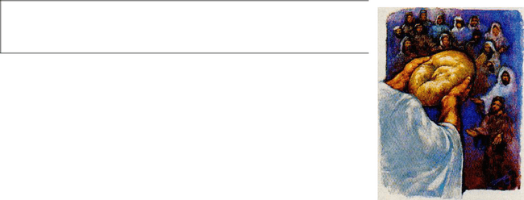

The teacher can preach about feeding the hungry while ignoring the social injustice / corruption in the community. This will be a sin.

The teacher must live the Word, anything less is deception, legalism and a religious spirit.

Domain of Personal Warfare:

The teacher must above all set an example of the good citizen reaching out to others and must guard against the tendency to withdraw from society.

The teacher must set practical examples to take a stand against:

- Any form of emotional irresponsibility where people do things only for themselves or for the wrong reasons – self-centeredness.

- any form of a “welfare spirit”:

- Where people expect you to do things for them,

- Where you pass your responsibility onto others,

- Where you try to control others,

I.e. all ministries must work through a local church is such a form of control.

- Any form of behaviour which is a violation of the law and other people’s rights but which does not cause direct damage, e.g. coming late for a meeting.

- Acts of habitual criminal nature which steals the community’s rights of respect and freedom.

153

The teacher must strive to:
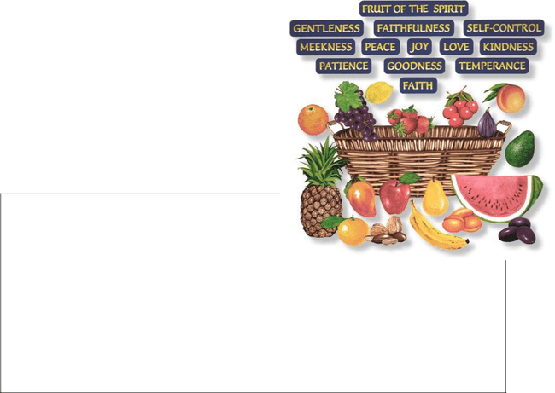

- Help others achieve their purpose in life.

- Help others who don’t necessarily want to change, e.g. prison ministry.

Sign of the Holy Spirit:

The “Fruit of the Spirit” would seem to reflect the teacher in the Holy Spirit.

Gal. 5:16-26 “22 But the fruit of the [Holy] Spirit [the work which His presence within accomplishes] is love, joy (gladness), peace, patience (an even

temper, forbearance), kindness, goodness (benevolence), faithfulness,
- Gentleness (meekness, humility), self-control (self-restraint, continence). Against such things there is no law [that can bring a charge].
- And those who belong to Christ Jesus (the Messiah) have crucified the flesh (the godless human nature) with its passions and appetites and desires.

- If we live by the [Holy] Spirit, let us also walk by the Spirit. [If by the Holy Spirit we have our life in God, let us go forward walking in line, our conduct controlled by the Spirit.]”

THE ATTACKS AGAINST THE GIFT OF TEACHER:


1. Influence of Parenting:

A father is called to role-model a lifestyle of loving relationship where family members and friends are treated equally, with respect and accepted in love.

A father who fails in this role, will create the foundation where the child will be filled with pride,

intolerant to others who are not as smart, and unteachable in respect of different viewpoints.

Prov. 11:2 “2 When swelling and pride come, then emptiness and shame come also, but with the humble (those who are lowly, who have been pruned or chiseled by trial, and renounce self) are skillful and godly Wisdom and soundness.”

A teacher who has this wrong role-model will also be too focused in life; the only thing that matters will be their own interests. The father should make sure that the teacher strives to live a balanced life.

154

A parent who has not shown love, acceptance and compassion will cause the teacher (normally safe person) to be unwilling to proceed until they are hundred percent sure of themselves and cause them to use “facts” in manipulation and not in deliverance, i.e. they will operate with a religious spirit.

The teacher can easily develop a sense of personal pride in the knowledge they have.


1 Cor. 8:1 “1 NOW ABOUT food offered to idols: of course we know that all of us possess knowledge [concerning these matters. Yet mere] knowledge causes people to be puffed up (to bear themselves loftily and be proud), but love (affection and goodwill and benevolence) edifies and builds up and encourages one to grow [to his full stature].”


A teacher, who is unsure of his own sense of self-worth, will become dogmatic and controlling, using the Word as a basis for rules.

2. Influence of Woundedness:


Teachers are best described with words which define the following attributes:

x intelligent,

x honest,

x diligent,

x Dependable.

Because teachers are focused on facts rather than emotions, they seldom (less than 10%) are affected by wounds of rejection or trauma. However if those hurts

are prolonged over a time (e.g. by an abusive parent), it will impact on the teacher’s ability to trust easily.

A teacher that has been wounded and rejected will seek to impose himself on the Body by the intensity of the research. He will also be hampered from speaking freely and probably hold back until he is

absolutely sure of the facts – this insecurity will mean that people do not get the manna that they need.

He will also lack focus and will continually be side-tracked by any new subject of interest.

155

3. Generational / Spiritual:

We have chosen to proclaim the blessing in this paragraph. We have not gone into the details or described the negative consequences on the life of believers which is caused by the negative impact of generational curses.


Please note that if this gift has been rejected / abused by the previous generations, then the gift will operate in the exact opposite way in which it should and the effect / impact thereof will be multiplied in the following generations (i.e. by my parents).

The teacher has the authority to see God’s Footprint in the Word, to experience God’s Presence and then incrementally reveal God’s Character.

Root iniquity: The teacher who only desires to have selected responsibility, i.e. “I only move and do things in my area of expertise.”


Teacher’s reward!!

156

4. THE GIFT OF THE EXHORTER

Yeshua as Exhorter:


Luke 6:27-35 “27 But I say to you who are listening now to Me: [in order to heed, make it a practice to] love your enemies, treat well (do good to, act nobly toward) those who detest you and pursue you with hatred,

28 Invoke blessings upon and pray for the happiness of those who curse you, implore God’s blessing (favor) upon those who abuse you [who revile, reproach, disparage, and high-handedly misuse you].

29 To the one who strikes you on the jaw or cheek, offer the other jaw or cheek also; and from him who takes away your outer garment, do not withhold your undergarment as well.

30 Give away to everyone who begs of you [who is in want of necessities], and of him who takes away from you your goods, do not demand or require them back again.
31 And as you would like and desire that men would do to you, do exactly so to them.
32 If you [merely] love those who love you, what quality of credit and thanks is that to you? For even the [very] sinners love their lovers (those who love them).
33 And if you are kind and good and do favors to and benefit those who are kind and good and do favors to and benefit you, what quality of credit and thanks is that to you? For even the preeminently sinful do the same.
34 And if you lend money at interest to those from whom you hope to receive, what quality of credit and thanks is that to you? Even notorious sinners lend money at interest to sinners, so as to recover as much again.
35 But love your enemies and be kind and do good [doing favors so that someone derives benefit from them] and lend, expecting and hoping for nothing in return but considering nothing as lost and despairing of no one; and then your recompense (your reward) will be great (rich, strong, intense, and abundant), and you will be sons of the Most High, for He is kind and charitable and good to the ungrateful and the selfish and wicked.”

Matt. 19:21 “21 Jesus answered him, If you would be perfect [that is, have that spiritual maturity which accompanies self-sacrificing character], go and sell what you have and give to the poor, and you will have riches in heaven;; and come, be My disciple [side with My party and follow Me].”

John 18:37 “37 Pilate said to Him, Then You are a King? Jesus answered, You say it! [You speak correctly!] For I am a King. [Certainly I am a King!] This is why I was born, and for this I have come into the world, to bear witness to the Truth. Everyone who is of the Truth [who is a friend of the Truth, who belongs to the Truth] hears and listens to My voice.”

157

TORAH EXAMPLE OF EXHORTATION

The children of Israel have been given the chance to go into Canaan but the ten spies tell of major problems that will be encountered.
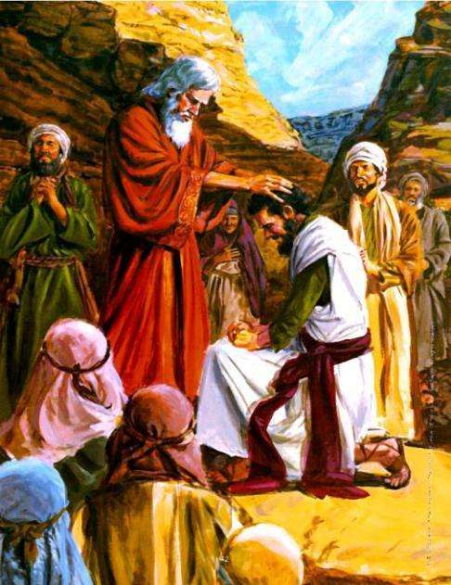

Moses is given the instruction to encourage (strengthen, fortify, make courageous) one of the remaining two spies (Joshua) because he will later lead the descendents into the land.

Deuteronomy 1:38 “38 But Joshua son of Nun, who stands before you, he shall enter there. Encourage him, for he shall cause Israel to inherit it.


Deuteronomy 3:28 “28 But charge Joshua , and encourage and strengthen him, for he shall go over before this people and he shall cause them to possess the land which you shall see.


Hezekiah, the king of Israel, encourages the people to observe the Commandments and judgements of God after he had re-instated the temple system.

2 Chronicles 35:2 “2 He appointed the priests to their positions and encouraged them in the service of the house of the Lord.

Every day people helped and encouraged one another.

Isaiah 41:6 “6 They help everyone his neighbor and say to his brother [in his tiresome idol making], Be of good courage!
7 So the carpenter encourages the goldsmith, and he who smooths [the metal] with the hammer [encourages] him who smites the anvil, saying of the soldering, That is good! And he fastens it with nails so that it cannot be moved.

Judges 20:22 “22 But the people, the men of Israel, took courage and strengthened themselves and again set their battle line in the same place where they formed it the first day.

Young men who will be leaders in later years were given the attributes and examples of exhortation.

Titus 1:9 “9 He must hold fast to the sure and trustworthy Word of God as he was taught it, so that he may be able both to give stimulating instruction and encouragement in sound (wholesome) doctrine and to refute and convict those who contradict and oppose it [showing the wayward their error].

158

Titus 2:6-9 “6 In a similar way, urge the younger men to be self-restrained and to behave prudently [taking life seriously].
7 And show your own self in all respects to be a pattern and a model of good deeds and works, teaching what is unadulterated, showing gravity [having the strictest regard for truth and purity of motive], with dignity and seriousness.

Hebrews 13:22 “22 I call on you, brethren, to listen patiently and bear with this message of exhortation and admonition and

encouragement, for I have written to you briefly.

THE TORAH: DEFINITION OF A TRUE EXHORTER

We acknowledge that the Exhorter is an important gift to the Body of Messiah. It is therefore important that we understand what exhortation means and what the limitation or problems can be.

Exhortation is made of three different, yet interflowing, facets:

(a) to comfort


Acts 9:31 “31 So the church throughout the whole of Judea and Galilee and Samaria had peace and was edified [growing in wisdom, virtue, and piety] and walking in the respect and reverential fear of the Lord and in the consolation and exhortation of the Holy Spirit, continued to increase and was multiplied.


(b) to exhort

Romans 12:8 “8 He who exhorts (encourages), to his exhortation; he who contributes, let him do it in simplicity and liberality; he who gives aid and superintends, with zeal and singleness of mind; he who

does acts of mercy, with genuine cheerfulness and joyful eagerness.

1 Timothy 4:13 “13 Till I come, devote yourself to [public and private] reading, to exhortation (preaching and personal appeals), and to teaching and instilling doctrine.

(c) to console someone

2 Corinthians 1:5-7 “5 For just as Christ’s [own]

sufferings fall to our lot [as they overflow upon His disciples, and we share and experience them] abundantly, so through Christ comfort (consolation and encouragement) is also [shared and experienced] abundantly by us.

159

6 But if we are troubled (afflicted and distressed), it is for your comfort (consolation and encouragement) and [for your] salvation; and if we are comforted (consoled and encouraged), it is for your comfort (consolation and encouragement), which works [in you] when you patiently endure the same evils (misfortunes and calamities) that we also suffer and undergo.
7 And our hope for you [our joyful and confident expectation of good for you] is ever unwavering (assured and unshaken); for we know that just as you share and are partners in [our] sufferings and calamities, you also share and are partners in [our] comfort (consolation and encouragement).

THREE MARKS OF AN EXHORTER

Interesting the criteria for an Exhorter are all warnings on what it should not be.

We find this definition as follows:

1 Thessalonians 2:3 “3 For our appeal [in preaching] does not [originate] from delusion or error or impure purpose or motive, nor in fraud or
deceit.

- An Exhorter should be without deceit

We see that this warning cover things such as


  - fraudulence

  - straying from orthodoxy

  - delusion (2 Tim 2:3)

  - deceiving (Eph 4:14)

  - error (Rom 1:27 / Jude 11 / James 5:2)

- An Exhorter should be without uncleanness (opposite of purity)

We are admonished not to minister to any corrupt passions


Romans 8:12 “12 So then, brethren, we are debtors, but not to the flesh [we are not obligated to our carnal nature], to live [a life ruled by the standards set up by the dictates] of the flesh.

13 For if you live according to [the dictates of] the flesh, you will surely die. But if through the power of the [Holy] Spirit you are [habitually] putting to death (making extinct, deadening) the [evil] deeds prompted by the body, you shall [really and genuinely] live forever.

160

(3) An Exhorter should be without guile

We are very specifically pointed to the habit of lying, being false, of laying bait.


Romans 1:29 “29 Until they were filled (permeated and saturated) with every kind of unrighteousness, iniquity, grasping and covetous greed, and malice. [They were] full of envy and jealousy, murder, strife, deceit and treachery, ill will and cruel ways. [They were] secret backbiters and gossipers,


Revelation 14:5 “5 No lie was found to be upon their lips, for they are blameless (spotless, untainted, without blemish) before the throne of God.
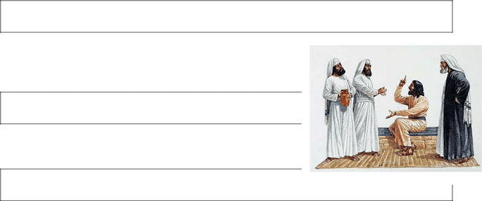

We also see that this includes:

- craft

Matthew 14:1 “1 AT THAT time Herod the governor heard the reports about Jesus,

- subtlety

Matthew 26:4 “4 And consulted together in order

to arrest Jesus by stratagem secretly and put Him to death.

PURPOSE:


The Exhorter is called on, to exercise control over the principle of pain and suffering, to use their ability to interact with many people to open their hearts to God’s plan for them, to see beyond the circumstance that others are currently living in, to develop the potential of the individual and the land.

In practical terms the purpose of the exhorter will be revealed in the following ways:


- By describing or prescribing a how-to-do-it list, they will advocate acting on some concept rather than by building a foundation of truth by facts.

- By the encouragement of others to live life “victoriously”, they will always be challenging the level of potential of others.

161

Proverbs 25:11 “11 A word fitly spoken and in due season is like apples of gold in settings of silver.
12 Like an earring or nose ring of gold or an ornament of fine gold is a wise reprover to an ear that listens and obeys.
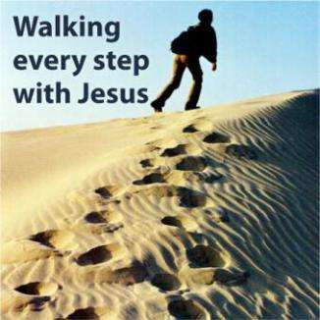

- Finding out what “works” for them through experience and then checking to see if they can validate this experience in Biblical terms.

- By living life of what they believe, instead of just talking the talk, i.e. to demonstrate their faith in practical ways.

Proverbs 27:10 “10 Your own friend and your father’s friend, forsake them not;; neither go to your brother’s house in the day of your calamity. Better is a

neighbor who is near [in spirit] than a brother who is far off [in heart].

- By the way in which they accept people (who are not perfect) and do not judge them, but love, accept and forgive them.

HOW DO WE IDENTIFY THE EXHORTER?

Someone who:

- is very horizontal / relational – they are always ready for a party, skilled at maintaining relationship at all cost.

- can easily talk to people they have never met – they have the ability to make people like them.

- is a master communicator, capable of having loud arguments.

- is not intimidated by new ideas, quick to see opportunity and/or abandon other plans.

- Takes opinion poles to find out what the majority think, before aggressively pursuing the

consensus idea, they will apply a truth without doing any research in to the subject matter.

- Who love to do personal counselling, but will equally quickly discontinue this if they do not see effort to change.

- Who want to clear up problems with others  quickly, even to the extent that they will take the blame to put the relationship in right standing.

162

THE SELF-IMAGE OF THE EXHORTER:

Generally the Exhorter will have a good self-image, because of their positive attitude and friendly disposition they will treat all problems as if they belong somewhere “else”.


The Exhorter will often resort to compromise, i.e. live and let live in order that they can retain their level of popularity.

Exhorters will also show a streak of independence, even a level of rebellion to authority figures.

They like to think that their ability to talk in every situation will get authority figures to change their minds on a decision that has already been made.

Exhorters exhibit some degree of temper tantrum – they will let you know if they don’t get their way in a situation.

CRITICAL SUCCESS FACTORS:

- The Exhorter must go regularly to God for direction, without God’s True Word they have nothing to put into the “place” that they have opened up in the hearts and minds of others.

They must take control of their “good intentions” and leave God to do the work or else they will pull people along a man-made plan just like the gravitation pull of the moon on the sea;; the “I-know-it-all / every situation” mentality.

They must not only surround themselves with people that are weaker or in need of them, but must submit to Godly leadership.

Proverbs 11:9 “9 With his mouth the godless man destroys his neighbor,


but through knowledge and superior discernment shall the righteous be delivered.

Proverbs 11:12 “12 He who belittles and despises his neighbor lacks sense, but a man of understanding keeps silent.

13 He who goes about as a talebearer reveals secrets, but he who is trustworthy and faithful in spirit keeps the matter hidden.

- The Exhorter must learn to be careful to speak only the minimum number of words which would adequately describe what God has told them to say.

Their willingness to add additional words to “explain” can cause wounds in the hearts of other people.

Proverbs 16:28 “28 A perverse man sows strife, and a whisperer separates close friends.

163

Proverbs 20:19 “19 He who goes about as a talebearer reveals secrets; therefore associate not with him who talks too freely.


Proverbs 29:5 “5 A man who flatters his neighbor spreads a net for his own feet.

PRACTICAL APPLICATION:

The Exhorter has the function to sow words of

life and direction into broken people to produce long-term enduring change.

It takes hard work, good communication, love, dedication, diligence and integrity to break through the levels of pain in order to get to the many facets of God’s principles that are needed to bring the restoration to each person.

The Exhorter is highly blessed with skills to relate to man – so much so that they can easily “fool” others.

God’s principles over matter and the spiritual domain remain fixed;; God does not change His Mind and is not fooled by the mask that the exhorter presents.

The Exhorter will have to guard against the escapism of turning to physical comforts of hospitality, wine, food, the world of denial and the opportunity to claim a harvest where they have not sown a crop.


Domain of Personal Warfare:

The Exhorter can easily turn to comforts and denial and in the process present a mask of holiness to fellow man.

The Exhorter must therefore make a stand / speak out against:

- Any acts where people try to smooth ruffled feathers by acts of manipulation or to gain materially/ positionally by such actions.

- Any proposals to suggest that “my” way is the easy way out of a problem.

- Any form of acts where my personal failure are put onto the backs of other believers or where we use the spirit of denial to
create a better image of situation.

- Any form of acts of hypocrisy, where I pretend that I have made a real effort to meet your need.

- Any proclamation that there are no consequences for my kind of sin, i.e. gluttony is okay.


164

- A spirit of entitlement – one where my needs dictate a right to be treated in a specific manner.

The Exhorter must proclaim:

- the commitment to live in reality of the pain that I may have caused.

- that I will invest time into my own growth.

Sign of the Holy Spirit:


The “Wind” of God would seem to reflect the gift of Exhorter for the Holy Spirit.

Gen. 1:2 “2 The earth was without form and an empty waste, and darkness was upon the
face of the very great deep. The Spirit of God was moving (hovering, brooding) over the face of the waters.”

THE ATTACKS AGAINST THE EXHORTER:

1. Influence of Parenting:

A father must teach the Exhorter that all people are equal, have the right to be heard / considered and have feelings / emotional responses that are different from others.

A father who fails in this role-modelling will produce an Exhorter who will be prone to dominating conversations and going so far as to give uncalled for advice.


Fathers must challenge the exhorters to be bound to the truth, to the facts or else we will see a trend where every event or story will be embellished with exaggerations / manipulation of the truth added to add colour to the situation.

The parent who does not discipline and build a strong foundation of principles and values, etc and a work ethic, will release an immature Exhorter into the world.


Characteristics of this immaturity are:

- Interrupting others to give your own opinion / advice.

- Becoming overly self-confident / opinionated.

- Using scripture out of context to prove a point.

165

God often has to force them into isolation and force revelation onto them to get anywhere (Moses, Paul, Jeremiah).

Note: All the Exhorters in the Bible have been subjected to this painstaking isolation (wilderness experience) to get them to a place of brokenness before God.


If you have not been there, you need to be careful of the use of your gift.

2. Influence of Woundedness (Battlefield is time):

The Exhorter’s friendly / happy nature and “let’s live” attitude means that they seldom have wounds.
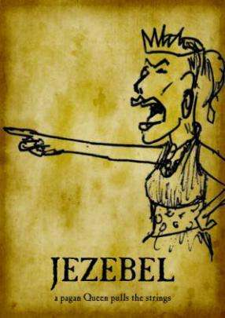

When authority figures cause wounds, rejection, e.g. not being there, molestation, or any other acts of commission or omission, the person can easily take a vow never to be under authority of someone else and then move into the domain of Jezebel.

In the extreme case, the level of control can be of such a nature the absolute havoc is caused using manipulation or overt power.

This woundedness will cause the exhorter to govern in a

group setting instead of confronting on an individual basis. Their judgement will be likened to the sun that burns day after day without singling anyone person out.

It is not wrong to be a mobilizer, but God wants it to happen supernaturally.

World changers, who do not walk in holiness, scar the Body of Yeshua.

3. Generational / Spiritual:


We have chosen to proclaim the blessing in this paragraph. We have not gone into the details or described the negative consequences on the life of believers which is caused by the negative impact of generational curses.

Please note that if this gift has been rejected / abused by the previous generations, then the gift will operate in the exact opposite way in which it should and the effect / impact thereof will be multiplied in the following generations (i.e. by my parents).

Root Iniquity: The stronghold of denial, and the inability to accept responsibility for what I have done.

166

5. GIFT OF THE GIVER:

Yeshua as Giver:
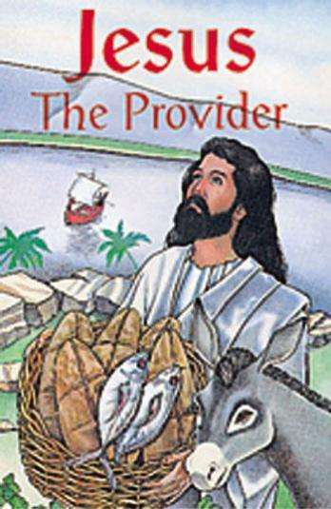

Mark 6:41 “41 And taking the five loaves and two fish , He looked up to heaven and, praising God, gave thanks and broke the loaves and kept on giving them to the disciples to set before the people; and He [also] divided the two fish among [them] all.”


John 15:13 “13 No one has greater love [no one has shown stronger affection] than to lay down (give up) his own life for his friends.”


PRINCIPLES OF THE GIVER’S ROLE IN THE TORAH / WORD

It is important to set out some of the Principles of Giving as set out in the Bible so that we can define boundaries of the Giver’s role.

These guidelines are largely from the New Testament as the Old Testament Principles of offering / tithe etc. are set in the context of a personal relationship / a sacrifice before God and a pathway to enter

into intimacy with God.

- A foundational principle is this – only when a man can give willingly and completely of himself, will he be able to give things to other.

2 Corinthians 8:5 “5 Nor [was this gift of theirs merely the contribution] that we expected, but first they gave themselves to the Lord and to us [as His agents] by the will of God [entirely disregarding their personal interests, they gave as much as they possibly could, having put themselves at our disposal to be directed by the will of God]—

- The Giver has been blessed with a gift but the act of giving is in fact a Commandment that they must obey to a higher, more stringent level than others – this does not mean that they give more (it can be so) but their giving must have the highest level of integrity / purity.

Luke 6:38 “38 Give, and [gifts] will be given to you; good measure, pressed down, shaken together, and running over, will they pour into [the pouch formed by] the bosom [of your robe and used as a bag]. For with the measure you deal out [with the measure you use when you confer benefits on others], it will be measured back to you.

167

- To whom should we give? x those who ask
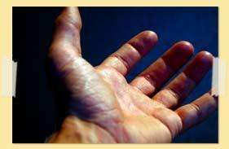
Matthew 5:42 “42 Give to him who keeps on begging from you, and do not turn away from him who would borrow [at interest] from you.


- the needy saints

Romans 12:12 “12 Rejoice and exult in hope; be steadfast and patient in suffering and tribulation; be constant in prayer.


- God

Revelation 14:7 “7 And he cried with a mighty voice, Revere God and give Him glory (honor and praise in worship), for the hour of His judgment has arrived.

Fall down before Him; pay Him homage and adoration and worship Him Who created heaven and earth, the sea and the springs (fountains) of water.

It is important to understand that you give what you can afford after doing justice to the family and the Principle of legacy.

2 Corinthians 9:6-8 “6 [Remember] this: he who sows sparingly and grudgingly will also reap sparingly and grudgingly, and he

who sows generously [that blessings may come to someone] will also reap generously and with blessings.
8 And God is able to make all grace (every favor and earthly blessing) come to you in abundance, so that you may always and under all circumstances and whatever the need be self -sufficient [possessing enough to require no aid or support and furnished in abundance for every good work and charitable donation].

- The Giver must take extreme care not to give into certain areas. x We must never give Holy things to rebellious people.
Matthew 7:6 “6 Do not give that which is holy (the sacred thing) to the dogs, and do not throw your pearls before hogs, lest they trample upon them with their feet and turn and tear you in pieces.

- We must never sow seed into the kingdom of darkness.

168

- What can the Giver give? x Holy things

Matthew 10:8 “8 Cure the sick, raise the dead, cleanse the lepers, drive out demons. Freely (without pay) you have received, freely (without charge) give.


- Things

1 Thessalonians 5:18 “18 Thank [God] in everything [no matter what the circumstances may be, be thankful and give thanks], for this is the will of God for you [who are] in Christ Jesus [the Revealer and Mediator of that will].


Psalm 96:8 “8 Give to the Lord the glory due His Name; bring an offering and come [before Him] into His courts.


- Time

1 Timothy 4:13-15 “13 Till I come, devote yourself to [public and private] reading, to exhortation (preaching and personal appeals), and to teaching and instilling doctrine.

14 Do not neglect the gift which is in you, [that special inward endowment] which was directly imparted to you [by the Holy Spirit] by prophetic utterance when the elders laid their hands upon you [at your ordination].

15 Practice and cultivate and meditate upon these
duties; throw yourself wholly into them [as your

ministry], so that your progress may be evident to everybody.

- Self-completely

1 Timothy 4:15 “15 Practice and cultivate and meditate upon these duties; throw yourself wholly into them [as your ministry], so that your

progress may be evident to everybody.

- Honour to your wife

2 Peter 3:7 “7 But by the same word the present heavens and earth have been stored up (reserved) for fire, being kept until the day of judgment and destruction of the ungodly people.

169

- Glory to God
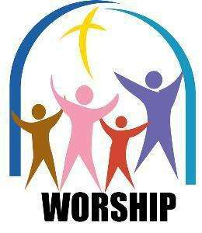

Revelation 14:7 “7 And he cried with a mighty voice, Revere God and give Him glory (honor and praise in worship), for the hour of His judgment has arrived. Fall down before Him; pay Him homage and adoration and worship Him Who created heaven and earth, the sea and the springs (fountains) of water.

- The Giver needs to reflect / role model the following characteristics that reflect God’s intention in respect of the Gift of Giving in the Body of Messiah.

x He must give freely

2 Corinthians 9:6 “6 [Remember] this: he who sows sparingly and grudgingly will also reap sparingly and grudgingly, and he who sows generously [that blessings may come to someone] will also reap generously and with blessings.

- He must give a good measure

Luke 6:38 “38 Give, and [gifts] will be given to you; good measure, pressed down, shaken together, and running over, will they pour into [the pouch formed by] the bosom [of your robe and used as a bag]. For with the measure you deal out [with the measure you use when you confer benefits on others], it will be measured back to you.

- He must give willingly - 2 Corinthians 8:12

- He must give with a purpose - 2 Corinthians 9:7

- He must give cheerfully


2 Corinthians 9:7 “7 Let each one [give] as he has made up his own mind and purposed in his heart, not reluctantly or sorrowfully or under compulsion, for God loves (He takes pleasure in, prizes above other things, and is unwilling to abandon or to do without) a cheerful (joyous, “prompt to do it”) giver [whose heart is in his giving].


170

PURPOSE:

The Giver has been given authority over the principle of stewardship:

- These people have a generational world-view,

- They are intentionally preparing the way for the family after them to accumulate resources.
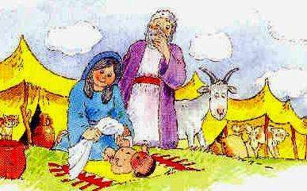

Abraham had wealth, peace and security, but he did not have a son to pass this onto and therefore came back to ask God for Isaac.

Proverbs 13:22 “22 A good man leaves an inheritance [of moral stability and goodness] to his children’s children, and the wealth of the sinner [finds its way eventually] into the hands of the righteous, for whom it was laid up.

Proverbs 20:7 “7 The righteous man walks in his integrity; blessed (happy, fortunate, enviable) are his children after him.


The restoration of God’s Gift of stewardship is manifested in:

- The level of intercession done by the Giver for the needs of others and for the joy which is manifested when his prayers are answered.

- By the quality / excellence of the work, gift

or help that is provided and the amount of careful consideration that is made with the gift.

- By the level / intensity of the hospitality that is extended to others.


Proverbs 13:22 “22 A good man leaves an inheritance [of moral stability and goodness] to his children’s children, and the wealth of the sinner [finds its way eventually] into the hands of the righteous, for whom it was laid up.


171

HOW DO WE IDENTIFY THE GIVER?

The Giver:

- is very independent, has a strong belief in the system of tithes and blessings.


Proverbs 10:4 “4 He becomes poor who works with a slack and idle hand, but the hand of the diligent makes rich.

5 He who gathers in summer is a wise son, but he who sleeps in harvest is a son who causes shame.

- will not be manipulated, they know that you must first get the harvest before you can give, will only give based on the leading of the Holy Spirit.

Proverbs 11:24-26 “24 There are those who [generously] scatter abroad, and yet increase more; there are those who withhold more than is fitting or what is justly due, but it results only in want.
25 The liberal person shall be enriched, and he who waters shall himself be watered.
26 The people curse him who holds back grain [when the public needs it], but a blessing [from God and man] is upon the head of him who sells it.

- is not confrontational by nature.

- will contribute money, time, encouragement, empowerment (i.e. teach the people to fish).
- has a heart for the Kingdom but is seldom an evangelist worker and will also want to delegate spiritual warfare to others.
- is alert to opportunities, has a natural ability toward business.
- is a very private person, will impact others without them knowing about it.


SELF-IMAGE OF THE GIVER:

Givers are generally happy / positive people, but tend to be reserved or shy.

This will mean that Givers will sometimes end up with a poor self-image. Givers who have learnt to talk about issues that they are facing will open up to their circle of friends. Casual acquaintances will not be included in these intimate details and could feel that they are cut off.

The Giver will seldom pick a fight and will avoid arguments.

172

CRITICAL SUCCESS FACTORS:
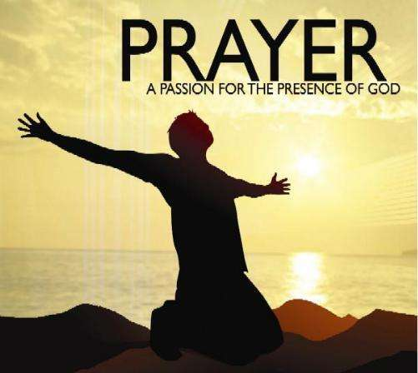

The Giver:

- Must walk in holiness. God promises to provide, but God expects a permanent wall of integrity.

- Must stay in relationship to God, i.e. must know and believe that God is the Source

– and that their blessing / wealth don’t come from their own talents/effort, but from the Hand of God.

Proverbs 12:12 “12 The wicked desire the booty of evil men, but the root of the [uncompromisingly] righteous yields [richer fruitage].

PRACTICAL APPLICATION:

The Giver has a calling to extend God’s Kingdom in his own lifetime as well as in the generations to come.

The overriding concept is to fulfil God’s agenda with God’s resources.

Dealing with the Spirit of Ownership:

The strongholds of fear – driven by Jezebel – that I will fail, will not have enough and control often cause the Giver to take ownership over money / assets instead of exercising authority over money / assets.

Ownership leads to:

- Pride – arrogance in my ability and a win / lose mentality.

- Independent spirit – where I can do it on my own.

- Stinginess – where I set limits on what others can get.

Eventually this manifests in a religious spirit of: “If you do this – God must do that!!!”, i.e. a formula for prosperity.

Domain of Personal Warfare:

The Giver most of all must set out to “subdue the land” to have faith – i.e. knowing that God will provide when we take the risk to step out in obedience, accepting that stewardship means that God has “all the rights”.

173

The Giver must take a stand / speak out against any:

- acts where people live life only for themselves, i.e. they add no value to the community.

- acts of exploitation, i.e. business / sexual / political corruption with the purpose of financial gain.
- acts of wilful theft, vandalism and destruction of other people’s property.

The Giver must proclaim that:

- I am my brother’s keeper.

- I will invest time, emotions and money in family.
- I will claim the land.
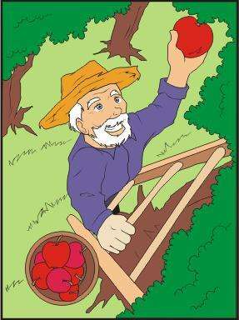

Sign of the Holy Spirit:

The gift of “first fruit” would seem to reflect the influence of the Holy Spirit on the Gift of giving.

Proverbs 3:9 “9 Honor the Lord with your capital and sufficiency [from righteous labors] and with the firstfruits of all your income;

10 So shall your storage places be filled with plenty, and your vats shall be overflowing with new wine

THE ATTACKS AGAINST THE GIFT OF GIVER:

1) Influence of Parents:


The parent who teaches his child that performance, the self, ambition and pride are values, will bring forth an immature Giver who will see his tithes and offerings as a form of tax and will wrestle with God every time he has to give, i.e. he will battle with the question as to who the owner of the asset is.

This type of Giver can easily set out to measure the performance of others by setting standards and pressing them to give.

174

2) Influence of Woundedness:

The Giver can be described with attributes such as:

- hard-working,

- generous,

- honest

- economical

but because they are shy and are not able to open their hearts easily, they will in ±30% of the time be wounded.

A childhood where love and affection was not shown, where they were dominated by a parent, will cause the Giver to retreat even further into his shell.


The spirit of independence:

The wound then comes from believing that my security is provided by my own hand will cause the Giver to struggle with the decision of whether or not he will trust in God.

This woundedness will cause him to decide for himself who should get what and how much, i.e. he will decide what constitutes satisfactory worship; i.e. the gift will always have some strings attached.

Alternatively, we could see an unpredictable pattern of giving emerge, one which is based on the “feelings of the moment”, instead of seeking God’s confirmation on when / what to give.

3. Generational / Spiritual:

We have chosen to proclaim the blessing in this paragraph. We have not gone into the details or described the negative consequences on the life of believers which is caused by the negative impact of generational curses. 


Please note that if this gift has been rejected / abused by the previous generations, then the gift will operate in the exact opposite way in which it should and the effect / impact thereof will be multiplied in the following generations (i.e. by my parents).

As Giver, they have a special anointing to nurture, protect the establishment of a new project / ministry.

Root Iniquity: The desire to control those who I have selected to support.

175

6. GIFT OF RULER

Yeshua as Ruler:


Mark 9:2-3 “2 Six days after this, Jesus took with Him Peter and James and John and led them up on a high mountain apart by themselves. And He was transfigured before them and became resplendent with divine brightness.
3 And His garments became glistening, intensely white, as no fuller (cloth dresser, launderer) on earth could bleach them.”

Mark 3:13-14 “13 And He went up on the hillside and called to Him [for Himself] those whom He wanted and chose, and they came to Him.

14 And He appointed twelve to continue to be with
Him, and that He might send them out to preach [as apostles or special messengers]”

THE RULER

It is clear that those with the Gift of Ruler will be someone who ends up taking up positions of authority or leadership in various places.

We see that God tells us that there is an Officer over the House of God.

Paul writes in his letter to the Corinthian Church how they should run their affairs according to the Torah.


1 Corinthians 9:11 “11 If we have sown [the seed of] spiritual good among you, [is it too] much if we reap from your material benefits?


We also see that where there is no “captain” or leader that the result will be chaos.

Proverbs 6:7 “7 Which, having no chief, overseer, or ruler,


176

Various places as examples in the Word which shows us that people are placed with the gift of Rulership:


1) Over Israel

Micah 5:2 “2 But you, Bethlehem Ephratah, you are little to be among the clans of Judah; [yet] out of you shall One come forth for Me Who is to be Ruler in Israel, Whose goings forth have been from of old, from ancient days (eternity).

Hosea 11:12 “12 Ephraim surrounds Me with lies and the house of Israel with deceit, and Judah is not yet steadfast with God, with the faithful Holy One.

2) Over every city

Matthew 23:1 “1 THEN JESUS said to the multitudes and to His disciples, 2 The scribes and Pharisees sit on Moses’ seat [of authority].
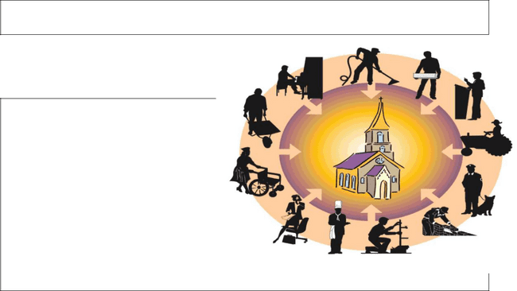

- Over the synagogues (Body of Messiah)

Matthew 5:35-38 “35 Or by the earth, for it is the footstool of His feet; or by Jerusalem, for it is the city of the Great King.

36 And do not swear by your head, for you are not able to make a single hair white or black. 37 Let your Yes be simply Yes, and your No be simply No; anything more than that comes from the evil one.

38 You have heard that it was said, An eye for an eye, and a tooth for a tooth.

- Over the King’s / God’s work - 1 Corinthians 9:16-18

- Over the Principalities of Darkness
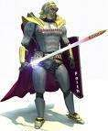

Ephesians 6:12 “12 For we are not wrestling with flesh and blood [contending only with physical opponents], but against the despotisms, against the powers, against [the master spirits who are] the world rulers of this present darkness, against the spirit forces of wickedness in the heavenly (supernatural) sphere.


177

PURPOSE:

The ruler must stand for and attain the spiritual dominion to release powerful generational blessing of freedom to those

who they have been able to call around them.

His righteousness, his sovereign anointing from God and his ability to provide resources to followers, will make him effective – it’s to be about the King’s business.

The restoration of God’s Gift of Rulership and the release of generational freedom is manifested:


- by someone who accepts responsibility for a job only when he has been appointed and given the full delegated authority – however in times of crisis, he will come to the fore to take leadership in a vacuum.

Proverbs 12:24 “24 The hand of the diligent will rule, but the slothful will be put to forced labor.

Proverbs 13:4 “4 The appetite of the sluggard craves and gets nothing, but the appetite of the diligent is abundantly supplied.

- by the excellence and the content of the communication on all matters that affect each level of stake holder.

Proverbs 13:20 “20 He who walks [as a companion] with wise men is wise, but he who associates with [self-confident] fools is [a fool himself and] shall smart for it.


- by the way in which he sees success as a collective achievement, readily giving credit to others for the work that they have accomplished.

Proverbs 14:15-17 “15 The simpleton believes every word he hears, but the prudent man looks and considers well where he is going.

16 A wise man suspects danger and cautiously
avoids evil, but the fool bears himself insolently and is [presumptuously] confident.
17 He who foams up quickly and flies into a passion deals foolishly, and a man of wicked plots and plans is hated.

178

- by the way that he regularly introduces new and / or old techniques to different situations as the need arises.

Matt. 13:52 “52 He said to them, Therefore every teacher and interpreter of the Sacred Writings who has been instructed about and trained for the kingdom of heaven and has become a disciple is like a householder who brings forth out of his storehouse treasure that is new and [treasure that is] old [the fresh as well as the familiar].”


HOW DO WE IDENTIFY THE RULER?


The Ruler:

- is someone who can use imperfect

people to implement and complete the
goal – the vision / the plan / the action.

- is skilled at time-management; is able

to put the pieces of the puzzle together
at the right time.

- pulls together people under a common vision, builds loyalty, he gets people to follow the cause or vision.

Prov. 29:18 “18 Where there is no vision [no redemptive revelation of God], the people perish; but he who keeps the law [of God, which includes that of man]—blessed (happy, fortunate, and enviable) is he.”


- gathers a core of good leaders – he identifies the ability of others, he nurtures and releases people into all aspects of leadership (delegates).

- does not believe in welfare.

- accepts the blame for mistakes and goes about fixing things.

- is an empire builder.


Proverbs 16:12-15 “12 It is an abomination [to God and men] for kings to commit wickedness, for a throne is established and made secure by righteousness (moral and spiritual rectitude in every area and relation).

13 Right and just lips are the delight of a king, and he loves him who speaks what is right.

Proverbs 21:1 “1 THE KING’S heart is in the hand

of the Lord, as are the watercourses; He turns it whichever way He wills.

179

THE SELF-IMAGE OF A RULER:

Generally the Ruler is a well-balanced individual who is extremely capable and has a large circle of friends. Consequently they have strong self-
images.

They are motivated by reason / facts and therefore do not easily allow their feelings to rule them.

Their levels of energy / enthusiasm will be high. Their mode of communication will be via systematic diagrams, drawings or plans.

CRITICAL SUCCESS FACTORS:


- Ruler:

  - must walk in integrity, in holiness, in freedom, in spiritual authority or else they will build a kingdom that will have no legacy.

Proverbs 22:29 “29 Do you see a man diligent and skillful in his business? He will stand before kings; he will not stand before obscure men.


- must be careful that his focus on the goal does not become too intense that he sometimes fails to see the other issues and neglects the people whom he has to serve.

- can’t be neutral, he must walk in holiness.

- must be able to handle a high level of criticism while they go about the job.

- must learn to allow other people to do things in their own level of timing

– the job does not always have to be done today.

PRACTICAL APPLICATION:

The Ruler has the gift to rise up in the opposite spirit to the world where we often hear “all men are equal but some are more equal than other”.

The Ruler recognizes the potential of the people and material, and uses God’s Principles to release the blessing of his gift.


- all people can find God.

- the world is a safe place.
- we can all find our purpose.
- we walk in obedience to God’s Word.

x we move equally with others with clear boundaries. x we leave the world a better place.


180

The Ruler speaks out / stands up against any:
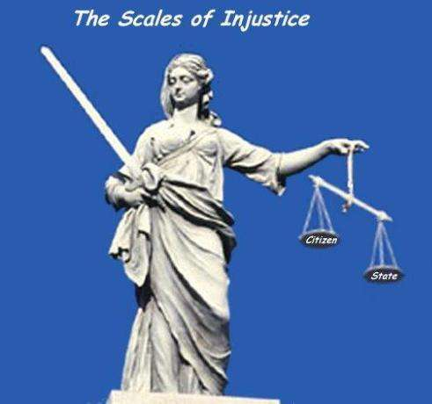

- Spirit of poverty, i.e. the attitude that I can’t make a difference.

- Predatory leadership in the Body of Messiah or business community.

- exploitation at a regional or national level which causes people to be put under bondage / curses, e.g.:

- inadequate education, o land expropriation

o work for alcohol.

The Ruler must proclaim that he will:
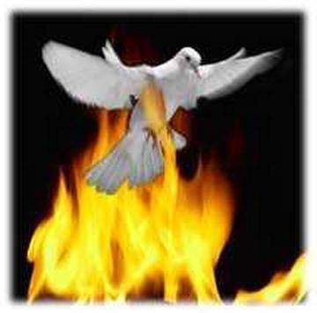

- live for the Kingdom, for future generations.

- “run the good race” (personally and generationally).

Sign of the Holy Spirit:

The “Fire of God” would seem to be reflected in the Holy Spirit’s influence on the gift of Rulership.

THE ATTACKS AGAINST THE GIFT OF RULER:


1. Influence of Parents:

A father needs to set an example of a balanced lifestyle, keeping his word for every commitment made or else the Ruler child will grow up with bad habits of procrastinating when work needs to be done.


They will over-extend themselves by trying to do everything that comes their way and neglect to do that which is mundane and routine.

Parents who have not discipled and disciplined a Ruler fairly will evoke the spirit of a dictator, tyrant, a cruel oppressor, i.e. the predator spirit – e.g. Hitler.

Such a person, instead of leading a group of willing followers, will want to take total control and dominate and will then be in total rebellion to God’s purpose of domination.

This type of ruler will neglect personal and family needs in pursuit of his own goals and wreck havoc on others.

181

- Influence of Woundedness (Battlefield will he be doing what God wants him to do):

The Ruler is defined by the following words:

- responsible,

- honest,

- capable,

and therefore seldom suffers from the wounding of others, unless this is done on a systematic basis by an abusive parent.


Wounds of rejection, boredom and the inappropriate calling to take up an office before you are mature, can lead to:

- the exploitation of others,

- the pursuit of vain things (Solomon).

Inactivity caused due to passiveness (Ahab) will lead to sinful and degrading acts against a fellow human being.

Regular and uncalled for criticism can cause a wounded Ruler to become callous.

3. Generational / Spiritual:

We have chosen to proclaim the blessing in this paragraph. We have not gone into the details or described the negative consequences on the life of believers which is caused by the negative impact of generational curses.

Please note that if this gift has been rejected / abused by the previous generations, then the gift will operate in the exact opposite way in which it should and the effect / impact thereof will be multiplied in the following generations

(i.e. by my parents).

The Ruler has the authority to work together in a team to achieve the highest level of spiritual dominion and thereby create the pace to

release the blessing from one generation to another.

Root Iniquity: the stronghold of exploiting others to achieve the vision / goal, i.e. to be right / successful at all cost.

182

7. THE GIFT OF MERCY

Yeshua as Mercy / Compassion:

Matt. 14:14 “14 When He went ashore and saw a great throng of people, He had compassion (pity and deep sympathy) for them and cured their sick.”

Matt.15:32 “32 Then Jesus called His disciples to Him and said, I have pity and sympathy and am deeply moved for the crowd, because they have been with Me now three days and they

have nothing [at all left] to eat; and I am not willing to send them away hungry, lest they faint or become exhausted on the way.”

Matt. 19:14 “14 But He said, Leave the children alone! Allow the little ones to come to Me, and do not forbid or restrain or hinder them, for of such [as these] is the kingdom of heaven composed.”

John 11:35 “35 Jesus wept.”

MERCY – THE GIFT OF OBEDIENCE

Mercy through grace triumphs over the consequence of Law (the consequence of wrong).


We need to understand that faith without works is dead. And works without faith is dead.

James 2:17-26 “17 So also faith, if it does not have works (deeds and actions of obedience to back it up), by itself is destitute of power (inoperative, dead).

18 But someone will say [to you then], You [say you] have faith, and I have [good] works. Now you show me your [alleged] faith apart
from any [good] works [if you can], and I by [good] works [of obedience] will show you my faith.
19 You believe that God is one; you do well. So do the demons believe and shudder [in terror and horror such as make a man’s hair stand on end and contract the surface of his skin]!

20 Are you willing to be shown [proof], you foolish (unproductive, spiritually deficient) fellow, that faith apart from [good] works is inactive and ineffective and worthless?
21 Was not our forefather Abraham [shown to be] justified (made acceptable to God) by [his] works when he brought to the altar as an offering his [own] son Isaac?

183

22 You see that [his] faith was cooperating with his works, and [his] faith was completed and reached its supreme expression [when he implemented it] by [good] works.

23 And [so] the Scripture was fulfilled that says, Abraham believed in (adhered to, trusted in, and relied on) God, and this was accounted to him as righteousness (as conformity to God’s will in thought and deed), and he was called God’s friend.

24 You see that a man is justified (pronounced righteous before God) through what he does and not

alone through faith [through works of obedience as well as by what he believes].

25 So also with Rahab the harlot—was she not shown to be justified (pronounced righteous before God) by [good] deeds when she took in the scouts (spies) and sent them away by a different route?

26 For as the human body apart from the spirit is lifeless, so faith apart from [its] works of obedience is also dead.

To understand this analogy clearly:

x | a fire can’t burn without fuel | Both are needed
x | fuel without a fire can’t burn | for the effect of fire


Neither faith nor works are complete in themselves.

That is why James can say that those who show mercy will not face judgement.


There is no mercy in judgement – judgement determines a fair result to the “crime”. But because Mercy-gifted people provides of themselves, they will be exalted over judgement.

James 2:13 “13 For to him who has shown no mercy the judgment [will be] merciless, but mercy [full of glad confidence] exults victoriously over judgment.

Attributes of mercy

- forgets injuries - continues good works in spite of ingratitude.

Luke 6:36 “36 So be merciful (sympathetic, tender, responsive, and compassionate) even as your Father is [all these].

- forgives without being asked

James 5:11 “11 You know how we call those blessed (happy) who were steadfast [who endured]. You have heard of the endurance of Job, and you have seen the Lord’s [purpose and how He richly blessed him in the] end, inasmuch as the Lord is full of pity and compassion and tenderness and mercy.

184

Promises of Mercy

Matthew 5:7 “7 Blessed (happy, to be envied, and spiritually prosperous— with life-joy and satisfaction in God’s favor and

salvation, regardless of their outward conditions) are the merciful, for they shall obtain mercy!

Colossians 3:12 “12 Clothe yourselves therefore, as God’s own chosen ones (His own picked representatives), [who are] purified and holy and well-beloved [by God Himself, by putting on behavior marked by] tenderhearted pity and mercy, kind feeling, a lowly opinion of yourselves, gentle ways, [and] patience [which is tireless and long - suffering, and has the power to endure whatever comes, with good temper].

13 Be gentle and forbearing with one another and, if one has a difference (a grievance or complaint) against another, readily pardoning each other; even as the Lord has [freely] forgiven you, so must you also [forgive].

Psalm 18:25 “25 With the kind and merciful You will show Yourself kind and merciful, with an upright man You will show Yourself upright,
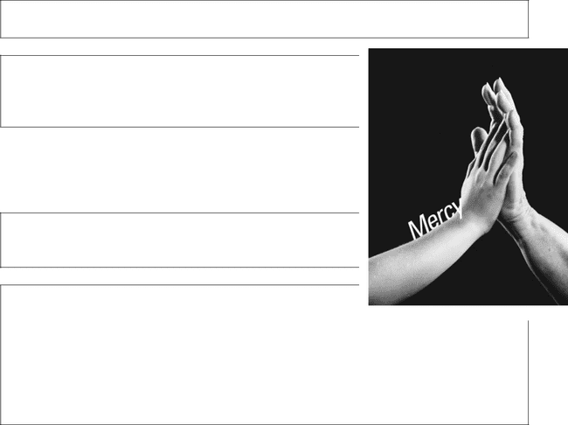

Micah 6:8 “8 He has showed you, O man, what is good. And what does the Lord require of you but to do justly, and to love kindness and mercy , and to humble yourself and walk humbly with your God?

Example of mercy

- God

Luke 6:36 “36 So be merciful (sympathetic, tender, responsive, and compassionate) even as your Father is [all these].

Luke 18:13 “13 But the tax collector, [merely] standing at a distance, would not even lift up his

eyes to heaven, but kept striking his breast, saying, O God, be favorable (be gracious, be merciful) to me, the especially wicked sinner that I am!
14 I tell you, this man went down to his home justified (forgiven and made upright and in right standing with God), rather than the other man; for everyone who exalts himself will be humbled, but he who humbles himself will be exalted.

Psalm 103:13 “13 As a father loves and pities his children, so the Lord loves and pities those who fear Him [with reverence, worship, and awe].

185

- Yeshua

Matthew 9:36 “36 When He saw the throngs, He was moved with pity and sympathy for them, because they were
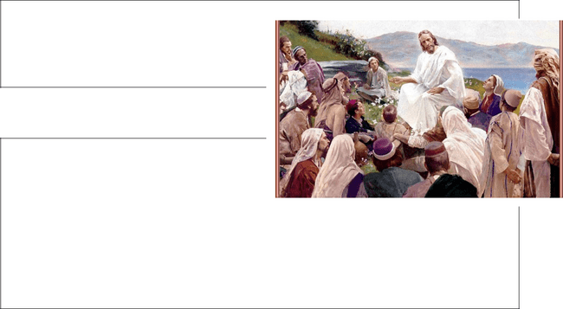
bewildered (harassed and distressed and dejected and helpless), like sheep without a shepherd.

- Prison warden to Joseph

Genesis 39:21-23 “21 But the Lord was with Joseph, and showed him mercy and loving-kindness and gave him favor in the sight of the warden of the prison.

22 And the warden of the prison committed to Joseph’s care all the prisoners who were in the prison; and whatsoever was done there, he was in charge of it.
23 The prison warden paid no attention to anything that was in [Joseph’s] charge, for the Lord was with him and made whatever he did to prosper.

- Joshua to Rahab

Joshua 6:25 “25 So Joshua saved Rahab the harlot, with her father’s household and all that she had; and she lives in
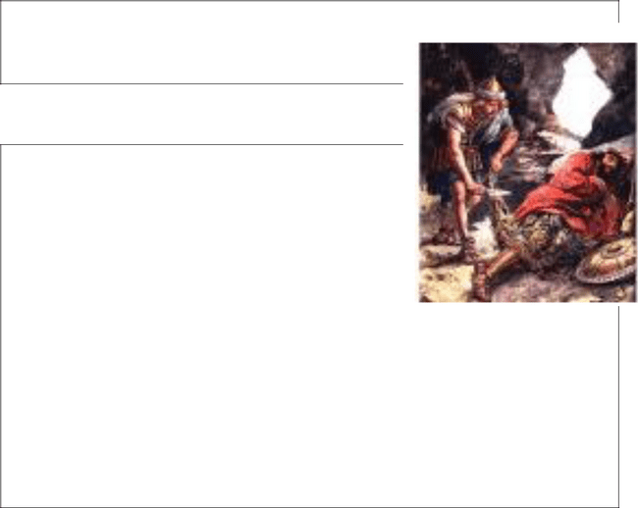
Israel even to this day, because she hid the messengers whom Joshua sent to spy out Jericho.

- David to Saul

1 Samuel 24:10-17 “10 Behold, your eyes have seen how the Lord gave you today into my hands in the cave. Some told me to kill you, but I spared you; I said, I will not put forth my hand against my lord, for he is the Lord’s anointed.

11 See, my father, see the skirt of your robe in my hand! Since I cut off the skirt of your robe and did not kill you, you know and see that there is no evil
or treason in my hands. I have not sinned against you, yet you hunt my life to take it.
12 May the Lord judge between me and you, and may the Lord avenge me upon you, but my hand shall not be upon you.

15 May the Lord be judge and judge between me and you, and see and plead my cause, and deliver me out of your hands.
16 When David had said this to Saul, Saul said, Is this your voice, my son David? And Saul lifted up his voice and wept.

17 He said to David, You are more upright in God’s eyes than I, for you have repaid me good, but I have rewarded you evil.

186

- Master to servant

Matthew 18:27 “27 And his master’s heart was moved with compassion, and he released him and forgave him [cancelling] the debt.
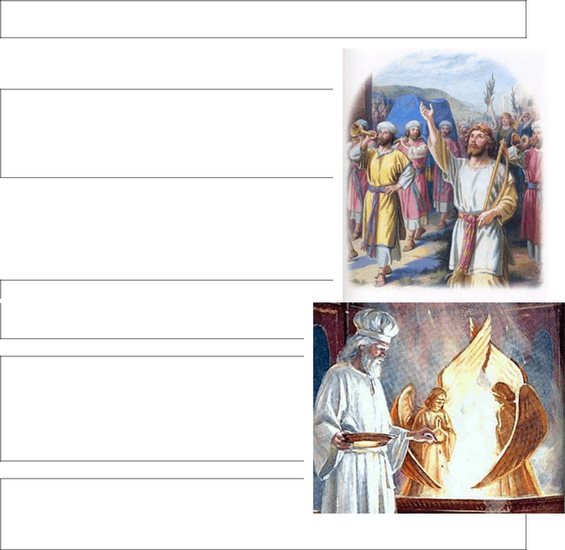

- Kings of Israel

1 Kings 20:31 “31 His servants said to him, We have heard that the kings of the house of Israel are merciful kings. Let us put sackcloth on our loins and ropes about our necks, and go out to the king of Israel; perhaps he will spare your life.

Blessings for those who act in the Gift of Mercy

- Those who operate in the gift of Mercy have a unique seat of anything.

Exodus 25:17 “17 And you shall make a mercy

seat (a covering) of pure gold, two cubits and a half long and a cubit and a half wide.

Exodus 25:22 “22 There I will meet with you and, from above the mercy seat, from between the two cherubim that are upon the ark of the Testimony, I will speak intimately with you of all which I will give you in commandment to the Israelites.

Hebrews 9:5 “5 Above [the ark] and overshadowing the mercy seat were the
representations of the cherubim [winged creatures which were the symbols] of glory. We cannot now go into detail about these things.

- Those whose offer their lives in a gift of Mercy have their reward in a result which endures forever.

Psalm 106:1 “1 PRAISE THE Lord! (Hallelujah!) O give thanks to the Lord, for He is good; for His mercy and loving-kindness endure forever!

^{i}Psalm 118:1-4 “1 O GIVE thanks to the Lord, for He is good; for His mercy and loving-kindness endure forever!

2 Let Israel now say that His mercy and loving-kindness endure forever.
3 Let the house of Aaron [the priesthood] now say that His mercy and loving-kindness endure forever.4 Let those now who reverently and worshipfully fear the Lord say that His mercy and loving-kindness endure forever.

- For further reading read Psalm 136:1-26

187

3. Those who do works of Mercy are answers to prayer.

Psalm 4:1 “1 ANSWER ME when I call , O God of my righteousness (uprightness, justice, and right standing with You)! You have freed me when I was hemmed in and enlarged me when I was in distress; have mercy upon me and hear my prayer.


- The gift of Mercy becomes a Fruit of the Holy Spirit.

James 3:17 “17 But the wisdom from above is first of all pure (undefiled); then it is peace - loving, courteous (considerate, gentle). [It is willing to] yield to reason, full of compassion and good fruits; it is wholehearted and straightforward, impartial and unfeigned (free from doubts, wavering, and insincerity).


- Gifts of Mercy get magnified.

Deuteronomy 5:10 “10 And showing mercy and steadfast love to thousands and to a thousand generations of those who love Me and keep My commandments.


PURPOSE:

The person who has the gift of Mercy knows the Heart of God, and can sense what they must do to bring to fulfilment God’s plan for others to possess their God-given birthright without any effort of their own.

So many people are hurting. Is that why we find that many people have been given the gift of mercy / compassion?

This person shows his compassion with a joyfulness, a

readiness of mind, to penetrate the heart of the afflicted, with the grace of a Giving God.

The restoration of this gift of fulfilling God’s plan of love is manifested by:


- an ability to always see the good in other people, by a capacity to reveal

God’s Love to them.

Proverbs 11:14 “14 Where no wise

guidance is, the people fall, but in the multitude of counselors there is safety.

188

Proverbs 11:17 “17 The merciful, kind, and generous man benefits himself [for his deeds return to bless him], ….


- an ability to sense / feel the emotional status of people and to reach out with words, acts of love and affirmation to change their perception of God.

- the number of times they will become the crusader for good causes, and how they will stand and fight for the lost, homeless and wounded.

Proverbs 13:12 “12 Hope deferred makes the heart sick, but when the desire is fulfilled, it is a tree of life.


- an ability to find ways to help people restore relationships with one another and will visibly grieve over the woundedness in relationships.

Proverbs 20:5 “5 Counsel in the heart of man is like water in a deep well, but a man of understanding draws it out.

- the degree to which we will see them rejoice when others are blessed or grieved when others are hurt.

Proverbs 21:21 “21 He who earnestly seeks after and

craves righteousness, mercy, and loving-kindness will find life in addition to righteousness (uprightness and right standing with God) and honor.

HOW DO WE IDENTIFY THE MERCY GIFT?

- They rarely have enemies / never hurt anybody, but they easily detect insincerity or wrong motives.

Proverbs 15:1 “1 A SOFT answer turns away wrath, but grievous words stir up anger.
2 The tongue of the wise utters knowledge rightly, but the mouth of the [self-confident] fool pours out folly.

- They are safe people to share / be with, they love doing good deeds for others.


Proverbs 17:17 “17 A friend loves at all times, and is born, as is a brother, for adversity.


- They have an inborn sense of knowing who the hurt / wounded are.

- They are slow to transition from on thing to the next.

- They crave soul and physical contact, they “feel” like the other people do.

- They have a pre-disposition to worship.

- They are ruled by the heart and not by the head.


Proverbs 22:11 “11 He who loves purity and the pure in heart and who is gracious in speech—because of the grace of his lips will he have the king for his friend.

THE SELF-IMAGE OF THE MERCY:

The Mercy child will usually have a poor self-image. Approximately 70% of all Mercy people will have been hurt by family and friends.

Their emotions are subject to highs and lows and mainly function on how they feel at that point in time, because they generally have a dislike for logical thinking patterns.

They would see every decision that does not fit with their needs as a personal wound. They are highly sensitive to the needs of others, but are often shy and therefore do not easily step forward to make new friendships.

There will be some idealism in their approach to life – they will always favour the underdog.

CRITICAL SUCCESS FACTORS:


Mercy:

- has to learn to confront people, or else they can easily be hurt.

- has to learn to be decisive, to make the correct decisions even though it will affect others negatively.

- must learn to handle spiritual leadership abuse effectively so that the anger which lies hidden does not explode.

190

- must sanctify time or else they will have their time taken up with

“good” deeds which are not necessarily what God wants.


- has to learn not to take up other people’s offences

and fight their battles for them – they must learn to be slow to take offence.

PRACTICAL APPLICATION:

The Mercy person has the goal to live life, in whatever place or situation God places you, with a contented spirit.

Rules for Engagement:

- Embrace the trials / tribulation God places in your path.

- Don’t take on other people’s problems.
- Reject satan’s problems.
- Develop an ability to solve problems.
- Enjoy the journey.
- Analyze your character traits, i.e. John wanted power / authority but ends up on Patmos talking only of relationship, i.e. from “who is greater” to “we must love one another”.

Mercy must speak out / take a stand against any:

- acts or attempt to exploit / create a victim spirit.
- attempts to pressurize people by manipulation / control.

Mercy must proclaim that God’s Sovereign Will in every circumstance is good / perfect / right.


Sign of the Holy Spirit:

The sign of the “Dove” would seem to reflect the Holy Spirit’s influence on the gift of Mercy.

THE ATTACKS ON THE GIFT OF MERCY:

1. Influence of Parents:

A father must create a “safe” environment for the Mercy child, a place where their creativity will be recognized and allowed to blossom, a place where their “faith” in fellowman will be protected from insensitive and other wounded people, so that their spirit can be released at the right time.

A father needs to love, cherish and accept the Mercy child as they are. A father, who fails in this task, exposes his child to a world where compromise will be the order of the day so that they don’t lose control of any situation.

191

The Mercy child will always be scared to commit and will want to go extremely slowly towards goals causing frustration for all those surrounding them.


Parents, who do not teach their child the Principle of Dominion – Godly rulership and specifically if the father figures in their lives are ungodly, will cause the Mercy gift to suffer from a “victim” spirit and will attract spiritual leadership that will abuse their goodness.

2. Influence of Woundedness:

The mercy individual will be identified with the following attributes:

- family activities,
- friendships,
- a need to be loved and valued.

A father that fails to show love, fails to spend real quality time, who chases after career or ministry without spending a great deal of time and love on a Mercy child, will cause deep wounds

A Mercy individual will make lasting friendships, relationships that will be protected at all costs, so when such a friend rejects /

causes a wound, the effects will be devastating.

Authority figures’ (especially father’s) wounds lead to an identity crisis, causing the child to be a people-pleaser, and consequently lack the ability / willpower to stand in holiness and purity.

This woundedness will cause the gift of Mercy to be rendered in a fashion where the intimacy of God’s Presence is destroyed.

3. Generational / Spiritual:

We have chosen to proclaim the blessing in this paragraph. We have not gone into the details or described the negative consequences on the life of believers which is caused by the negative impact of generational curses.


Please note that if this gift has been rejected / abused by the previous generations, then the gift will operate in the exact opposite way in which it should and the effect / impact thereof will be multiplied in the following generations (i.e. by my parents).

The Mercy gift has the ability to move in the most intimate / Holy place and is blessed with the gift of being able to sanctify the environment / places where they go.

Root Iniquity: The stronghold of stubbornness – the desire to want everything to be done my way.

192

PART 11: OBTAIN GOD AND YOUR FATHER’S BLESSING TO FLOW IN YOUR ANOINTING AND CALLING:


THE POWER OF BLESSING

Each male/father is seen as the Priest of his family and the home is seen as a sanctuary.

The father declares these words over his family.

Num. 6:24-27 “24 The Lord bless you and watch, guard, and keep you; 25 The Lord make His face to shine upon and enlighten you and be gracious (kind, merciful, and giving favor) to you;
26 The Lord lift up His [approving] countenance upon you and give you peace (tranquility of heart and life continually).

27 And they shall put My name upon the Israelites, and I will bless them.”

Since we have accepted Yeshua as Messiah and are now grafted into the Natural Olive, i.e. we are now Israelites in the spirit. We need to make sure that we keep God’s Commandments to speak out the blessing over His nation and children.

a) The Power of Blessing

Definition: A specific spiritual moment in time when we are able to strengthen our individual bond with God and raise our sights to fulfill our potential.

The Torah shows us a picture of God as Father: as soon as Adam and Eve have been created, He blesses them – with Words of Life, direction and vision.

Not long after that He commands Aaron (the High Priest over the people of Israel) to speak these Words of Life and connectivity over all the children of Israel:


As the priest in our own home, we are commanded to do the same.

As we “put” God’s Name on each child so too do we declare their worth and purpose:

Num. 6:23,27 “22 And the Lord said to Moses,

23 Say to Aaron and his sons, This is the way you shall bless the Israelites. Say to them…

…27 And they shall put My name upon the Israelites, and I will bless them.”

193

- Circle of Blessing GEN. 12:3

THANKSGIVING

ROM. 12:4-6

COMMUNITY

ROM. 12:6-8

GIFT

GOD


BLESSING

GEN. 1:28

FATHER

NUM. 6:22-27

FAMILY

c) Blessing passes through the Father

Gen. 12:3


3 And I will bless those who bless you [who confer prosperity or happiness upon you] and curse him who curses or uses insolent language toward you; in you will all the families and
kindred of the earth be blessed [and by you they will bless themselves].

Fathers build houses – words of faith by the father are the keys to unlocking God’s purpose.

THE ROLE OF THE FATHER:
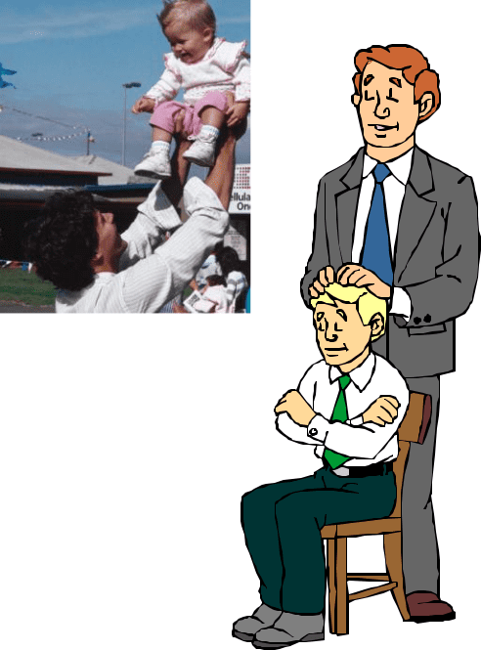

Definition from the Webster Dictionary:

“Father”: The one that gives us significance.

GOD’S MANDATE TO FATHERS

To bless - “baruch”:

To kneel down before someone.
To empower to prosper
To succeed in marriage, finances, health, career, ministry, etc.
To have a pleasant, fulfilling journey

Blessing = God’s impartation of identity and destiny

194

Father’s lifestyle:
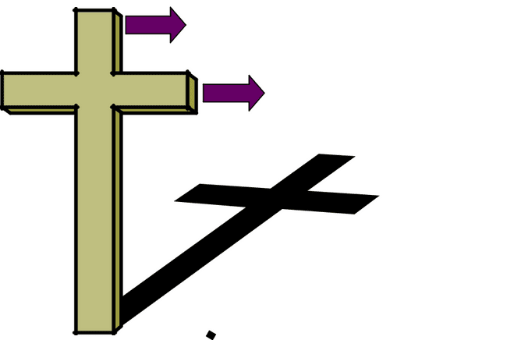

Humbleness to God - Sons

Servant hood to community.

New Testament: we are
“servants”.

Hebrew letter Gimmel 

In its picture form it is a camel – a symbol of blessing. In order to use the camel, it has to kneel.

This is the image that a father should give to his family.


195

PART 12: OUR PURPOSE / GIFTS CAN BE CURSED

Renewing our minds, breaking generational bondages that have perverted the purity of the outpouring of our gift:

God tells the priests (those who are born again believers in Yeshua the Messiah) that if they don’t hear, listen and obey, that their blessing will be cursed.

Mal. 2:1-3 “1 AND NOW, O you priests, this commandment is for you. 2 If you will not hear and if you will not lay it to heart to give glory to My name, says the Lord of hosts, then I will send the curse upon you, and I will curse your blessings; yes, I have already turned them to curses because you do not lay it to heart.

3 Behold, I will rebuke your seed [grain—which will prevent due harvest], and I will spread the dung from the festival offerings upon your faces, and you shall be taken away with it.”

How do we get to this place?

- We fail to take up our birthright, i.e. we fail to identify our gifting and we don’t operate in these principles impacting the Body of Messiah.

- We fail to deal with the illegitimacy lies that satan has told us and although we know what our gift / purpose is, we are less than effective in the Kingdom of God, because we fail to believe that God’s

Promise is true.

Every gift that God has made and given to man is seen as a powerful tool in building God’s Kingdom and the tabernacle on earth.

Satan has a curse for every gift in order to delay, prevent this purpose from being materialized.

I have been given all the gifts in my spirit, but at least one or two gifts will be prominent to be the foundation of my Godly purpose.

I can expect satan and the kingdom of darkness to come and attack me at this level.

God shows Daniel that there are various kingdoms that come against the people of Israel / the Kingdom of God.

Each attack has a strategy / goal.

196

In a similar way, satan has a type of attack to neutralize the gift / purpose.

Breastplate of
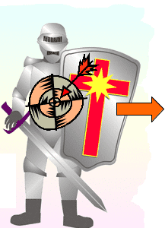

Righteousness
Kingdom of

darkness


Gift of | Spirit of
Servant | Haman


Mal. 2:3 however tells us that when I don’t protect, use, operate in my gift / purpose, my seed (children) will have their harvest destroyed.

Mal 2:3 “3 Behold, I will rebuke your seed [grain—which will prevent due harvest], and I will spread the dung from the festival offerings upon your faces, and you shall be taken away with it.”

When my parents have misused / abused their gift, I will be open to generational attack on this level as well but multiplied generational level.
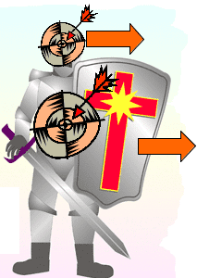

Helmet of | Gift of |  | Kingdom of
Salvation | Giver |  | darkness
Breastplate |  |  | Spirit of
of Righteous- |  |  | Spirit of
ness |  |  | Jezebel
 |  |  | Spirit of
 |  | Gift of | Spirit of
 |  | Servant | Haman


Let’s assume that the parent was a “giver”, i.e. Helmet of Salvation, we will be subjected to the curse of Jezebel at a generational level.

197

1. The Spirit of Sisera - Attack against the Prophetic Gift

An excellent example of the spirit that rises up against the prophetic gift is that evidenced by Sisera. This man is the Commander in Chief of the Canaanite king’s army.

Judges 4:2,3 “2 So the Lord sold them into the hand of Jabin king of Canaan, who reigned in Hazor. The commander of his army was Sisera, who dwelt in Harosheth-hagoiim [fortress or city of the nations].
- Then the Israelites cried to the Lord, for [Jabin] had 900 chariots of iron and had severely oppressed the Israelites for twenty years.”

The circumstances of the Israelites are extremely bad. They are being oppressed from all sides and could no longer live normal lives – they were forced to walk on the byroads to avoid conflict.

Judges 4:3 Then the Israelites cried to the Lord, for [Jabin] had 900 chariots of iron and had severely oppressed the Israelites for twenty years.

Deborah is a prophetess – she sat under the authority of her husband and the leaders of the land and judged wisely, causing all manner of people to approach her for a word of wisdom on how to deal with their problems.

Judges 4:5 “5 She sat under the palm tree of Deborah between Ramah and Bethel in the hill country of Ephraim, and the Israelites came up to her for judgment.

Goal of this spirit:

To cause you to feel, see, experience that no matter what you do or try, it seems as if there is permanent injustice and that no appeal to a higher court is successful. It seems as if everyone in the city is corrupt and consequently you never taste success.

Judges 4:13,14 “13 Sisera gathered together all his chariots, even | 900

chariots of iron, and all the men who were with him from Harosheth-hagoiim to the river Kishon.
14 And Deborah said to Barak, Up! For this is the day when the Lord has given Sisera into your hand. Is not the Lord gone out before you? So Barak went down from Mount Tabor with 10,000 men following him.

How do I Cause this spirit to Attack?

- I seek legitimacy in the wrong way; I do things to impress people.

198

- I seek compromise with the political structure in the city / land and let them have permanent control in exchange for interim / short-term gain.

I open my life to “things without substance”.

- I try to do things / attempt to answer some call when I know that I can’t do it and then compromise with the kingdom of darkness (false teaching) in order to deliver of the promise.

How do I deal with this?

I must speak into the political world without compromise and I must give God all the Glory. If I walk in the opposite spirit – the system will give me favour.

I will take the same stance as Deborah – speaking out against the corruption of the Political system.

How this spirit manifests:

The Israelites are unarmed (in the physical) and outnumbered (in absolute terms). The enemy comes with strength and might to crush them.

199

Deborah’s Blessing and Song

Deborah recognizes that men have a unique call to leadership. She sees that this is:

- In the physical e.g. as a general of an army, who must go to war to claim the victory;

- In the spiritual, as a leader who should hear from God and apply the direction in his life.

Deborah Song

- Speak out to all of those who answer the call to go to the war against every form of oppression,

- Gives honor to those who obey the spiritual call to stand in the face of danger,

- Gives recognition to Barak who, although he did not stand as spiritual leader, nevertheless went to war against all odds without any weapons.
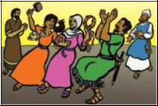

200

- The Spirit of HAMAN – Attack Against the Servant Gift


Goal of this Curse:

To cause you to feel that even though you work hard, you never get honour, that your boundaries are often being violated, that your reputation is subject to frivolous gossip.

This spirit’s nature is demonstrated so well for us in the story of Mordecai. We see recorded that Mordecai is:

- A man of honor – he is raising the

daughter of one of his family as if she is his own.

Esther 2:7 “7 He had brought up Hadassah, that is Esther, his uncle’s

daughter, for she had neither father nor mother. The maiden was beautiful and lovely, and when her father and mother died, Mordecai took her as his own daughter.

- A man who serves the King (a foreigner) with integrity. When two of the king’s own people come with a plot to cause harm to the king he raises the alarm and saves the day.

Esther 2:21-23 “21 In those days, while Mordecai sat at the king’s gate, two of the king’s eunuchs, Bigthan and Teresh, of those who guarded the door,

were angry and sought to lay hands on King Ahasuerus.

- And this was known to Mordecai, who told it to Queen Esther, and Esther told the king in Mordecai’s name.
- When it was investigated and found to be true, both men were hanged on the gallows. And it was recorded in the Book of the Chronicles in the king’s presence.

- A man who sought the welfare and peace of his people all the days of his life.

Esther 10:3 “3 For Mordecai the Jew was next to King Ahasuerus and great among the Jews, and was a favorite with the multitude of his brethren, for he sought the welfare of his people and spoke peace to his whole race.

We can really see that Mordecai has the gift of servant.
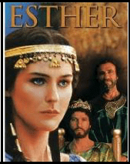

How did this spirit manifest?

Mordecai looks after Esther with great care and yet she is “taken” to be the wife of this foreign / pagan king.

201

Mordecai protects the king against a plot of treason – yet he is “robbed” of his reward for a long time.

Esther 6:2,3 “2 And it was found written there how Mordecai had told of Bigthana and Teresh, two of the king’s attendants who guarded the door, who
had sought to lay hands on King Ahasuerus.

- And the king said, What honor or distinction has been given Mordecai for this? Then the king’s servants who ministered to him said, Nothing has been done for him.

How do I Cause this Curse to Alight?


- I allow people, e.g. parents / authority figures, to bully me into doing things I don’t want to do.

- I stay in a place where authority figures misuse my talents instead of finding a leader who will build a platform under me to support the gift.
- I take my freedom in an illegitimate way, e.g. by force, against God’s timing, etc.

- I find my identity in the place of abuse
instead of using my gifting to build a platform for others.
- I allow others to control the “gateway” to my land.
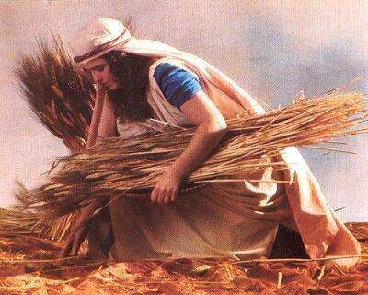

How do I Deal with This?

I choose to walk on the middle road between judgement / punishment and mercy (forgiveness) waiting on God for His Timing.

Ruth serves in a Godly way until God brings her to Boaz.

Esther set the standard in a righteous lifestyle and reinstated the borders of the covenantal relationship.

ESTHER'S BLESSING:

The Haman Curse causes those in authority to limit the freedom of those under them, requiring those under authority to serve those in authority at the expense of possessing their own birthright.

Breaking the curse simply releases the individual to pursue their own life. Esther's Blessing means not only having release, but also having your authorities build a platform for success under you during times of transition.

202

You stay humble, fasting and praying. You continue to develop, teaching Godly Principles to those around you.

You encourage other Believers to be bold in the face of adversary.

Most cultures expect the family to come alongside and help with the transitions of birth, coming of age, wedding and death. Many people have other unique times of transition in their lives where a helping hand from family or community is vital.

Esther walked in that blessing. When she was orphaned, her relative Mordecai took her in and groomed her for excellence.

When she had to face the king, uninvited, for the sake of her life and the lives of the Jews, Mordecai not only gave her perspective and encouragement, but he also mobilized all the Jews in the capital city of Susa to fast and pray for three days in support of her mission.

That represented a massive, community effort to empower her during a critical transition in her reign. It built a platform under her for success.

After the initial crisis, the king gave her the authority to govern but she had no experience in governing. Mordecai came alongside her again with administrative skills which made her look good in the use of the power she had been granted.
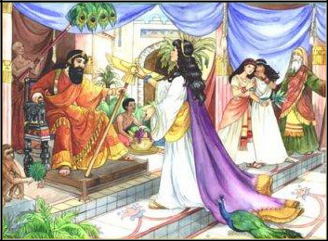

203

- The Spirit of the Five Kings of the Philistines – Attack Against the Teaching Gift:

Goal of this Spirit:

To cause you to feel / experience that God’s purpose for your life is not enthroned, to have you always searching for the one small piece of the puzzle⁴ necessary for success. (The man at the pool of Bethesda needed someone to pick him up.)

Josh 13:3 ” 3 From the Shihor [River] which is east of Egypt, northward to the boundary of Ekron, all of it counted as Canaanite ; there are five rulers of the Philistines, those of Gaza, Ashdod, Ashkelon, Gath, and Ekron, and those of the Avvites;

In Chapter 5 of the Book of Joshua we see Joshua using the heavens extensively in the battle against the five Amorite kings who invaded the Gibeonites.
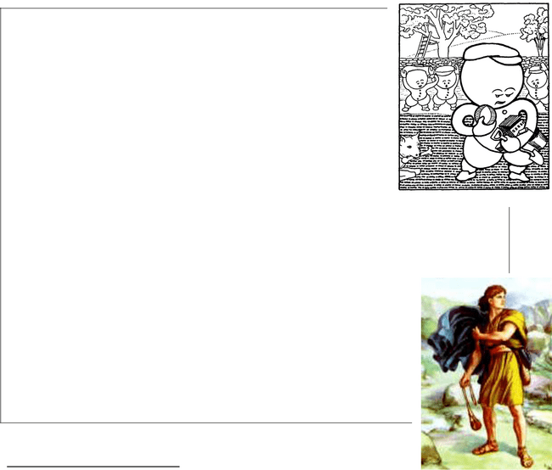

Joshua 10:3 So 1. Adoni -zedek king of Jerusalem sent to 2.Hoham king of Hebron, to 3. Piram king of Jarmuth, to 4. Japhia king of Lachish, and to 5. Debir king of Eglon,

13 And the sun stood still, and the moon stayed, until the nation took vengeance upon their enemies. Is not this written in the Book of Jasher? So the sun stood still in the midst of the heavens and did not hasten to go down for about a whole day.

14 There was no day like it before or since, when the Lord heeded the voice of a man. For the Lord fought for Israel.

15 Then Joshua returned, and all Israel with him, to the camp at Gilgal.
16 Those five kings fled and hid themselves in the cave of Makkedah.

18 Joshua said, Roll great stones to the cave’s mouth, and set men to guard them.

19 But do not stay. Pursue your enemies and fall upon their rear; do not allow them to enter their cities, for the Lord your God has given them into your hand.
Open the mouth of the cave and bring out those five kings to me from the cave.

23 They brought the five kings out of the cave to him—the kings of Jerusalem, Hebron, Jarmuth, Lachish, and Eglon.

24 Come, put your feet on the necks of these kings. And they came and put their feet on the [kings’] necks.

- 1 Sam. 13:19 “19 Now there was no metal worker to be found throughout all the land of

Israel, for the Philistines said, Lest the Hebrews make swords or spears.”

204

25 Joshua said to them, Fear not nor be dismayed; be strong and of good courage. For thus shall the Lord do to all your enemies against whom you fight.

These Five kings come with a special combination of evil to combat against the believer who has this gift.
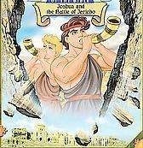

By a study of the names of these kings we see the forces that will stand against the teacher.

- Adoni-Zedek – causes confusion and defeat, causes the teacher to experience injustice, fear and worry,

- Hoham – that causes the teacher to be exhausted, weary and attacks all relationships,

- Piram – that causes barrenness, isolation

and poverty so that the teacher does not have a voice,

- Japhia – causes the spirit of blindness to fall on the teacher, it causes you to lose vision and the ability to receive revelation,

- Debir – spirit of accusation, to bring dissention over the content of the teacher’s word.

How do I Cause this Spirit to Attack?

- I find / obtain specialized knowledge and then keep this to myself so that others will need me I believe that I am the sole “owner” of a particular truth.

- I rely on my credentials / experience and titles to make a way for me – all others are less important.
- I am blessed to find a revelation from God and then I want to copyright it (claim ownership of something that belongs to God).
- I choose relationship (and the sin in the camp) and will overlook the truth in order not to offend them.

How do I Negate?

My lifestyle exposes the truth of who I am and I ensure that all have the liberty to express their truth.

I let God use the foolish things in life to bring the release – it’s God’s Power (i.e. David and the slingshot).

I wait on God like Daniel for supernatural strategies to meet the attack of the kingdom of darkness.

205

JOSHUA AND DANIEL'S BLESSING:

The Philistine spirit causes a person to be one piece short of being able to complete a project. Usually that piece is knowledge or a knowledge-based credential. When you are under the curse, it is very easy for the devil to

block your progress.

Breaking the curse means the enemy can no longer derail you with such ease. The blessing is receiving from God supernatural strategy to overcome the devil, instead of having to war vigorously for each victory. You overcome the devil with greater ease than the ease with which he used to stop you.

God never used ordinary means to defeat the Philistines. There were ordinary battles for other foes, but when His people went up against the Philistines at His command, He always gave supernatural strategies.

Daniel also emphatically refused to engage in a normal, legitimate power play. Serving as a top-level officer in the greatest empire in world history, yet he refused to embrace human power as a means of defeating the devil.

His victories stemmed from an uncommon strategy and required minimal effort on his part and had far reaching effects
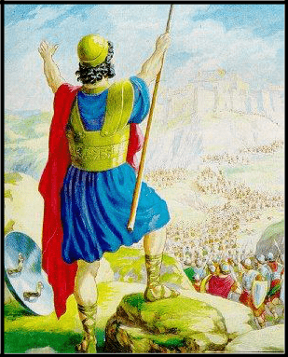
bringing life to many more than just those involved in the events themselves.

Joshua also responded to his enemies with a superior answer than that of normal warfare. He asks God to cause the sun to stand still until he had the COMPLETE victory.

Favour in the family and in the community is a powerful foundation. Having the family or community there to build a platform for you in times of transition gives you greater momentum but you still have to deal with the devil.

This Blessing allows you to overcome the devil swiftly rather than being delayed in life with an extended, grinding spiritual battle.

206

4. Curse of Job’s Friends – Attack Against the Exhorter Gift:

Goal of this Curse:

To cause you to believe that people will want me, need me because of my network skills to get to the right person or to introduce you to the right anointing.
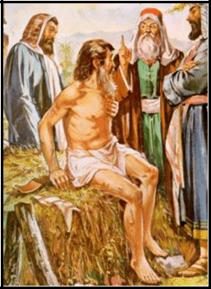

The story of Job teaches us many things. One of the major lessons is that sometimes our worst enemy is someone that we thought was a friend.

These people, who supposedly have the same belief system and value structures, are intimately knowledgeable about you, become the very tool used to pull you down.

Let’s look at how these “friends” try to break your spirit.

Eliphaz – he sees that behind every deed there lies a spirit of deceit, inequity, gossip. He sees that every good deed done is based on your own ego, on work of self-effort.

Job 4:8-9 “8 As I myself have seen, those who plow iniquity and sow trouble and mischief reap the same.
9 By the breath of God they perish, and by the blast of His anger they are consumed.

Job 4:19 “19 How much more those who dwell in houses (bodies) of clay, whose foundations are in the dust, who are crushed like the moth.

Bildad – he recognizes that we face circumstances but fails to see these as God-ordained tribulations or even attacks from the kingdom of darkness and causes to proclaim that we have forgotten the path of God.

He chooses to break down the foundation of faith and trust that you have in the faithfulness of God.

Job 8:13-15 “13 So are the ways of all who forget God; and the hope of the godless shall perish.
14 For his confidence breaks, and [the object of] his trust is a spider’s web.

15 He shall lean upon his house, but it shall not stand; he shall hold fast to it, but it shall not last.

Zophar – he chooses to ridicule your effort of word study and listening to the voice of God.

207

His disputes your integrity of your search for answers from God and declares that you are a fraud; thief and man empty of all wisdom.

Job 11:13 “13 If you set your heart aright and stretch out your hands to [God], 15 Then can you lift up your face to Him without stain [of sin, and unashamed]; yes, you shall be steadfast and secure; you shall not fear.

Friends like this present:

- With word of apparent wisdom,

- With a veneer of friendship and Godliness,

- With a comforting word and a hand of supposed help.

In these most difficult of times it is not easy to discern between Godly wisdom and word of jealousy and hatred covered with a layer of honey.

How do you identify this spirit:

Note how Job’s friends come to sit with him in his time of trouble, seemingly prepared to share the burden.

Note too, that the advice sounds “good” to the layman’s ears.

Only if you are able to listen clearly to God’s Voice will you be able to see the manipulation.

How do I Cause this Spirit to Attack?

- I go from one abusive relationship to another.

- I exploit people for the benefits that I get.
- I give people the “intangible”, i.e. love, prayers, etc but take back the
tangible, i.e. I want the support of those who follow me – I live with an entitlement spirit – you owe me for what I have done.

4) I enforce my rules on everyone but waive them for myself / my friends.
5) I refuse to acknowledge the cause and effect of incidents and put my own spin on things.
6) I use my influence to get others to do wrong and then go to great length to validate why we did it

(Gideon – ephod)

How to Negate:

Stand up and cause life to flow from me to others.

I am able to develop and release the resources made available to me.

Make time to meet God Face to face to gain Godly direction.

208

JOBS' BLESSING:

Job’s Curse causes a person to be so overworked by the demands of their authorities that they have no time to develop their own giftings and potential.

When you break the curse, there is discretionary time to pursue unleashing the potential God placed in you, but you don't necessarily have all the other accessories.

As an Exhorter, Moses' biggest responsibility was to get to know God and to teach the people of Israel about Him.

In the wilderness, Moses had control of his own schedule, he had lots of leaders under him to whom he could delegate, and he had God awaiting him in a tent outside the camp as often as Moses wanted to go visit with Him, face to face.

The fruit of that opportunity to grow was a spirit large enough to write five of the most important books of the Bible, the authority to appeal to God on world-changing issues, and the skill to lead a people with an obdurate slave mentality.

Job too has the same calling i.e. to develop the insight and Godly wisdom to look past the words of man and to rely on the Holy Spirit to give him discernment so that he could stand on God’s faithfulness not withstanding the advice of man.


209

5. Spirit of Jezebel – Attack Against the Giver Gift:

Goal of this Spirit:


To cause you to have doubt that you will ever come out on top, to rob you annually – year after year – or in a series of years. The raven does not care what it eats, the wolf eats anything that is left open – the devouring spirit is rampant in your life.

We read in the story of Ahab and Jezebel how the “giver” is implicated by deceit, false witness and greed.

God declares that every single man of every tribe would  inherent a piece of land. God goes on to put in place the Principle that land could never be sold – the year of Jubilee brought the asset back to the next generation.

1 Kings 21:1-3 “NOW NABOTH the Jezreelite had a vineyard in Jezreel, close beside the palace of Ahab king of Samaria; and after these things,
- Ahab said to Naboth, Give me your vineyard, that I may have it for a garden of herbs, because it is near my house. I will give you a better vineyard for it or, if you prefer, I will give you its worth in money.
3 Naboth said to Ahab, The Lord forbid that I should give the inheritance of my fathers to you.

This land and Principle is the foundation of the giver. Each father was empowered to build a legacy, to be a giver to the community.

The spirit of Jezebel came to remove this foundation. Without the basis on which to build, i.e. plant a harvest, the giver is reduced to a beggar.

1 Kings 21:9-16 “9 And in the letters she said, Proclaim a fast and set Naboth up high among the people.

- And set two men, base fellows, before him, and let them bear witness against him, saying, You cursed and renounced God and the king. Then carry him out and stone him to death.
- And the men of his city, the elders and the nobles who dwelt there, did as Jezebel had directed in the letters sent them.
- They proclaimed a fast and set Naboth on high among the people.

- Two base fellows came in and sat opposite him and they charged Naboth before the people, saying, Naboth cursed and renounced God and the king. Then he was carried out of the city and stoned to death.

- Then they sent to Jezebel, saying, Naboth has been stoned and is dead.
- Then Jezebel said to Ahab, Arise, take possession of the vineyard of Naboth the Jezreelite which he refused to sell you, for Naboth is not alive, but dead.
- When Ahab heard that, he arose to go down to the vineyard of Naboth the Jezreelite to take possession of it.

210

How I cause this Spirit to Attack:

- I allow others to open doors for me with strings attached – I get the results but due to the perversion they take control and they make me dependant on them.

- When I give to others but I have my own agenda and manipulate the result.
- When I use someone else’s resources and someone else’s agenda.
- When I consider the resource as my own (ownership) and I control the need – when I allow my own comfort and security to open the doors for the kingdom of darkness.
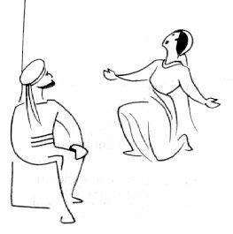

How do I negate?

I declare my dependence on God, and want above all else to possess my birthright. I will not be distracted, will not worry about my own needs, will be able to ask others to meet my needs.

I will trust in God in the same way as Job, and stand up like Gideon:

Judg. 6:13-14 “13 And Gideon said to him, O sir, if the Lord is with us, why is all this befallen us? And where are all His wondrous works of which our fathers told us, saying, Did not the Lord bring us

up from Egypt? But now the Lord has forsaken us and given us into the hand of Midian.
14 The Lord turned to him and said, Go in this your might, and you shall save Israel from the hand of Midian. Have I not sent you?”

The Jezebel spirit prevents you from accruing the capital needed to produce change through the leverage of resources such as money and relationships but can include other things.

Breaking the curse stops the devouring of that

which is accumulated through labour. Abraham’s Blessing causes the family and the extended family relationships to be life-giving, and it causes one's resources to multiply supernaturally speeding the process of accumulation.

Abraham was prepared to let Lot choose which land he wanted. He knew that God was the Author of the Promise and would therefore provide.

211

6. The Spirit of Delilah – Attack Against The Gift of Ruler

Goal of this Spirit:


The goal of this curse is to cause me to get involved, doing things that God has not sent me to do, to focus on events that happen anyway and get distracted, to focus on the crowds while not performing my job as leader to disciple others, to cause betrayal from within the inner circle.

Our first example of this principle is in the life of David

David’s rulership gift is fairly obvious to any who read of his conquests.

His kingdom stretches from one end of Canaan to the other. He is able to unite two kingdoms under one banner.

In his time, he presents an Old Testament picture of the Body of Messiah working in unity.

Rulers are also called into the role of a father. In this role – bring a model of the attribute of God, David fails to teach his son, who sees the example of the sin of Bathsheba and the murder of her husband.

Absalom rises up against David when he perceives an injustice and a pattern of overlooking / condoning sin.

2 Sam 15:4,6 “4 Absalom added, Oh, that I were judge in the land! Then every man with any suit or cause might come to me and I would do him justice!
- And whenever a man came near to do obeisance to him, he would put out his hand, take hold of him, and kiss him.
- Thus Absalom did to all Israel who came to the king for judgment. So Absalom stole the hearts of the men of Israel.

Another story is that of Samson

We read in the story of Samson something very interesting. Samson is called to be a Nazarene – someone set apart by God.

He is born in a time when the Israelites are suffering great oppression.

Judges 13:1 “AND THE Israelites again did what was evil in the sight of the Lord, and the Lord gave them into the hands of the Philistines for forty years.

212

Samson is born to be a ruler – someone who can rise up, call other less talented than he is to follow and go act to defeat the Philistines.

Judges 13:5-7 “5 For behold, you shall become pregnant and bear a son. No razor shall come upon his head, for the child shall be a Nazirite to God from birth, and he shall begin to deliver Israel out of the hands of the Philistines.
- Then the woman went and told her husband, saying, A ^{m}Man of God came to me and his face was like the face of the Angel of God, to be greatly and reverently feared. I did not ask him from where he came, and he did not tell me his name.

- But he said to me, Behold, you shall become pregnant and bear a son, and now drink no wine or strong drink and eat nothing unclean, for the child shall be a Nazirite to God from birth to the day of his death.

He is side-tracked by the spirit of Delilah and loses direction in following his vision.

Judges 16:1,4,6,15,17-20 “THEN SAMSON went to Gaza and saw a harlot there, and went in to her.

- After this he loved a woman in the Valley of Sorek whose name was Delilah.
- And Delilah said to Samson, Tell me, I pray you, wherein your great strength lies, and with what you might be bound to subdue you.
- And she said to him, How can you say, I love you, when your heart is not with me? You have mocked me these three times and have not told me in what your great strength lies.
- Then he told her all his mind and said to her, A razor has never come upon my head, for I have been a Nazirite to God from my birth. If I am shaved, then my strength will go from me, and I shall become weak and be like any other man.
- And when Delilah saw that he had told her all his mind, she went and called for the Philistine lords, saying, Come up this once, for he has told me all he knows. Then the Philistine lords came up to her and brought the money in their hands.
- And she made Samson sleep upon her knees, and she called a man and caused him to shave off the seven braids of his head. Then she began to torment [Samson], and his strength went from him.
- She said, The Philistines are upon you, Samson! And he awoke out of his sleep and said, I will go out as I have time after time and shake myself free. For Samson did not know that the Lord had departed from him.

How I Cause this Spirit to Attack:

- I am open to a sense of betrayal or division.

- Those in position of power exploit their position.

^{m}It is clear from Judg. 13:3, 21 that this messenger was the Angel of the Lord.

213

- I violate the debt of gratitude which others have built up in furthering my walk in life.
- I make efforts to get rid of opposition, others who can compete with me.
- I allow “discontent” to rule my decisions, the thoughts of rebellion and lawlessness to reign to the extent that I no longer have a guilty conscience.

How do I Negate?

- I submit to an accountability structure.

- I serve God faithfully wherever He calls me to go.
- I honour covenantal relationships – for example: Jonathan’s family and
Mephibosheth.

NEHEMIAH'S BLESSING:

This sprit causes betrayal from within an organization, usually by trusted leaders. When the curse is broken, there can be a stable organization that grows normally.

Nehemiah demonstrated this by building the wall of Jerusalem with people who were not wall builders, who had no previous relationship with him, and who had every reason to fail at their task.

Because the blessing was flowing through him, ordinary people worked as a team, doing something they had never done before, and they got a hugely disproportionate result for their
effort. Their minimal skills meshed in a supernatural way to produce an outstanding result.

214

7. Spirit of Inferiority – Attack Against the Gift of Mercy

The Goal of this Spirit:

To cause you to believe that you will never make it, that what I think God means and what happens are worlds apart, that I got a raw deal from God.

Jephthah came to fight the Ammonites as an illegitimate⁵ son not believing that his calling is

“mighty warrior⁶”.

Judges 11:1 “1 NOW JEPHTHAH the Gileadite was a mighty warrior, but he was the son of a harlot. Gilead was Jephthah’s father.

2 And Gilead’s wife also bore him sons, and when his wife’s sons grew up,

they thrust Jephthah out and said to him, You shall not have an inheritance in our father’s house, for you are the son of another woman.
3 Then Jephthah fled from his brothers and dwelt in the land of Tob; and worthless men gathered around Jephthah and went on raids with him.

Judg. 11:30 “30 And Jephthah made a vow to the Lord and said, If You will indeed give the Ammonites into my hand…”

How I cause this spirit to Attack:

- I go into works (make wrong vows) because I don’t believe in the mercy of God.
- I give away resources that God provided as an inheritance / legacy and then don’t have seed to sow for the

harvest.
3) My excellence provokes a reaction from others whose mediocrity I highlight, to the extent that wrongdoers are protected.
4) When I walk / do what other people expect me to do
– when I go with the system – I am silent to sin when in fact I should be standing up for God’s principles.

- I reduce God and His principles to a formula where God
“must” respond, i.e. by making an illegitimate vow.

- Judg. 11:2 “2 And Gilead’s wife also bore him sons, and when his wife’s sons grew up, they thrust Jephthah out and said to him, You shall not have an inheritance in our father’s house, for you are the son of another woman.”
- Judg. 11:1 “1 NOW JEPHTHAH the Gileadite was a mighty warrior, but he was the son of a harlot.”

215

How to Negate:

I decline to embrace man’s opinion of me and accept what God says of me. I overcome the stigma; I refuse to adapt to man’s norms; I walk in holiness. I choose to live in the opposite

spirit – I serve God unconditionally.

I proclaim a Living God because He wanted to bless me.


216

PART 13: PRAYERS OF RENUNCIATIONS

REDEMPTIVE GIFT OF THE PROPHET

Father, we come today to proclaim that we accept our unique creative ability that You have placed inside of us.

We further declare that we choose to embrace the particular set of gifts that You have chosen for us.

We declare that we understand that this gifting places us in a particular place in the Body of Messiah.

We, just as the Israelites of old, come to stand before Yeshua and acknowledge and accept the Banner under which You have placed us.

We declare that we choose not to be envious of other giftings, nor to break other giftings down, nor to misuse the gifting of our personal gain.

Wounding

We recognize that we have grown up in a broken world. We have been interacting with people / leaders / peers whose influence on ourselves has left marks / wounds.

We exercise our freedom of choice to come in line with Your Word to publicly forgive each and everyone who have left a mark on my soul.

I choose to proclaim that I will work to renew my mind by feeding on the Word in order that I will grow in my self-image and therefore realize that my mistakes are not complete failure.

I will take courage from the knowledge that Yeshua is my Source and Protector and therefore I will not be afraid to try new things.

Generational Bloodlines

I come to stand before You God to repent of every sin, iniquity, lost opportunity, etc, done by any one member of my generational family.

I repent of every occultic form of idol worship and immoral act committed by anyone in my family.

I repent of every word raised in anger, murmuring, and dissent against You, God or any one of the Godly leaders that You have appointed over me on earth.

217

I specifically cancel every seed of rebellion whether in deed or finance sown into the kingdom of darkness.

We renounce every covenantal promise, sacrifice, or agreement made with any entity or representative from the kingdom of darkness. We break and cancel every single agreement and declare them null and void.

Specifically we repent of any abuse / misuse of the rights of individuals or groups of individuals who have committed themselves to serving us.

We cancel the generational line of abuse of power in Yeshua’s Name.

Individual Choices

I repent of the fact that I have made individual choices to react to circumstances so as to cause an opening in my life that would allow the demonic kingdom to launch an attack on my life.

I repent of every act of compromise, whether it was because I was ashamed, or whether it was because I felt that it was the only way to achieve the goal.

I repent of every single time when I allowed myself to be influenced by man in order that I could receive honor / recognition. I cancel every vow and false proposal made in exchange for empty words.

Re-Dedication

I choose to declare that I will make a real commitment to build my spirit-man, renew my soul, and walk in a spirit of discipleship.

Accordingly I choose to commit to making a First Fruit offer of my time. I will take everyday as it comes, give God the First Fruit of time so that my day may be redeemed.

I choose to walk in Godly relationships – I will submit to a group of people to whom I will be transparently accountable.

I choose to entrench myself in the Word so that my response will always be based on Your truth.

218

REDEMPTIVE GIFT OF SERVANT

Father, we come today to proclaim that we accept our unique creative ability that You placed inside of us.

We further declare that we choose to embrace the particular set of gifts that You have chosen for us.

We declare that we understand that this gifting places us in a particular place in the Body of Messiah.

We, just as the Israelites of old, come to stand before Yeshua and acknowledge and accept the Banner under which You have placed us.

We declare that we choose not to be envious of other giftings, nor to break other giftings down, nor to misuse the gifting of our personal gain.

Wounds

We recognize that we have grown up in a broken world. We have been interacting with people / leaders / peers who influence on ourselves has left marks / wounds.

We exercise our freedom of choice to come in line with Your Word to publicly forgive each and everyone who have left a mark on my soul.

I choose to declare that my fear of the unknown, my sense of insecurity in the face of the unknown circumstances is a barrier to the flow of my gift.

I declare that any feeling of shyness or uncertainty will be rejected. I choose to move out to meet new people and to trust them.

I choose to renounce any need of acknowledgment or encouragement that is based on the act of pleasing people. Accordingly I declare that I will guard against any compromise.

I reject any thought pattern that leads to an acceptance of the spirit of manipulation.

Generational Curses

I come to stand before You God to repent of every sin, iniquity, lost opportunity, etc, done by any one member of my generational family.

I repent of every occultic form of idol worship and immoral act committed by anyone in my family.

219

I repent of every word raised in anger, murmuring, and dissent against You, God or any one of the Godly leaders that You have appointed over me on earth.

I specifically cancel every seed of rebellion whether in deed or finance sown into the kingdom of darkness.

We renounce every covenantal promise, sacrifice, or agreement made with any entity or representative from the kingdom of darkness. We break and cancel every single agreement and declare them null and void.

I renounce any and every act by any one of my generational line which meant that we avoided conflict and took wrong choices in order to maintain the peace in a relationship.

We repent of allowing the ⁷spirit of Jezebel to rule unchecked in our family line.

Individual Choice

I repent of the fact that I have made individual choices to react to circumstances so as to cause an opening in my life that would allow the demonic kingdom to launch an attack on my life.

I repent my own action where I have allowed people to bully me or someone close to me, and even where I have permitted a level of abuse to take place.

I repent where I have allowed my gifting and talent to be misused to advance other people / leaders contrary to the Will of God.

I recognize that You will hold me accountable to explain how / when / why I used my God-given ability and that any wrongful use will need to be accounted for.

I repent for any time / action where I took my freedom from authority figures in a rebellious / illegitimate way.

Re-Dedication

I choose to declare that I will make a real commitment to build my spirit man, renew my soul, and walk in a spirit of discipleship.

I choose to rededicate my gift to You Almighty God. I proclaim that my gift is special and must be protected at all times.

- See Prayers of Renunciation of Jezebel available from Kanaan Ministries

220

I accepted accountability for the use of my gift. I stand upon the authority of Yeshua to declare that I will listen to the prompting of the Holy Spirit for direction on when / how to use the gift.

I proclaim my willingness to receive gifts / blessing from others with a good heart. I will recognize and be responsive to all acts of graciousness towards me.

I proclaim that I will guard my gifting carefully with respect to my children and will seek guidance and counsel to ensure that I maintain a Godly standard towards them.

I recognize my calling to be a spiritual warfare warrior. I commit to stand against every attack by the spirit of death.
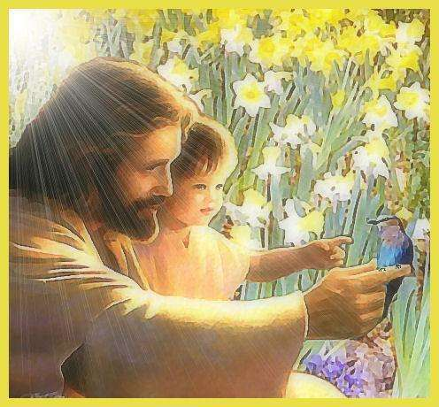

221

REDEMPTIVE GIFT OF TEACHER

Father, we come today to proclaim that we accept our unique creative ability that You placed inside of us.


We further declare that we choose to embrace the particular set of gifts that You have chosen for us.

We declare that we understand that this gifting places us in a particular place in the Body of Messiah.

We, just as the Israelites of old, come to stand before Yeshua and acknowledge and accept the Banner under which You have placed us.

We declare that we choose not to be envious of other giftings, nor to break other giftings down, nor to misuse the gifting of our personal gain.

Wounding

We recognize that we have grown up in a broken world. We have been interacting with people / leaders / peers who influence on ourselves has left marks / wounds.

We exercise our freedom of choice to come in line with Your Word to publicly forgive each and everyone who have left a mark on my soul.

I choose to repent of every act of pride, intolerance and rebellious act committed by myself.

I choose to renew my mind and soul to understand that I am equal to all others and that no single gift / talent is better than any other.

I choose to lay down any pattern/ habit of superiority that I have developed. I choose to accept the love, attention and acceptance of God the Father, and declare that this love is enough to fulfill all my needs.

Generational Bloodline

I come to stand before You God to repent of every sin, iniquity, lost opportunity, etc, done by any one member of my generational family.

I repent of every occultic form of idol worship and immoral act committed by anyone in my family.

I repent of every word raised in anger, murmuring, and dissent against You God or any one of the Godly leaders that You have appointed over me on earth.

222

I specifically cancel every seed of rebellion whether in deed or finance sown into the kingdom of darkness.

We renounce every covenantal promise, sacrifice, or agreement made with any entity or representative from the kingdom of darkness. We break and cancel every single agreement and declare them null and void.

I repent of any action by family to only accept responsibility when they were absolutely sure of themselves.

I acknowledge that every time my family stood back in a time of need, we created / helped to cause pain / discomfort to others.

I repent of allowing others to struggle on their own and for not taking care to lend a hand.

Individual Choices

I repent of the fact that I have made individual choices to react to circumstances so as to cause an opening in my life that would allow the demonic kingdom to launch an attack on my life.

I repent for every time that I build up a base of knowledge and experience and then kept this for myself.

I repent to every action to present myself as the only owner of a piece of knowledge.

I repent of my efforts to build up my title / my position / my credentials and for using these to open doors for me.

I acknowledge that I have wounded the Holy Spirit by this action.

I repent for my actions to compromise with things that are wrong so that I can avoid conflict.

Re-Dedication

I choose to declare that I will make a real commitment to build my spirit man, renew my soul, and walk in a spirit of discipleship.

I repent of every misuse of time / relationship / money.

I choose to rededicate my lifestyle to one of stewardship of those things in my life. I declare that I will be accountable to some form of leadership where I can be discipled in this regard.

223

I proclaim that my prayer life will be strong, that my time in prayer will be in proportion to my study. I commit to dedicate my body and soul to the discipleship of prayer and fasting.

I ask that the Holy Spirit will be quick to challenge me to renew my level of intimacy.

I repent of every time that I used the Word / knowledge as a standard and became judgmental of others that do not meet the standard.

I proclaim a willingness to submit my views in love.

I declare that I will renew my mind until I am open-minded so as to accept other people’s views as of equal value.
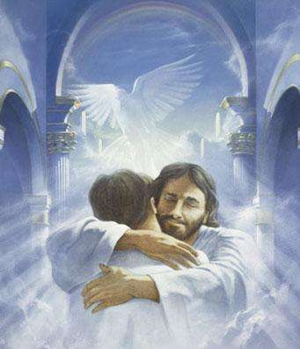

224

REDEMPTIVE GIFT OF EXHORTER
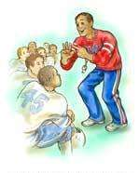

Father, we come today to proclaim that we accept our unique creative ability that You placed inside of us.

We further declare that we choose to embrace the particular set of gifts that You have chosen for us.

We declare that we understand that this gifting places us in a particular place in the Body of Messiah.

We, just as the Israelites of old, come to stand before Yeshua and acknowledge and accept the Banner under which You have placed us.

We declare that we choose not to be envious of other giftings, nor to break other giftings down, nor to misuse the gifting of our personal gain.

Wounding

We recognize that we have grown up in a broken world. We have been interacting with people / leaders / peers who influence on ourselves has left marks / wounds.

We exercise our freedom of choice to come in line with Your Word to publicly forgive each and everyone who have left a mark on my soul.

I recognize that I have not regarded all people as equal.

I repent of my nature / attitude to dominate conversations and relationships.

I choose to renew my soul / mind to such a place where I can give others a chance to respond to emotional issues in a different way to myself.

I repent of my immaturity and all the times that I acted in an overbearing manner.

I choose to forgive my parents for not disciplining me adequately in this area.

Generational Curse

I come to stand before You God to repent of every sin, iniquity, lost opportunity, etc, done by any one member of my generational family.

I repent of every occultic form of idol worship and immoral act committed by anyone in my family.

I repent of every word raised in anger, murmuring, and dissent against You God or any one of the Godly leaders that You have appointed over me on earth.

225

I specifically cancel every seed of rebellion whether in deed or finance sown into the kingdom of darkness.

We renounce every covenantal promise, sacrifice, or agreement made with any entity or representative from the kingdom of darkness. We break and cancel every single agreement and declare them null and void.

I repent for any action / words by my family line where we have built wrong foundations, caused wounding to relationship because we have not accepted responsibility for the wrongs that we have done.

I choose to break down the stronghold of denial that will always find a way to transfer blame onto others.

We repent of all unfair guilt and judgmental opinions that we have spoken over others and the slander / gossip that causes us to position ourselves better than others.

Individual Choices

I repent of the fact that I have made individual choices to react to circumstances so as to cause an opening in my life that would allow the demonic kingdom to launch an attack on my life.

I repent of creating an abusive relationship with others, where I have deliberately controlled, manipulated others to suit my views.

I repent for exploiting others to see what I could get from the relationship, physically and spiritually.
I acknowledge that I gave “intangibles” words of love and comfort, but that I demanded in return the tangible “following” of these people, to be the “leader”.

I repent of putting my rules / standards as bondages on people and I repent for all of those things which happened and which I had explained away.

Re-Dedication

I choose to declare that I will make a real commitment to build my spirit man, renew my soul, and walk in a spirit of discipleship.

I acknowledge that I must dedicate my time / prayer life to God.

I acknowledge that I must learn to speak to others only when I have heard from God.

I declare that I will renew my mind and soul. I will bring my intentions under the authority of the Holy Spirit.
I proclaim that I will submit to Godly leadership, that I will be transparent in my actions towards a stronger leadership grouping.

I repent of the spirit of rebellion in my life and commit to submit fully to authority figures.

226

REDEMPTIVE GIFT OF GIVER

Father, we come today to proclaim that we accept our unique creative ability that You placed inside of us.


We further declare that we choose to embrace the particular set of gifts that You have chosen for us.

We declare that we understand that this gifting places us in a particular place in the Body of Messiah.

We, just as the Israelites of old, come to stand before Yeshua and acknowledge and accept the Banner under which You have placed us.

We declare that we choose not to be envious of other giftings, nor to break other giftings down, nor to misuse the gifting of our personal gain.

Wounding

We recognize that we have grown up in a broken world. We have been interacting with people / leaders / peers who influence on ourselves has left marks / wounds.

We exercise our freedom of choice to come in line with Your Word to publicly forgive each and everyone who have left a mark on my soul.

I recognize that I have been influenced by leadership / family to measure my success / financially and otherwise based on my own self-effort / performance.

I forgive my parents and leaders for teaching me this spirit of independence.

I release them, forgive them and ask that You help me to understand that every blessing comes from God.

I recognize the wounding that makes me want to stay in control – to want to determine what happens with that which I give.

Generational Curses

I come to stand before You God to repent of every sin, iniquity, lost opportunity, etc, done by any one member of my generational family.

I repent of every occultic form of idol worship and immoral act committed by anyone in my family.

I repent of every word raised in anger, murmuring, and dissent against You, God or any one of the Godly leaders that You have appointed over me on earth.

227

I specifically cancel every seed of rebellion whether in deed or finance sown into the kingdom of darkness.

We renounce every covenantal promise, sacrifice, or agreement made with any entity or representative from the kingdom of darkness. We break and cancel every single agreement and declare them null and void.

I renounce and repent of every act of control that my family has exercised over others.

We specifically name every act of financial, manipulative and personal control that was exercised to get people to do what we wanted them to do.

I repent of every act of creating poverty / need in order to get my way.

Individual choices

I repent of the fact that I have made individual choices to react to circumstances so as to cause an opening in my life that would allow the demonic kingdom to launch an attack on my life.

I repent of every time that I placed conditions / rules and my will onto a gift of giving – I declare that every act that someone else did due to my wrong influence is an abomination.

I repent of all the hurt and hatred that I have created through these deeds.

I repent for every time when I used someone else’s assets / resources to help someone else’s agenda and have then taken the honor.

I renounce any harvest of bad seed that is in the ground due to this kind of sowing.

I repent of the perversion and illegitimate power that I used to push people in a direction that I wanted.

Re-Dedication

I choose to declare that I will make a real commitment to build my spirit man, renew my soul, and walk in a spirit of discipleship.

I declare that I will walk in holiness. I lay my talents down on the altar.

I recognize that the blessing that I get comes from You.

I commit to hear from the Holy Spirit in respect of any single act of giving that I make.

I ask that You renew my mind so that I do not seek man’s honor.

228

REDEMPTIVE GIFT OF RULER

Father, we come today to proclaim that we accept our unique creative ability that You placed inside of us.

We further declare that we choose to embrace the particular set of gifts that You have chosen for us.

We declare that we understand that this gifting places us in a particular place in the Body of Messiah.

We, just as the Israelites of old, come to stand before Yeshua and acknowledge and accept the Banner under which You have placed us.

We declare that we choose not to be envious of

other giftings, nor to break other giftings down, nor to misuse the gifting of our personal gain.

Wounding

We recognize that we have grown up in a broken world. We have been interacting with people / leaders / peers who influence on ourselves has left marks / wounds.

We exercise our freedom of choice to come in line with Your Word to publicly forgive each and everyone who have left a mark on my soul.

I recognize some deviant habits pattern in my life – namely that I am not used to being disciplined, and consequently like to have my way and often leave things that need to be done.

I choose to declare that I forgive all of these authority figures who did not lay a Godly platform in my life.

Generational curses

I come to stand before You God to repent of every sin, iniquity, lost opportunity, etc, done by any one member of my generational family.

I repent of every occultic form of idol worship and immoral act committed by anyone in my family.

I repent of every word raised in anger, murmuring, and dissent against You, God or any one of the Godly leaders that You have appointed over me on earth.

229

I specifically cancel every seed of rebellion whether in deed or finance sown into the kingdom of darkness.
We renounce every covenantal promise, sacrifice, or agreement made with any entity or representative from the kingdom of darkness.
We break and cancel every single agreement and declare them null and void.

I repent of every time that my family used its gifting of rulership to exploit others in order to achieve their goals.

I repent of every time that we let our gifting turn into a form of dictatorship.

We renounce any / all false commitment and covenant that we made to exchange personal power and glory for the right to manipulate people.

Individual choices

I repent of the fact that I have made individual choices to react to circumstances so as to cause an opening in my life that would allow the demonic kingdom to launch an attack on my life.

I repent of every time that I allowed feelings of discontent and unhappiness to rule my decision.

I repent of the spirit of rebellion / lawlessness that would be the basis of every decision taken.

I repent of every desire / action taken to slander / back-mouth / scheme to harm / get rid of someone who was in opposition to me.

I repent of every time that I failed to recognize / honour others who were instrumental in any success that I may have had – especially where I took all the honor for a project that was largely someone else’s efforts.

I repent for every time when I used my position to exploit people.

Re-Dedication

I choose to declare that I will make a real commitment to build my spirit man, renew my soul, and walk in a spirit of discipleship.

I declare and proclaim that I commit to walk in integrity / holiness – I submit to Godly counsel and spiritual authority.

I commit to renew my mind to ensure that I build a structure of truth so that my basis for evaluation will always be sound.

I proclaim that I will submit to an accountably structure so that I can always test whether my focus on the goal at hand is becoming too intense or not.

I will reset my standard of performance in respect of other people so that I can permit them to be what they are in their own time.

I proclaim that I will determine a path of building other people’s potential at all times.

230

REDEMPTIVE GIFT OF MERCY

Father, we come today to proclaim that we accept our unique creative ability that You placed inside of us.


We further declare that we choose to embrace the particular set of gifts that You have chosen for us.

We declare that we understand that this gifting places us in a particular place in the Body of Messiah.

We, just as the Israelites of old, come to stand before Yeshua and acknowledge and accept the Banner under which You have placed us.

We declare that we choose not to be envious of other

giftings, nor to break other giftings down, nor to misuse the gifting of our personal gain.

Wounding

We recognize that we have grown up in a broken world. We have been interacting with people / leaders / peers who influence on ourselves has left marks / wounds.

We exercise our freedom of choice to come in line with Your Word to publicly forgive each and everyone who have left a mark on my soul.

I choose to forgive my parents / authority figures for the wounds created when:

- They failed to show love,

- They failed to spend time,

- They failed to protect me from hurtful relationships.

I choose to forgive them for having failed to recognize my sensitivity and did not encourage me to stand on my own feet.

Generational Bloodlines

I come to stand before You God to repent of every sin, iniquity, lost opportunity, etc, done by any one member of my generational family.

I repent of every occultic form of idol worship and immoral act committed by anyone in my family.

I repent of every word raised in anger, murmuring, and dissent against You God or any one of the Godly leaders that You have appointed over me on earth.

231

I specifically cancel every seed of rebellion whether in deed or finance sown into the kingdom of darkness.

We renounce every covenantal promise, sacrifice, or agreement made with any entity or representative from the kingdom of darkness. We break and cancel every single agreement and declare them null and void.

I repent and renounce every act of willful stubbornness that my ancestors took part in and which caused division in families.

I recognize that these acts would have set the path for many wrongful acts, the consequences of which would still be seen today in family feuds.

Individual Choices

I repent of the fact that I have made individual choices to react to circumstances so as to cause an opening in my life that would allow the demonic kingdom to launch an attack on my life.

I repent of every act of compromise that I have stepped into.

I acknowledge that my being silent, instead of defining God’s standard will have caused others to walk down a path with the wrong results.

I renounce every vow that I made where I “defined” what God should do because of my deeds or my being a victim.

I repent of being hasty to help others. I recognize that I gave away seed which was supposed to be sown to get a harvest – consequently my “good” deed was in fact an act of unchecked emotion.

Re-Dedication

I choose to declare that I will make a real commitment to build my spirit man, renew my soul, and walk in a spirit of discipleship.

I declare / proclaim that I will take steps to renew my mind and conform my soul to God’s Will, so that I will be able to identify abuse by spiritual leadership and effectively deal with it.

I commit to subject myself to Godly accountable leaders who will help speak into my life so that they can help me make the hard decisions, tell others what they should be doing, especially if those decisions will impact others negatively.

I declare that I will resist every effort to take up other people’s battles to fight it for them.

I will learn to understand that they have to fight their own battles.

232

PART 14: WALK IN DOMINION – BY REVEALING YOUR CALLING IN GRACE TO THE BODY OF MESSIAH

We have followed the pattern set out by God for Man at the start of Creation.

- We have identified the unique group of gifts (redemptive calling) that God has placed inside of us.

- We have stood before spiritual fathers who has “blessed” us and released that gift with power, authority.

We now have to begin to walk in the path of:

- Developing these gifts with word study, prayer and intercession.

- working on our weaknesses and faults so that we purify the intensity and colour of the light that we cause to shine:

Practical examples of counselling with specific individuals to highlight the unique gifts/ the effect of the curses and the prayer of renunciation to release the individual from bondage.

Person A: “Mary”:

Father God,

We come to petition for Mary.

We have been legitimised by the work of the atonement made by Yeshua on the cross.

We declare that we are grafted into the Natural Olive, that we draw sap from the Maker/Creator. Because we are Your children we can claim the inheritance, legacy rights of a child of the King.

We come to ask for Your favour, for Your sceptre to be held out in Mary’s direction for this year.

We repent that her parents did not understand the importance of identifying her gifts and talents, while Mary was being created and raised. We repent that their role -model of a reflection of the Father’s Heart was blemished with the efforts of self.

We declare that You our God, wove Mary together in her mother’s womb.

You ordained this time for her.

233

Ps. 139: 13-17 “13 For You did form my inward parts; You did knit me together in my mother’s womb.
14 I will confess and praise You for You are fearful and wonderful and for the awful wonder of my birth! Wonderful are Your works, and that my inner self knows right well.

15 My frame was not hidden from You when I was being formed in secret [and] intricately and curiously wrought [as if embroidered with various colors] in the depths of the earth [a region of darkness and mystery].
16 Your eyes saw my unformed substance, and in Your book all the days [of my life] were written before ever they took shape, when as yet there was none of them.
17 How precious and weighty also are Your thoughts to me, O God! How vast is the sum of them!”

Jer 1:5 “5 Before I formed you in the womb I knew [and] approved of you [as My chosen instrument], and before you were born I separated and set you apart, consecrating you;; [and] I appointed you as a prophet to the nations.”

Therefore, just as Yeshua had a predetermined purpose/calling, so too have You, O God, set out a plan for Mary.

Acts 2:23 “23 This Jesus, when delivered up according to the definite and fixed purpose and settled plan and foreknowledge of God, you crucified and put out of the way [killing Him] by the hands of lawless and wicked men.”

We praise You for this purpose/calling. We recognise and call forth Mary to step up to that birth right. We proclaim that she shall live a victorious, abundant life. The gifts and calling are irrevocable.

Rom. 11:29 “29 For God’s gifts and His call are irrevocable. [He never withdraws them when once they are given, and He does not change His mind about those to whom He gives His grace or to whom He sends His call.]”

Therefore, the fact that her parents did not identify, release and bless this into being, does not matter. In the Name of Yeshua, we now release these gifts into Mary’s life!

Prov 16:1-4 “THE PLANS of the mind and orderly thinking belong to man, but from the Lord comes the [wise] answer of the tongue.
2 All the ways of a man are pure in his own eyes, but the Lord weighs the spirits (the thoughts and intents of the heart). [I Sam. 16:7; Heb. 4:12.]

3 Roll your works upon the Lord [commit and trust them wholly to Him; He will cause your thoughts to become agreeable to His will, and] so shall your plans be established and succeed.
4 The Lord has made everything [to accommodate itself and contribute] to its own end and His own purpose—even the wicked [are fitted for their role] for the day of calamity and evil.”

234

Hab 3:2-4 “And the Lord answered me and said, Write the vision and engrave it so plainly upon tablets that everyone who passes may [be able to] read [it easily and quickly] as he hastens by.
3 For the vision is yet for an appointed time and it hastens to the end
[fulfillment]; it will not deceive or disappoint. Though it tarry, wait
[earnestly] for it, because it will surely come; it will not be behindhand on
its appointed day. [Heb. 10:37, 38.]
4 Look at the proud; his soul is not straight or right within him, but the [rigidly] just and the [uncompromisingly] righteous man shall ªlive by his faith and in his faithfulness. [Rom. 1:17;; Gal. 3:11.]”

We proclaim to the world, that Mary has been endowed with these gifts.
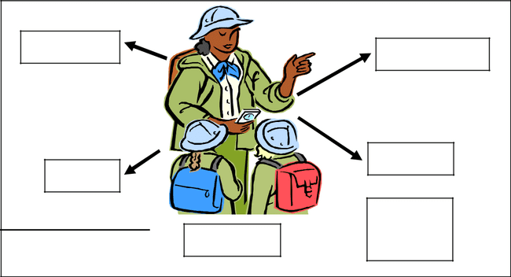

1. Teacher | 2. Prophetic
3. Ruler | 4. Giver
Trials and tribulations | Business
Trials and tribulations | Property
 | MARY

Father, we petition with You today against the two trials that Mary is carrying and which limit the experiential growth that is a reality of Your blessing.

- Health – We don’t know why Mary had to be inflicted with this illness or why people were not able to see the early warning signs, so that alternative help could have been the case.

Your word for Mary is that You will give her the desires of her heart. Her desire is to be healed. Our petition is that this will be a complete healing!

- Loneliness – Mary has wanted her life partner, her other half, for a number of years. Your Word commands us to be fruitful, multiply and fill the earth.

Gen. 1:28 “28 And God blessed them and said to them, Be fruitful, multiply, and fill the earth, and subdue it [using all its vast resources in the service of God and man]; and have dominion over the fish of the sea, the birds of the air, and over every living creature that moves upon the earth.”

235

We stand on this Covenantal Commandment, since You have decreed it will be so, we now call forth her partner to come to stand by her side.

We petition for the right man, a Godly man of integrity and values.

We block off any:

- Attempt to get Mary to stay single

- Attempt to send the wrong partner across her path.

We therefore petition for God’s plan for Mary’s life to be catapulted forward in the path that you have pre-determined for her to walk⁸.

Is 25:1 “1 O LORD, You are my God;; I will exalt You, I will praise Your name,

for You have done wonderful things, even purposes planned of old [and fulfilled] in faithfulness and truth.”

Prov 16:3 “3 Roll your works upon the Lord [commit and trust them wholly to Him; He will cause your thoughts to become agreeable to His will, and] so shall your plans be established and succeed.”

We petition against the internal conflict that can arise in Mary’s soul as a result of the mixture of gifts.

- Against the natural habit of the prophetic to declare every thing black and white. We ask for Your grace on her to see the other side of an event.

- Against the inherent essence of the need to do things quickly (of the prophet) with the responsibility of the teacher to take time to sort out the facts first.
- Against the inherent attribute of not accepting guilt. Whilst her motivation will always be to “fix it”, we petition that she learns to acknowledge her failures.

We petition against the kingdom of darkness and declare that no foot-hold will be given in respect of the above.

We proclaim that You, O God, will give Mary:

ABUNDANT FAITH

+
INCREDIBLE DILIGENCE

to face every circumstance.

We stand against the kingdom of darkness and all of its agents working to restrict Mary’s life plan.

- See Petition for Marriage Partner also Delayed Marriages in the Petition book available from Kanaan Ministries.

236

We cancel the effect of the curse of the Five kings of the Philistines, the Delilah curse, and the Sisera curse⁹.
We reverse any sacrifice made or curse spoken to come against Mary.

Mary, we seek to bless you and declare that you will:

- be a well respected leader in your community,

- have a strong social network.
- enthrone Yeshua, in your heart and therefore the truth of the revelation given to you will stand.

- impact all spheres of governmental authority with integrity and

- rule your courts with a just hand.

We proclaim there will be PEACE IN THE LAND.

Mary’s calling:

We want to release God’s plan for your life as evidenced by the combination of the gifts that He has placed inside of you at your conception. We want to release the multi-faceted ability God has given you to reach out to people to identify their talents and abilities, and to empower them to change for the better by:

- Revealing God’s design.

- Calling them to a vision.

- Empowering them with incremental knowledge and experience so that they grow in maturity.

- See Curses against the Gifts on page 200.

237

Person B: John

Father God,

We come to petition for John.

We have been legitimised by the work of the atonement made by Yeshua on the cross.

We declare that we are grafted into the Natural Olive, that we draw sap from the Maker/Creator. Because we are Your children we can claim the inheritance, legacy rights of a child of the King.

We come to ask for Your favour, for Your sceptre to be held out in John’s direction for this year.

We repent that his parents did not understand the importance of identifying his gifts and talents, while John was being created and raised. We repent that their role -model of a reflection of the Father’s Heart was blemished with the efforts of self.

We declare that You our God, wove John together in his mother’s womb. You ordained this time for him.

Ps. 139: 13-17 “13 For You did form my inward parts; You did knit me together in my mother’s womb.
14 I will confess and praise You for You are fearful and wonderful and for the awful wonder of my birth! Wonderful are Your works, and that my inner self knows right well.

15 My frame was not hidden from You when I was being formed in secret [and] intricately and curiously wrought [as if embroidered with various colors] in the depths of the earth [a region of darkness and mystery].
16 Your eyes saw my unformed substance, and in Your book all the days [of my life] were written before ever they took shape, when as yet there was none of them.
17 How precious and weighty also are Your thoughts to me, O God! How vast is the sum of them!”

Jer 1:5 “5 Before I formed you in the womb I knew [and] approved of you [as My chosen instrument], and before you were born I separated and set you apart, consecrating you;; [and] I appointed you as a prophet to the nations.”

Therefore just as Yeshua had a predetermined purpose/calling, so too You have set out a plan for John.

Acts 2:23 “23 This Jesus, when delivered up according to the definite and fixed purpose and settled plan and foreknowledge of God, you crucified and put out of the way [killing Him] by the hands of lawless and wicked men.”

238

We praise You for this purpose/calling. We recognise and call forth John to step up to that birth right. We proclaim that he shall live a victorious and abundant life. The gifts and calling are irrevocable.

Rom. 11:29 “29 For God’s gifts and His call are irrevocable. [He never withdraws them when once they are given, and He does not change His mind about those to whom He gives His grace or to whom He sends His call.]”

Therefore, the fact that his parents did not identify, release and bless this into being, does not matter. In the Name of Yeshua we now release these gifts into John’s life!

Prov 16:1-4 “THE PLANS of the mind and orderly thinking belong to man, but from the Lord comes the [wise] answer of the tongue.
2 All the ways of a man are pure in his own eyes, but the Lord weighs the spirits (the thoughts and intents of the heart). [I Sam. 16:7; Heb. 4:12.]

3 Roll your works upon the Lord [commit and trust them wholly to Him; He will cause your thoughts to become agreeable to His will, and] so shall your plans be established and succeed.
4 The Lord has made everything [to accommodate itself and contribute] to its own end and His own purpose—even the wicked [are fitted for their role] for the day of calamity and evil.”

Hab 3:2-4 “And the Lord answered me and said, Write the vision and engrave it so plainly upon tablets that everyone who passes may [be able to] read [it easily and quickly] as he hastens by.
3 For the vision is yet for an appointed time and it hastens to the end
[fulfillment]; it will not deceive or disappoint. Though it tarry, wait
[earnestly] for it, because it will surely come; it will not be behindhand on
its appointed day. [Heb. 10:37, 38.]
4 Look at the proud; his soul is not straight or right within him, but the [rigidly]
just and the [uncompromisingly] righteous man shall ªlive by his faith and in his faithfulness. [Rom. 1:17; Gal. 3:11.]”

We proclaim to the spiritual realm John’s reality, worthiness and value of the redemptive gifts that God has placed inside of him.
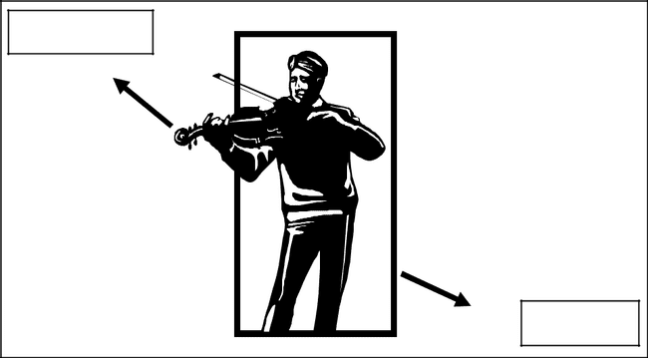

1. | Prophet
 | 2. | Ruler
 |  | 239

Trials and Tribulations

Father, we repent for the sin of silence, of his parents not standing up for him, for not seeking a Word from You and for allowing a religious, Jezebelic spirit to wound him.

We repent for the wrong father role-model that was lived out for John to follow; for allowing a patterning of frustration and anger to be passed on generationally to him when his father perceived injustice.

We repent for his father not having discipled John in the way of good relationships especially with women.

We repent that his father allowed other people’s opinion and direction to be the only way for John to walk.

These sins and the consequent hurt have impacted John emotionally, as well as spiritually. These sins have hardened John’s heart to the church world and is part of his uneasy walk with You, O God.

We bring a praise and thanksgiving offering to You for the goodness that You have shown John.

We bear witness of:

- This emotional improvement

- His enthusiasm of music

- His dedication to training his skills in music

- His commitment to the business

We petition, Father, for the continued development and restoration in these areas.

We petition specifically for the restoration of his spirit man.

We ask that You will reveal Yourself to John so that he can see how YOU see him.

240

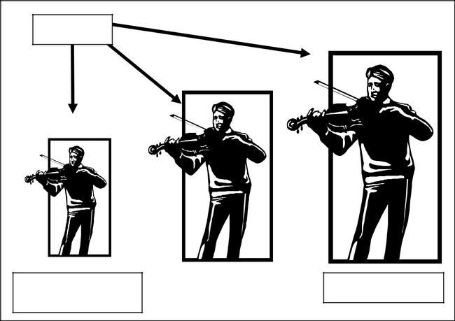

GOD

John thinks he is Greater in stature

small in Your sight

We ask You to open John’s eyes so that he can see You better.

Increase his vision of You, O God, that he will truly stand in all circumstances because he will have seen the “army of angels” send on his behalf.

We petition that God’s plans for John will exponentially empower him and that he will accomplish his full potential.

Is 25:1 “1 O LORD, You are my God;; I will exalt You, I will praise Your name, for You have done wonderful things, even purposes planned of old [and fulfilled] in faithfulness and truth.”


Prov 11:3 “3 The integrity of the upright shall guide them, but the willful contrariness and crookedness of the treacherous shall destroy them.”

We petition against the internal conflicts between his unique gifts.

We recognize that the gift of prophet is black and white. John, more than others, does not have much “grey”. His heart causes him to distrust people. He therefore resists the natural gift to help people and develop their talents.

We raise a banner over John that he will step up to his place so that he can rule fairly, empowering people by using his gift of prophecy against the spirit of poverty that has taken people’s dignity away.

241

We proclaim into the heavenlies, that every curse raised against John will be broken and cancelled in the Name of Yeshua, specifically the spirit of

Delilah and of Sisera¹⁰.

We declare the harvest of evil in John’s life to be nullified from today. We destroy every evil seed which has been planted in his path of life.

We specifically cancel every declaration of words spoken against him namely:

- That John will not prosper.

- That John will not grow in stature.

- That John will fail in work, business, spiritual growth and relationships.

We proclaim that John:

- will find favour in all governmental sectors in the land, that he will always receive justice.

- that John will be able to develop, grow and be surrounded with a social structure of wonderful friends, business people and administrators so that he will be publicly acknowledged as a music leader in the community.

John, we seek to bless you:

- with the fullness of the gift of prophecy so that you will restore people’s dignity and self worth back to them.
- with the fullness of the gift of ruler to establish social structures and establish generational blessings for the descendants to come.

John’s calling:

We want to bless you with the calling of ruling with grace, achieving substantial goals while you go about the restoration of all the people you are assigned to lead. We specifically bless you to release/destroy the spirit of poverty in peoples’ souls and look forward to see the restoration of peoples’ dignity. We declare that the calling of leadership will focus on restoring God’s vision with integrity and commitment.

- See Curses against the Gifts on page 200

242

Person C: Jane (married to Bob – Person D)

Father God,

We come to petition for Jane.

We have been legitimised by the work of the atonement made by Yeshua on the cross.

We declare that we are grafted into the Natural Olive, that we draw sap from the Maker/Creator. Because we are Your children we can claim the inheritance, legacy rights of a child of the King.

We come to ask for Your favour, for Your sceptre to be held out in Jane’s direction for this year.

We repent that her parents did not understand the importance of identifying her gifts and talents, while Mary was being created and raised. We repent that their role -model of a reflection of the Father’s Heart was blemished with the efforts of self.

We declare that You our God, wove Mary together in her mother’s womb.

You ordained this time for her.

Ps. 139: 13-17 “13 For You did form my inward parts; You did knit me together in my mother’s womb.
14 I will confess and praise You for You are fearful and wonderful and for the awful wonder of my birth! Wonderful are Your works, and that my inner self knows right well.

15 My frame was not hidden from You when I was being formed in secret [and] intricately and curiously wrought [as if embroidered with various colors] in the depths of the earth [a region of darkness and mystery].
16 Your eyes saw my unformed substance, and in Your book all the days [of my life] were written before ever they took shape, when as yet there was none of them.
17 How precious and weighty also are Your thoughts to me, O God! How vast is the sum of them!”

Jer 1:5 “5 Before I formed you in the womb I knew [and] approved of you [as My chosen instrument], and before you were born I separated and set you apart, consecrating you;; [and] I appointed you as a prophet to the nations.”

Therefore, just as Yeshua had a predetermined purpose/calling, so too have You, O God, set out a plan for Jane.

Acts 2:23 “23 This Jesus, when delivered up according to the definite and fixed purpose and settled plan and foreknowledge of God, you crucified and put out of the way [killing Him] by the hands of lawless and wicked men.”

243

We praise You for this purpose/calling. We recognise and call forth Jane to step up to that birth right. We proclaim that she shall live a victorious, abundant life. The gifts and calling are irrevocable.

Rom. 11:29 “29 For God’s gifts and His call are irrevocable. [He never withdraws them when once they are given, and He does not change His mind about those to whom He gives His grace or to whom He sends His call.]”

Therefore, the fact that her parents did not identify, release and bless this into being, does not matter. In the Name of Yeshua, we now release these gifts into Jane’s life!

Prov 16:1-4 “THE PLANS of the mind and orderly thinking belong to man, but from the Lord comes the [wise] answer of the tongue.
2 All the ways of a man are pure in his own eyes, but the Lord weighs the spirits (the thoughts and intents of the heart). [I Sam. 16:7; Heb. 4:12.]

3 Roll your works upon the Lord [commit and trust them wholly to Him; He will cause your thoughts to become agreeable to His will, and] so shall your plans be established and succeed.
4 The Lord has made everything [to accommodate itself and contribute] to its own end and His own purpose—even the wicked [are fitted for their role] for the day of calamity and evil.”

Hab 3:2-4 “And the Lord answered me and said, Write the vision and engrave it so plainly upon tablets that everyone who passes may [be able to] read [it easily and quickly] as he hastens by.
3 For the vision is yet for an appointed time and it hastens to the end
[fulfillment]; it will not deceive or disappoint. Though it tarry, wait
[earnestly] for it, because it will surely come; it will not be behindhand on
its appointed day. [Heb. 10:37, 38.]
4 Look at the proud; his soul is not straight or right within him, but the [rigidly] just and the [uncompromisingly] righteous man shall ªlive by his faith and in his faithfulness. [Rom. 1:17;; Gal. 3:11.]”

We proclaim to the spiritual realm that Jane has been given these gifts – given by God:
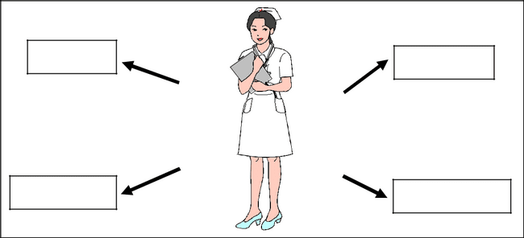

 | 1. Mercy | 2. | Giver
3. | Servant | 4. | Prophetic
 |  |  | 244

Trials and Tribulations

Father, we come to repent before You that her parents did not see and identify any of Jane’s gifts and talents. We also repent for the wrong type of role model they lived out for Jane to follow. They were overprotective, and did not give Jane enough opportunity to experiment and to have adventure.

We acknowledge that a large part of the “victim spirit” comes from her parents not raising her in a Godly way¹¹ (fathers must repent of bad leadership) which caused the inner turmoil and frustration. We repent that they did not build an inner strength, a self-confidence based on the work of Yeshua in her.

You have promised Jane CHANGE for this year. We know that all things are for our good. We therefore declare that we are ready for Your impact in Jane’s life.

We proclaim and petition that the nurse’s training that Jane is doing will not only add to her knowledge and experience but will also be a healing process. We ask that every lesson is the removal of another layer of her hurts and at the same time is building a stone on the foundation of truth of how God sees her.


GOD

God sees her

BIG even
when Jane
sees herself
as SMALL

We cancel the thought patterns of

a victim spirit forever.

We therefore petition for God’s plan for Jane’s life to be catapulted forward in the path that you have pre-determined for her to walk¹².

- See Follow-up on this book: Generational Blessings for guidelines of Godly parenting / leadership.

- See Petition for Marriage Partner also Delayed Marriages in the Petition book available from Kanaan Ministries.

245

Is 25:1 “1 O LORD, You are my God;; I will exalt You, I will praise Your name, for You have done wonderful things, even purposes planned of old [and fulfilled] in faithfulness and truth.”

Prov 16:3 “3 Roll your works upon the Lord [commit and trust them wholly to Him; He will cause your thoughts to become agreeable to His will, and] so shall your plans be established and succeed.”

We petition against the internal conflict between her gifts.

- Against the fact that mercy does not like to confront others and yet as the giver must be able to stand up against any devouring spirit. We petition that You will give her the anointing and discernment and the courage to act when she needs to.

- Against the sense of anger at the injustice when her gifts are abused/misused. We petition that You will give Jane the strength of character to say NO, gently but firmly and not to carry other peoples problems for them.

- Against the sense of pressure that is placed on her by other gifts such as the ruler. We acknowledge that Jane will be slow to make transitions. We know that her gifting is to cause natural objects/places to become sanctified by Your presence.

We raise a banner over Jane – no foothold of these things will be shown to the kingdom of darkness.

We put on all of the armour of God. We stand as the weaker partner of the covenant and we ask You to come to our help against the forces of the kingdom of darkness.

- We specifically break every hold and stronghold erected by the feelings of inferiority as well as the Jezebel and Haman spirits¹³.

- We nullify every sacrifice, ritual or agreement made to come up against Jane.
- We petition for every lost crop, every stolen harvest, every stolen sense of achievement.

We proclaim that:

- Jane will rise out above the mediocrity of her peers; that she will stand out as a blessed daughter of the King. That she will be accepted for who she is.

- Jane will reap the right to the freedom to accumulate the resources/blessings that are her inheritance.

- See Curses against the Gifts on page 200

246

- Jane will find herself being lifted up, held on high, elevated to the position that is her inheritance. Jane will have a solid foundation of faith under her.

- Jane will have a double portion of the blessings of cheerfulness/happy heart and the liberty to give in faith.

Jane we seek to bless you

- With the fullness of the experience of worship, of understanding the presence of God, of knowing God’s Heart at all times.

- With the authority to sanctify/anoint instruments/places for the work of God, to ensure that the tabernacle is holy and pure.
- With the anointing to take authority over the spirit of death. You have been gifted with that aspect of God’s character that declares LIFE!!

Jane’s calling

Jane we bless you with the ability to study and understand the workings of a sick person’s mind and to release the generational gifts inside of you which results in the healing of the hearts of patients so that they can progress in life and reflect a loving God. We recognise that as you serve and show compassion, that you will experience and reveal to others, the heart of worship for God. Jane, bring a piece of heaven to earth by the restorative work that you have been called to do.

247

Person D: Bob (married to Jane – Person C)

(Please note: the petition also covers the gifts of both husband and wife and where possible misunderstandings of each one’s gift can cause conflicts.)

Father God,

We come to petition for Bob.

We have been legitimised by the work of the atonement made by Yeshua on the cross.

We declare that we are grafted into the Natural Olive, that we draw sap from the Maker/Creator. Because we

are Your children we can claim the inheritance, legacy rights of a child of the King.

We come to ask for Your favour, for Your sceptre to be held out in Bob’s direction for this year.

We repent that her parents did not understand the importance of identifying his gifts and talents, while Bob was being created and raised. We repent that their role model of a reflection of the Father’s Heart was blemished with the efforts of self.

We declare that You our God, wove Bob together in his mother’s womb. You ordained this time for him.

Ps. 139: 13-17 “13 For You did form my inward parts; You did knit me together in my mother’s womb.
14 I will confess and praise You for You are fearful and wonderful and for the awful wonder of my birth! Wonderful are Your works, and that my inner self knows right well.

15 My frame was not hidden from You when I was being formed in secret [and] intricately and curiously wrought [as if embroidered with various colors] in the depths of the earth [a region of darkness and mystery].
16 Your eyes saw my unformed substance, and in Your book all the days [of my life] were written before ever they took shape, when as yet there was none of them.

17 How precious and weighty also are Your thoughts to me, O God! How vast is the sum of them!”

248

Jer 1:5 “5 Before I formed you in the womb I knew [and] approved of you [as My chosen instrument], and before you were born I separated and set you apart, consecrating you;; [and] I appointed you as a prophet to the nations.”

Therefore, just as Yeshua had a predetermined purpose/calling, so too have You, O God, set out a plan for Bob.

Acts 2:23 “23 This Jesus, when delivered up according to the definite and fixed purpose and settled plan and foreknowledge of God, you crucified and put out of the way [killing Him] by the hands of lawless and wicked men.”

We praise You for this purpose/calling. We recognise and call forth Bob to step up to that birth right. We proclaim that he shall live a victorious, abundant life. The gifts and calling are irrevocable.

Rom. 11:29 “29 For God’s gifts and His call are irrevocable. [He never withdraws them when once they are given, and He does not change His mind about those to whom He gives His grace or to whom He sends His call.]”

Therefore, the fact that his parents did not identify, release and bless this into being, does not matter. In the Name of Yeshua, we now release these gifts into Bob’s!

Prov 16:1-4 “THE PLANS of the mind and orderly thinking belong to man, but from the Lord comes the [wise] answer of the tongue.
2 All the ways of a man are pure in his own eyes, but the Lord weighs the spirits (the thoughts and intents of the heart). [I Sam. 16:7; Heb. 4:12.]
3 Roll your works upon the Lord [commit and trust them wholly to Him; He will cause your thoughts to become agreeable to His will, and] so shall your plans be established and succeed.
4 The Lord has made everything [to accommodate itself and contribute] to its own end and His own purpose—even the wicked [are fitted for their role] for the day of calamity and evil.”

Hab 3:2-4 “And the Lord answered me and said, Write the vision and engrave it so plainly upon tablets that everyone who passes may [be able to] read [it easily and quickly] as he hastens by.
3 For the vision is yet for an appointed time and it hastens to the end
[fulfillment]; it will not deceive or disappoint. Though it tarry, wait
[earnestly] for it, because it will surely come; it will not be behindhand on
its appointed day. [Heb. 10:37, 38.]

4 Look at the proud; his soul is not straight or right within him, but the [rigidly] just and the [uncompromisingly] righteous man shall ªlive by his faith and in his faithfulness. [Rom. 1:17;; Gal. 3:11.]”

249

We proclaim into the spiritual realm the plans in Bob’s life is to excel in the gifts of:


1. Teacher

and Giver

2. Prophet

He has a capacity

for faith

Trials and tribulations

We hear Bob’s words when he said that their family had been robbed so that EVERY NEXT generation has to start at the bottom again. We therefore recognize the Jezebel spirit as a generational curse on his family.

Father, You have promised Bob “change” for this year. We believe that change to be a movement forward towards his calling and purpose. We hereby come to petition for the generational blessing and fruit of this word for Bob.

We petition for the fullness of Your plan to be made evident to Bob and that he be propelled into Your space and time.

Isaiah 25:1 “1 O LORD, You are my God; I will exalt You, I will praise Your name, for You have done wonderful things, even purposes planned of old [and fulfilled] in faithfulness and truth.

Proverbs 16:3 “3 Roll your works upon the Lord [commit and trust them wholly to Him; He will cause your thoughts to become agreeable to His will, and] so shall your plans be established and succeed.

We petition against the internal conflict of Bob’s gifts:

- Against the nature of the prophet to receive and process some new concepts quickly and want to react on it while the gift of teacher wants to take time to verify/sort out all of the facts. We petition for Bob to move/wait for the times and seasons so that both gifts flow together.

250

- Against the high timing/need for action of Bob’s gifts versus the need to give time to allow his wife, Jane to process things in the time needed for mercy and servanthood. We petition to seek a balance between

Bob’s capacity of faith and Jane’s capacity of compassion.

- Against the aspect of teacher that does not want to oppose/deal/confront people who are in sin. We therefore petition that his gift of the prophet will manifest in all of these circumstances.

We raise a banner of protection over Bob that the kingdom of darkness will in no way gain a foothold in Bob’s life by causing stressful conflict between the aspects of Bob’s gifts.

We come to You, O God, and petition for Your favour as we stand in war against the kingdom of darkness. We recognise that some curses in Bob’s life have a generational momentum.

- We cancel every sacrifice/ritual or curse that has been made over Bob or his family.

- We specifically petition against the Jezebel spirit¹⁴. We petition that the exponential effect of this curse be broken. We repent of any place where his ancestors:
  - opened doors for others with strings attached
  - where they came to others with their own agenda in place
  - where they have considered the blessing a direct result of their work and have not acknowledged God’s Hand.

We specifically declare Bob’s dependence on God, and proclaim that he will not worry over his own needs, nor ask others to meet his needs.

We also petition against the power of the Sisera curse and the Five Philistine kings’ curse and declare that every connection/agreement on which these curses have operated be destroyed now in Yeshua’s Name.

We cancel and nullify every evil crop or harvest that has risen up due to Bob’s family door being opened to these curses and we ask that it be burned up now with the fire of God.

We proclaim Bob’s purpose and calling with the gifts

- That he will stand against any devouring spirit which manifests itself against the gift of stewardship.
- That he will nurture and birth ministries and works of God to ensure that they stand – in all aspects (not just finances)
- That he will stand up against the poverty spirit in men which causes people to loose their dignity
- That he will proclaim and give prophetic word which restores man’s image to the likeness of You, O God.

- See Curses against the Gifts on page 200

251

- That Bob will let his gift of prophet come to the fore when he has to stand up to confront issues in the Body of Christ.

- That Bob will flow in the fullness of the gift of giving so that he can build a generational legacy of stewardship.
- That he will use his gift of teacher to challenge old thinking and concepts and to present Your Word in Truth and Love

We declare that God assigned Bob and commanded him to be alert.

Mark 13:34 “34 It is like a man [already] going on a journey; when he leaves home, he puts his servants in charge, each with his particular task, and he gives orders to the doorkeeper to be constantly alert and on the watch.”

Bob, we come to bless you:

- that you will carry the mantle of stewardship, the mantle of teaching, the mantle of prophet (God’s design) with integrity, truthfulness and grace.

- that you will be endowed with a special anointing to cover Jane with her need for “time” to hear God’s heart and her gift of mercy to reach out to others in trouble.

Bob’s calling:

We want to release God’s calling over your life with this prophetic declaration. We recognise that you have an authority over the responsibility to reveal God’s truth, spelt out in terms of the prophetic anointing by revealing God’s design to the Body of Messiah.
We want to recognise your gift to birth and nurture new “things” both in business and ministry. We believe that this birthing will arise from the interaction with others as you teach God’s design principles.

We proclaim that Bob will fulfil his calling. Therefore we can say like David, Let: Bob’s cup overflow!
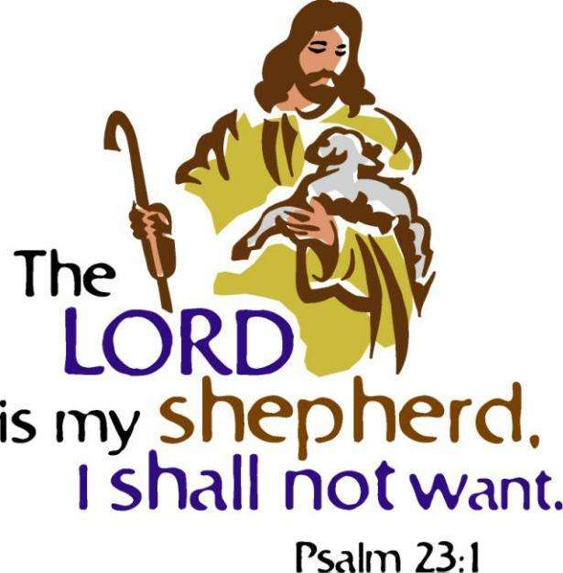

252

A Life of Fulfilment:

A person created in God’s Image has unlimited potential. We need to overcome our own misconceptions of our ability, our wounds arising from past failures and move on to find / develop / use the potential deposited by God.

The Paradox of Israel and the Promised Land:

God gives the people the land of Canaan, repeatedly He tells them it is theirs as an inheritance…
BUT

God tells them that they have to take possession of the promise, meaning that we have to remove the giants and occupy the ground.

Equally, each one of us have been given a redemptive gift…

BUT
we have to develop that ability so that we can occupy the land of promise.

It is only when we are living at this level of purpose that we will experience the fulfilment of seeing a harvest of grapes so large that two men have to carry it.
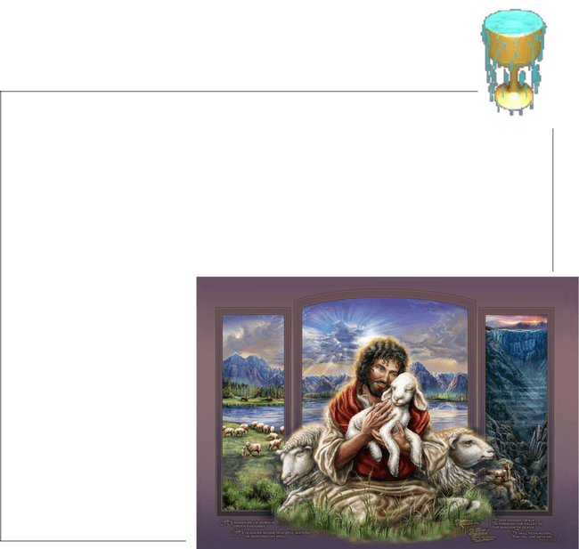
Is it possible? YES!!
David says: “My cup runs over!”

Ps. 23 “1 THE LORD is my Shepherd [to feed, guide, and shield me], I shall not lack.

2 He makes me lie down in [fresh, tender] green pastures; He leads me beside the still and restful waters.
3 He refreshes and restores my life (my self); He leads me in the paths of righteousness [uprightness and right standing with Him—not for my earning it, but] for His name’s sake.

4 Yes, though I walk through the [deep, sunless] valley of the shadow of death, I will fear or dread no evil, for You are with me; Your rod [to protect] and Your staff [to guide], they comfort me.

5 You prepare a table
before me in the presence of my enemies. You anoint my head with

oil; my [brimming] cup runs over.
6 Surely or only goodness, mercy, and unfailing love shall follow me all the days of my life, and through the length of my days the house of the Lord [and His presence] shall be my dwelling place.”

253

CONCLUSION:

We have spent some time in the Torah / Word of God to:

- Confirm that we are made in God’s Image

- Understand that each one has a unique calling, a responsibility to reach out and impact the Body of Christ so that we “fit” together as one unit.

- Identify the unique gift that God gave to each individual and to set a process of introspection in place as we measure our lifestyle in terms of God’s Plumbline of expectation.

- Develop an understanding that I am responsible for my own actions, to change to God’s pattern and come in line with my purpose.

The Book Song of Songs is a love song between:

- the Bridegroom (God) and Yeshua and
- the Holy Spirit and the Bride of Yeshua.

In this Book we come to see the level of intimacy that God wants us to have with Him.

He tells us that:

- We do NOT keep our own vineyard but

instead


x chose to keep the vineyard of others

Song of Songs 1:6 [Please] do not look at me, [she said, for] I am swarthy. [I have worked out] in the sun and it has left its mark upon me. My stepbrothers were angry with me, and they made me

keeper of the vineyards; but my own
vineyard [my complexion] I have not
kept.

Clearly this verse has many meanings, but realistically it also tells us that many of us have chosen to live within the Greco-Roman world; we compete for position, power, and wealth on a worldly platform.

It also tells us that the vineyard which we have been given to tend, our unique combination of gifts, has been left unattended, by ignorance or by design.

We therefore don’t achieve God’s purpose for our lives.

254

Furthermore, God tells us what happens to us when we choose to walk in a path of our own choice.
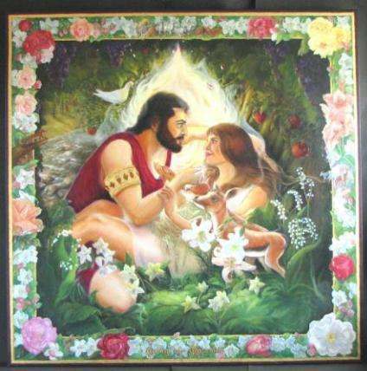

Song of Songs 1:7,8 “[Addressing her shepherd, she said] Tell me, O ªyou whom my soul loves, where you pasture your flock, where you make it lie down at noon. For why should I [as I think of you] be as a veiled one straying beside the flocks of your companions? [Ps. 23:1, 2.]

8 If you do not know [where your lover is], O you fairest among women, run along, follow the tracks of the flock, and [amuse yourself by] pasturing your kids beside the shepherds’ tents.

God compares us with “sheep”. He says that we have moved off from the paths of righteousness. He asks us, what will we do when the midday sun (at its hottest) starts to make life extremely uncomfortable for us?

He tells us that we will experience great distress / discomfort and that we will wander aimlessly about, even though we “think” that we are successful in achieving our goals in life.

God’s answer for us is simple:

Song of Songs 1:8 If you do not know [where your lover is], O you fairest among women, run along, follow the tracks of the flock, and [amuse yourself by] pasturing your kids beside the shepherds’ tents.

Ps 85:13 “Righteousness shall go before Him and shall make His footsteps a way in which to walk.

He tells us to follow the Footsteps / the path that is set out in the Word of God. A careful lifestyle of following God’s landmarks and keeping His commandments will lead us to a life of purpose.

Jer 31:21 “Set up for yourselves highway markers [back to Canaan], make for yourselves guideposts; turn your thoughts and attention to the
way by which you went [into exile]. Retrace your steps, O Virgin Israel, return to these your cities.

When you and I walk on God’s chosen path, when we become worthy utensils operating to the fullest extent of our gifts; when we become fathers and mothers fulfilling our destiny, we begin to set in

motion the wave of generational blessings that will continue to flow for many generations to come.

Build a generational wave of blessing!

Be a blessing to the Bride of Messiah!!

255

PART 15: IMPROPER FATHERING WOUNDS THE SPIRIT AND THEREFORE BLOCKS THE GIFTS OF THE SPIRIT FROM BEING ABLE TO OPERATE.

We live in a broken world with broken people and specifically broken parents.

No one has the perfect father; therefore we all have to deal with the issues of imperfect sonship because we all had imperfect fathering.

There are two types of father wounds:


Type A:

An absence of good things you should have received from your father. These wounds are not obvious. You are highly successful, married and have children, serve in church, and yet carry with you wounds that you don’t have language for, that you can’t define, you don’t know what you’re missing. These feelings influence your sonship, the way you perceive Almighty God and the way you look at life.

Type B:

Sometimes bad things happen to us – traumas that arise from the way we are fathered. These wounds have received a great deal of attention and many strategies have been developed to help people. We can remember the cause and effect and therefore these wounds are easier to deal with because they are evident.

We are going to focus on TYPE A wounds.

2 Pet 1:5 “5 For this very reason, adding your diligence [to the divine promises], employ every effort in exercising your faith to develop virtue (excellence, resolution, Christian energy), and in [exercising] virtue [develop] knowledge (intelligence),”

When we understand SONSHIP, our knowledge can be translated into effective ways to heal Type A wounds.

256

If we have not been Fathered Properly, we will be wounded in our

Spiritman:

1. The Gift of Prophet

The prophet was supposed to connect a person’s spirit with God and make that introduction and that bond strong. When that does not happen there is an
obsession with the pursuit of the spiritual.


The past number of years there has been a very strong drive towards the prophetic – everybody is trying to get in touch with God through the prophet. We have had a tremendous pursuit of worship as well because worship is another vehicle where your spirit can touch the Spirit of God.

There has also been a tremendous pursuit of the occult because those spirits are easier to get in touch with than the Spirit of the Living God.

Because of a culture-wide deficit of fathers who have not introduced the child’s spirit to God nor made that bond, we now have a generation that’s pursuing the prophetic, worship and the occult in order to fill that void.


2. The Servant

When the child has not had the privilege of

exploring you find the adults who are day-
dreaming, losing themselves in a fantasy of what they
could be, the things they could do. They are just trying to
live out in their forties in their mind what they could not
live out when they were two years old.

So often our culture does not understand the unique callings on our children.

When a child has something in him that he wasn’t able to discover when he was a toddler, he is going to be searching randomly out there – maybe not physically – but his mind is going to be probing every other profession trying to see if it fits, it it’s him, if that is what he was made to be.

3. The Teacher

The teacher whose spirit was not prepared and taught properly is going to be inclusive of sinners without being able to heal them. They will not be able to discern right from wrong.

The teacher is going to talk about giving more and more time for somebody to repent.

257

When an adult does not know how to reconcile other people – when an adult doesn’t know how to bridge that gap – they will make excuses for the apparent behaviour.


Why do we have a generation of parents who are scared of their children?

These parents make all sorts of excuses for their children’s inappropriate behaviours because the parents don’t know how to establish a standard and enforce that standard, and reconcile when there has been a breach to the standard. And since they don’t know, they just lower the standard and say:

“Well, he’s just going through a stage! He just needs more time!”

The truth is that it is the father that needs more wisdom and not the child that needs more time!!

4. The Exhorter


If that portion of the parenting was not done, you will have one of two things:

1. An individual that seeks relationship with non-humans as in a relationship with pets, invisible friends, video creatures.

Many children who did not learn to interact
with other children are bonded to non-
humans and not other people.

- Individuals that are in a group, they are incredibly lonely because there is a mantle of invisibility over them. They move in a group, everybody greets them but there is no connectedness because that mantle of invisibility keeps them a mile apart from the person they are sitting right next to.

They crave group belonging but they cannot get it no matter how much they try and socialize in groups.


5. The Giver

If the giver portion of parenting did not happen, you are going to have individuals that seek fulfilment and security in external resources – in their possessions instead of internal resources.

God designed us to find fulfilment in what we do and

not in what we have. We will not have the skills within us to do anything that brings us fulfilment and so we will gravitate to toys in a very superficial way.

258

6. The Ruler

If the ruler portion of parenting doesn’t take place we are going to be craving to associate with a visible source of power.


For example: We will want to be part of a corporation, or we will want to hang out with this really spiritual person. There will be a surrogate source of power other than Godly dominion that comes from within us.

7. Mercy

If they have not been blessed and released into adulthood, the mercy is going to be on a never-ending

chase to buy the approval of God.

Every day they have to perform at a higher level to be sure that He is pleased with them today and you never-ever arrive.


259

PART 16: GOD IS ALREADY BUSY RE-PARENTING US

God is already hard at work re -parenting us – He is passionate about re-parenting us!! He is very good at re-parenting us. He is committed to doing it through the stuff of daily life.

As soon as we recognise what God is doing, we can partner with Him and allow Him to continue that process of re-parenting.

James 1:17 “17 Every good gift and every perfect (free, large, full) gift is from above; it comes down from the Father of all [that gives] light, in [the shining of] Whom there can be no variation [rising or setting] or shadow cast by His turning [as in an eclipse].”

GOD HAS ONE AGENDA AND THAT IS FOR YOU TO BE FULLY A SON.

GOD WANTS YOU TO STEP INTO YOUR SONSHIP FULLY EQUIPPED AND EVERYTHING THAT CAME

INTO YOUR LIFE TODAY WAS FATHER-FILTERED.

Rom 8:28 “28 We are assured and know that [God being a partner in their labor] all things work together and are [fitting into a plan] for good to and for those who love God and are called according to [His] design and purpose.”


GOD’S PURPOSE IS FOR YOU TO BE A SON!!

1. The Prophet


Rom 8:16 “16 The Spirit Himself [thus] testifies together with our own spirit, [assuring us] that we are children of God.”


It is God that builds that sense of liberty / legitimacy into you.

It is not just a one-time thing – it is an everyday constant affirmation from your Father!

260

2. The Servant

Ps 37:4 “4 Delight yourself also in the Lord, and He will give you the desires and secret petitions of your heart.”


A child is trying to discover what he likes – “who put the lights in the sky? Who made me love land?”

Almighty God places the desire in my heart and then leads me to a place where I can experience those desires.

3. The Teacher

John 16:12-13 “12 I have still many things to say to you, but you are not able to bear them or to take them upon you or to grasp them now.
13 But when He, the Spirit of Truth (the Truth-giving Spirit) comes, He will guide you into all the Truth (the whole, full Truth). For He will not speak His own message [on His own authority]; but He will tell whatever He hears [from the Father; He will give the message that has been given to Him], and He will announce and declare to you the things that are to come [that will happen in the future].”

2 Cor 5:19-20 “19 It was God [personally present] in Christ, reconciling and restoring the world to favor with Himself, not counting up and holding against [men] their trespasses [but cancelling them], and committing to us the message of reconciliation (of the restoration to favor).

20 So we are Christ’s ambassadors, God making His appeal as it were through us. We [as Christ’s personal representatives] beg you for His sake to lay hold of the divine favor [now offered you] and be reconciled to God.”

God leads us into situations that we are not looking to learn!!

He teaches us about reconciling a person back unto Himself as well as back to his neighbour.

4. The Exhorter

Hebrews 10:24-25 “24 And let us consider and give attentive, continuous care to watching over one another, studying how we may stir up (stimulate and incite) to love and helpful deeds and noble activities,
25 Not forsaking or neglecting to assemble together [as believers], as is the habit of some people, but admonishing (warning, urging, and encouraging) one another, and all the more faithfully as you see the day approaching.”

261


What is the natural human reaction when we have

been hurt by people?
You withdraw!

God wants you to grow up as mature adults who can handle difficult situations in life in a Godly way, including dealing with conflicts in relationships.

5. The Giver

Eph. 4:11 “11 And His gifts were [varied; He Himself appointed and gave men to us] some to be apostles (special messengers), some prophets (inspired preachers and expounders), some evangelists (preachers of the Gospel, traveling missionaries), some pastors (shepherds of His flock) and teachers.”


God brings people to you that give you pieces of the puzzle so that you can build the bigger picture.

People draw out of you the gift that God has placed there and help you to grow and develop.

6. The Ruler

Matt 16:18-19 “18 And I tell you, you are Peter [Greek, Petros—a large piece of rock], and on this rock [Greek, petra—a huge rock like Gibraltar] I will build My church, and the gates of Hades (the powers of the infernal region) shall not overpower it [or be strong to its detriment or hold out against it].

19 I will give you the keys of the kingdom of heaven; and whatever you bind (declare to be improper and unlawful) on earth must be what is already bound in heaven; and whatever you loose (declare lawful) on earth must be what is already loosed in heaven.”

God helps you to grow your faith to be able to believe things you could not believe before.

He will increase your passion for rebuilding.

For example:

Children with learning disabilities can be built up and restored to mental, emotional, spiritual, and physical wholeness – we only need the faith to believe!

NOTHING IS IMPOSSIBLE WITH GOD!!

262

7. The gift of Mercy

John 15:15 “15 I do not call you servants (slaves) any longer, for the servant does not know what his master is doing (working out). But I have called you My friends, because I have made known to you everything that I have heard from My Father. [I have revealed to you everything that I have learned from Him.]”


None of us have perfect friends.

We love our friends just because we do. They do have some bad habits but we overlook those things and we love them anyway.

It is in this area that God disconnects gifts with performance.

He visits us any time He wants and not only when we are fasting or praying or being spiritual.

God sees us in an adult context – He sees us in totality and not judging us for what we communicated to Him in the last 10 minutes.

God knows when we are imperfect; He knows where we failed yesterday, and He knows where I will fail tomorrow.

And He is willing to risk it!

- He is willing to partner with me.

- He is willing to trust me.

- He is willing to give me revelation.

- He believes in me.

And I don’t have to prove myself everyday!

He still disciplines us – there are still issues that we will deal with but we do not have to prove ourselves!

I need to grow and get to that place in God that I have peace with the fact that there is simply no correlation whatsoever between God’s love for me and my behaviour today.

I am His son / daughter and that is the end of that!!

263

IN CONCLUSION: ALWAYS REMEMBER!!

God is very busy re-parenting us – He knows those seven areas in our lives – He knows where we were not parented adequately – He knows where our biggest Type A wounds are and He is planning and strategizing and bringing:

- people (good and bad),

- feast and famine,

- pleasure and pressure into our lives
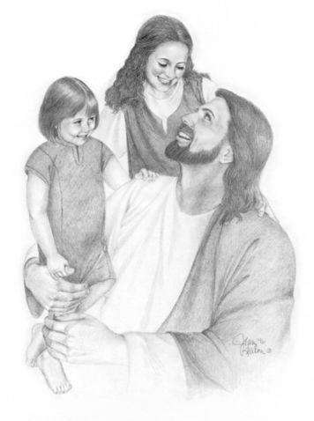

He is masterfully working:

- to shape us

- to change us

- to re-parent us

- to heal us.

THE GOOD NEWS!! THE PRESSURE IS NOT ON US!!

- The pressure is not on that newly conceived baby to introduce its own spirit to God.

- The pressure is not on the toddler to make a safe living room.
- The pressure is not on the three year old to figure out how to reconcile with dad after doing something naughty.

It is the parent that has the pressure to be the parent.

STEP OUT OF SLAVERY!!


Slavery means it is your job to figure out how to do it right so

that you don’t make the master upset. Slavery says the pressure is on you endlessly because if you mess up you are going to hurt real badly.

As a son, the pressure is on the Father to know you and to look at the incredible complexity of the world you live in and to micro-manage customized situations that will draw you to a place of wholeness.

264

LIBERTY / LEGITIMACY


Liberty / Legitimacy is based on the Spirit of God speaking to your spirit in a language you can understand and deeply rooting in you a sense that you are okay!

According to scripture our spirit is LIGHT – it is made of light and the light is the Light of God Himself.

Each one of our spirits came from the Essence of

Almighty God – we are part of the Spirit and Nature of God and it does not get any more legitimate in eternity or the universe than being part of the Nature of God.

2 Pet 1:3 “3 For His divine power has bestowed upon us all things that [are requisite and suited] to life and godliness, through the [full, personal] knowledge of Him Who called us by and to His own glory and excellence (virtue).”

PRAYER
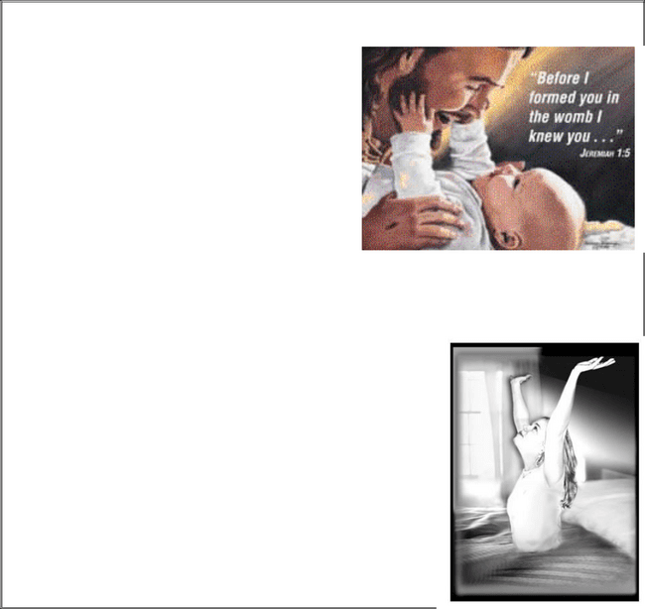

Father, we proclaim the Truth – there is not one single person who is not created by You. No demon, nor angel, nor any other entity created any one of us.

Every single one of us was Master-planned by You – uniquely designed for this particular point of time and history. You designed our spirits, You designed our souls, You designed our bodies.

You chose the time in history and the family that You would place us into.

Father, we now declare that this Truth will stand before Your throne for all eternity.

We call your spirit to attention in the Name of Jesus Christ of Nazareth

We call the slumbering spirits to wake up! Those of you who’s spiritman has been turned inward – we say to you it is safe, it is time, and right for your spirit to turn outward and upward and look in the Face of God.

Father, now we ask Your Spirit to come and speak to our spirits the truth that we are acceptable in Your eyes,

265

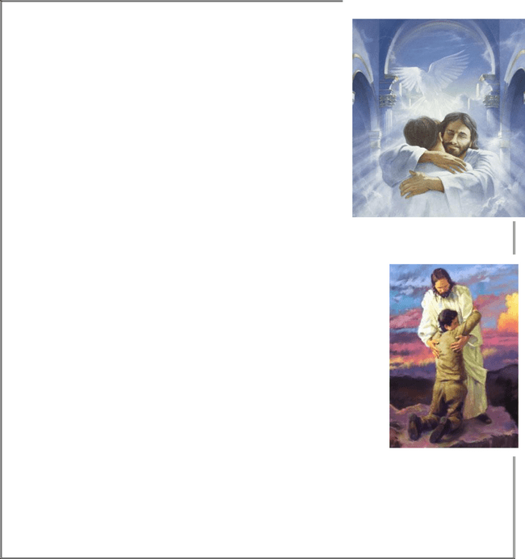
That there is no performance that will detract from who we are in Your eyes.

Nothing can separate us from Your love.

- That You like us the way You made us

- That You are not intimidated by the areas where there is imperfection.
- That You are perfectly sure of Your ability to heal those areas to finish the parenting in our lives

Father, Your Spirit needs to speak to our spirits in a language that we can understand And that is Your promise to us!

So, Father,

- cut through the lies,

- cut through the soulishness,

- Cut through the performance,

- Cut through the religious spirit,

Let Your Spirit speak to our spirit as never before in human history.

Let us know, that we know, that we know, that we are part of You and You are part of us,

You will never let us go,

You are pleased with the work of Your Hands,

You are not sorry You made us!!

AMEN!!
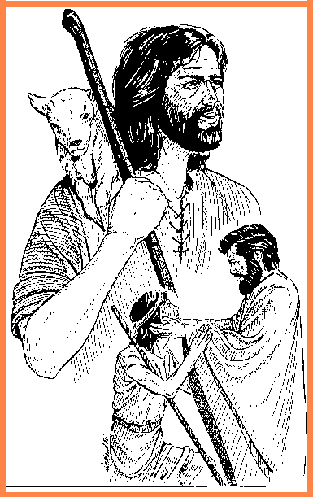

266

RESOURCES:

- Discover your God-given Gifts – Don and Katie Fortune

- Yom Kippur – Reflections on the Life of Jonah available at Kanaan Ministries

- Extracts from the following CD series by Arthur Burk that were processed into personalized teachings:

o Nurturing Your Spirit Seminar I & II o Redemptive Gifts of Individuals
o Seven Curses

(Contact Details for Arthur Burk materials in SA:

Niell and Marie Bester
Tel. no: 012 664 0710
E-mail: jjop@mweb.co.za (Niell)
Lyttleton, Pretoria.
Website: http://www.plumblineministries.com/south_africa1)

267

Additional Resources

Please be sure to work through all the books in the “Journey2Freedom” series:

- J2F1 Man’s Purpose And The Gifts Of The Spirit

- J2F2 Generational Blessings

- J2F3 Blessings And Curses Over Motherhood

- J2F4 Water/Spirit Baptism

- J2F5 Spying Out The Land

- J2F6 Dealing With The Giants

- J2F7 Uprooting Generational Heart-Attitudes And Roots

- J2F8 Childhood Pain, The Brain, And Arrested Development ... How Do We HEAL And Come To MATURITY?

- J2F9 Mother-Bonds, Deception, And The False Prophetic

As well as our follow-on series to J2F — “Journey2Wholeness”:

- J2W1 Breaking The Curse Of Illegitimacy And Shame

- J2W2 Emotional Pain And Building Healthy Relationships

- J2W3 Emotional Pain And Restoring Relationships


In closing, after these curses have been dealt with and broken, it is very important to restore BLESSINGS ... we want to encourage fathers to take this calling seriously, and to begin BLESSING their families according to the Commandment of the LORD that the priests bless with the following blessing ...

Priestly Blessing
Numbers 6:24-27

“Y’varekh’kha YHVH v’yishmerekha.

May YHVH bless you and keep you.

Ya’er YHVH panav eleikha vichunekka.

May YHVH make His Face shine on you and show you His favour.

Yissa YHVH panav eleikha v’yasem l’kha shalom.

May YHVH lift up His Face toward you and give you peace.

Numbers 6:27 “In this way they are to put My Name on the people of Isra’el, so that I will Bless them.”


